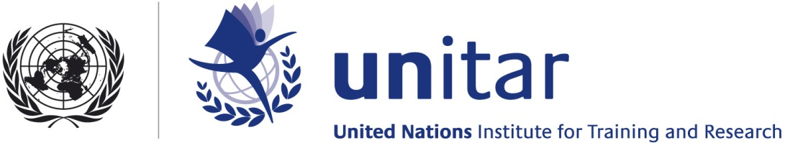

GLOBAL PLATFORM FOR DISASTER RISK REDUCTION
GENEVA, MAY 2013

The engagement of the United Nations Institute for Training and Research (UNITAR) in disaster risk reduction dates back to UNITAR’s membership in the ISDR Inter-Agency task Force for Disaster Reduction. UNITAR works alongside ISDR and other UN agencies and programmes to support DRR as a strategic set of principles and guidelines of great importance to achieve the main goals of the global agenda for sustainable development. DRR is also a moral imperative for the welfare of people at risk worldwide.
The Institute approach is based on its mandate in training and research and its mission to help member states build national skills and competencies to implement at national level the principles and goals set out by the international community at global level. UNITAR trains thousands of professionals each year in a vast range of disciplines, some of which have a strong connect with the goals of disaster risk reduction. In addition, UNITAR Operational Satellite Applications Programme (UNOSAT) conducts applied research in satellite applications for disaster reduction and directly supports UN agencies and members states in case of major disasters.
We involve citizens and the youth with projects like ‘Map Your School’, a joint initiative of UNITAR/UNOSAT, UNICEF and the Government of Panama. Map Your School is an online platform allowing children to enter information about hazards and resources in and around their schools and community. The information is then displayed on an overview map allowing citizens to visualise hazards in their neighborhood and to receive quick guidance on how best to mitigate them, or areas to be avoided. Incorporating satellite imagery into this process results in an intuitive interface that we expect will help become an economical and useful tool for local communities.
UNITAR has been a pioneer in the area of satellite technology and geographic information systems (GIS) applied to DRR. Already in 2005, together with the European Space Agency, UNITAR pleaded in Kobe for the inclusion of new satellite technologies in the Hyogo Framework for Action. Most recently we have created a web-platform to promote the use of GIS and earth observation (EO) for DRR. The platform, named geodrr.org, is a window for best practises, examples of practical solutions and on-going activities in the GEODRR domain.
Our satellite solutions programme UNOSAT works with DRR partners worldwide to make sure member states and vulnerable communities share together the benefits of technology in support of DRR. With the Intergovernmental Authority on Development (IGAD), we work in Eastern Africa to develop the capacity with technical training and senior decision makers’ awareness. UNOSAT also shares risk related data with the IGAD Secretariat and to Climate Prediction and Application Centre (ICPAC), the Conflict Early Warning and Response Mechanism (CEWARN) and the Centre for Pastoral Areas and Livestock Development (ICPALD). We do the same in Asia together with our major partners ESCAP and ADPC with whom we deliver regional as well as national training. To ensure that this training fits with the contributions of all other UN partners along the disaster management cycle, we coordinate with OCHA and with OOSA/SPIDER across Asia and the Pacific.
UNITAR is active in the area of Climate Change, working on the nexus between adaptation to climate change and disaster reduction. We serve as the secretariat of the UN CC:LEARN, the “One UN Training Service Platform for Climate Change”. CC:LEARN is a collaboration between 33 multilateral organisations providing country-driven and results-oriented learning and skills development and is based on the one-UN principle . To maximise our contribution, we have also begun working with the UN Development Group to provide integrated training to UN country teams on disaster risk reduction, environmental sustainability and climate change.
The expanding Local Development Programme at UNITAR work with member states in strategic areas of local development. DRR cuts across many of the areas in which we help countries build capacity. Several learning activities conducted by LDP and its Network of 10 International al Training Centers for Local Actors (CIFALs) across the world contribute to stepping up resilience to natural hazards in local communities around the world. These areas included in 2012: low-carbon cities and Green Growth, urban infrastructure financing, community resilience, the SymbioCity approach to achieve urban sustainability. In 2013 we are also partnering with the Andean Development Corporation (CAF) for the organization of learning events on DRR in Latin America.
Together with UNDP, IOM and others and with the support of the City of Bergen in Norway, we are researching the interaction between climate change, human rights and development which in several cases is also an accelerator of vulnerability and a threat to community resilience. We have focused this initiative on bringing knowledge and practical solutions to local actors where most of the risk is generated, with a hope to make a tangible difference for future generations.

