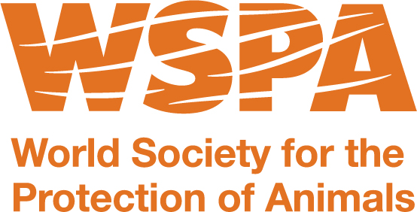
ISDR Global Platform Side Event

Animals: build community resilience with innovative solutions
May 23, 2013 13:00 – 13:55

Organized by: World Society for the Protection of Animals (WSPA)

Presenters

Introduction and welcoming remarks by Lindsay Jardine, Disaster Operations Manager, World Society for the Protection of Animals (WSPA).

Mike Baker
CEO, World Society for the Protection of Animals (WSPA)
Cesar D’Avila
Representative from the Aldama Municipality of Chihuahua, Mexico
Ing. Oscar Zepeda Ramos
Representative from the National Centre for Disaster Prevention/Mexico
Gerardo Heurtas
Director of Disaster Management – Americas, World Society for the Protection of Animals (WSPA)

