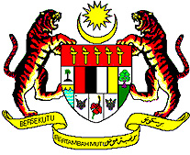
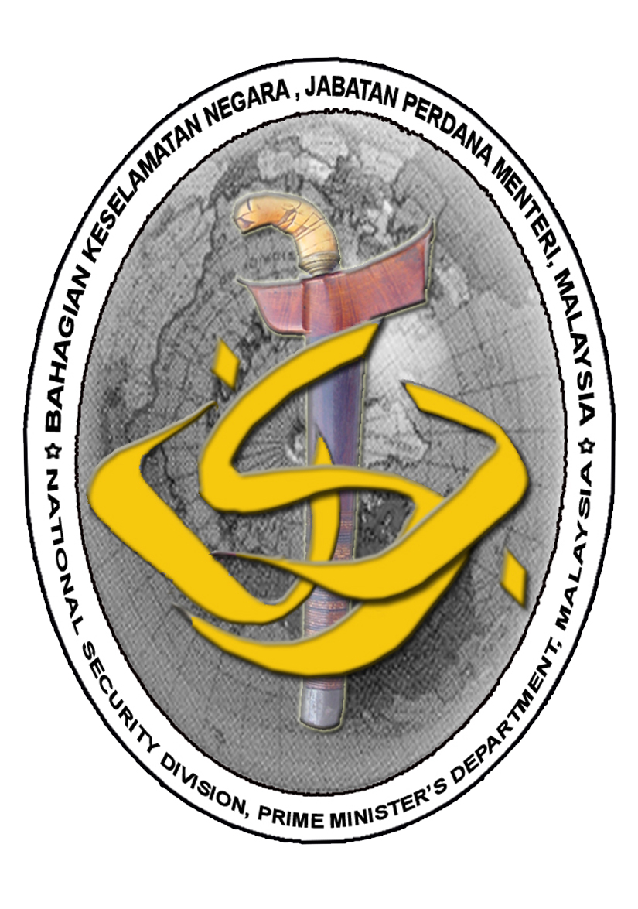

MALAYSIA

FOURTH SESSION OF THE GLOBAL PLATFORM
FOR DISASTER RISK REDUCTION

UNITED NATIONS OFFICE FOR DISASTER RISK REDUCTION (UNISDR)

PLENARY STATEMENT BY:

THE HON. DATUK MOHAMED THAJUDEEN BIN ABDUL WAHAB
SECRETARY
NATIONAL SECURITY COUNCIL
PRIME MINISTER’S DEPARTMENT

GENEVA
22 MAY 2013

STATEMENT BY
HON. DATUK MOHAMED THAJUDEEN BIN ABDUL WAHAB
SECRETARY, NATIONAL SECURITY COUNCIL
HEAD OF DELEGATION, MALAYSIA

Mr. Chairman,

Excellencies,

Distinguished Delegates,

Ladies and Gentlemen,

- At the outset, allow me to congratulate the United Nations Office for Disaster Risk Reduction (UNISDR) for the convening of the Fourth Session of the Global Platform for Disaster Risk Reduction as well as the Government of Switzerland for hosting this event. This year’s session is a pivotal one as it will set the tone for international cooperation in DRR post 2015 leading to the World Conference on Disaster Risk Reduction in Japan.

- It is a fact that no country, even the most developed, is immune from the impact of natural disasters. As such DRR and resilience should be viewed as matters of common concern to both the developing and the developed world. It serves the common interest that international cooperation in this matter be intensified. It is therefore heartening to see increasing willingness among countries everywhere to jointly address this shared problem especially since the First Session of the Global Platform held in 2007.

- Over the past 20 years, losses caused by natural disasters have been steadily rising. Beyond their human toll which is in fact incalculable, economic losses have exceeded USD200 billion. Although high income countries have incurred greater losses in monetary terms, low and middle income countries have suffered greater impacts relative to their GDPs. Developing countries have also disproportionately suffered in terms of human fatalities due to their weaker infrastructures and response capabilities

- It is becoming more and more evident that holistic and innovative approaches are mandatory for addressing disaster risks. This is due to the close inter-relationships and inextricable linkages that exist between disaster risks and other key challenges of poverty reduction, sustainable development, environmental stability as well as the emerging reality of global climate change.

- With the onslaught of climate change, worldwide disasters are anticipated to increase. We need to inculcate a sense of urgency towards this issue because if we adopt a “business as usual” attitude the consequences can be quite disastrous. The high level of scientific uncertainty about the nature and consequences attributable to climate change, and the intrinsic relationship between climate change and DRR, both call for intensive research by scientific and academic institutions so that state-of-the-art knowledge and know-how can be translated into national policies and local actions.

- Various types of partnerships need to be forged to tap scientific and technological knowledge to facilitate informed policy and decision making for DRR and climate change adaptation (CCA). The elements that bring about successful partnerships must be identified and understood, documented and disseminated so that such partnerships can be replicated worldwide. In this way, scientific and technological knowledge can then be effectively used at all levels, both national and local levels.

Distinguished Delegates,

Ladies and Gentlemen,

- In 2005, Malaysia adopted the Hyogo Framework for Action (2005-2015) together with 167 other countries. One of the positive results of the HFA implementation is the widespread recognition and acceptance of DRR as a valuable instrument for national planning and implementation.
- DRR has also served to heighten awareness about disasters at various levels. Many countries have also strengthened their respective national platforms for building multi-stakeholder consensus. This in turn has improved DRR governance.

- Malaysia is happy to announce today that it is in the midst of setting up its own multi-stakeholder National Platform on Disaster Management which will be ready by the end of this year. We will then have an integrated approach to reducing the risks of disasters.

- Malaysia fully supports the ongoing work of the UNISDR to promote and accelerate the implementation of HFA, including the development of a post-2015 framework for DRR. On this matter, many views and options have been expressed to date. In our view, the preparation of a successor document to HFA need not involve a re-writing and adoption of an entirely new document.

- The successor document to HFA should focus upon making concrete progress in the implementation of existing measures, including provisions which can be used to measure and quantify progress. It should also concentrate upon formerly abandoned and neglected elements of the HFA. We should certainly refrain from building any new system to implement DRR. We merely need to maximize the utilization of existing systems and networks.

- Looking beyond 2015, the post-HFA framework and its implementation monitoring system should be institutionalised at the national levels. We should strive for a framework that is flexible and usable by the range of situations that countries and local communities find themselves in. The framework should provide different starting points and different choices while prioritizing implementation. This will facilitate the identification of supporting action and progress monitoring.

- Malaysia looks forward to a successful conference here in Geneva. In particular we hope to see fruitful deliberations on the post-HFA framework. We also look forward to achieving consensus on how local, national, regional and international stakeholders can effectively address the new challenges brought about by disasters and climate change.

- Thank you.

