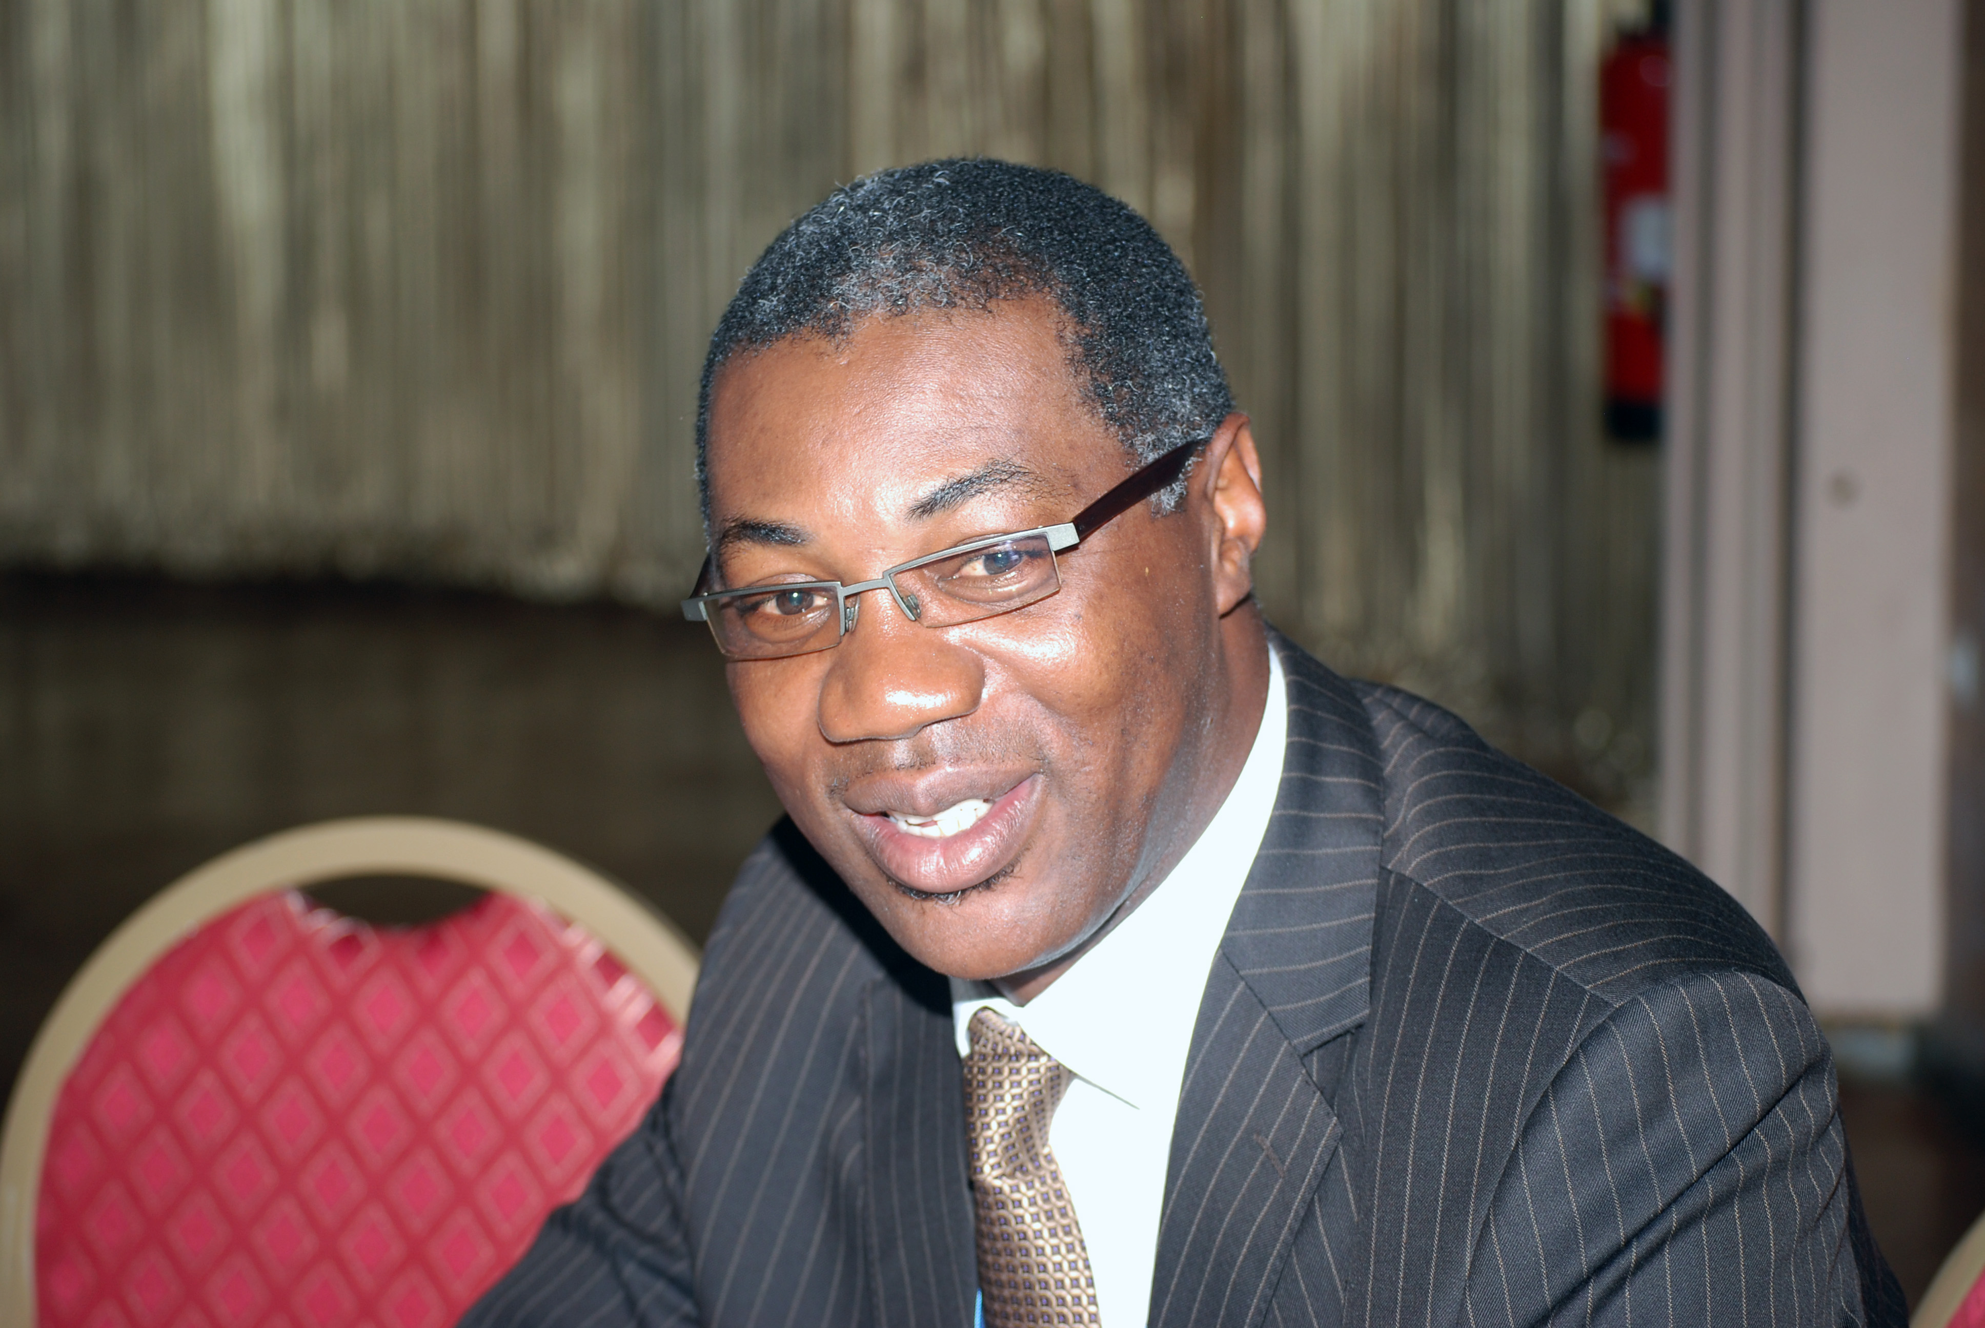
Dr Lucien Manga
Coordinator
Health and the Environment Programme.

World Health Organization,
Regional Office for Africa
Brazzaville, Congo

Dr Lucien Manga is Regional Advisor for the Protection of the Human Environment for the World Health Organization in the African Region. In this capacity, he coordinated the First and Second Inter-Ministerial Conferences on Health and Environment in Africa held respectively in Libreville, Gabon in 2008 and in Luanda, Angola in 2010. The Libreville conference endorsed the Libreville Declaration on Health and Environment in Africa and created the health and environment strategic alliance. The Declaration has been adopted jointly by Ministers of Health and Ministers of Environment in 52 African countries and implementation activities are currently underway in about 30 countries. Building on the positive policy response to this multi-sectorial effort in 2011 Lucien Manga led the development of a framework for public health adaptation to climate change as well as a 5-year plan of action for its implementation in Africa. Since this year Lucien has been leading the establishment of Climate and Health Consortium for Africa (Clim-HEALTH Africa) to support development and deployment of early warning and early response systems for the sound management of health impacts of Climate Change.

Lucien Manga joined the World Health Organization in 1997 as the Head of the Vector Biology and Control Unit at the Regional Office for Africa. He spearheaded the development of Integrated Vector Management and contributed to its endorsement at the global level as the main strategic approach to vector control. In 2000, Lucien Manga led the establishment of the African Network on Vector Resistance to Insecticide (ANVR). This network is currently instrumental in capacity building for vector control and in monitoring trends in insecticide resistance throughout Africa. Originally from Cameroon, he gained his Doctorate in Biology from the University of Yaoundé, Cameroon (1992) and a PhD in Medical Entomology and Parasitology from the University of Montpellier I, France (1999). His research work while based at the University of Yaoundé and Ngaoundere in Cameroon and at the OCEAC in Yaoundé has focused on the relationship of malaria to environmental factors, including urban malaria.

