Maryam Golnaraghi, Ph.D.
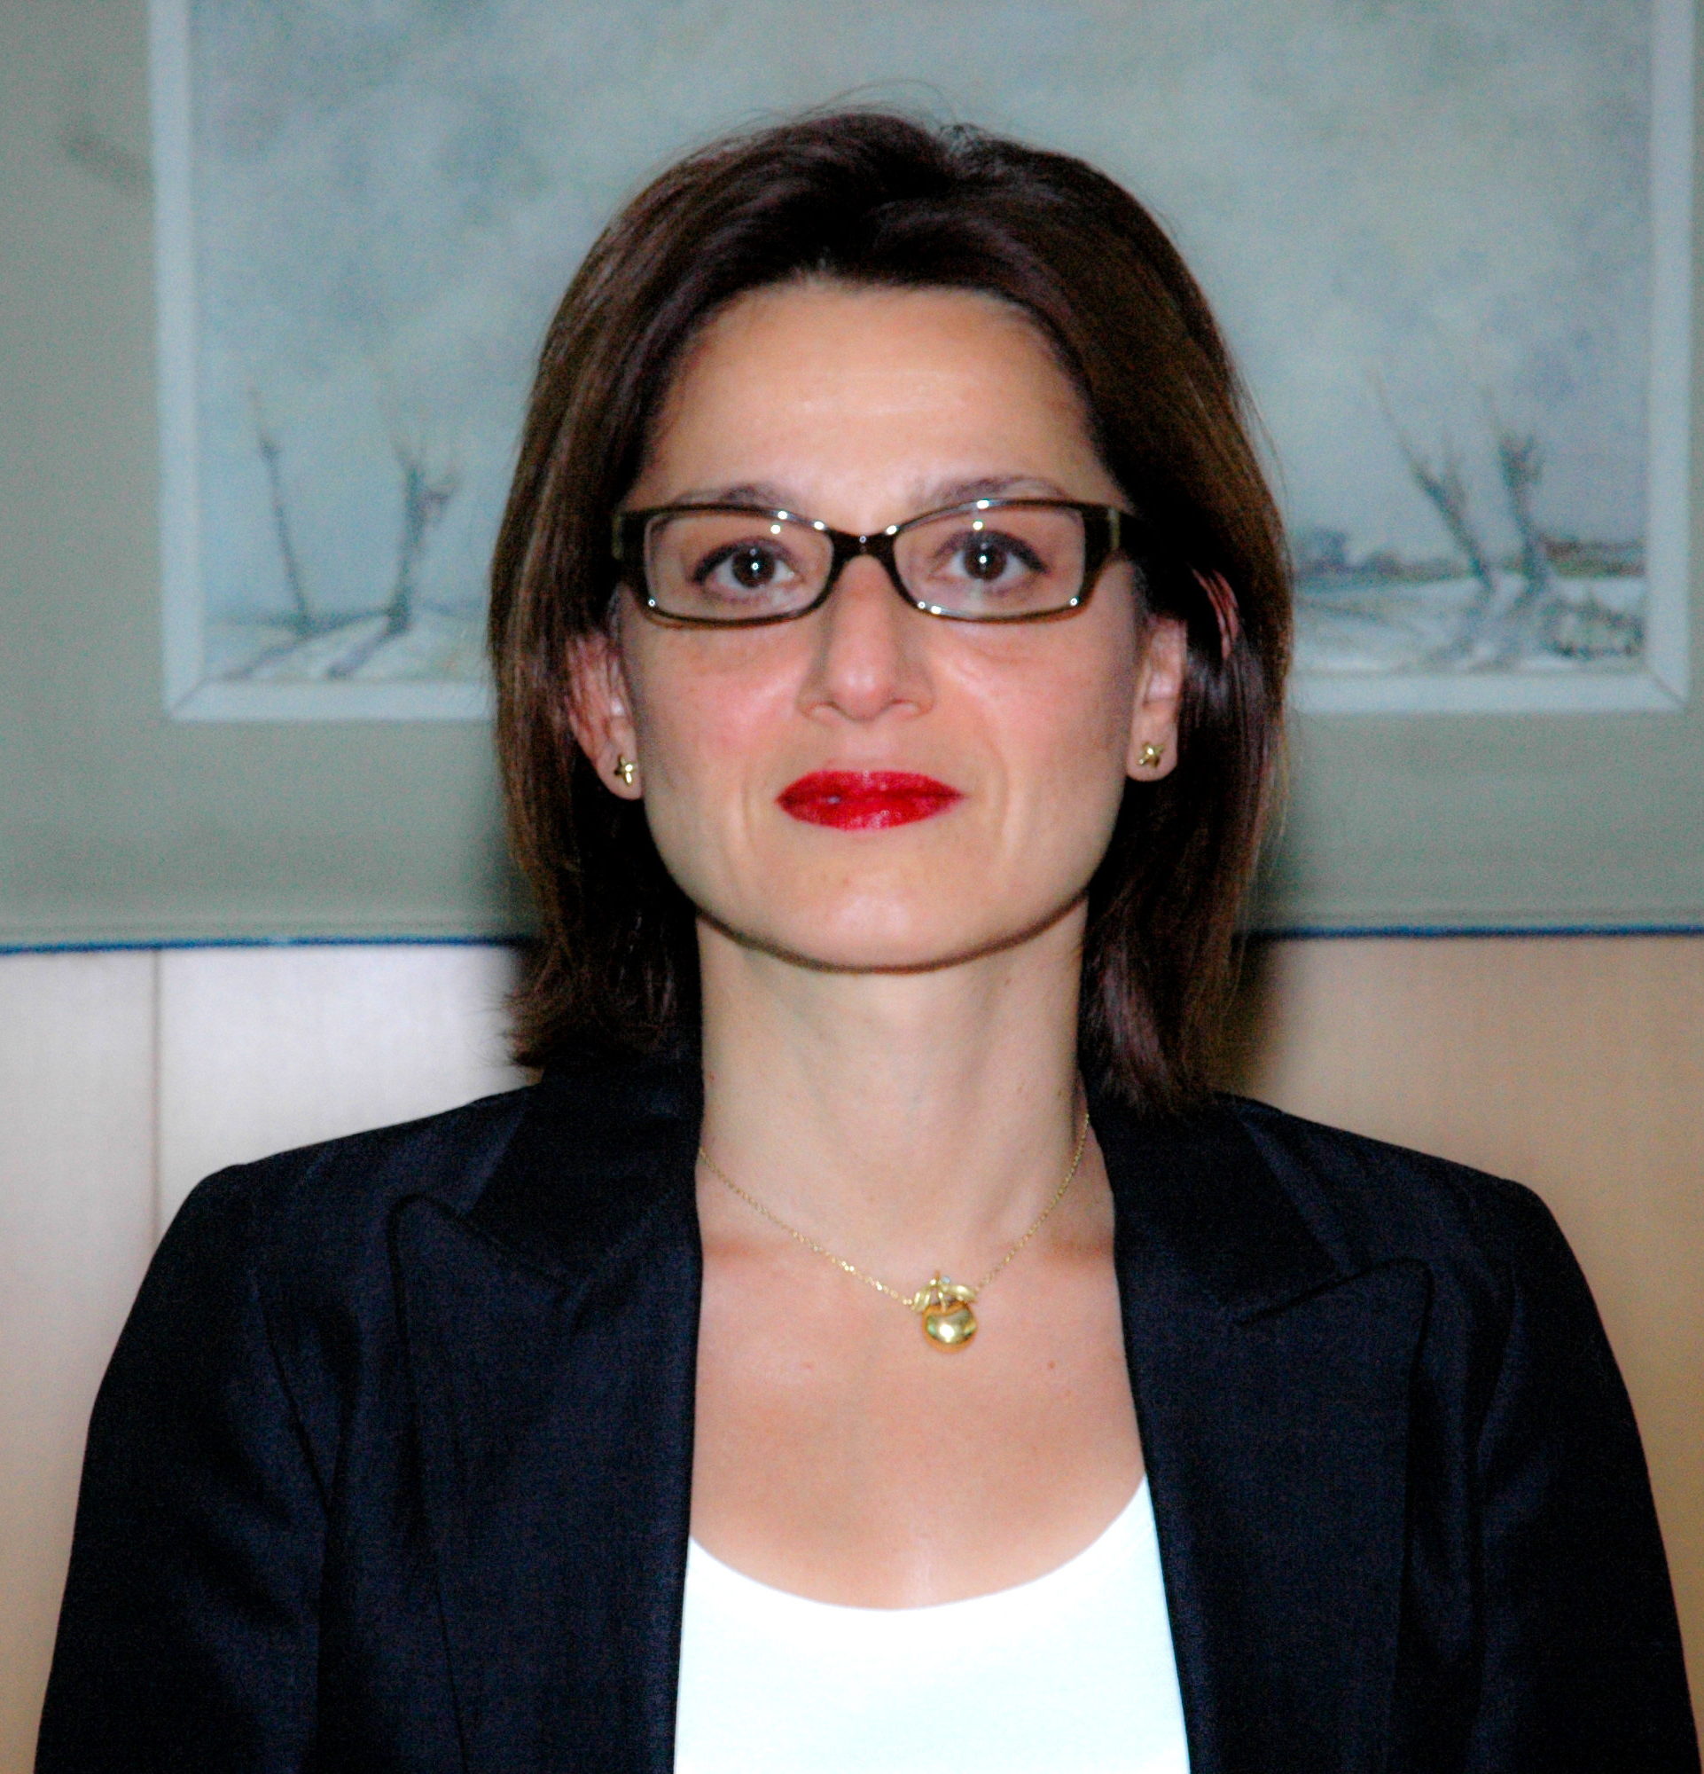
Dr. Golnaraghi is the Chief of the Disaster Risk Reduction Programme at the World Meteorological organization. She joined the WMO in 2004 to develop strategic, institutional, financial, and thematic aspects of the programme with focus on meteorological, hydrological and climate services to support risk analysis, early warning systems, sectoral risk management and disaster risk financing (http:/www.wmo.int/disasters).

In 1996 she founded and served as the President of Climate Risk Solutions, Inc. (CRS) a research and consulting firm, which worked with the private and public sectors and the academia to provide climate and CAT risk assessment and innovative climate information products for energy, agricultural and financial sectors.

Her technical expertise spans areas of ocean/climate modelling, science-driven policy development, catastrophe risk modelling, early warning systems, climate risk assessment and management with focus on financial, agriculture and energy sectors.

Dr. Golnaraghi serves on a number of international committees and advisory boards and as senior advisor to officials from the United Nations, governments and the private sector.

Ms. Golnaraghi was the executive editor of The Climate Report, a quarterly publication of CRS and has served on a number of editorial boards of international publications. She has authored a number of papers in science and policy. She is the editor of the book, entitled, “Institutional Partnerships in Multi-Hazard Early Warning Systems,” published by Springer Verlag in 2012 and is working on a second book on “Climate Services for Disaster Risk Financing and Insurance.”

Ms. Golnaraghi holds a B.Sc. (Chemical Engineering) from Cornell University, a Masters of Science (Applied Physics) and a Ph.D. (Physical Oceanography and Modelling) from Harvard University, after which she joined the Harvard Business School as a senior research associate focusing on commercialization of technology, public/private partnerships and new product development.

