Designing the Santiago Network
for Loss and Damage
Steps to developing a Santiago Network that can deliver on the needs of developing countries in the implementation of approaches to address loss and damage caused by climate change.

Authors:
Heidi White, Kate Raffety, Laura Schäfer, and Doreen Stabinsky
This paper was conceived and produced by the Santiago Network Working Group of the Loss and Damage Collaboration (L&D Collaboration). Members of the L&D Collaboration include UNFCCC Party negotiators, loss and damage technical experts from academia and civil society, and others working on the issue of loss and damage caused by climate change.
Members of the Santiago Network working group of the L&D Collaboration who have contributed to the report include: Sunil Acharya (Practical Action, Nepal); Istiakh Ahmed (ICCCAD, Bangladesh); Christopher Bartlett (Vanuatu); Rebecca Byrnes (FFNPT, Australia); Saleemul Huq (ICCCAD, Bangladesh); Colin McQuistan (Practical Action, UK); Sandeep Chamling Rai (WWF-International); Salote Soqo (Unitarian Universalist Service Committee, USA); Sara Stillwell (Stamp out Poverty, UK); Lauren Stuart (Oxfam-US).

Draft for circulation and comment
October 2020

Executive Summary
At COP25 in December 2019, the Santiago Network for Loss and Damage (SNLD) was established as part of the Warsaw International Mechanism for Loss and Damage (WIM) by Decision 2/CMA.2 as follows:
43. Establishes, as part of the Warsaw International Mechanism, the Santiago network for averting, minimizing and addressing loss and damage associated with the adverse effects of climate change, to catalyse the technical assistance of relevant organizations, bodies, networks and experts, for the implementation of relevant approaches at the local, national and regional level, in developing countries that are particularly vulnerable to the adverse effects of climate change;
No further guidance or pathway was provided by the Parties towards the establishment and implementation of the network.
In 2020, the Loss and Damage Collaboration (the L&D Collaboration) carried out a survey of United Nations Framework Convention on Climate Change (UNFCCC) country focal points and loss and damage and climate risk management experts at country, regional, and international levels. The survey was designed to understand exactly what technical assistance might be needed by Parties to avert, minimize and address loss and damage – currently and in the future – and what assistance could be delivered by the SNLD and the organizations, bodies, networks, and experts that will make up the network.
Part one of this report presents the results of the survey.
Part two of this report analyses the Climate Technology Network (CTN) that is part of the Climate Technology Centre and Network (CTCN), as an example of a functioning technical assistance network under the UNFCCC. Although the mandate of the CTN is to mobilise climate technology while the SNLD will be designed to respond to climate events, there are lessons that can be learned about the CTN’s institutional structure, how it mobilizes finance, and how country needs are identified and addressed.
Part three of the report is guided by the analysis in part one and two of this report and the objective that the SNLD support developing countries to address loss and damage. We propose possible functions of the SNLD which fall within three categories: (1) Technical assistance and capacity building; (2) Developing and creating access to knowledge and information on loss and damage; and (3) Fostering coordination and collaboration among key stakeholders. To fulfil these functions, we suggest a structure where the SNLD is comprised of a Network, an advisory board, a coordinating entity, and a loss and damage focal point for each country.
Part four of the report turns to the question: what are the next steps to operationalize the SNLD? Steps to be taken could include:
- The WIM ExCom could assess various existing institutional arrangements under the Convention to see whether they might serve as a model for the SNLD, including the CTN. The ExCom could include the results of such an assessment in its annual report to COP26.
- The SBI and SBSTA would consider the annual report of the ExCom and provide recommendations to the COP on structure, function, and modalities of the SNLD and steps to operationalize it.
- Parties to the COP would take a decision at COP26 on the operationalization of the SNLD.

Table of Contents

1 The Santiago Network for Loss and Damage Survey 5
1.1 Who answered the survey? 5
1.2 What challenges and gaps do developing countries face? 5
1.3 What do developing countries require finance for? 6
1.4 What functions and services should the Santiago Network for Loss and Damage deliver on a scale of 1 (not important) to 5 (critically important)? 6
1.5 What else did participants list as possible functions or services of the SNLD? 9
1.6 At what level should the work of the Santiago Network for Loss and Damage be targeted on a scale of 1 (strongly disagree) to 5 (strongly agree)? 9
2 The model of the Climate Technology Centre and Network 10
2.1 What is the institutional structure of the CTCN? 10
2.2 What does the Network do? 11
2.3 How are country needs identified and actioned? 11
2.4 Finance and the CTCN 12
2.5 Is the Climate Technology Network a good model for the SNLD? 12
2.6 Are Nationally Designated Entities a good model? 13
2.7 Is the Advisory Board a good model? 13
3 The functions and structure of the Santiago Network for Loss and Damage 15
3.1 What is the objective of the Santiago Network for Loss and Damage? 15
3.2 How could the Santiago Network for Loss and Damage function? 15
3.2.1 Technical assistance and capacity building 16
3.2.2 Developing and creating access to knowledge and information on Loss and Damage 17
3.2.3 Fostering coordination and collaboration among key stakeholders 17
3.3 How could the Santiago Network for Loss and Damage be structured? 18
4 What are the next steps to operationalize the Santiago Network for Loss and Damage? 20
5 Conclusion and way forward 20
Annex I: Survey Questions 21

The Santiago Network for Loss and Damage Survey
The Loss & Damage Collaboration prepared a survey (see annex I) to understand what technical assistance Parties might need from the SNLD and what assistance the SNLD and its members could deliver. In this section we will present the survey responses that will form the basis our recommendations on the structure and functions of the SNLD.

Who answered the survey?
Responses were received from countries across the regions of: Asia, Oceania, Africa, Americas, and Europe. Respondents included:
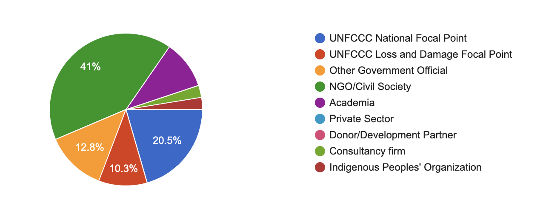

What challenges and gaps do developing countries face?
Survey responses indicate that the most prevalent challenges and gaps faced are: lack of capacity (19 responses or 50%); lack of finance and support (19 responses or 50%); lack of awareness and education about loss and damage (14 responses or 37%); lack of documentation and ineffective government policies (12 responses or 32%).
Additional challenges and gaps include: lack of adaptation activities; lack of early warning systems/slow emergency response; lack of coordination between communities, civil society and government; inadequate planning; government corruption; infrastructure; lack of social safety nets and insurance; cultural barriers; powerful vested interests; lack of support from UNFCCC; weak participation of private sector; and lack of climate justice principles.
For example, “…Pakistan has experienced damages worth an estimated USD 10 billion dollars as a result of the floods of 2010, according to World Bank and Asian Development Bank reports. The World Resources Institute, a global research organisation, further testifies Pakistan’s vulnerability to extreme weather events, and ranks Pakistan at number five in the list of top 15 counties whose 80 per cent of the total population is exposed to river flood risk. Pakistan ranks 135th in terms of greenhouse gas emissions. Yet, it’s amongst the countries most affected by climate change. Over the years, it has lost billions of dollars due to increase in the intensity and frequency of extreme weather events. However, sufficient resources have not been allocated to address the issue.”

What do developing countries require finance for?
Survey responses indicate that the developing countries most require finance for: capacity building (13 responses or 34%); disaster risk reduction (9 responses or 24%); insurance mechanisms (9 responses or 24%); education (8 responses or 21%); risk assessments (8 responses or 21%); coordination and cooperation between governments, civil society and the public (7 responses or 18%); effective government policy (7 responses or 18%); early warning systems (6 responses or 16%); infrastructure (6 responses or 16%).
Finance is also required for: coastal protection; adaptation planning; the provision of technical support; technology; rehabilitation; lead government focal points for loss and damage; planned relocation activities; best agriculture practices; non-economic losses; housing; research development; human resources management; reducing corruption; reporting and accounting mechanisms; reparation and compensation mechanisms; water.
For example, in Peru, “[t]he mobilization of financial resources for the implementation of adaptation measures is key to meet the targets of reducing vulnerability and increasing the adaptive capacity of the country's populations and ecosystems. Furthermore, financial resources are a very important enabling condition for dealing loss and damages climate change. Financial resources are required to: (i) strengthen national and sub-national capacities to implement adaptation NDC; (ii) reduce financing gaps between what is planned and the budget available by the relevant sector, through the promotion of private investment, access to international cooperation resources, among other mechanisms and incentives; (iii) development of integrated studies of impact, vulnerability, risk and adaptation to climate change; in order to face loss and damages.”

What functions and services should the Santiago Network for Loss and Damage deliver on a scale of 1 (not important) to 5 (critically important)?
Implementation of Existing Approaches to Address Loss and Damage  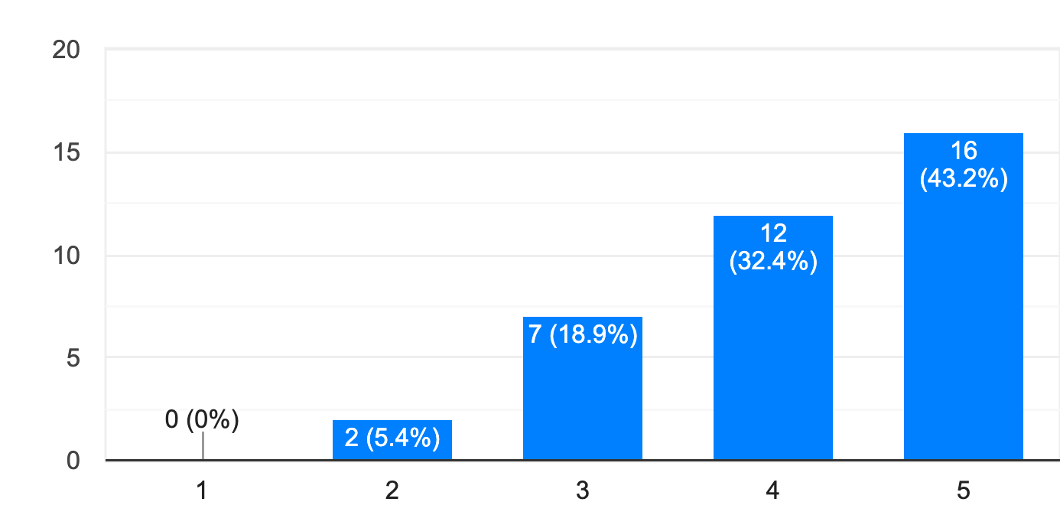 |  | Development of New Approaches/Options to Address Loss and Damage.  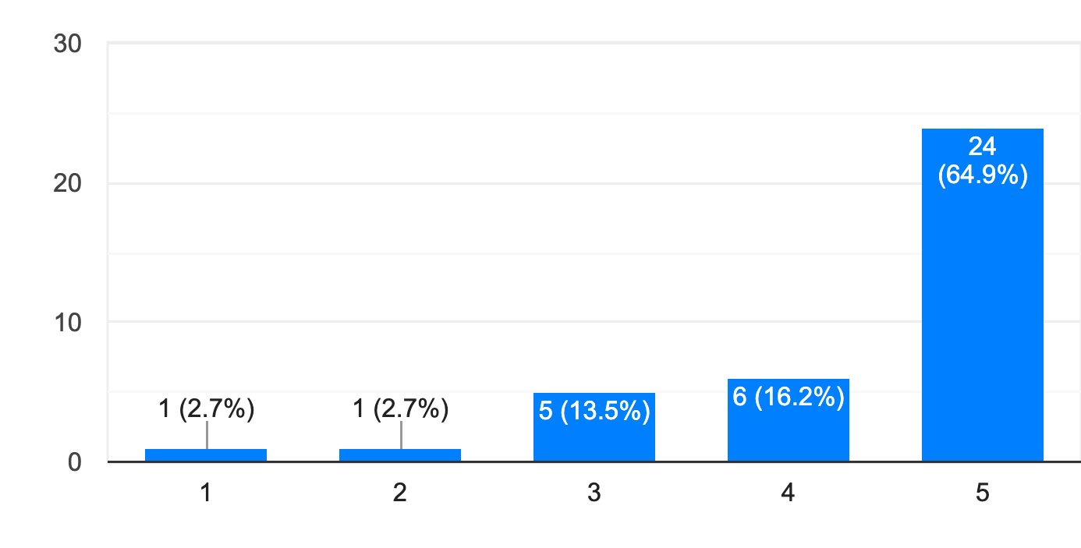
Technical Support and Guidance on Approaches to Address Loss and Damage  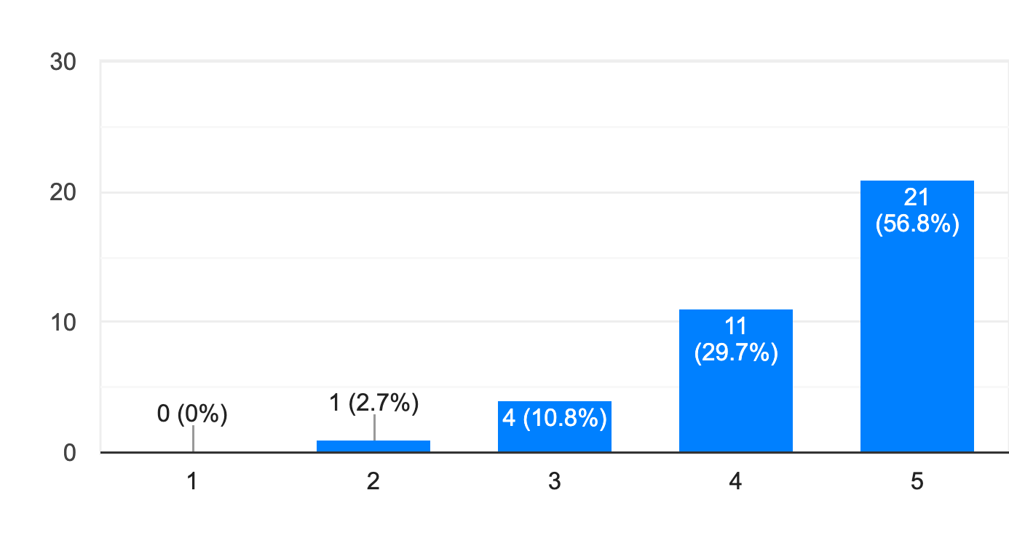 |  | Loss and Damage Finance (e.g., accessing finance for loss and damage / facilitating access to finance / supporting the development of new project proposals focused on loss and damage)  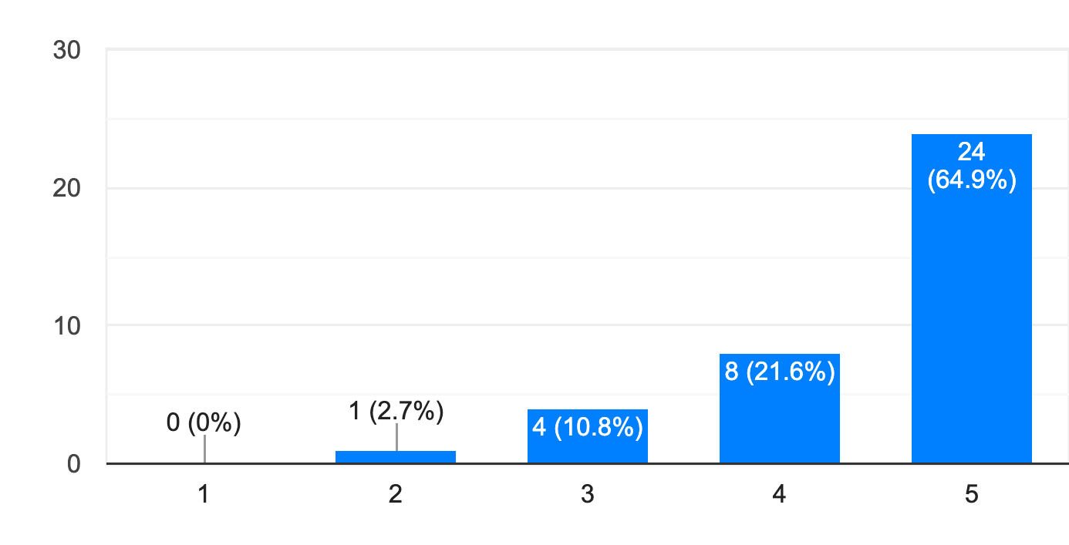
Capacity Building, Education, and Learning  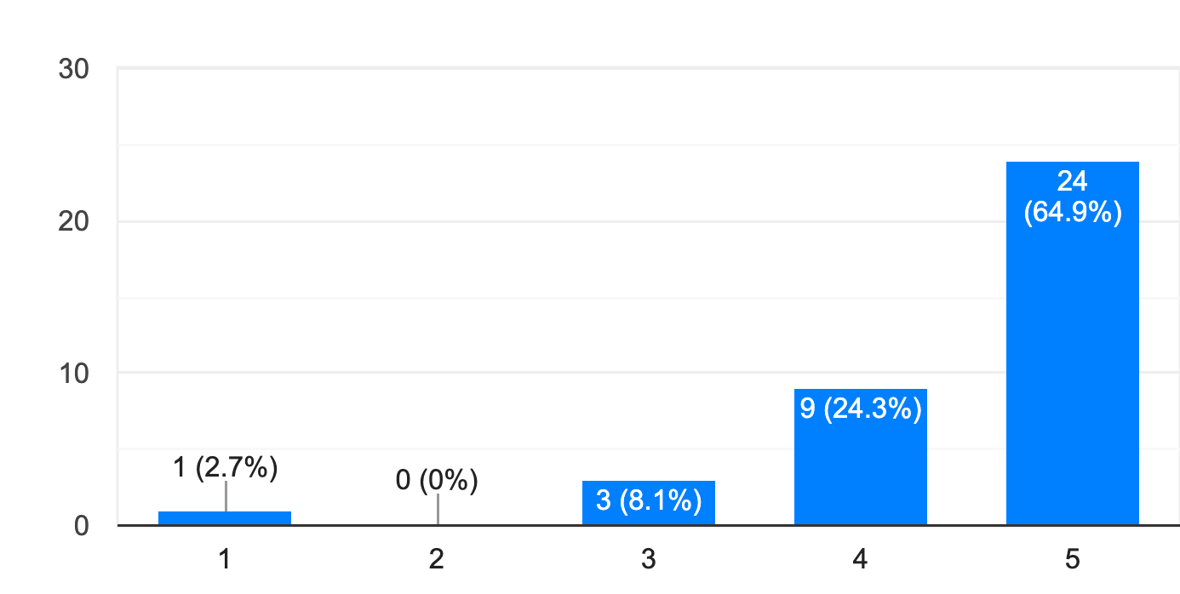 |  | Policy Development, Review, and Strengthening (e.g., support for the development of loss and damage policy and planning strategies and documents)  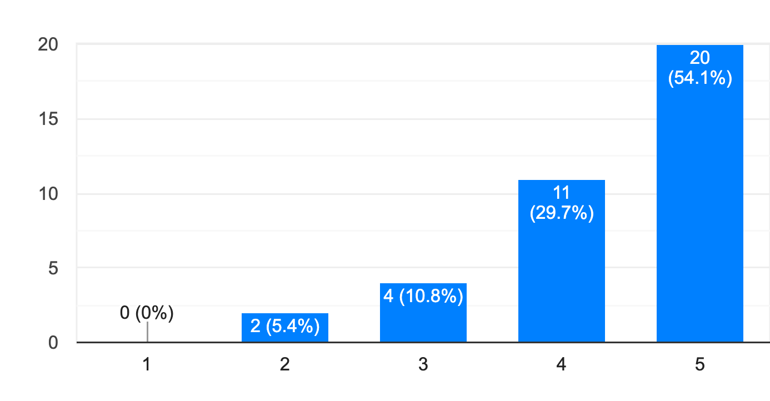
Information Sharing and Knowledge Brokering (e.g., linking countries to tailored information and expertise)  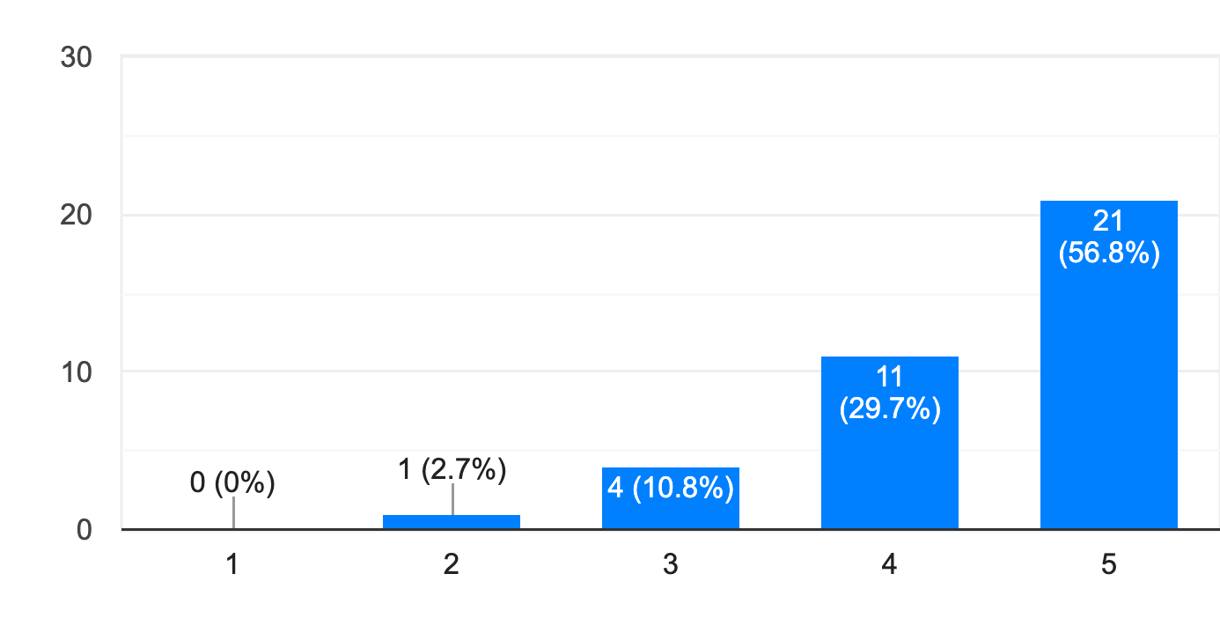 |  | Loss and Damage Public Awareness, Communications, and Publicity (e.g., communicating loss and damage impacts, solutions, innovations and good practice)  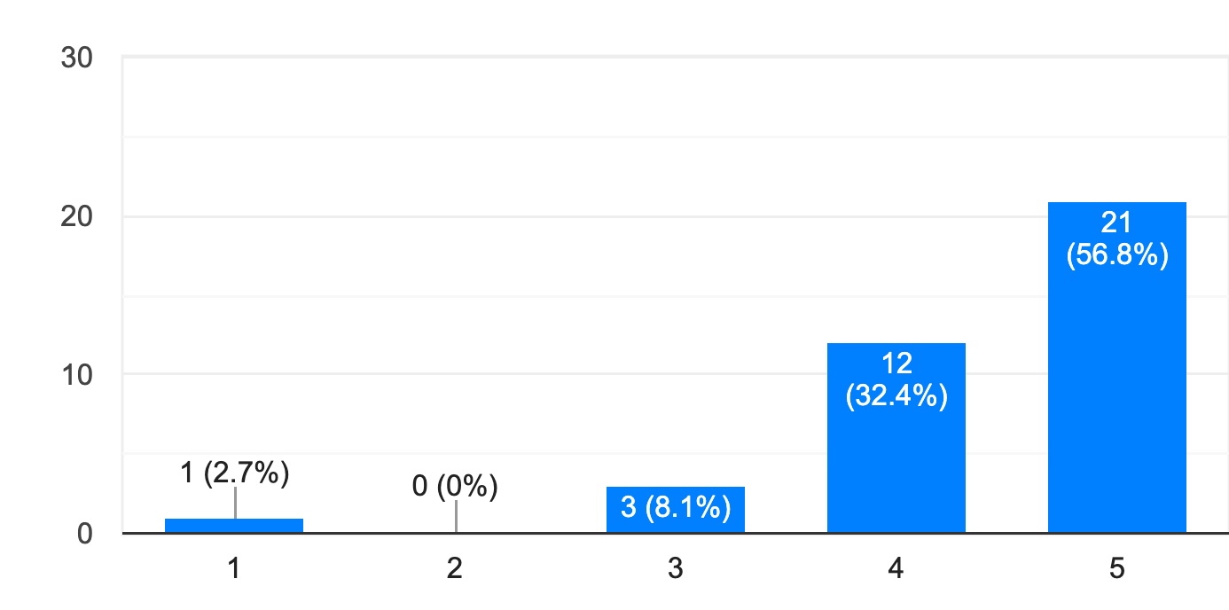
Loss and Damage Research (e.g., loss and damage assessment, M&E and quantification)  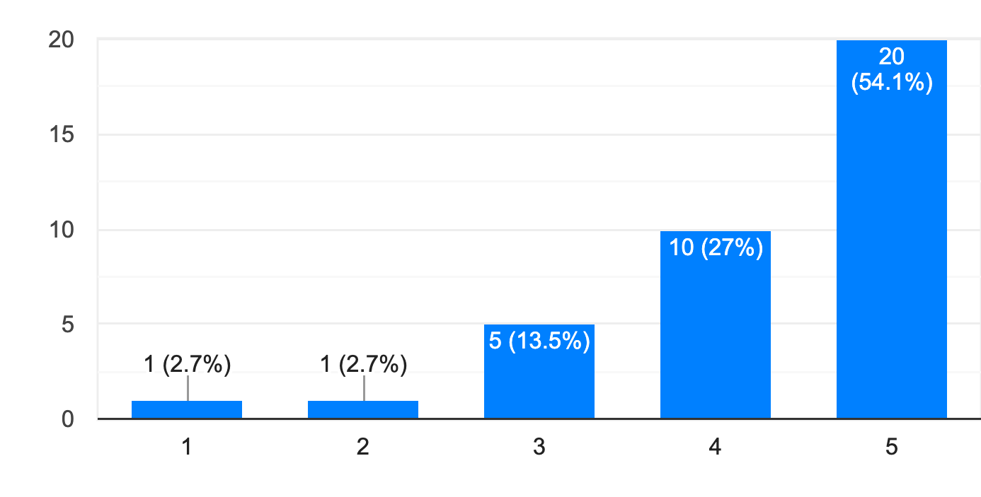 |  | Urgent Response to Severe Impacts (e.g., after an extreme weather event)  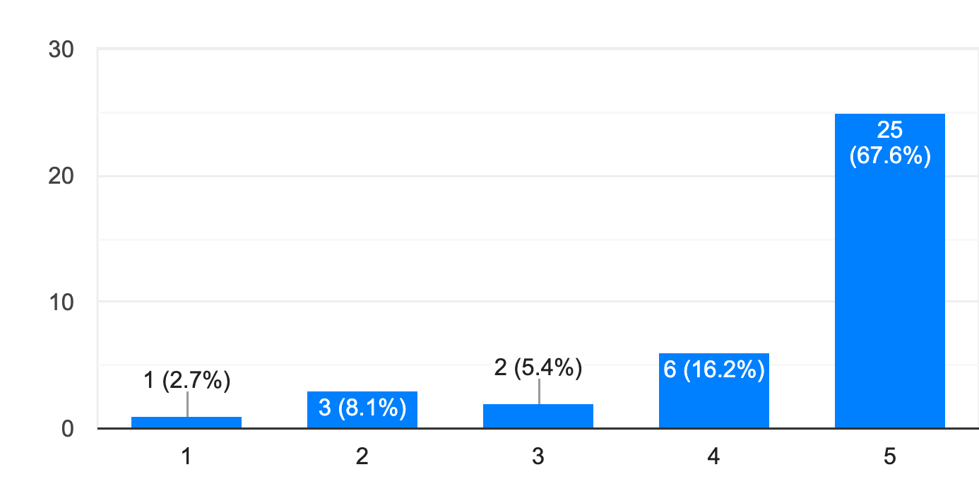
Development and Implementation of Responses to Slow Onset Events (e.g., sea level rise, increasing temperatures, ocean acidification, glacial retreat and related impacts, salinization, land and forest degradation, loss of biodiversity and desertification)  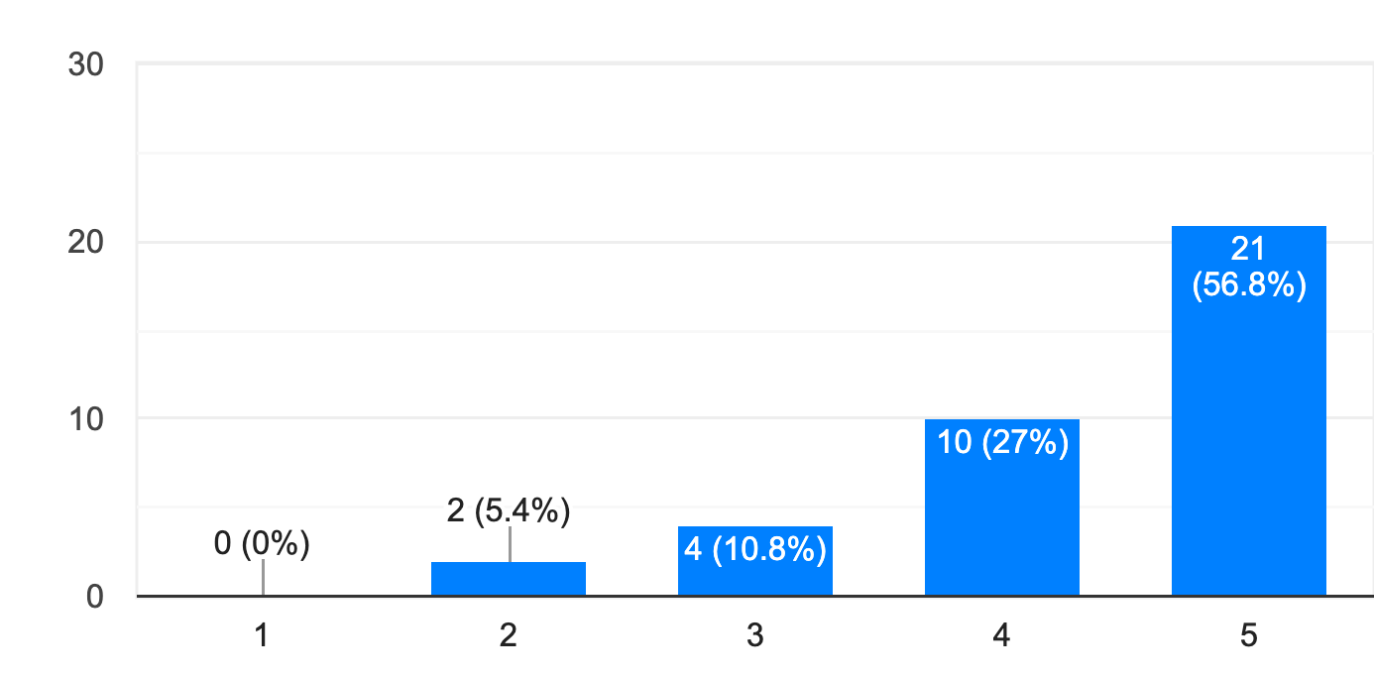 |  | Coordination among Loss and Damage Stakeholders (e.g., experience sharing on national loss and damage approaches / facilitating south-south learning / coordination mechanism to share knowledge among relevant organisations)  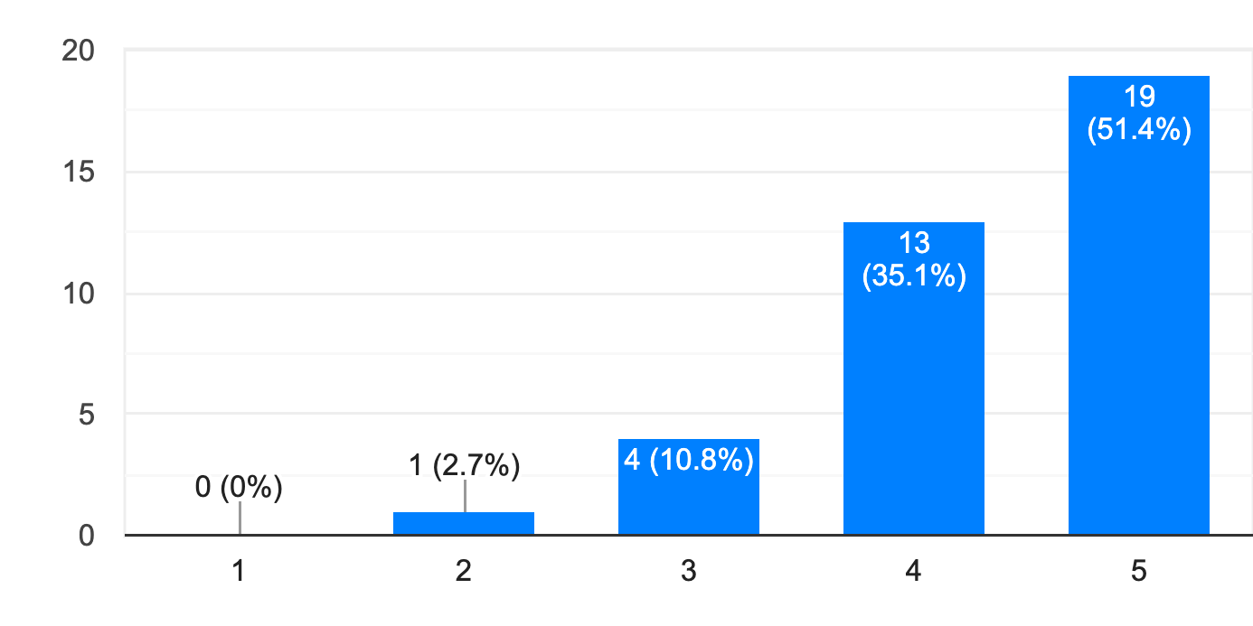
Links to UNFCCC Negotiations and WIM ExCom (e.g., between WIM/ExCom and Loss and Damage national contact points / input to the Global Stocktake process)
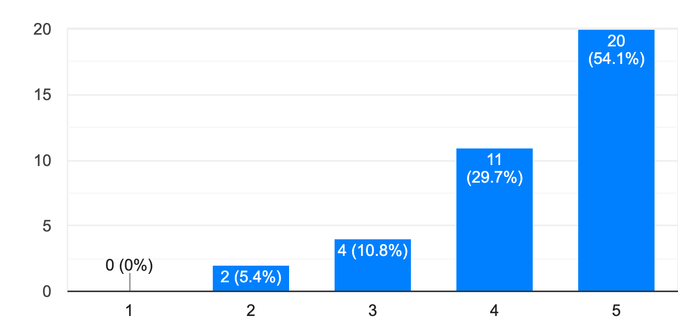

What else did participants list as possible functions or services of the SNLD?
“Involving the grassroots woman from start to finish. Who is more burdened is a service that can help reduce the loss and damage of climate change. In addition, investing in behaviour change campaigns at grassroots level (community conversations) can help change the mindset towards climate change issues. Leadership development and training is very vital too.” – NGO/Civil Society
"[A]ddressing compound effects of COVID 19 and unseen risks to climate related L&D” – UNFCCC National Focal Point
“(a) Develop capacity to monitor progress in building resilience - particularly of Non-State Actors; (b) Promote endogenous knowledge systems to loss and damage by slow and fast (extreme weather event and Slow-Onset) and (c) develop local capacities to administer Loss and Damage as encapsulated in the Santiago Network” – Academia

At what level should the work of the Santiago Network for Loss and Damage be targeted on a scale of 1 (strongly disagree) to 5 (strongly agree)?
The responses indicate that participants believe that the most important level of engagement is with local, grassroots and subnational level initiatives.
The Santiago Network should catalyse support for local, grassroots and subnational level initiatives.  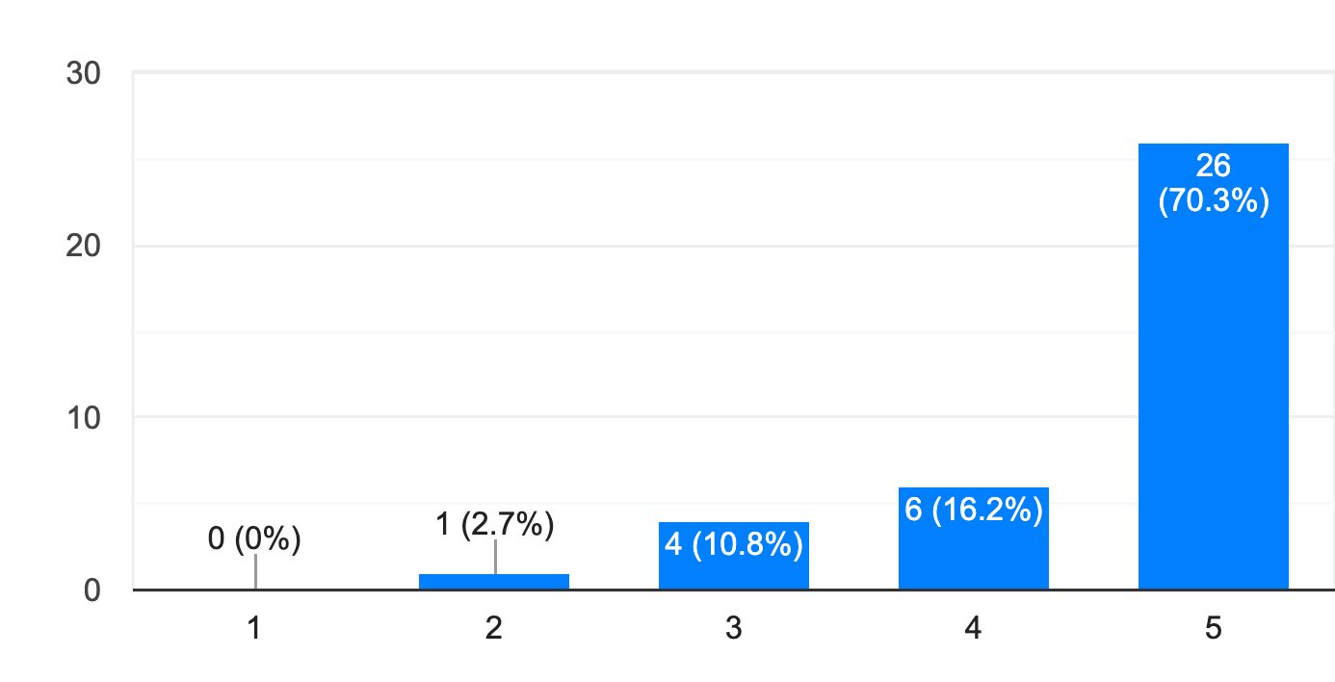 |  | The Santiago Network should catalyse support for national level initiatives.  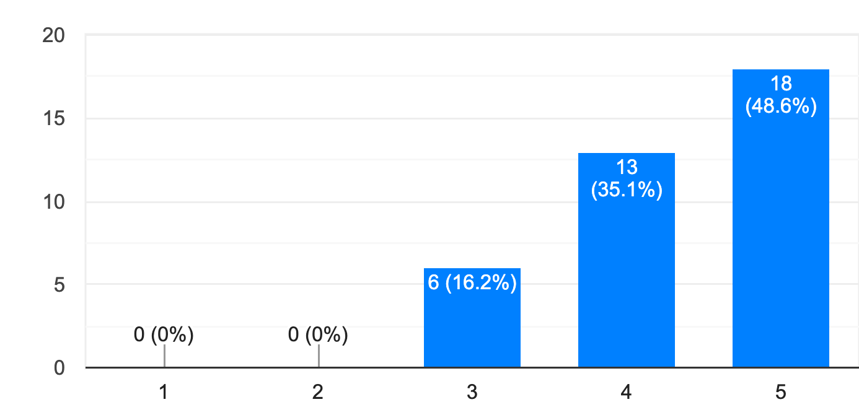
The Santiago Network should catalyse support for regional level initiatives.  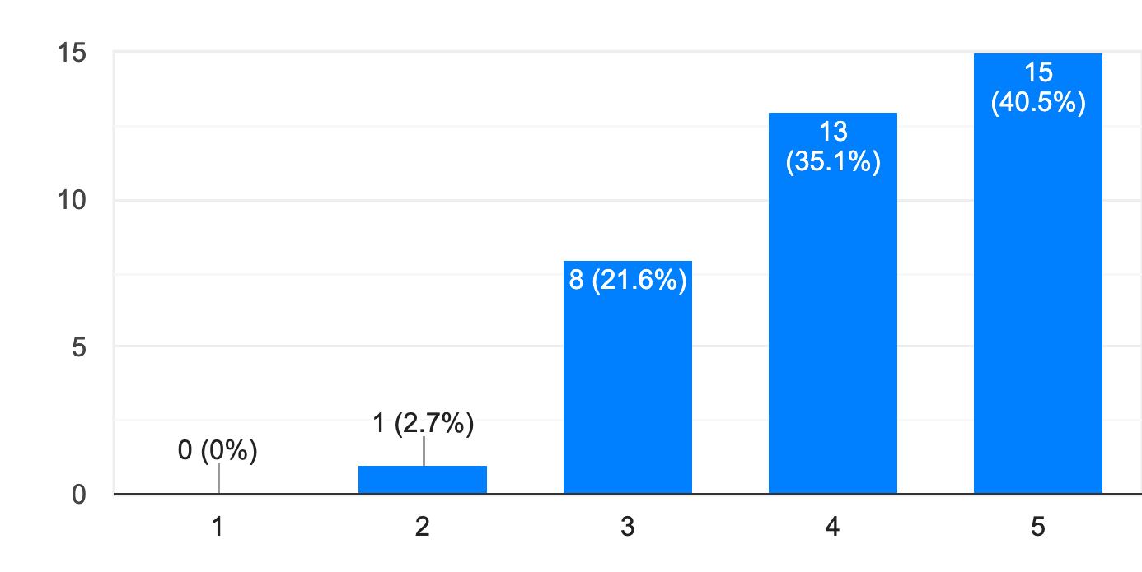 |  | The Santiago Network should catalyse support for international level initiatives.  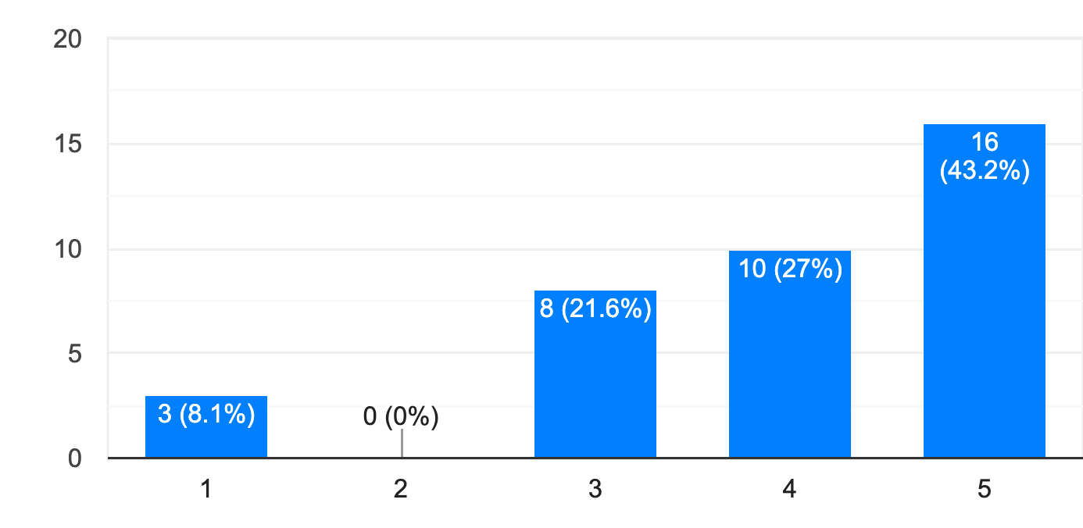

The model of the Climate Technology Centre and Network
This section looks at the Climate Technology Centre and Network (CTCN) and explains what it looks like and how it operates to identify what aspects might be used as a model for the SNLD.

What is the institutional structure of the CTCN?
As set out in Figure 1 and Figure 2 below, the UNFCCC Technology Mechanism (TM) consists of two bodies: the Technology Executive Committee (TEC) and the Climate Technology Centre and Network (CTCN). The TEC is the policy arm of the TM (ExCom equivalent), consisting of a committee of UNFCCC parties’ nominated representatives who provide policy recommendations. The CTCN is the implementation arm of the TM, hosted by the UN Environment Programme (UNEP) and the UN Industrial Development Organization (UNIDO). The CTCN consists of the Climate Technology Centre (CTC) which is the coordinating entity and the Network which implements/delivers CTCN services.
There is an Advisory Board which determines the CTCN operational modalities and rules of procedure. Further, Parties are required to have a National Designated Entity (NDE) which act as focal points for interacting with the CTCN. For example, developing countries send assistance requests to the CTCN through their NDE.
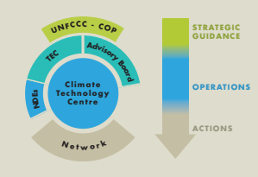  Figure 1 | 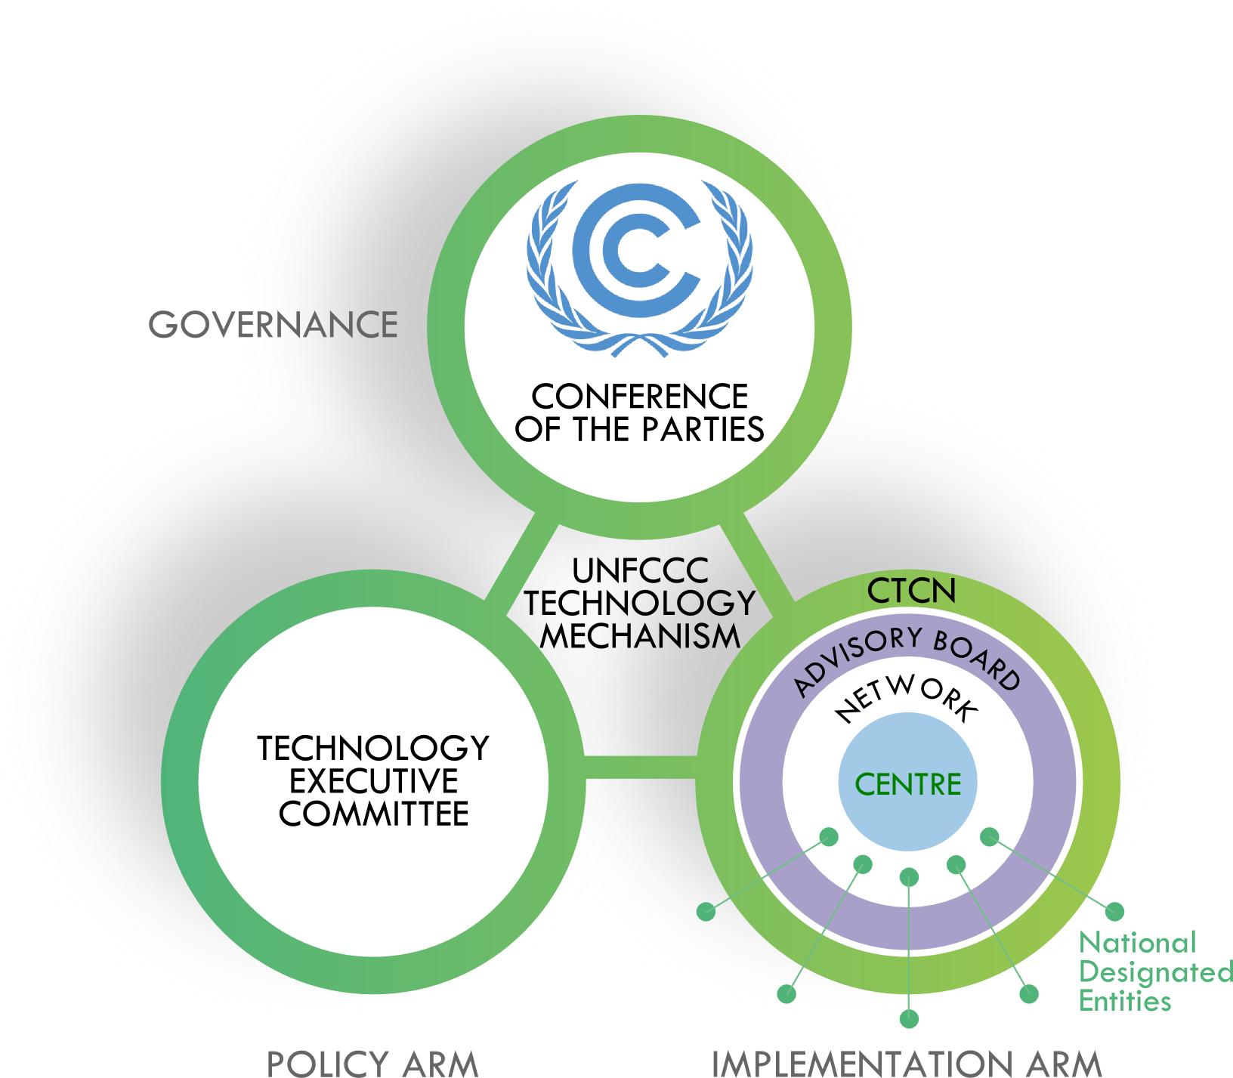  Figure 2

What does the Network do?
The CTCN has three core mandates: provide technical assistance based on requests from developing countries; provide a forum for information and knowledge exchange on climate technologies; and deliver capacity building through presentations and workshops delivered to peers and developing country stakeholders.
To fulfil this mandate, the CTN responds to requests for assistance by developing country Parties and mobilizes policy and technical expertise through its members. It acts as a broker or matchmaker pairing developing countries with experts, service providers and funding to deliver on the developing country needs.
The CTCN delivers five main types of technical support on climate technologies:
- Technical assessments, including technical expertise and recommendations related to specific technology needs, identification of technologies, technology barriers, technology efficiency, as well as piloting and deployment of technologies.
- Technical support for policy and planning documents, include strategies and policies, roadmaps and action plans, regulations, and legal measures
- Trainings
- Tools and methodologies
- Implementation plans
The members of the CTN include a range of international, regional and national member institutions. They include “academic, finance, non-government, private sector, public sector, and research entities, as well as over 150+ National Designated Entities (CTCN national focal points selected by their countries).” Membership is free and by emailed application.

How are country needs identified and actioned?
Country needs are identified and actioned through Technology Needs Assessments (TNAs). TNAs are undertaken in countries to determine their climate technology needs, such as how to reduce their greenhouse gas emissions or adapt to the adverse impacts of climate change. The TNAs involve different stakeholders in a consultative process and identify barriers to technology transfer and measures to address these barriers through sectoral analyses. The TNA process is designed to feed into the formulation of national Technology Action Plans (TAPs). The TAP is a concise plan for the uptake and diffusion (transfer) of prioritized technologies and is made up of projects, programmes or strategies and outline a process to assist in preparing specific project ideas for each prioritized sector and attract investment for those projects. The process is set out at Figure 3.
Since 2010, the United Nations Environment Program (UNEP) and Danish Technical University Partnership (DTU) have provided technical and methodological support to developing countries to undertake TNAs. The Global Environment Facility (GEF), through its Poznan strategic programme on technology transfer, has provided support for these TNA projects. In addition to the GEF support, the Green Climate Fund (GCF) strategic plan identifies developing countries’ intended nationally determined contributions and TNAs as important reference points for GCF programming.

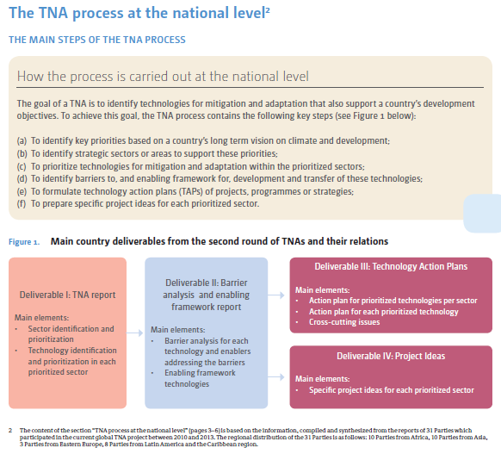
Figure 3

Finance and the CTCN
The work of the CTCN is dependent on donor countries and institutions including the GEF, GCF, UNIDO, the EU and Denmark. The GEF leads the funding of the TNA project. Between 2010 and 2018, the GEF provided finance to support UN Environment and UNEP DTU to complete TNAs in more than 60 countries with the objective of going beyond narrow identification of technology needs and work towards stimulating investment in each country. As a CTN member, UNEP DTU also assists countries to turn project ideas into proposals to the GCF.

Is the Climate Technology Network a good model for the SNLD?
The broad mandate of the CTN is to mobilize climate technology, while the SNLD will be designed to respond to climate events. Although there is a difference of purpose, both are dependent on two limiting factors: finance to support their activities and the technical resources and capacities to meet the diverse needs of their members.
In relation to finance, the CTN is dependent on donors. The issue with the work of the CTCN being driven by donors is that this results in work being project driven or tied to specific projects, which might not be what countries need, being more closely aligned with developed country investment aims. For the SNLD it would be ideal if funding went directly to the SNLD so they can determine allocations to ensure that it aligns with the priorities and what countries need to respond to loss and damage.
In relation to the technical capacity, the CTN is limited to the technical capacity that the specific members can provide. This leads to action being driven by the expertise of members and experts instead of responding to country needs. For example, members of the CTN may have the technical expertise to replicate a large-scale energy national grid program across multiple countries, but that program may fail to respond to the specific energy needs of those countries particularly delivering energy to remote off grid locations.
It is also important to note that because UNIDO and UNEP host the CTCN, this creates further tension in what the CTN does as it is based on the interests of these two host organisations.

Are Nationally Designated Entities a good model?
Parties must assign an NDE to participate in the technical assistance process and make requests of the CTCN. NDEs facilitate support to their countries from the CTCN by:
- Serving as National Focal Point on CTCN activities.
- Supporting the articulation and prioritization of requests and proposals.
- Managing the national submission process of technical assistance requests to the CTCN
NDEs aim to ensure that national circumstances and priorities are reflected in these processes. They facilitate cooperation and engagement at the national level by engaging with ministries, UNFCCC focal points, the private sector, civil society and academia.
Although it is positive that there is a specific focal point or contact person, the NDEs have a difficult role. They often sit in the ministry which is the UNFCCC focal point but this ministry has a limited mandate and they will be required to work across multiple areas and coordinate across numerous ministries. Therefore NDEs struggle to coordinate across ministries to ensure that requests reflect the most important priorities of the country. They are often criticized for overemphasizing big projects such as large power grids and systems and do not focus on small-scale solutions.
These challenges may be more straightforward for the SNLD. Although the loss and damage focal point would sit in one ministry, their tasks under the SNLD would be targeted to respond to external events, for example, to coordinate action to a specific slow onset climate event or focus on responding to a specific extreme event.

Is the Advisory Board a good model?
The Advisory Board determines operational modalities and rules of procedure for the CTCN. The board tends to periodically identify different issues to explore in more detail. It has representatives from civil society, brings together knowledge from various constituencies and ExCom members. This is a positive aspect of the CTCN and the SNLD would benefit from mirroring this.
Resources
- www.ctc-n.org
- https://unfccc.int/ttclear/misc_/StaticFiles/gnwoerk_static/TNA_key_doc/137ce42be33c4341a9b9e6679f7f8539/4a057ad243164ac6bbaa62bcb96bc39a.pdf
- https://unepdtu.org/project/technology-needs-assessments/
- https://unfccc.int/sites/default/files/climate_technology_centre_and_network._introducing_the_ctcn._submitted_by_the_u.s.pdf

The functions and structure of the Santiago Network for Loss and Damage
Based on the survey results and the CTCN model, we now propose the functions and structure for the SNLD that could best meet the needs of vulnerable developing countries.

What is the objective of the Santiago Network for Loss and Damage?
The ExCom guides the implementation of the functions of the WIM. Its work is organized into five workstreams. The work for each workstream is carried out by an assigned task force or technical expert group, except workstream (e) on action and support which does not have an associated body to undertake the work.
The lack of a body to carry out work under workstream (e) has led to inadequate action to address the third function of the WIM, which is “[e]nhancing action and support, including finance, technology and capacity-building, to address loss and damage associated with the adverse effects of climate change”.
On a scale of 1 (no capacity) to 5 (very high capacity), 82% of survey participants rated the WIM’s current capacity to catalyse the technical assistance required by developing countries for implementing loss and damage approaches at a 2 or 3. The SNLD was established for the purpose of filling this critical gap to provide reliable support for the most vulnerable countries and communities to address loss and damage.
According to Decision 2/CMA.2, para 43, the SNLD is established to:
catalyze the technical assistance of relevant organizations, bodies, networks and experts, for the implementation of approaches [to address loss and damage] at the local, national, and regional level in developing countries that are particularly vulnerable to the adverse effects of climate change.
As part of the WIM, the objective of the SNLD should be to provide reliable support for the most vulnerable countries and communities to address loss and damage on the ground and give voice and agency to frontline communities, those affected by loss and damage.

How could the Santiago Network for Loss and Damage function?
The functions of the SNLD need to reflect the objective of the SNLD to catalyze technical assistance of relevant organizations, bodies, networks, and experts, for the implementation of approaches to address loss and damage in developing countries.
Participants rated the importance of the following services and functions that the SNLD should deliver as follows (in order of what is considered most important to least important): Urgent Response to Severe Impacts (67.6%); Development of New Approaches/Options to Address Loss and Damage (64.9%); Loss and Damage Finance (64.9%); Capacity Building, Education, and Learning (64.9%); Technical Support and Guidance on Approaches to Address Loss and Damage (56.8%); Information Sharing and Knowledge Brokering (56.8%); Loss and Damage Public Awareness, Communications, and Publicity (56.8%); Development and Implementation of Responses to Slow Onset Events (56.8%); Policy Development, Review, and Strengthening (54.1%); Loss and Damage Research (54.1%); Links to UNFCCC Negotiations and WIM ExCom (54.1%); Coordination among Loss and Damage Stakeholders (51.4%); and Implementation of Existing Approaches to Address Loss and Damage (43.2%).
It is essential that the SNLD functions match the needs expressed by developing countries and address the challenges they face in addressing loss and damage. As noted in section one, the most prevalent challenges and gaps reported are: Lack of capacity (19 responses or 50%); Lack of finance and support (19 responses or 50%); Lack of awareness and education about loss and damage (14 responses or 37%); Lack of documentation and ineffective government policies (12 responses or 32%).
The survey results tell us what developing countries need to address loss and damage. We analyse three possible functions below (noting that this is not a closed list): (1) Technical assistance and capacity building; (2) Developing and creating access to knowledge and information on Loss and Damage; and (3) Fostering coordination and collaboration among key stakeholders.

Technical assistance and capacity building
The lack of capacity to address loss and damage (L&D) on the ground (50%) as well as the lack of finance and support (50%) were the two top gaps survey participants identified with regard to the challenge to effectively deal with climate related loss and damage. Capacity building was also the most common response from participants to the question of what their country needs financial resources for dealing with L&D.
Through its network of regional and sectoral networks, the SNLD could provide technical assistance and capacity building at the request of developing countries on the implementation of approaches to address L&D. This could include technical assistance and capacity building for e.g. (the following order reflects the prioritisation of activities by the survey participants):
- Accessing finance for L&D/facilitating access to finance/supporting the development of new project proposals focused on loss and damage (e.g. projects under the GCF) (64.9%);
- Facilitating urgent response to severe Impacts (e.g. after an extreme weather event) (62.5%);
- Technical support and guidance on approaches to address L&D (56.8%);
- Concrete implementation projects to address L&D on the ground (guided by types of L&D reported by survey participants) (41%);
Additional to the points highlighted by survey participants, the SNLD in this function could provide technical assistance for assessing loss and damage, identifying options and designing and implementing country-driven risk management strategies and approaches, and implementing comprehensive approaches to address loss and damage (para 6 from decision 3/CP.18).

Developing and creating access to knowledge and information on Loss and Damage
Lack of awareness and education about loss and damage was the second most frequently mentioned answer by survey participants on the question regarding challenges to effectively deal with L&D. Moreover, 64.9% of survey participants prioritized “Capacity Building, Education and Learning” and 56.8% prioritized “Information Sharing and Knowledge Brokering” as function for the SNLD. As a “Knowledge-Hub” on Loss and Damage, the Santiago Network, via its expert network, could create access to knowledge and information and undertakes research on relevant questions related to Loss and Damage. This could include e.g. (the following order reflects the prioritisation of activities by the survey participants):
- Developing new approaches to address L&D (64.9%);
- The development of policy and planning strategies and document (54.1%);
- Development and implementation of responses to slow onset hazards (56.8%);
- Communicating L&D impacts, solutions, innovations and good practice (56.8%);
- Research on L&D (e.g. L&D assessment, M&E and quantification) (54.1%);
Additional to the points highlighted by survey participants, the SNLD could:
- Develop a better understanding of L&D needs of developing countries to feed into UNFCCC processes.
- Gather experience and information on concrete approaches to address L&D;
- Provide aggregate information on country needs regarding L&D by conducting/facilitating an annual L&D gap report as a reliable assessment of both, finance needs for L&D measures and the funding available on an annual basis is needed;
- Exploring the boundaries of Loss and Damage and how and why it is different to adaptation and resilience and why existing mechanisms within the global community are inadequate to meet the needs to address Loss and Damage;

Fostering coordination and collaboration among key stakeholders
“Coordination and collaboration among L&D stakeholders” is a priority for 51.4% of survey participants as a key function for the SNLD. To foster coordination and collaboration among stakeholders from the field of L&D, Climate Risk Management, Humanitarian Aid (etc), the SNLD could facilitate information exchange and awareness raising. This could include for example:
- Providing a coordination mechanism to share knowledge among relevant organizations, e.g. Information and experience sharing of countries, communities and other actors that work on addressing L&D with national L&D approaches;
- Facilitating south-south learning;
Additional to the points highlighted by survey participants, the SNLD could channel information from the WIM to the local level where it can be used by households and decision-makers (70.3% of survey participants highlighted that the SNLD should catalyse support for local, grassroots and subnational level initiatives).

How could the Santiago Network for Loss and Damage be structured?
Based on the survey results and guided by the example of the CTCN, we considered the structure of the SNLD could be composed of a network, advisory board, coordinating entity and a national loss and damage focal point (LDF).
Survey participants considered it important that the SNLD has linkages to the ExCom. We have therefore proposed that the SNLD would be guided by an advisory board and recommend that ExCom members be represented on that advisory board. A coordinating entity would further steer the SNLD activities.
Requests for technical assistance could be submitted by developing countries via their LDF. Upon receipt of such requests, the Network could mobilize experts to deliver solutions ensuring that the solutions are tailored to local needs. Response to country requests should be done in timely and appropriate ways.
To aid this process, the SNLD could learn from the TNA model of the CTCN and do a L&D national assessment to determine risks. The SNLD will need to learn from the limitations of the TNA process, however, to the extent that the CTCN is limited in its scope where they do not have relevant technical expertise for a specific task which can result in projects being limited in scope, take too long, and ultimately fail to deliver.
Countries could send requests for technical assistance through their LDF. The SNLD would need to prioritize countries that are most vulnerable to L&D and work with the LDF to examine risks faced by the country and consider how the network could catalyze technical assistance. It will be essential in doing so to be responsive to requests and mobilize a coherent and coordinated response that meets needs, particularly at the grassroots level.
The membership of the SNLD could be a network of national, regional, international, and sectoral organizations including academic, NGO, private sector, public sector and research entities.
To set up and maintain such a structure, additional financial resources would be needed. A collaboration with partner institutions that provide regular contribution to the SNLD could be one solution. It will be important, however, to learn from the CTCN and ensure that the SNLD has control over where that finance goes (for example has one bucket to distribute funds to any project without conditions) to best meet country needs.

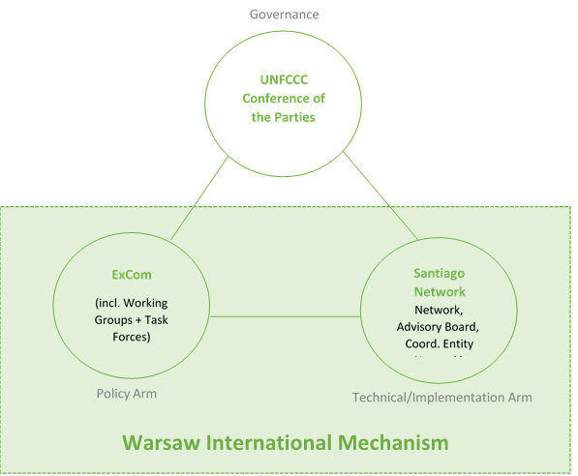

What are the next steps to operationalize the Santiago Network for Loss and Damage?
Parties drive the implementation of decisions and it is up to the Parties to determine how to design and operationalize the SNLD. Expediting the operationalization of the SNLD is a priority for vulnerable developing countries. The ExCom should begin consideration of needs for operationalization of the network, to feed into negotiations on a decision by Parties at COP26. Steps to be taken include:
- The WIM ExCom could assess various existing institutional arrangements under the Convention to see whether they might serve as a model for the SNLD, including the CTN. The ExCom could include the results of such an assessment in its annual report to COP26.
- The SBI and SBSTA would consider the annual report of the ExCom and provide recommendations to the COP on structure, function, and modalities of the SNLD and steps to operationalize it.
- Parties to the COP would take a decision at COP26 on the operationalization of the SNLD.

Conclusion and way forward
This report has identified the needs expressed by countries in the survey, analyzed the CTCN as a model for the SNLD, and discussed the possible structure and functions of the SNLD. Operationalizing those functions remains a priority for vulnerable developing countries experiencing the impacts of loss and damage caused by climate change.
We are in the beginning phase towards the operationalization of the SNLD. Our findings inform the work ahead. In conclusion we emphasize the following findings for consideration by Parties:
- The SNLD needs to be structured so that it is responsive to country needs.
- The CTCN structure of a network, advisory board, coordinating entity and national focal point is relevant and replicable.
- The CTCN model could be modified, taking into consideration lessons learned from an assessment of its functioning, including:
  - The donor structure leads to assistance being provided by narrow projects that do not necessarily address the grassroots issues
  - The NDE does not always succeed in ensuring that requests for assistance reflect the needs of all areas because coordinating various ministers can be difficult.
  - The assistance provided is often driven by the expertise available by members so there is a need to ensure expertise matches needs
- We consider only a short list of possible SNLD functions which is not exhaustive: (1) Technical assistance and capacity building; (2) Developing and creating access to knowledge and information on loss and damage; and (3) Fostering coordination and collaboration among key stakeholders.

Annex I: Survey Questions
Section 1: Survey on the Santiago Network Functions and Services
Decision 2/CMA.2 Para 43
Establishes, as part of the Warsaw International Mechanism, the Santiago Network for averting, minimizing and addressing loss and damage associated with the adverse effects of climate change to catalyse the technical assistance of relevant organizations, bodies, networks and experts for the implementation of relevant approaches at the local, national and regional level in developing countries that are particularly vulnerable to the adverse effects of climate change.
Survey Rationale
This survey has been compiled by "The Loss & Damage Collaboration", a group of UNFCCC Party negotiators, loss and damage technical experts from academia and civil society and others in order to expedite the operationalization of the Santiago Network, as established in December 2019 at COP26/CMA2.
The survey is targeted at UNFCCC country focal points as well as at loss and damage and climate risk management experts from the country, regional, and international levels. Your contribution will greatly improve the functions and services the Santiago Network will be able to provide to particularly vulnerable developing countries in the future.
The results will be shared with you, and also used to prepare a briefing paper with the objective to 1) refine and prioritize the scope of the Santiago Network, 2) guide upcoming UNFCCC negotiations, and 3) seek financial and technical resources for the Santiago Network.
The survey will take approximately 20 minutes, please be as comprehensive and specific as possible in your feedback.
Thank you very much for participating in our survey!
Section 2: Biographical Information
- Full name
- Which category best describes you?
- Email address
- Position Title
- Department & Organization
- Focus Region
- Country of Focus
- Do you agree that your responses may be used anonymously in publicly-released survey reports and Santiago Network planning documents?
Section 3: The status quo
- What are the top 3 types of climate-related loss and damage in your country/region?
- Please list an example of how you currently address loss and damage in your country/region.
- What are the top 3 challenges and gaps in your country/region with regard to effectively dealing with climate related loss and damage?
- Please list an example of how you currently address loss and damage in your country/region.
- What are the top 3 things (measures, activities, etc.) your country/region requires financial resources for to effectively address loss and damage?
- On a scale of 1-5 (no capacity to very high capacity), rate the WIM’s current capacity to catalyse the technical assistance required by developing countries for implementing loss and damage approaches.
- On a scale of 1-5 (not supportive to highly supportive), rate your level of support for the establishment of the Santiago Network as per Decision 2/CMA.2 Para 43 at COP25 in Madrid https://unfccc.int/sites/default/files/resource/cma2019_06_add.01_.pdf
- On a scale of 1-5 (not at all important to critically important), how important is it that further arrangements for the Santiago Network are discussed and agreed at COP26/CMA3:
Section 4: Potential Functions & Services of the Santiago Network
- From your perspective: What are the top 3 success factors for the Santiago Network?
Please indicate the importance of each of the potential functions/services of the Santiago Network in your country of focus on a scale of 1-5 (not important to critically important)
- Implementation of Existing Approaches to Address Loss and Damage
- Development of New Approaches/Options to Address Loss and Damage
- Technical Support and Guidance on Approaches to Address Loss and Damage
- Loss and Damage Finance (e.g., accessing finance for loss and damage / facilitating access to finance / supporting the development of new project proposals focused on loss and damage)
- Capacity Building, Education, and Learning
- Policy Development, Review, and Strengthening (e.g., support for the development of loss and damage policy and planning strategies and documents)
- Information Sharing and Knowledge Brokering (e.g., linking countries to tailored information and expertise)
- Loss and Damage Public Awareness, Communications, and Publicity (e.g., communicating loss and damage impacts, solutions, innovations and good practice)
- Loss and Damage Research (e.g., loss and damage assessment, M&E and quantification)
- Urgent Response to Severe Impacts (e.g., after an extreme weather event )
- Development and Implementation of Responses to Slow Onset Events (e.g., sea level rise, increasing temperatures, ocean acidification, glacial retreat and related impacts, salinization, land and forest degradation, loss of biodiversity and desertification)
- Coordination among Loss and Damage Stakeholders (e.g., experience sharing on national loss and damage approaches / facilitating south-south learning / coordination mechanism to share knowledge among relevant organisations)
- Links to UNFCCC Negotiations and WIM ExCom (e.g., between WIM/ExCom and Loss and Damage national contact points / input to the Global Stocktake process)
- List any other potential functions/services of the Santiago Network relevant to your country of focus.
Section 5: Level of Engagement
On a scale of 1-5 (strongly disagree to strongly agree), rank your agreement with the following statements: The Santiago Network should catalyse support for...
- ...local, grassroots and subnational level initiatives
- ...national level initiatives
- ...regional level initiatives
- ...international level initiatives
Section 6: Scenario Real Life Example
If you could make one request for support to the Santiago Network for your country/region of focus in the next 12-24 months...
- Who would be the primary/direct beneficiary of support?
- Who would be the secondary/downstream beneficiary of support?
- Who/which organization would the Santiago Network ideally mobilize to provide the support?
- Who/which organization would the Santiago Network ideally mobilize to provide the necessary financial resources?
- Would your agency be able to co-contribute resources? What/How much?
- How long would support be required?

Independent Consultant, heidimareewhite@gmail.com
Independent Consultant, kmdraffety@gmail.com
Germanwatch e.V. schaefer@germanwatch.org
College of the Atlantic, dstabinsky@coa.edu
Institutional affiliation is provided for identification purposes only and does not constitute institutional endorsement.
A group of United Nations Framework Convention on Climate Change (UNFCCC) Party negotiators, loss and damage technical experts from academia and civil society, and others working on the issue of loss and damage caused by climate change.
See Annex I.
The Technology Mechanism (TM) was established in 2010 by COP decision 1/CP.16, and in 2015 its mandate was extended to also serve the CMA by article 10.3 of the Paris Agreement. Its mandate is to facilitate enhancing technology development and transfer to developing countries.
See Decision 14/CP.18.
https://unfccc.int/ttclear/tna
Technology Executive Committee, ‘Results and Success Factors of TNAs’ (2013) https://unfccc.int/ttclear/misc_/StaticFiles/gnwoerk_static/TEC_column_L/6506e4f81d2746de8347b9742ff164ad/a956cb76053549a6b22c9df690f708d3.pdf )
https://www.ctc-n.org/about-ctcn/national-designated-entities
Decision 2/CP.19 paragraph 5 provides that “The WIM shall fulfil the role under the Convention of promoting the implementation of approaches to address loss and damage...by undertaking, inter alia, the following functions:...(c) Enhancing action and support, including finance, technology and capacity-building...including by: (i) Providing technical support and guidance on approaches to address loss and damage associated with climate change impacts, including extreme events and slow onset events; (ii) Providing information and recommendations for consideration by the Conference of the Parties when providing guidance relevant to reducing the risks of loss and damage and, where necessary, addressing loss and damage, including to the operating entities of the financial mechanism of the Convention, as appropriate; (iii) Facilitating the mobilization and securing of expertise, and enhancement of support, including finance, technology and capacity-building, to strengthen existing approaches and, where necessary, facilitate the development and implementation of additional approaches to address loss and damage associated with climate change impacts, including extreme weather events and slow onset events.”

