REGIONAL CONSULTATIVE WORKSHOP
Scaling up DRR in Humanitarian/Development Contexts in Asia Pacific
12 December 2019, Bangkok │ Sukosol Hotel, Bangkok

Breakout Group Discussion
14:30 – 15:15

SCENARIO
All participants will be divided into 5 groups, generally around the main elements of the Humanitarian Programme Cycle (HPC) and enablers, with information and data cross-cutting across all the elements:
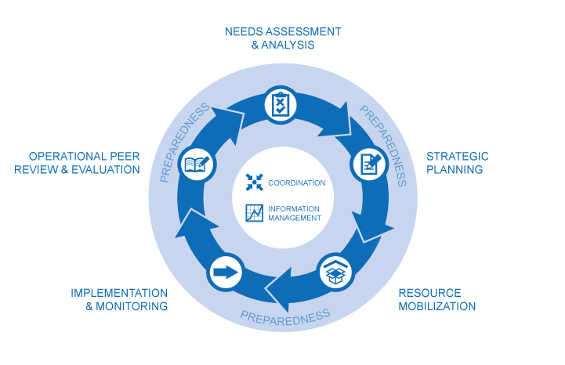

- Preparedness
- Assessment and analysis
- Planning
- Financing
- Coordination

- All the groups will meet in the same workshop room. Participants will remain at their tables and facilitators will join each one of the groups.
- Facilitators and note-takers have been pre-assigned to each group. Rapporteurs would be self-nominated in the groups. Rapporteurs will report back on the group discussions outcomes in the plenary session.
- Each group will have 5 minutes to report back using the reporting template to present the results of their group deliberation.

DISCUSSION GUIDELINES
Each group will discuss their given topics around the same set of questions (reflecting on the specific phase assigned to their group):
  - How is DRR already being featured in this phase of the HPC? Where are the current gaps? What opportunities exist to more effectively integrate DRR in this case?
  - Consider this for both protracted crises, as well as for more development contexts with recurrent humanitarian crises. What will be different about how this is approached? What is the same?
  - What are the implications for humanitarian, development and DRR actors in terms of how they respond and coordinate in each of these contexts?
  - What are key elements that fall outside the HPC processes (such as intergovernmental processes) that also need to be addressed

GROUP FACILITATORS

Group | Facilitator
- Preparedness | John Long (OCHA)
- Assessment & Analysis | Iria Touzon Calle (UNDRR)
- Planning | Rob Smith (OCHA)
- Financing | Sylvie Montembault (ECHO)
- Coordination | Amy Martin (OCHA)

The humanitarian programme cycle (HPC) is a coordinated series of actions undertaken to help prepare for, manage and deliver humanitarian response. It consists of five elements coordinated in a seamless manner, with one step logically building on the previous and leading to the next. Successful implementation of the humanitarian programme cycle is dependent on effective emergency preparedness, effective coordination with national/local authorities and humanitarian actors, and information management. Source: OCHA.

