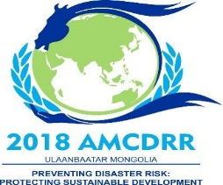
Appendix
2018 ASIAN MINISTERIAL CONFERENCE
ON DISASTER RISK REDUCTION
JULY 3-6, 2018 | ULAANBAATAR
Preventing Disaster Risk: Protecting Sustainable Development

“BESREG NAADAM” CULTURAL EVENT FORM

[To be submitted by participants interested in attending the cultural event on 06 July]

- Registration ID: ____________
- Country / Organisation: _______________________________
- Full name: _______________________________
- Contact details:
Email: _______________________________

Kindly submit the completed registration form by June 15, 2018,
Either by e-mail to the following contact:
2018 AMCDRR Secretariat

Phone number: +976-62263399
Ms. E.Enerelbuyan Mobile: (+976)- 94992120
Email: enerelbuyane@nema.gov.mn
Ms. B.Gerelzaya Mobile: (+976)- 99990979
Email: gerelzaya.b@nema.gov.mn

Cultural Event: Besreg Naadam

“Besreg Naadam” is a unique festival presenting Mongolian cultural and art heritage, hosted by the Government of Mongolia on 6 July in Chinggis Khaani Khuree Camp located at the outskirts of Ulaanbaatar City.

Buses depart from the main venue (Shangri-La Hotel) between 12:00 and 13:00 pm to leave for the camp. After the event, buses will depart at 6:00pm sharp from the camp to the Shangri-la Hotel. Please be seated by the departure time.

Catering services will be available in the Camp for self-purchase. Conference participants are advised to carry small cash in Mongolian Tugrug (MNT) when coming to the venue.
While it unlikely to rain during the conference period, participants are requested to carry an umbrella or raincoat when going to the outskirts of the city.

Enjoy!

