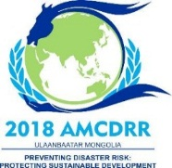
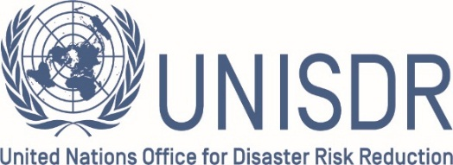

2018 ASIAN MINISTRIAL CONFERENCE ON DISASTER RISK REDUCTION
3-6 JULY 2018 | ULAANBAATAR
Preventing Disaster Risk:
Protecting Sustainable Development

Request Form for Bilateral Meeting Room
Day: 4-6 July 2018
Time: 09:00-18:00
Duration of the meeting: 25 min (each)

 | We request to have bilateral meetings with  (Title, Name, Position and Country): | Requested date | Requested  time | Number of delegates to attend  (from both side) |  | Special request  (e.g: signing of bilateral agreement)
 |  |  |  | from your side | from requested side

Bilateral meeting requested by:
Name:
Position:
Organization:
Country:
Contact details:
Phone number:
E-mail address:

Kindly submit the completed registration form to the 2018 AMCDRR Secretariat
by e-mail to the following contact:

Email: meetings@nema.gov.mn
Telephone number: +976-11-242616/263562/263567

Please note that early submission of the request will be prioritized to allocate the requested time of the meeting rooms. Thank you!

