Asian Ministerial Conference on Disaster Risk Reduction
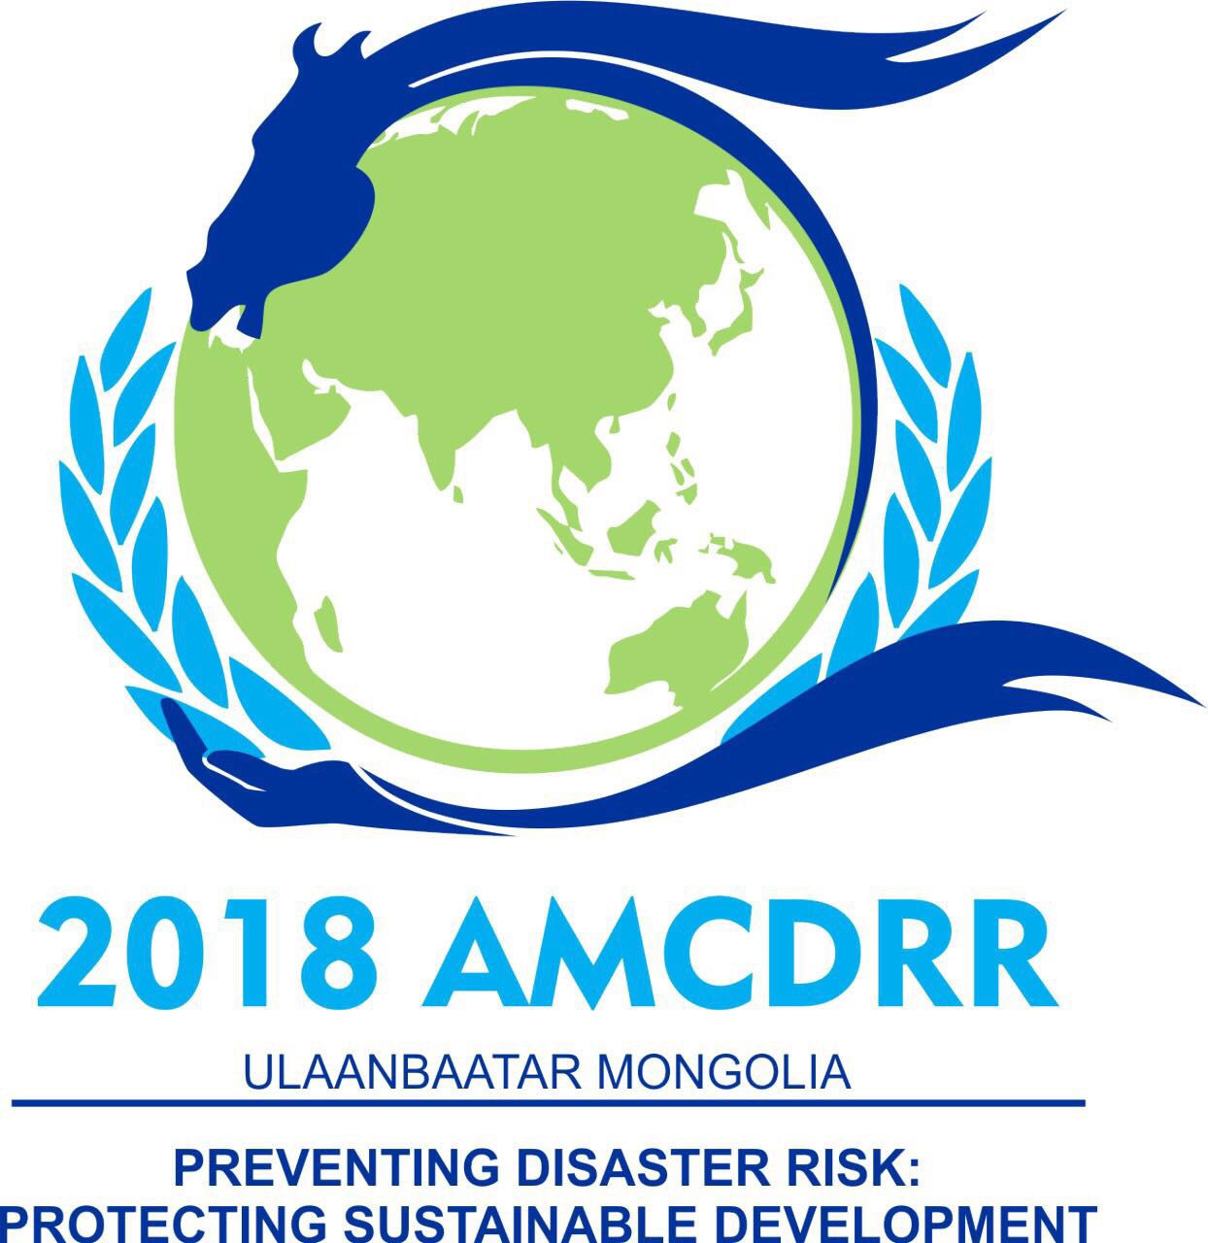
03- 06 July 2018, Ulaanbaatar, Mongolia
Market Place

The 2018 Asian Ministerial Conference on Disaster Risk Reduction (AMCDRR) provides an opportunity to all participating countries and organisations to showcase products, publications and good practices in disaster risk reduction.
Objectives: The main purpose of the Market Place is to promote/ advocate/ showcase good practices in disaster risk management through national organizations/ country level initiatives. Organizations are encouraged to use visual materials, publications, posters, multi medias to showcase best practices in disaster risk management.
Guidelines
- The exhibition booth should focus on areas concerning disaster risk reduction.
- The Market Place will be set up as an enclosed space in the Sükhbaatar Square (the central square located in walking distance from the various conference venues).
- The exhibition booths will be of a standard uniform size and pre-allocated to the successful applicants.
- The conference organisers will provide the space and help setting up the exhibition booths. However, cost of banners, transportation and shipping, will be met by the applicants. All display materials and audio-visual equipment etc. will be the responsibility of the respective organizations.
Submission: A call for expression of interest to set up booths will be announced through the conference website (https://www.unisdr.org/amcdrr2018). Interested countries and organisations are requested to express their interest in hosting an exhibition booth at the Market Place by submitting the annexed application form.
The form should be submitted to Mr Surachai Srisa-ard (srisa-ard@un.org) before 15 May 2018 with copy to amcdrr2018@nema.gov.mn and isdr-bkk@un.org. Please mark with the subject line as “AMCDRR Market Place - <Name of the Organisation>”.
Video Material for Display: The AMCDRR also provides opportunities to display video in the screens on the conference screens. The organisations are also encouraged to share their videos (uploaded on a shared space or shared through YouTube links). Note that the AMCDRR also features the ‘DRR Asia Video Competition’ that is channelled through a different and competitive process (https://filmfreeway.com/amcdrr2018videocontest).

Asian Ministerial Conference on Disaster Risk Reduction
03- 06 July 2018, Ulaanbaatar, Mongolia
Market Place

Application for Market Place (Exhibition Booths)

Name of the applicant organization/s
Type of organization | ☐ Government  ☐ Intergovernmntal Organisation  ☐ UN/ International Organisation  ☐ NGO  ☐ Other Stakeholder Groups
Contact details | Name:  Email:  Phone number:  Address:  Country:
Proposed theme of the market place booth
Kind of exhibit/s proposed
Specific requirements (Note that the host will only provide the booth, all other audio visual equipment need to be arranged by exhibitors)
Technical Equipment

Deadline for Submission: 15 May 2018

