Asian Ministerial Conference on Disaster Risk Reduction
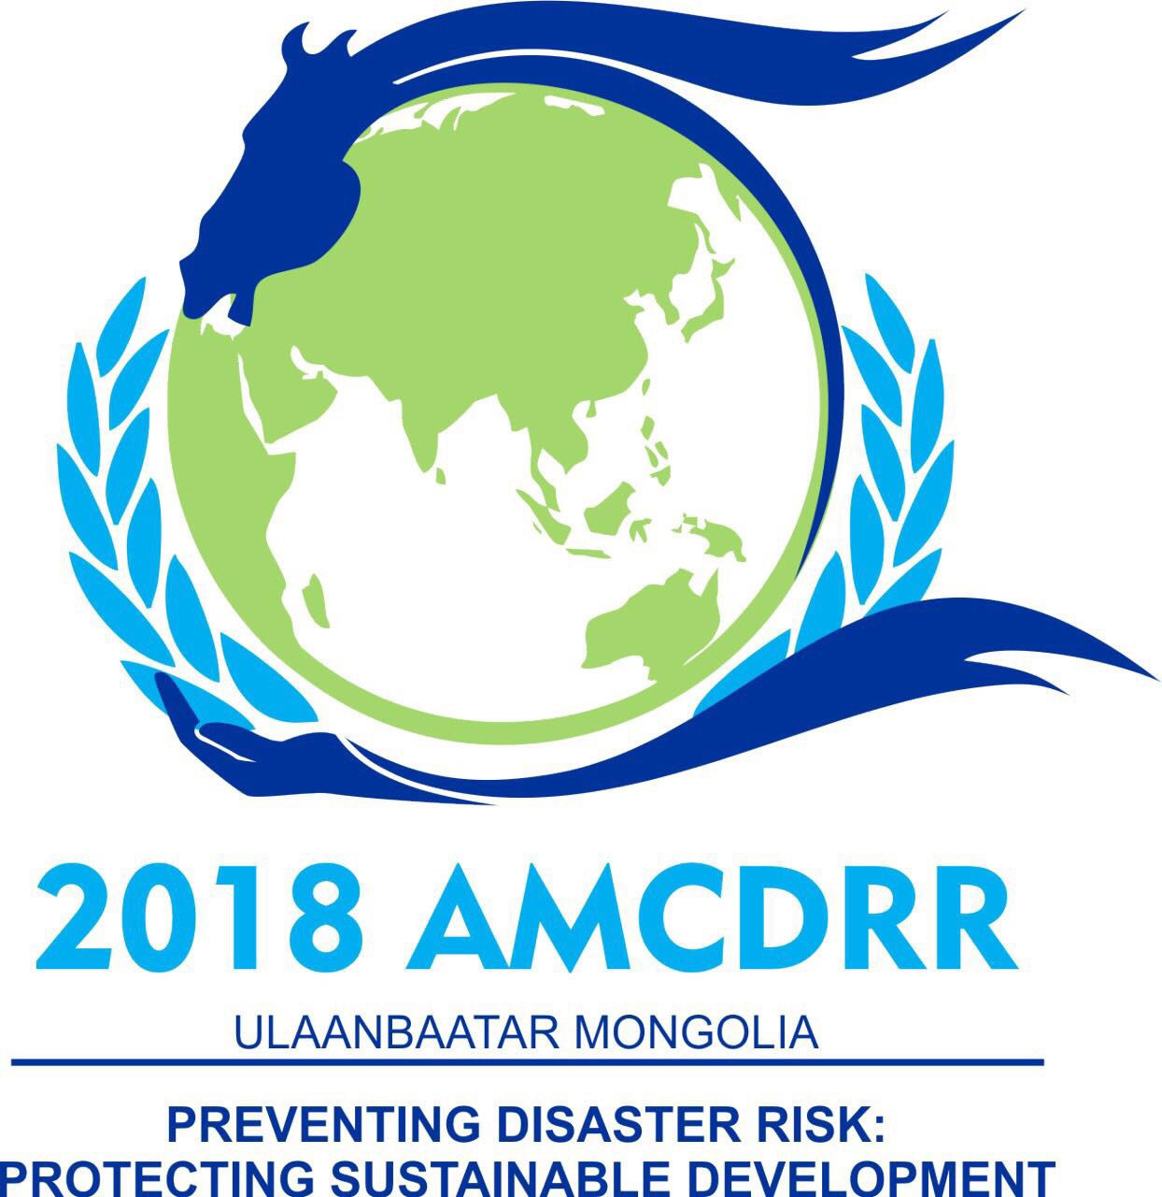
03- 06 July 2018, Ulaanbaatar, Mongolia
THEMATIC EVENTS: DRR IN ACTION

The Asian Ministerial Conference on Disaster Risk Reduction 2018 (AMCDRR), being jointly hosted by the Government of Mongolia and the United Nations Office for Disaster Risk Reduction (UNISDR), seeks to accelerate the implementation of the Sendai Framework and the Asia Regional Plan. The Asia Regional Plan encourages identification of identifying priorities to support national and local actions, enhance exchange of good practice, knowledge and information among governments and stakeholders.
Objective: The AMCDRR, being organised under the overarching theme ‘Preventing Disaster Risk: Protecting Sustainable Development’, forms the regional platform to share good practices, lessons and experiences in disaster risk management among governments, intergovernmental organizations, regional and international organizations, United Nations Organizations and stakeholder groups and organisations.
The AMCDRR Thematic Events: ‘DRR in Action’ will offer an opportunity to various organisations to share and discuss experiences in practical implementation of disaster risk reduction practices and programmes. The application of disaster risk reduction concepts and practices forms the focus of these thematic events.
Format of the Event: As the name suggests, the thematic events will focus on action-oriented disaster risk reduction initiatives, projects and programmes that can serve as a good model for sharing and replication. Activities at community level are, in particular, encouraged to be showcased.
A standard thematic event, 90 minutes in duration, will comprise of a chair, not more than four speakers and a discussant:
- 5 mins: The Chair introduces the topic under discussion and the panellists.
- 30 mins: Each speaker outlines one case study that is relevant to the given theme or topic. The speakers will be given seven minutes each to present their case studies.
- 5 mins: The discussant recapitulates the case studies pulling out common success traits and good practices across the given examples. S/he highlights the relevance of the case studies for the implementation of the Sendai Framework/the Asia Regional Plan and the 2030 Agenda for Sustainable Development. Focusing on the big picture, the discussant provides constructive recommendations for replication and upscaling.
- 30 mins: The Chair opens the floor for discussion. The audience may seek further clarification from the speakers on their case studies, and/or offer similar examples from other parts of the region, while adding and qualifying the recommendations.
- 20 mins: The Chair asks the speakers and the discussant to offer their closing remarks and provides a short summary of discussion and recommendations. The Chair, in particular, offers views on how the good practices and recommendations can inform the decision-making.
Themes: The thematic events will feature case studies on the following topics:
- Remarkable successes in reducing disaster impact (mortality and affected people)
- Community/local action for resilience
- Gender and Inclusiveness
- Technology and innovations
- Social protection and vulnerability reduction
- Ecosystems-based disaster risk reduction
- Early Warning and Early Action
- Private sector interventions
Submission: Interested organisations are requested to submit case studies in the attached format. Based on screening of the expression of interests, the conference secretariat will confirm the acceptance of the case studies to partners. All case studies need to be in line with the pre-determined themes and topics as listed above. The outcomes of these events will be considered by the AMCDRR Drafting Committee to inform the outcome documents and will be reflected in the proceedings.
Interested organisations/ group of organisations are invited to submit a concept note in the format given below.
Please submit your expression of interest by email through this form to: isdr-bkk@un.org (Copy: animesh.kumar@un.org; amcdrr2018@nema.gov.mn) with the subject line “AMCDRR Thematic Event Application <Name of the Event>”.
Deadline for Submission: 30 April 2018

Asian Ministerial Conference on Disaster Risk Reduction
03- 06 July 2018, Ulaanbaatar, Mongolia
THEMATIC EVENTS: DRR IN ACTION

APPLICATION FORMAT
Title of the Case Study
Event code | To be filled by Secretariat
Theme (Please select a theme that is most relevant for your proposed event) | ☐ Remarkable successes in reducing disaster impact (mortality and affected people)  ☐ Community/local action for resilience  ☐ Gender and Inclusiveness  ☐ Technology and innovations  ☐ Social protection and vulnerability reduction  ☐ Ecosystems-based disaster risk reduction  ☐ Early Warning and Early Action  ☐ Private sector interventions
Sendai Framework Priority for Action | ☐ Priority 1: Understanding disaster risk  ☐ Priority 2: Strengthening disaster risk governance to manage disaster risk  ☐ Priority 3: Investing in disaster risk reduction for resilience  ☐ Priority 4: Enhancing disaster preparedness for effective response and to “Build Back Better” in recovery, rehabilitation and reconstruction  ☐ Cross-cutting
Organizers | Lead:  Collaborators:  Contact Details* (lead):  Name:  Designation:  Email and phone number:  Organization name and address:
Stakeholder group (Please select one if you are applying on behalf of a stakeholder group) | - Children, Youth and Child-centered Organizations  - Civil Society Organizations  - Individuals and Organizations Concerned with Disability  - Individuals and Organizations Concerned with Gender issues  - Mayors/ Local Government Authorities | - Media  - National Societies of Red Cross and Red Crescent  - Parliamentarians  - Private sector  - Academia and Research Stakeholders
Date and Time | The date and time will be allocated by the AMCDRR secretariat based on screening of all applications
Venue/ Room no. | To be filled by AMCDRR2016 Secretariat
Background and context (rationale of the event) 300 Words max.
What were the key achievements?
Intended main outcome and Key messages | Please provide succinct bulleted list of 5-7 key messages
Background document | Are you submitting a separate background document on the theme related to your event?  Yes or No
Technical Equipment | Projector, computer, microphones, others: ______________
Please submit your expression of interest by email through this form to: isdr-bkk@un.org (Copy: animesh.kumar@un.org; amcdrr2018@nema.gov.mn) with the subject line “AMCDRR Thematic Event Application <Theme>”.
Deadline for Submission: 30 April 2018

www.unisdr.org/amcdrr2018
The case studies need to reflect good practices and success stories.
An organizing team will screen the submissions for the thematic events.

