Asian Ministerial Conference on Disaster Risk Reduction
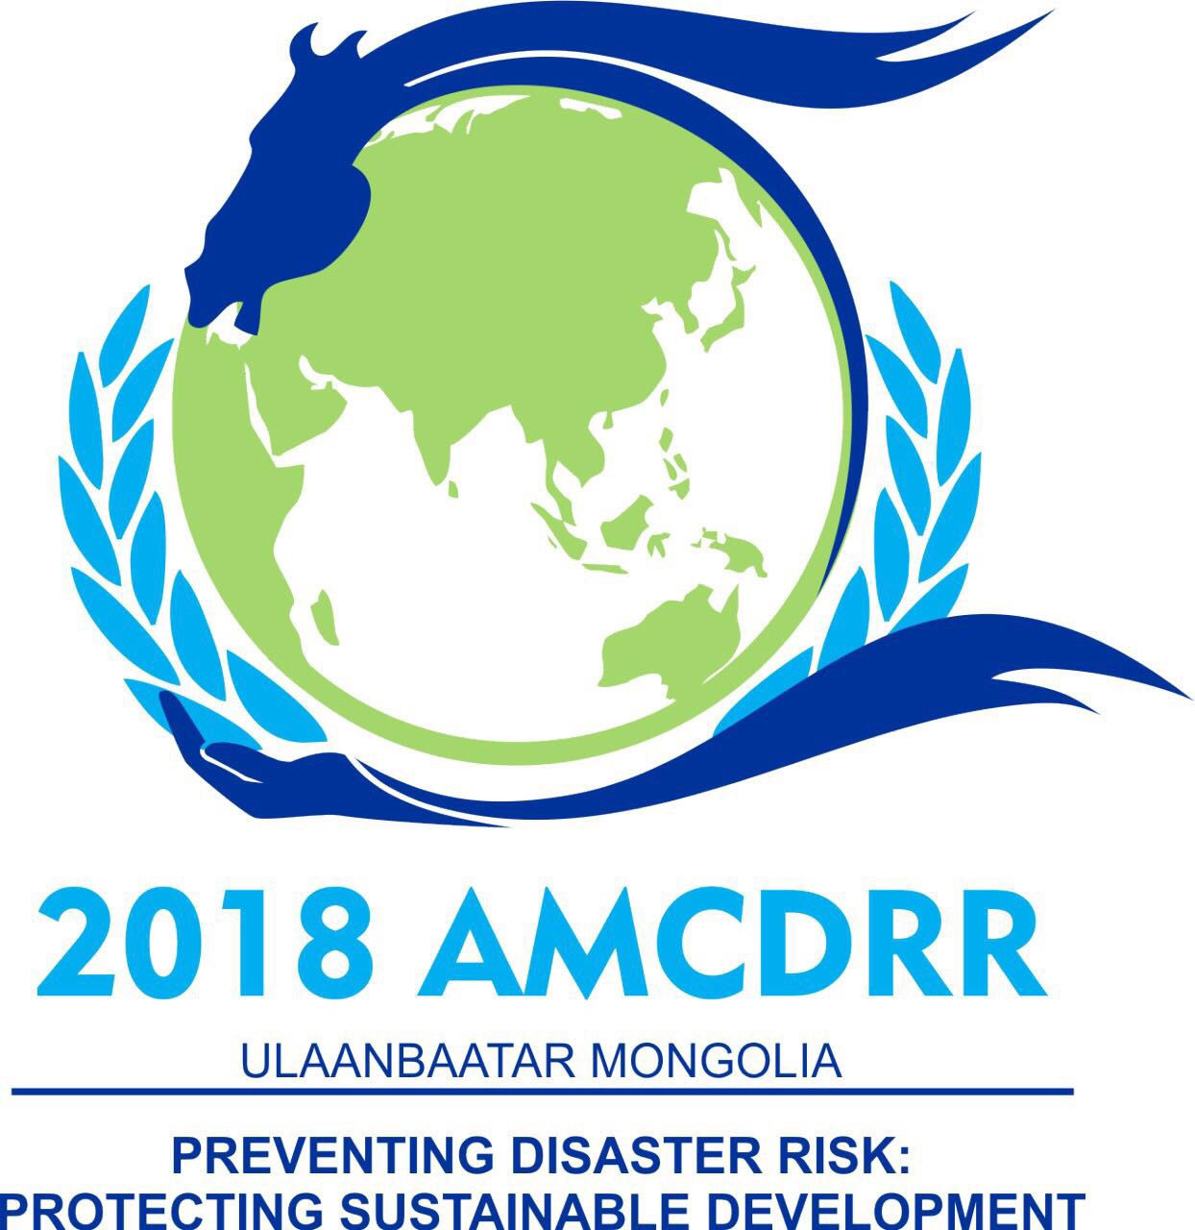
03- 06 July 2018, Ulaanbaatar, Mongolia
Side Events

The Asian Ministerial Conference on Disaster Risk Reduction 2018 (AMCDRR), being jointly hosted by the Government of Mongolia and the United Nations Office for Disaster Risk Reduction (UNISDR), seeks to accelerate the implementation of the Sendai Framework and the Asia Regional Plan. Interested governments, Inter-Governmental Organisations, United Nations, media and stakeholders are invited to express their interest in organising side events during the Conference.
Objective: The AMCDRR is being organised under the overarching theme ‘Preventing Disaster Risk: Protecting Sustainable Development’. Side events applications should focus on topics relevant to this theme. Some indicative topics are listed in the application form.
Duration of the Event: Side events will have a standard duration of 60 minutes and will run parallel to the main sessions of the conference. A dedicated venue will be allocated for the side events.
Submission: Based on screening of the expression of interests, the conference secretariat will confirm the awarding of the side events to the applicants. The outcomes of these events will be reflected in the proceedings (the side event organiser will submit a 300 word outcome summary of the event to the Secretariat).
Interested organisations/ group of organisations are invited to submit a concept note in the format given below.
Please submit your expression of interest by email through this form to: isdr-bkk@un.org with the subject line “AMCDRR Side Event Application <Name of the Event>”.
Deadline for Submission: 30 April 2018

Asian Ministerial Conference on Disaster Risk Reduction
03- 06 July 2018, Ulaanbaatar, Mongolia
SIDE EVENTS

APPLICATION FORMAT
Event title
Event code | To be filled by AMCDRR Secretariat
Theme (Please select a theme that is most relevant for your proposed event) | ☐ Risk assessment and disaster loss accounting  ☐ Governance and accountability for DRR  ☐ Making development risk sensitive: How to?  ☐ Preparedness to “build back better”  ☐ Tsunami awareness  ☐ Gender sensitive DRR  ☐ Application of Science and Technology for Disaster Risk Reduction  ☐ Risk resilient critical infrastructure | ☐ Ecosystems-based disaster risk reduction  ☐ Risk financing  ☐ Health aspects in DRR  ☐ Risk sensitive land use and urban planning  ☐ Multi hazard early warning systems  ☐ National and local strategies  ☐ Social protection  ☐ Tourism  ☐ Education  ☐ Making cultural heritage risk resilient
Sendai Framework Priority for Action | ☐ Priority 1: Understanding disaster risk  ☐ Priority 2: Strengthening disaster risk governance to manage disaster risk  ☐ Priority 3: Investing in disaster risk reduction for resilience  ☐ Priority 4: Enhancing disaster preparedness for effective response and to “Build Back Better” in recovery, rehabilitation and reconstruction  ☐ Cross-cutting
Organizers | Lead:  Collaborators:  Contact Details* (lead):  Name:  Designation:  Email and phone number:  Organization name and address:
Stakeholder group (Please select one if you are applying on behalf of a stakeholder group) | - Children, Youth and Child-centered Organizations  - Civil Society Organizations  - Individuals and Organizations Concerned with Disability  - Individuals and Organizations Concerned with Gender issues  - Mayors/ Local Government Authorities |  | - Media  - National Societies of Red Cross and Red Crescent  - Parliamentarians  - Private sector  - Academia and Research Stakeholders
Date and Time | The date and time will be allocated by the AMCDRR secretariat based on screening of all applications
Venue/ Room no. | To be filled by AMCDRR2016 Secretariat
Session Objectives | Please provide 2-3 main objectives
Background and context (rationale of the event) 300 Words max. | Context and Rationale  Expected Outcome
Session format and programme (detailed agenda) | Please provide a detailed agenda with time, topics, presenters/ panel members etc.
Intended main outcome and Key messages | Please provide succinct bulleted list of 5-7 key messages
Technical Equipment | Projector, computer, microphones, others: ______________
Please submit your expression of interest by email through this form to: isdr-bkk@un.org with the subject line “AMCDRR Side Event Application <Name of the Event>”.
Deadline for Submission: 30 April 2018

www.unisdr.org/amcdrr2018

