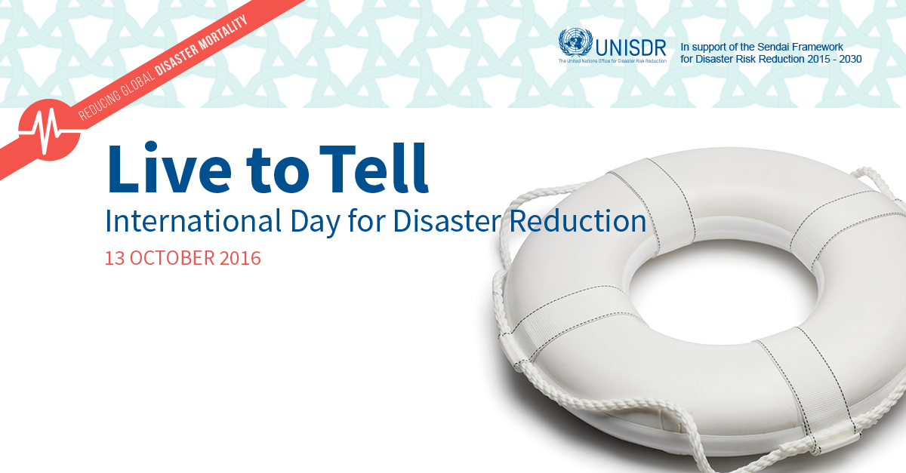
(Misr University for Science and Technology Campus, 6th of October city, Egypt
(13th of October, 2016)

Time Slot | Agenda
10:00 - 10:30 | Official Opening :  - Dr. Mohamed El-Azazy, President,MUST  - Dr. Ashraf Haider, Dean of Medicine, MUST  - Dr.Yasmine El-Kashef, Head of International Cooperation, MUST  - Ambassdor Shahira Wahbi, Chief of Natural Resources Sustainability and Regional and International Cooperation, League of Arab States  - Ms. Luna Abu-Swaireh, Head of UNISDR Regional Office for Arab States  Master of Ceremony: Mr.Majid Shangab
10:30 – 10:50 | Sendai Framework for Disaster Risk Reduction 2015-2030: role of youth in implementation starts with understanding disaster risk.  - Ms. Luna Abu-Swaireh, Head of UNISDR Regional Office for Arab States
10:50 – 11:10 | Role of Science and Technology in reducing disaster mortality  - Dr. Wadid Erian , Arab Science and Technical Advisory Group for Disaster Risk Reduction (Arab STAG)
11:10- 11:30 | Role of National Societies in reducing disaster mortality  - Dr.Nehal Hefny, Egyptian Red Crescent
11:30- 12:00 | Coffee break
12:00 – 1:30 | Arab Youth Forum for Disaster Risk Reduction ( presentation and consultation)  - Facilitated by Mr. Majid Shangab, MUST
1:30 - 2:00 | Road Map for Arab youth to implement Sendai Framework and way forward.  - Mr.Ragy Saro, Programme Officer, UNISDR

