1st Asian Science and Technology Conference for Disaster Risk Reduction:
Science-Policy dialogue for Implementation of the Sendai Framework:

23-24 August 2016
Venue: Swissotel Nai Lert Pak hotel, Bangkok, Thailand

Background

The Asian region has always faced a significant impact of disasters. The trend of human and economic losses due to disasters in this region has been in an increasing order. Although countries in this region have demonstrated a significant progress in establishing policies, institutions and processes towards disaster risk management, the fundamental understanding of disaster risk, losses and the underlying causes of hazards turning into disasters are often at low level.
The Sendai Framework, adopted in 2015, calls for a shift from managing disasters to managing risks. This requires a more holistic approach to risks and a stronger focus on risk-creation processes. The framework provides an opportunity to approach disaster risk reduction (DRR) as an integral part of sustainable development. This will require even greater understanding of risks, losses and the underlying causes of risks that are affecting the development gains through sound scientific research and evidence base information. The framework therefore calls for : “Academia, scientific and research entities and networks to: focus on the disaster risk factors and scenarios, including emerging disaster risks, in the medium and long term; increase research for regional, national and local application; support action by local communities and authorities; and support the interface between policy and science for decision-making”.

The role of science, technology and research in providing evidence and knowledge on disaster risks and ‘How to’ reduce risks have been emphasized in all major international and regional frameworks and agendas. In the last decade, the science, technology and research has progressed significantly in all fronts and across all sectors. Scientists and researchers have brought a deeper understanding of the hazards, vulnerabilities, disaster risks and its linkages to the development processes. However, we often hear the challenges and gaps in translating this scientific information in to the policy making arena that can make policies science and evidence based.

To this end, there is a need to foster the much-needed dialogue between science and policy to what kind of science product is required and how to apply the scientific knowledge in evidence based DRR policy making. This has been discussed in several forums and there are many initiatives exist to improve communication between science and policy. However, often these largely conform to a ‘linear’ model of communication in which scientific facts and knowledge are transmitted/ shared directly to policymaker to “solve problems”. This linear communication mostly assumes that policy makers pose well-defined questions and scientists provide credible, legitimate and relevant scientific information; and the policy makers well understand the scientific information provided by the scientists. Most often this assumption is proven otherwise. While this model can help to start a dialogue, it is, on its own, insufficient to contribute to an evidence based policy making; as policy making is complex and often selective in the information used and as such incorporating scientific knowledge into policy is also a challenge.

To address need of science based policy making for disaster risk reduction; and of science-policy interface to the better balance between the supply and demand between science community and the governments, the 1st Asian Science and Technology Conference for Disaster Risk Reduction will be organized by the Hydro and Agro Informatics Institute (HAII) of the Royal Thai Government and UNISDR Asia Pacific office, in collaboration and support of Asian Science Technology and Academia Advisory Group (ASTAAG), Integrated Research on Disaster Risk (IRDR) and other scientific organizations/ networks. The science–policy dialogue will be initiated in this occasion which will be the main theme of the conference.

The main collaborators for the 1st Asian Science and Technology Conference for Disaster Risk Reduction and the Science-policy dialogue series will bring together their institutional capacities and resources to organize these dialogues annually on a rotational basis. The outcome of each Science-policy dialogue will strive to guide countries and regional entities in fostering science-policy interface for effective implementation of the Sendai Framework. The recommendations and key messages emanating from these dialogues will feed in to the key regional and international processes such as the regional and global platforms for DRR.

The Science-Policy Dialogue:

The 1st Asian Science and Technology Conference for Disaster Risk Reduction will be organized by HAII and UNISDR Asia and the Pacific and the Asian Science Technology and Academia Advisory Group (ASTAAG). The dialogue will aim to bring together key DRR policy-makers (HFA/ Sendai Focal points) and representatives of key scientific organizations from Asian countries to discuss on strengthening the science-policy interface towards science based DRR policy development.

The key recommendations and messages from this dialogue will feed in to the deliberations in the succeeding Asian Science Conference to be held in Bangkok and subsequently will feed in to the Asian Ministerial Conference on Disaster Risk Reduction 2016 to be held in New Delhi, India.

The main objectives of the dialogue are to:
- Discuss the key issues, challenges, needs and opportunities in application of science in policy making and share good practices from the region.
- Discuss the way forward for promotion of science-policy interface for evidence based DRR policy making in Asian countries.
- Agree on a set of key messages towards ‘Application of Science and Technology in Disaster Risk Reduction’ (which is a main theme in the AMCDRR 2016)

The expected outcome of this dialogue will be:
- A statement of commitment from participants on application of Science and technology in disaster risk reduction, in line with Sendai Framework
- A set of key recommendations to be considered by the AMCDRR 2016.

Tentative Agenda

23-24 August 2016
Venue: Swissotel Nai Lert Pak hotel, Bangkok, Thailand
Day1
Opening Ceremony
Master of Ceremony from Thailand
09:00 – 10:15 | - Welcome Address: Dr. Sumet Tantivejkul, Chairman of Utokapat Foundation and Honorary Chairman of HAII, Thailand
 | - Key note: The need for Science–policy dialogue for DRR – H. E Kiren Rijiju, Minister of State for Home Affairs and Regional DRR Champion (TBC)
 | - Opportunities of the application of Science and Technology in disaster risk reduction
- Review of current status of science and technology applied in disaster risk reduction: challenges and opportunities in Asia

- Future Earth and its focus on enhancing science capacities in Asia
10:15 – 10:45 | Coffee Break
Session One: Context setting: Opportunities and challenges in science-policy nexus
Chair: Sujit Mohanty, UNISDR Asia and Pacific
10:45 – 12:30 | - Update on the outcome of the international science and technology conference on disaster risk reduction  - Understanding of risk: communicating disaster risks with policy makers
- Public-Private-Science Partnership for evidence based policy making: The opportunities

- Applications of space technology in disaster risk reduction

 | - Plenary discussion
12:30 – 13:30 Lunch

Session two: Sharing good practices: Application of methods and tools for risk-sensitive policy and practices
Chair: Dr. Royboon Rassameethes, Deputy Director of Hydro and Agro Informatics Institute (HAII)
 | 13:30 – 15:30 | - Improving planning to respond to climate impacts across scales  - Scientific methods and tools in Seismic risk reduction  - Scientific knowledge and methods in floods management at community level  - Today’s and tomorrow’s abilities within Flood and Drought Forecasting  - Sharing of good practices from Private Sector  - Scientific methods and tools in climate risk related reduction  Questions and Answers
 | 15:30 – 16:00 | Coffee Break
 | Session three: The Sendai Framework for Disaster Risk Reduction and focus on Science and technology in Asia
Plenary Discussion on Understanding Disaster Risk
Chair: Prof. Shi Peijun, Professor, Beijing Normal University
Rapporteur: Sugeng Triutomo, Indonesia
 | 16:00 – 17:30 | - Methods, models and tools including spatial for national risk assessments and monitor changes in disaster risk and risk profiling  - Partnerships between science and technology, private sector and the disaster risk management institutes and agencies  - Expertise and personnel using the statistics for policies in disaster risk reduction  - Coherence with disaster risk reduction and post-2015 agenda (in particular SDGs and climate change) in data collection and indicators assisting monitoring and evaluation  - Integrated and multi-disciplinary research bridging social and natural sciences using both quantitative and qualitative data.  Chair’s summary and wrap up
 | Day 2:
 | 09:00 – 09:15 Recap of Day 1 and introduction to Day 2
 | Session three: Panel discussions: The Sendai Framework for Disaster Risk Reduction and focus on Science and technology in Asia (Continuation from Day 1)
 | 09:15 – 10:45 | Plenary Discussion on Strengthening Disaster Risk Governance to Manage Disaster Risk  Chair: Prof. Rajib Shaw, Executive Director, IRDR  Rapporteur: Associate Prof. Takako Izumi International Research Institute of Disaster Science (IRIDeS), Tohoku University, Japan  - Dialogue and networking on disaster risk reduction between scientists and policy-makers  - Scientific awareness and understanding of the impact of disaster risks on societies  - Disaster risk assessments in planning and development especially in land-use mapping (coastal areas, river basins, cities), rural development, and ecosystem management  - Engagement of science in national coordination mechanisms or platforms for disaster risk reduction  Chair’s summary and wrap up
 | 10:45 – 11:00 | Coffee Break
 | 11:00 – 12:30 | Plenary Discussion on Investing in disaster risk reduction for resilience  Chair: Prof. Joy Jacqueline Pereira, Professor and Principal Research Fellow, SEADPRI-Universiti Kebangsaan Malaysia  Rapporteur: Prof. Saini Yang, Beijing Normal University  - Funding and resources for science and technology to inform on understanding of risk, through incentives and cooperation with the commercial sector and enhanced knowledge and technology transfer  - The impact of investment in disaster risk reduction based on the assessment on economic growth and the safety and wellbeing of the general public  - Innovation in earth observation and geo spatial data for risk profiling and decision making  - Roles of social and anthropological sciences in the analysis of investing in disaster risk reduction  Chair’s summary and wrap up
 | 12:30 – 13:30 | Lunch
13:30 – 15:00 |  | Plenary Discussion on Enhancing Disaster Preparedness for Effective Response and “Build Back Better” in Recovery, Rehabilitation and Reconstruction  Chair: Prof. Vinod Sharma, IIPA, India  Rapporteur: Dr. Ali Ardalan, Adviser to Health Deputy Minister, Director of DRM Office, I.R. Iran  - Multi-hazard early warning systems with improved climate information, aerial and spatial data, emergency response services and communication to end users.  - Institutionalization of effective recovery and reconstruction as strategies to reduce risks and promote resilient development.  - Incorporation of build back better in insurance policies.  - National disaster risk reduction plans and strategies that focus on community preparedness and awareness, including the needs of women, children, people living with a disability and the elderly in vulnerable situations.  - Promotion of science based decision-making for resettlement processes.  Chair’s summary and wrap up
 | 15:00 – 15:15 | Coffee Break
 | Session Four: | Way forward: Adoption of the outcome document
15:15 – 17:30 |  | Presentation on draft regional declaration/ statement on Application of Science and technology in disaster risk reduction, in line with Sendai Framework  Plenary discussion
 |  | Adoption of the outcome document
Closing addresses:
H.E. Dr. Pichet Durongkaveroj,
Minister of Science and Technology, Thailand

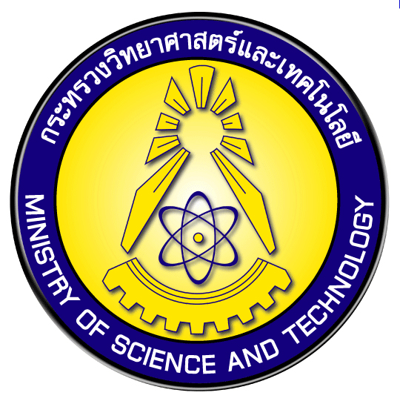
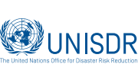
Organizers:

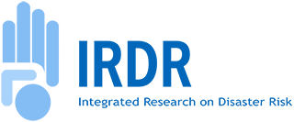
Sponsors:

Hydro and Agro Informatics Institute (HAII) is a public organization under the Ministry of Science and Technology with main responsibilities in developing and applying science and technology to support better agricultural and water resource management.

