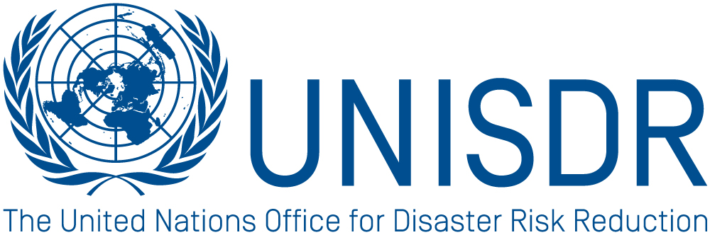

Summary Report
Regional Consultation with Local Governments
on a Post-2015 Framework for DRR (HFA2)
UNISDR Asia & Pacific Office
Colombo, Sri Lanka
27th November 2013

I. Background

2015 will mark the end of the 2005-15 Hyogo Framework of Action for Disaster Risk Reduction along with the Millennium Development Goals. The process to develop a successor arrangement is well underway. An overall consensus has now been reached that the new instrument (informally referred to as HFA2) should build on the Hyogo Framework for Action and introduce the innovations necessary to address the challenges of increasing risk over the next 20 to 30 years.
Consultations during Phase 1 (from March 2012 to May 2013) were conducted at the local, national and sub-regional level across various thematic areas and concluded with the 4th Session of Global Platform held in May 2013. This initial phase focused on broad substantive issues to be reflected in the new framework. Phase 2 of the consultations (from July 2013 until the 3rd World Conference on Disaster Reduction in March 2015), will now focus on more specific content, indicators and measurement of the draft HFA2.

II. Introduction
As part of the above process, UNISDR facilitated a regional consultation with UCLG (United Cities and Local Governments) in Colombo Sri Lanka, on 27th November 2013. The consultation saw the participation of some 80-100 Mayors and Local Government representatives from over 15 countries in the Asia Pacific Region. This is only one in a series of regional and national local level consultations the UNISDR AP office intends to conduct for Phase 2, with support from regional and national partners.

UNISDR will also ensure consultations and inclusion of local governments in the upcoming 6th Asia Ministerial Conference for DRR (6th AMCDRR), which is a key milestone events in the design of HFA2 in the region.
III. Emerging Consensus

Overall, the consultation confirmed the high interest and recognized the pivotal role of Local Governments in disaster risk reduction. The consultation reaffirmed that local action is fundamental to successfully reducing disaster risks as are stronger linkages between national and local governments - particularly the alignment of national policies to local needs.

In light of the above, the consultation also reaffirmed that efforts should be made to strengthen decentralization of responsibilities, capacities and resources to local governments with particular attention given to improved regulation, mechanisms for financing DRR and increased accountability.
Additionally, all participants in the consultation re-emphasized that the post-2015 framework for Disaster Risk Reduction should be designed with local governments in mind as one of the primary implementers. The new framework should therefore ensure that disaster risk reduction is made a core function of the Local Governments, with consistent budget allocation and staffing. Efforts should be made to clearly demarcate responsibilities between the central, provincial, district and municipal levels in the new framework.
IV. Specific Recommendations
Below are some of the specific recommendations derived from the consultation. Recommendations have been compiled as a result of working group exercises, plenary discussions and answers provided by individual participants to the questions listed in Annex I:

- Lack of political will and accountability were often referred to, during the consultation, as one of the main obstacles to effective DRR implementation. Greater emphasis should therefore be put in the HFA 2 on monitoring and accountability instruments to guarantee DRR implementation and law enforcement.

- Additionally, the HFA2 should put greater emphasis on generating social demand for DRR at the local level. This was also referred to by several participants as the most effective way to pressurize local governments to implement DRR and appreciate the value of DRR measures.

- The HFA 2 should also support strengthening and enhancing of linkages between national and local governments – including the alignment of national policies with local needs.

- When addressing the issue of decentralization, participants stressed that the focus should be not on decentralization per se but rather on “good decentralization”. In other words, decentralization of responsibilities to the local level should always be matched by (i) delegation of power/authority, (ii) allocation of financial resources and (iii) building of local capacities.

- As a matter of fact, local governments often lack the capacity to identify and implement suitable DRR measures for their local communities. More attention should be given to capacity-building and awareness raising at the local level in the HFA2, including further training of local governments and communities and enhanced access to available tools and knowledge.

- The future international framework on disaster risk reduction should be translated and made accessible to local stakeholders in local languages.

- When requested how to strengthen DRR as an imperative for local sustainable development, participants suggested the following: (i) developing and including targets in local development plans (e.g. 0 casualty or reduced economic losses as a percentage of GDP) and (ii) assigning a mandatory % of budget for disaster prevention and risk reduction activities at the local government level.

(UNISDR: Michele Cocchiglia, Programme Officer, Asia & Pacific Office).

ANNEX I

Questions

1). How effectively have the national policies on DRR been implemented at the local government level?
Effectively Not effectively With mixed results
If not effective, why:
National policies not informed by local level issues
No allocation of resources
No legal authority
No monitoring and accountability framework
Others, please specify___________________________________________
What can be improved? ___________________________________________

2). What are the major challenges in investing in disaster prevention / risk reduction at the local level?
Lack of budget
Difficult to evaluate benefit vs. cost
Existing cultural mindset of response vs. prevention
Others, please specify__________________________________________
What can be improved? __________________________________________

3). What are the typical challenges faced by cities / local governments in accessing resources for DRR?
No clear guidance from national government on how to access resources
Limited local capacity to identify DRR measures
Lack of capacity to prepare funding proposals
Others, please specify ___________________________________________

4). What are the typical challenges faced by cities and local governments in developing Local DRR Plans?
Lack of disaster risk information
Limited capacity of staff to identify measures
Others, please specify____________________________________________

5). How can DRR be strengthened as an imperative for sustainable development at the local level?
Include targets in local development plans (e.g. 0 casualty or reduced economic losses as a percentage of GDP)
Assign mandatory % of budget for disaster prevention and risk reduction activities at the local level
Ensure accountabilities for disaster losses
Others, please recommend________________________________________

6). Are disaster risk assessments incorporated into relevant local development planning in your city local government?
Yes No Don’t know
If Yes, how can risk information be strengthened and better used to:
Land use, urban and spatial planning? ______________________________
Inform public and private investment? _______________________________
Improve post disaster reconstruction? _______________________________

7). How can targets be used to support accountability?
How can progress in DRR be measured at local level?
Suggest possible targets: _________________________________________
Indicators are often input oriented (they measure the actions of the local or national governments). Suggest an indicator which could help measure the impact at local level? __________________________________________

8). What are 3 of the most critical issues, imperative to building local resilience to disasters that need to be addressed in the Post-2015 Framework for DRR?
1. ___________________________________________________________
2. ___________________________________________________________
3. ___________________________________________________________

http://www.preventionweb.net/files/34419_savethedatewcdrr.jpg

