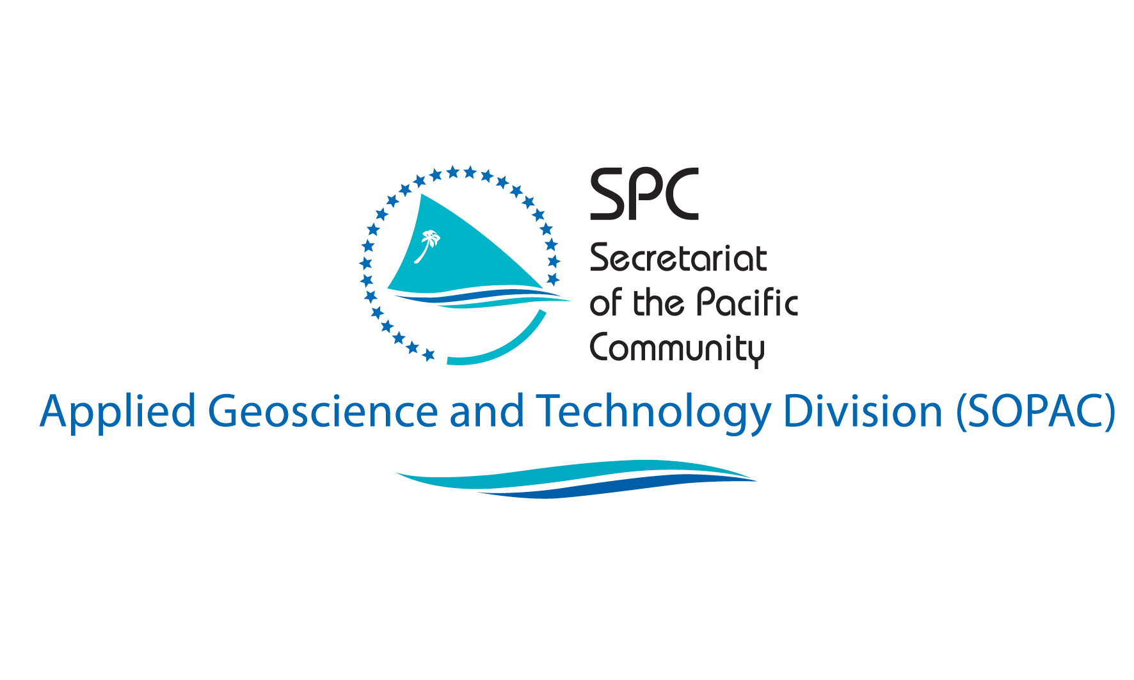

Towards a Post-2015 Framework for Disaster Risk Reduction

Comments from the Multi-Stakeholder Consultations in the Republic of Palau

Submitted by Herman Timmermans
SPC SOPAC ISDR HFA Review Consultant

INTRODUCTION
Countries party to the adoption of the Hyogo Framework for Action 2005 – 2015 at the World Conference on Disaster Reduction in 2005 have been invited to provide inputs into the design of a ‘framework’ to succeed the HFA when it expires in 2015.

The consultations in Palau were conducted in June 2012 as a ‘complementary activity’to the ISDR HFA Monitor Country Progress Reviews (2011-2013) facilitated by SPC SOPAC. The question of a post-2015 framework was posed to participants attending a multi-stakeholder HFA Review workshop in Koror (21-22 June 2012).Forty six stakeholders representing a cross-mix of society attended (see Annex 1).

Guiding Questions for 'Roadmap' National Consultations
Current Levels of Awareness & Understanding
Levels of awareness and understanding of the RFA and HFA were limited. Only about 1/3 of participants had heard of the frameworks and only those working directly in the DRM field (NDMO staff) had more detailed knowledge of them.
There was however a greater level of awareness as well as conceptual understanding of disaster risk management and climate change adaptation and mitigation more generally.

Achievements, Challenges and Opportunities
Since 2005, there have been some significant developments in Palau’s disaster management capacities.
Achievements include:
- Preparation of a National Disaster Risk Management Framework in 2010, with a strengthened emphasis on DRRand adopting an all‐hazards, integrated, whole‐of‐government and whole‐of country approach.
- DRM plans exist for 13 of the 16 States.
- A number of agency and hazard specific response plans.
- Construction of a new dedicated NEOC building that also serves as offices for NEMO.
- Strengthened GIS capability through a dedicated GIS unit (PALARIS).
- Establishment of State Planning Commissions.
- The establishment of a Hazard Mitigation Sub-Committee of the National Emergency Committee.
- A number of climate risk assessments spanning multiple sectors.
- Strengthened monitoring of climatic, seismological, and environmental hazards.
- Strengthened communication systems for Early Warning.
- Specific education materials have been developed for school grades 6 – 8 for typhoon, drought, earthquake, landslides and tsunami and are included in the science curriculum.

Factors contributing to these achievements include:
- Growing political appreciation for the importance of disaster risk reduction and climate change.
- Increased engagement of regional and international development organisations on issues of disaster risk management and climate change.
- Multi-sector nature of disaster risk management and climate change.
- Importance attributed to disaster risk management and climate change as a development issue at the regional and international level.

Major challenges include:
- Disaster Management Office is under-resourced in terms of core operating budget, staff, and equipment.
- Integration of DRM and Climate Change.
- Integrity of the Development Consent Process and EIAs – too many questionable developments still taking place.
- No dedicated government budget for community-level DRM and CC activities.
- Weaknesses in governance capacity.

Factors contributing to these challenges include:
- In a highly competitive environment, government planners do not see DRM and CC as a core government development function, preferring to rely on funding from development partners.
- Climate change is viewed as having its origins in developed countries and the feeling was that developed countries should pay for the negative impacts on small island countries.
- DRM and CC are exploited for political gain – politicians are quick to respond after a disaster, often with unrealistic promises of assistance.

Integrated regional strategy for DRM and Climate Change
Palau supports the integration of DRM and Climate Change, as evidenced by its own interest in developing a Joint National Action Plan for DRM and CCA. It is felt that an integrated regional strategy will promote improved integration amongst development partners and national government agencies.

Significant elements for DRM and Climate Change that should be addressed in the integrated regional strategy in 2015
Palau is in favour of a greater focus on implementation of community level activities as well as a simplification and clarification of the concepts and terms used in the regional strategy. A greater emphasis on how to achieve sectoral integration is encouraged.

Disaster/Climate and Development
Understanding of the relationship between disasters and development
Participants had ageneral understanding of the relationship between disasters and development based on past experience of natural and technological disasters, such as the Koror‐Babeldaob bridge collapse in 1997, and the Aimeliik Power Plantfire in 2011.

Development sectors that have been most affected by disasters
Agriculture, infrastructure and social and economic development are the sectors most affected by disasters. A number of hazards are related to the health sector, such as dengue, SARS, H1N1 influenza, and non-communicable diseases. Water quality and supply is at risk from environmental degradation and drought.

Successes in mainstreaming disaster and climate risk into development planning and sectors
DRM does not yet feature strongly in Palau’s National Development Plan and much work is still needed to achieve sectoral integration. A number of states are showing interest in establishing planning commissions and adopting a spatial approach to their development planning. A proposed Sustainable Land Use Policy proposes integration of climate and disaster risk assessment and planning into the development of ‘State Master Plans’.

Accountability and Governance
Responsibility for implementation of the RFA and PIFACC at national level.
The National Emergency Management Office (NEMO) in the Office of the Deputy President and the Office for Environmental Response and Coordination in the President’s Office are responsible for implementation of the RFA and PIFAC respectively. These responsibilities were allocated to them by national government and they are also the respective focal points for SPC SOPAC and SPREP.

Responsibility for integrating disaster and climate related risks into development planning and budgetary processes at national, sub national and local/community level
It is the responsibility of all relevant ministries and agencies to ensure that disaster and climate risks are integrated into development planning and that costs are built into their budgetary submissions.

With respect to macro-development planning specifically, this responsibility lies with the Bureau of Budget & Planning.
Palau has 16 States that are empowered to formulate their own constitutions and elect their own representatives. Also, further subdivisions below the state level such as villages are the responsibility of each separate state. State are headed by Governors and have the power to establish their own legislation.

National governance structure of disaster risk management and climate change
Governance of disaster risk management comprises a National Emergency Committee, a Hazard Sub-Committee, a National Emergency Management Office, and State Disaster Coordinators. Climate Change is coordinated by the Office of Environmental Response and Coordination. Palau does not have an active climate change country programme, nor does it have a National Climate Change Country Team or a National Platform.

Transparency, accountability and decentralization of DRM and Climate Change as part of development policy and strategy
Accountability is built into existing governance reporting systems as required by the Public Service Commission and Treasury. Decentralisation is promoted through the system of States, with state-level governors having a key role in development planning.

What needs to be done to incorporate accountability in DRM and Climate Change in development planning and practices at national and local level?
The requirement to integrate DRM and Climate Change thinking into development planning and reporting could be reinforced through regular formal reminders to each ministry and agency at appropriate times during the annual planning cycle. Accountability could also be strengthened through improved community monitoring and participation.

Linking DRM and Climate Change
Progress in linking DRM and Climate Change
The Republic of Palau has indicated its intention to develop a Joint National Action Plan for DRM and CC. However, to date, there has been little active linking of DRM and Climate Change.

Integrating disaster/climate risk assessment into land use and planning
Palau has a relatively strong set of environmental policies ranging from environmental quality protection regulations governing development applications, to progressive energy, water, biodiversity and protected areas policies.A new Sustainable Land Management Policy has been prepared and is awaiting approval. The absence of a land use policy represents a critical gap concerning the issue of underlying risk associated with land use and development zoning. The proposed policy also makes provision for the adoption of a national building code.
Palau has two institutions dedicated to promoting environmental good governance. They are the Environmental Quality Protection Board (EQPB) and the Office for Environmental Coordination and Response (OERC). The Belau Watershed Alliance is an innovative multi-stakeholder forum that is promoting a spatial, cross-scale, intersectoral approach to development planning, based on natural geographical boundaries.

Integrating disaster/climate risk assessment into urban planning and development
The absence of land use planning legislation and building standards and codes constitute a critical gap in Palau’s settlement planning and has resulted in a situation in which a number of incompatible developments are located in close proximity to each other, elevating the hazard risk to the population.
The Environmental Quality Protection Board (EQPB)regulates developments through the allocation of building permits after a process of screening. EQPB regulations control, inter alia, building on slopes or in flood plains. Larger developments require Environmental Impact Assessments.

CONCLUSION
The above reflects comments received from the Republic of Palau relating to the HFA ‘Guiding Questions for 'Roadmap' National Consultations’ that were conducted as part of the HFA Monitor National Progress Review in June 2012.

ANNEX 1: PALAU MULTI-STAKEHOLDER WORKSHOP PARTICIPANTS – Government Building, Koror, 21-22 June 2012

Name of the organization | National Emergency Management Office (NEMO)
Type of the organization | Government
Focal point details | Alonzo Kyota, Coordinator, Email: palaunemo@gmail.com

Name of the organization | Bureau of Budget Management
Type of the organization | Government
Focal point details | Dennis Oilouch, Director, Email: bpbm@palaugov.net

Name of the organization | Office of Planning Statistics
Type of the organization | Government
Focal point details | Rhinehart Silas, Coordinator, Email: rsilas23@gmail.com

Name of the organization | Bureau of Public Works
Type of the organization | Government
Focal point details | Techur Rengulbat, Director of Public Works Email: bpw@palaunet.com

Name of the organization | Bureau of Agriculture
Type of the organization | Government
Focal point details | Fernando Sengebau, Director, Email: ffms@palaunet.com

Name of the organization | National Emergency Committee (NEC)
Type of the organization | Government Inter-sectoral
Focal point details | Honorable Kerai Mariur – Vice President and Minister of Finance, Email: vpmofmariur@palaugov.net

Name of the organization | US Embassy
Type of the organization | Diplomatic
Focal point details | Helen P. Reed-Rowe, Ambassador, Email: Reed-RoweHP2@state.gov

Name of the organization | National Development Bank of Palau
Type of the organization | Financial sector
Focal point details | Karla West, Energy Loan Program Manager, Email: kwest@ndbp.com

Name of the organization | Chamber of Commerce
Type of the organization | Business sector
Focal point details | Jennifer Gibbons, Executive Director, Email: pcoc@palaunet.com

Name of the organization | Palau Automated Land and Resources Information System (PALARIS)
Type of the organization | Government - Technical GIS mapping agency
Focal point details | Madelsar Ngiraingas, Project Coordinator, Email:madelsar@palaunet.com

Name of the organization | Bureau of Lands and Surveys – Land Resource Information
Type of the organization | Government
Focal point details | Sterlina Gabriel, Chief of Division, Email:

Name of the organization | Office of Environmental Response & Coordination
Type of the organization | Government
Focal point details | Jerome Temengil, Climate Change Coordinator, Email: Jerome@palaunet.com

Name of the organization | Solid Waste Management
Type of the organization | Government
Focal point details | Calvin Ikesiil, Manager, Email:

Name of the organization | Capital Improvement Projects
Type of the organization | Government
Focal point details | Brian Melairei, Office Manager, Email:

Name of the organization | Ekei Womens’ Group
Type of the organization | Civil Society Organisation
Focal point details | Roberta Louch, President, Email:

Name of the organization | UN Joint Presence
Type of the organization | Development Partner
Focal point details | Sharon Sakuma, Country Development Manager, Email: sharon.sakuma@undp.org

Name of the organization | Bureau of Public Safety
Type of the organization | Government
Focal point details | Norvert Yano, Director, Email: BPSfire@palaunet.com

Name of the organization | Bureau of Public Health
Type of the organization | Government
Focal point details | Everlynn Temengil, Acting Director, Email: temengil-ej@gmail.com

Name of the organization | OMEKESANG (Disabled Office)
Type of the organization | Civil Society Organisation
Focal point details | Villaney Remengesau, President, Email:omekesang@gmail.com

Name of the organization | Energy Office
Type of the organization | Government
Focal point details | Greig Decherong, Director, energy@palaunet.com

Name of the organization | Energy Office
Type of the organization | Government
Focal point details | Nyk Kloulubak, Energy Planner, nyk@palaunet.com

Name of the organization | Ministry of Education
Type of the organization | Government
Focal point details | Faith Swords, Chief Curriculum Instruction, faithsword@palaumor.net

Name of the organization | Ministry of Education
Type of the organization | Government
Focal point details | Pillar Ngiraswei, Social Studies Specialist, pillarngiraswei@palaumoe.net

Name of the organization | MCCA
Type of the organization | Government
Focal point details | Tobias Marbou, Director, Email: kobe@palaunet.com

Name of the organization | Belau Tourism Association
Type of the organization | Private Sector
Focal point details | Terra Nabeyama, Executive Director, bta@palaunet.com

Name of the organization | Office of the Attorney General
Type of the organization | Government
Focal point details | Hussein Derbai, Legal Assistant, boboy@gmail.com

Name of the organization | Division of Environmental Health
Type of the organization | Government
Focal point details | Charley Simon

Name of the organization | Ministry of Public Infrastructure, Industry and Commerce
Type of the organization | Government
Focal point details | Hayes Moses, Director, dot@palaunet.com

Name of the organization | Ministry of Health, Emergency Management
Type of the organization | Government
Focal point details | Ritter Udui, Admin Manager, rbudui@gmail.com

Name of the organization | Ministry of Health, Emergency Management
Type of the organization
Focal point details | Toshikazi Misawa, Database Specialist, toshipalau@gmail.com

Name of the organization | Bureau of Aviation
Type of the organization | Government
Focal point details | Charles Obichang, Director

Name of the organization | Civil Action Team (US Army)
Type of the organization | Military
Focal point details | Gregory Shultz, OIC, oic@catpalau.com

Name of the organization | Office of the President
Type of the organization | Government
Focal point details | Fermin Meriang, Press Secretary, meriangf@gmail.com

Name of the organization | Ministry of Education
Type of the organization | Government
Focal point details | Jefferson Thomas, Education Specialist, jeffersonthomas@palau.net

Name of the organization | Republic of China Embassy
Type of the organization | Diplomatic
Focal point details | Randy Wang, Councellor, randywg@hotmail.com

Name of the organization | National Weather Service
Type of the organization | Government
Focal point details | Maria Ngemaes, Meteorologist in Charge, maria.ngemaes@noaa.gov

Name of the organization | MOS, BITTA
Type of the organization | Government
Focal point details | Ngerikl Baules, Chief, nbaules@gmail.com

Name of the organization | BPS
Type of the organization
Focal point details | Peter Napolen Chief, ppsfire@palaunet.com

Name of the organization | Environmental Quality Protection Board
Type of the organization | Government
Focal point details | Roxanne Blesam, Acting Executive Officer, eqpb@palau.net

Name of the organization | WCCA
Type of the organization
Focal point details | Tobias Marbou, Director, kobe@palaunet.com

Name of the organization | US Embassy
Type of the organization | Diplomatic
Focal point details | Bernie Besebes, Human Resource Manager

Name of the organization | Belan Cares
Type of the organization | NGO
Focal point details | Lorraine Rivera, Admin. Officer, Lorraine.riviera@gmail.com

Name of the organization | Office for Environmental Response and Coordination
Type of the organization | Government
Focal point details | Reagan Belechi, Chief Finance Officer, nrbelechi@gmail.com

Name of the organization | Ministry of Education
Type of the organization | Government
Focal point details | Deborah Nagata, Education Specialist, Debbienagata@palaumoe.net

Name of the organization | Ministry of Education
Type of the organization | Government
Focal point details | Pillar Ngiraswei, Social Studies Specialist, pillarngiraswei@palaumoe.net

Name of the organization | Bureau of Domestic Affairs
Type of the organization | Government
Focal point details | Eunice Akiwo, Director,

Name of the organization | Ministry of Helath
Type of the organization | Government
Focal point details | Melinda Lawrence, Coordinator, palaukpp@hotmail.com

Name of the organization | Bureau of Agriculture
Type of the organization | Government
Focal point details | Olkeriil Yaoch, Quarantine Officer,

