Assessing Tabriz Situation from Seismicity and Strategies for confronting with It from Urban Planning View

Nader Zali, Assistant Professor, Urban Planning Department, University of Guilan, Rasht, Iran
Hassan Norouzi , M.A degree in Urban planning, university of marand.

Abstract

Due to the great importance of Tabriz from political, economic, and social aspects and its high seismicity, this paper examines the problems of this city from urban planning and design view. The issues impressing the ways of facing a likely earthquake in this city are introduced and some short term and long-term strategies are represented for removing its unpleasant consequences. Demographic issues, the lack of fundamental facilities, improper urban development, heterogeneous distribution of service centers, and the lack of proper constructions based on geologic requirements are considered issues in this study. Among offered strategies, modifying existing conditions and revising comprehensive project of Tabriz are mostly emphasized. Undoubtedly, exerting these strategies can increase urban readiness for facing the probable earthquake in this city and decrease its unfavorable consequences.

Key words: Tabriz metropolis, earthquake, vulnerability, urban planning and designing

Introduction

From 1900-1990, around 1100 lethal earthquakes occurred in 75 countries across the world and caused death of many people in 6 countries. With 120, 000 casualties, Iran is among those countries. Since 1982-1991, Iran has experienced the most frequent earthquakes. About 6000 earthquakes have been registered in Iran since 600-1976. In all countries, especially in developing ones, urban life is spreading fast, creating potentials for more losses during natural disasters’ occurrence. Examining the damages and loss amount is directly or indirectly in relation with their unfavorable urban planning and design. Bad establishment of fundamental centers and improper usages of lands, inefficient communication network, compressed urban structure, high urban density, improper sub-structure foundation, unsuitable and scarce outdoor spaces, and etc can play significant roles in increasing the losses in the city during earthquake. Iran has witnessed the spread of metropolises but this issue that to what extent they should spread and which trend should be regarded for their constructions are important considerations which have been mostly neglected.

North Tabriz fault seismicity
North Tabriz fault has a complicated structure starting from northwest to southeast, located in northwest of Iran. It has a length of 150 km (which reaches 210 km regarding North Misho Fault following its northwest tail). It begins from south Marand and continues until Bostanabad Town crossing north borders of Tabriz. It bonds with an upside-down fault from northwest which turns toward west-southwest in the north of Orumieh Lake (Sofian and Tasooj faults). The southeast residue of North Tabriz fault bonds with upside-down north and south faults of Bozgoosh, Doozdoozan, and south Sarab that sometimes changes its direction toward east-north (Berberian and Yeats, 1999). Researchers have forecasted the occurrence of an intermediate/ large earthquake on north fault of Tabriz in this century; it is of great importance for this metropolis and its suburb with the population of around 1,300,000 people. In 2 previous centuries, large earthquakes have occurred on North Tabriz Fault. Among historical earthquakes of Tabriz, destructive earthquakes of 1042 and 1721 with the magnitude of 7.3 and the earthquake of 1780 with the magnitude of 7.4 led to surface rupture in North Tabriz Fault. The earthquakes of 1721 and 1780 which occurred with a low time interval (around 60 years) have created 50 and 60 km surface fault (Ambraseys and Melville, 1982).

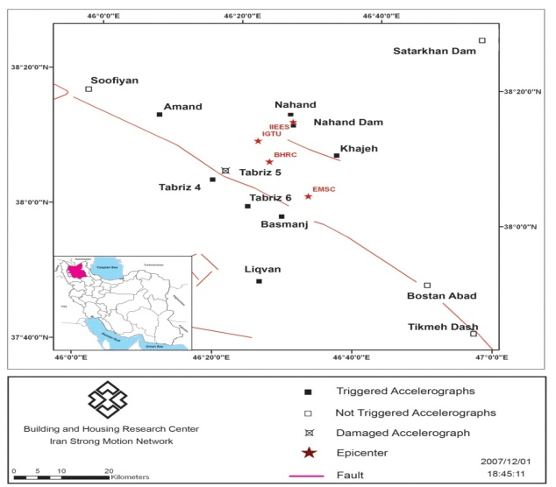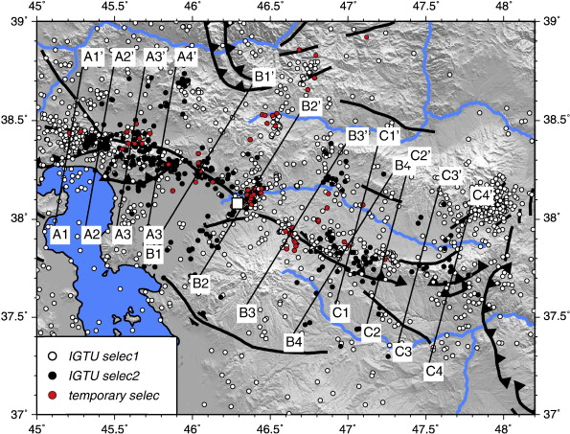
Figure.1. East Azerbaijan Province Hazards points

Background

Regarding natural disasters in urban planning and design, different studies have been done some of which are as follows:
In this respect, first survey was done in 1971, regarding post-earthquake reconstruction in 1980s; afterwards, urban planning and design got significance in that time. First urban planning directory in which the earthquake was regarded as a natural disaster was published in the early 1980s. Primary studies on urban planning for earthquake were done in late 1970s. Common studies have been done by America and Japan through the collaboration of Hawaii University and Japanese Architectural Institute and American and Italian universities. In those studies, land uses and their relation with decreasing earthquake damages and the roles of different urban elements have been regarded in urban mechanism. In the mid1980s, urban planning for earthquakes received the highest attention to regard the vulnerability of urban elements, urban design, and regional planning. (Ambraseys and Melville, 1982).
In Tehran, the first studies on urban vulnerability were published in the form of different maps in the early 21st century. Primary studies on urban planning of Tehran were in late 1990s in Seismology and Earthquake Engineering Institute. There was also a study on post-earthquake traffic problems in Tehran and their effects on emergency fire station responses in late 1990s. Using urban techniques for predicting the impacts of different urban uses, their proper locations and optimized replacement, designing urban structures, their elements and providing needed substructures for facilitating rescue and emergency services are the factors that can reduce urban vulnerability (Faryadi 1995).

Selected vulnerability criteria in Tabriz

Based on the studies, distance from the fault, soil type, and land slope can be regarded as land vulnerability criteria for the earthquake. The ways of combining and arranging compartments in forming various structures and their vulnerability features are effective human elements. In evaluating land partitioning, land’s geometric shape (regular or irregular), area, land dimensions and size, proportion of length to the width of the land based on uses, and ownership type are considered. The number of buildings on the land and the direction of their settlement from the view of destruction in open spaces affect land vulnerability (Veiseh, 2003).The patterns of constructions and usage adjacency also impress vulnerability to the earthquake.
Now, the question is this that if there are natural characteristics for the city increasing its flexibility against earthquake. It seems that open places have more flexibility than dense spaces for the changes. High population density equals with more damages during earthquake. Based on mentioned human indices, 6 criteria including construction type, adjacency to harmful applications, pass-way accessibility, open space availability, land shape, and population density are regarded in this study (Afolayan, 1987). In Tabriz, such areas include about 40% of residential sections. From the other hand, less than 6m pass-way distribution may lead to critical conditions. Historical organic structures and regular urban construction concentration in the city structure are evident (Asgari, 1998). One or two-storey buildings are concentrated in old structure; but, 4 or 5-storey buildings are observed in business district of the city. There are also sterile lands in some parts of residential sections in the form of deserted houses. The compression of residential section in the old section of under-study area increases higher casualty likelihood. Residential applications are mostly focused in the western half of the structure in dense form. Main focus of business district is in the market in which the lack of lateral spaces like public parking and specific-purpose parking lots is felt. It must be notified that District 8 of Tabriz lacks accessibility hierarchy. Main pass-way doesn’t have much penetration into the area. Pass-ways are mostly narrow and roundabout. Pass-way distribution with the width of less than 4 m is observed in 30% of residential section. This issue doubles crisis range and makes proper rescue operations impossible. District 8 of Tabriz has gas, telephone, and electricity but lacks sewage system. So, it should be regarded along with surface and agricultural water. This is while all existing projects for historical –cultural sections emphasize tourism and recreational aspects regarding natural and environmental concerns. From the other hand, the existence of open spaces and bare lands near this area create many possibilities for planning rescue services which is an advantage of it (Alizadeh, 1994).

Urban planning problems of Tabriz

Since the goal of urban planning is making correct decisions about the quantity and quality of population distribution, urban elements, land applications, development, and reconstruction of the city, it reveals itself in the form of correcting distribution of the elements across the city and removing the shortages. The cases that need correction, development and completion include:
a. Population and its excessive growth for migration. At the first glance, population growth and earthquake look irrelevant. But with more scrutiny, earthquake crisis rises by increasing population. So, controlling it can be of great help to the crisis managers.
b. Improper population distribution. People’s reactions in the primary minutes of earthquake occurrence can disrupt rescue operations. This problem will duplicate in the areas with improper population distribution.
c. Environmental pollution. Air and sound pollution and garbage spread across the city can increase the chance of infective illnesses.
d. Too much concentration of some facilities. Too much concentration of some facilities like many industrial, public and service buildings, not frequently used by the citizens, can paralyze rescue teams’ operations during the earthquake. (Hamidi, 1995)
e. Mismatch of service provision with population density in different urban sections. The shortage of fundamental utilities like gas and electricity can worsen the post-earthquake crisis.
f. Inefficiency of transportation mechanism, especially in downtown. Inefficiency of internal transportation system can stop or make serious problems for rescue operations during the earthquake.
g. Excessive development. Without concerning the capacities and resources of Tabriz and environmental concerns, development limits service provision for undefined areas and even internal sections as well as damaging the environment itself.
h. Physical development of urban spaces. Ignoring earthquake dangers, many buildings have been constructed on the faults which can create problems in the case of alluvium rupture on land surface. Besides, since urban development for population growth has accelerated excessively in some areas, neglecting soil period and earthquake danger, vulnerability of those areas duplicates.
i. Inefficiency of fundamental centers. The shortage of fire and police stations and clinics duplicates the harshness of the conditions and endangers many lives during crisis. Besides, many police stations don’t have necessary structural resistance against earthquake.
j. Improper distribution of medical centers. Improper distribution of medical centers and especially hospitals which is for ignoring population concentration (in a way that some populated areas don’t have any hospitals yet) imposes unnecessary internal transportation during crisis and delays patient transfer to the hospitals, increasing tolls.
k. Mismatch of water service and the needs of different sections. Inefficiency of water system for its oldness or the lack of proper design for earthquake time can be very problematic.
l. The lack of establishment of the buildings including the fundamental departments near crisis management center. The final problem from the view of urban planning is the lack of closeness of fundamental departments and crisis management center. This confronts the officials of crisis management center with serious problems. It also increases the harshness of the situation and reduces the speed of emergency reactions significantly. In present conditions, if the officials of fundamental departments want to reach crisis management office, if not impossible, will lose much time or have many difficulties.

Tabriz problems from the view of urban designing

The goal of urban designing is deciding on the quality elements like buildings, open spaces, and other components of urban places. Their volume, the ways, location of settlement, size, and appearance can increase their vulnerability against earthquake.
From the other hand, the location of some elements in the city duplicates the harshness of post-earthquake conditions which relates to the problems of urban designing as follows:
a. Improper combination of residential and un-residential structures (business, public, recreational, and etc). The first problem of urban designing in Tabriz is improper combination of residential and un-residential structures. The presence of some governmental centers in residential areas is a good example for it. Another example is the existence of technical workshops near the houses or in the basements of residential areas which not only disrupts peace of the people, but also damages the statistics of vulnerability during earthquake, hurting people’s distribution in city level.
b. Mismatch of building structure with the place. This predicament stems from issuing construction certificate for multi-storey buildings in different areas of Tabriz which causes scene heterogeneity. Overbuilding ignoring population and pass-ways capacity also duplicates situation’s harshness in emergency conditions. .
c. Mismatch and the lack of urban identity. If a person with closed eyes is taken to a street of Tabriz, asked to identify a path leading to downtown, he can’t do that. This is because low and high or modern and traditional structures are so irregularly interwoven that distinguishing them is difficult.
d. Mismatch of pass-ways’ width and buildings density in different sections of the city. This problem can disrupt rescue operations seriously. The location of many schools in the bottom of blind alleys with narrow widths is the example for this. Also, in many residential areas, central sections are only accessible via narrow pass-ways which hardens rescue operations.
e. Destroying green spaces, turning into dense complexes. Besides damaging environmental resources, this issue yields improper open space distribution which creates shortages for the settlement of casualties. Being too far from damaged houses disrupts mental peace of earthquake-stricken people who are naturally willing to be near their places. This also necessitates many public commuting in the critical conditions. Improper distribution of the open spaces like parks, sport fields, and outdoor spaces is also noticeable.
f. Inaccessibility of fundamental centers like hospitals. Inaccessibility of fundamental centers like hospitals lengthens the time of rescue operations. In some cases, improper paths and the existence of vulnerable construction elements may occlude some routes, delaying rescue operations.
g. Settlement of fundamental centers in risky areas susceptible to earthquake. It is clear that if an important building is constructed with 0.35 base acceleration according to the construction rules and directory its location in maximum acceleration of 0.60g makes it vulnerable against the earthquake. Settlement on the slopes susceptible to sliding or near-fault areas can also duplicate the danger.
h. Settlement of many key constructions like water resources near or on the fault. Such settlements significantly raise the probability of post-earthquake water cut-off. It also increases the probability of flood occurrence. Some bridges and highways are also located next to fault range which increases their vulnerability.
The results showed that attitude difference among the organizations and the lack of an integrated urban management or urban micro-view are the most important barriers on the way of confronting the probable earthquake. However, such organizations don’t intend to change anything and express their concern toward reducing organizational authorities in the frame of forming a unified urban management. From the other hand, comparing preparation, legislation, and program performance in Iran with other countries show their impracticality, inefficiency and obsess with formality and bureaucracy. So, it can be concluded that embedding for coordinating the organizations will be one of the important steps in improving these conditions.
Representation of Strategies

Based on descriptive and inferential analysis above, the following strategies can affect organizing Tabriz and increasing its resistance against the earthquake. These strategies can be in short term or long term.

A. Short term strategies

The actions done in less than 5 years with an orientation toward the things which remove risky items from the lives of citizens without a tangible change in their routines, increasing rescue operation success and crisis control are called short term strategies. Examples include:
1. Preventing from population growth
2. Optimizing seismicity-prone hospitals and building new ones in the areas with their shortage
3. Optimizing existing fire stations and making new ones in the areas with the shortage of them
4. Stopping constructions in faults’ range with instable soil
5. The lack of overbuilding in risky areas and limiting the number of floors
6. Building local and versatile places for promoting citizens’ readiness against earthquake
7. Promoting social readiness for emergency reactions
8. Promoting executive readiness for post-earthquake emergency reactions
9. Providing a comprehensive post-earthquake reconstruction scheme

B. long term strategies

Long term strategies are the actions which last over 5 years with significant effects on the present status of the city as follows:
1. Adopting construction structure with construction rules
2. Transferring fundamental buildings located in risky area to safer places
3. Architectural modifications of special buildings
4. Making fundamental buildings accessible
If the locations of fundamental buildings are proper but they are inaccessible in critical conditions:
5. Pass ways’ widths should increase and overbuilding should be controlled.
6. The centers of fundamental buildings officials should be close to crisis management.
7. Utilities should be optimized inside the city.
8. Public departments should be transferred to resistant towns around Tabriz
References
- Afolayan, A.A. (1987) ‘The Sosa Resettlement Project: A Study in Problems of Relocation’. Habitat International. 11(2). pp. 43–57.
- Alizadeh, M. (1994) Economic Losses in 1990’s Earthquake of Northern Region of Iran. National Disaster Prevention Centre of Iran, Tehran.
- Ambersays, N.N. & Melville, C.P. (1982) A history of Persian earthquakes, Cambridge university press.
- Anderson, M. (1994) ‘Understanding the disaster-development continuum’. Focus on Gender. 2(1). pp.7–10.
- Asgary, A. (1998) A Decision Support Systems for Management of Natural Hazards Risks within the GIS Environment. International Symposium on Information Technology and Natural Hazards’ Risk Management, 4–6 February, Bangkok, Thailand.
- Bahrainin, S.H. (1993). Urban planning in the areas susceptible to earthquake. The project of gathering technical skills of Iran for confronting earthquake, Housing Department, The Study Center of Natural Disaster, Tehran.
- Bahrainy, H. (1998) ‘Urban Planning and Design in a Seismic-Prone Region (The Case of Rasht in Northern Iran)’. Journal of Urban Planning and Development. 124(4). pp. 148–181.
- Berberian, M. & Yeats, R.S., 1999. Patterns of historical earthquake rupture in the Iranian plateau, Bull. seism. Soc. Am., 89, 120–139.
- Burbridge, P., R.B. Norgaard and G.S. Hartshorn (1988) Environmental Guidelines for Resettlement Projects in the Humid Tropics. FAO Environment and Energy Papers. Food and Agriculture Organization of the United Nations (FAO), Rome.
- Cernea, M.M. (2000) ‘Risks, Safeguards, and Reconstruction: A Model for Population Displacement and Resettlement’. In M.M. Cernea and C. McDowell (eds.) Risks and Reconstruction: Experiences of Resettlers and Refugees. World Bank, Washington, DC. pp. 11–55.
- Consultant Engineers of Tehran Padir (2010). Studies of partitioning earthquake susceptible areas of Tabriz, Housing and Urban Planning Department of East Azerbaijan.
- Downing, T.E. (2002) ‘Creating Poverty: The Flawed Economic Logic of the World Bank’s Revised
- Ebrahimi, M., & Jazayeri, A (1995).Comprehensive project of crisis management in Iran, The articles of second international conference of seismology and earth quake engineering , Internal Institute of Seismology and Earth Quake Engineering, Tehran.
- Habib, F. (1992).The role of city form in reducing earthquake dangers, The articles of first international conference of natural disaster in urban areas, internal institute of seismology and earth quake engineering, Tehran.
- Hamidi, M. (1995). The role of urban planning and designing in reducing crisis management risks. The articles of second international conference of seismology and earth quake engineering, Internal Institute of Seismology and Earth Quake Engineering, Tehran.
- Veiseh S, Yousefi AA, The use of polystyrene in lightweight brick production, IRAN POLYM J 12 (4): 323-329 JUL-AUG 2003
- Yahya, Z. (1979).Tabriz earthquakes, Ketabsara Press.
- Zare, M. (2001).Construction dangers in North Tabriz Fault. Seismology and Earth Quake Engineering Journal, 4th year, No. 2, 3.

