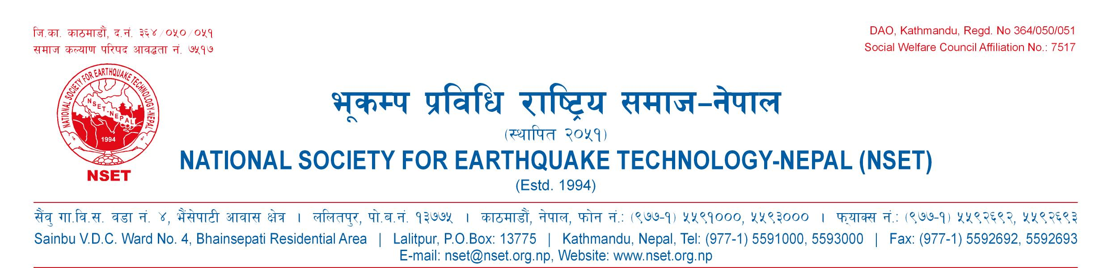

Thank you for taking the time to apply for volunteer or internship program at National Society for Earthquake Technology-Nepal (NSET). This application form will help us efficiently identify the positions and jobs that are best suited to your experience and learning objectives. Please fill out this application to the best of your ability. Please keep in mind that some of the questions may not apply to you. If you have any questions about this application, please contact us.

______________________________________________________________________________________________

Last Name, First Name Middle

Home Address: _________________________________________________________________________________

Home Phone: _____________________________ Personal Email:________________________________________

Current Employer: _______________________________________________________________________________

Work Address: _________________________________________________________________________________

Work Phone: _______________________________ Work Email: _________________________________________

Position: ____________________________________________ Period of Current Position____________________

Mobile Phone (optional): ______________________________________

What is your preferred method of being contacted?

INTERN/VOLUNTEER INTEREST

Why are you interested in volunteering or doing an internship at NSET? __________________________________

Are you volunteering or doing an internship at NSET as per Memorandum of Understanding (MOU) with your organization? □ Yes □ No

Are you volunteering or doing an internship at NSET with your direct approach? □ Yes □ No

If yes, how did you know about NSET ? ______________________________________________________________

Are you a student? □ Full Time □ Part Time □ No

If student, what program are you in? ____________________________________________________________

Will your volunteer/internship hours count towards university class credit? □ Yes □ No

If so, what is the name of the course or faculty advisor: __________________________________________________

Please specify the College/University degrees obtained/expected __________________________________________

What is the source of support to you for volunteer/internship program? – Self support/ Institutional support/ scholarship/Other (specify)_________________

Outline what you expect to learn or achieve from volunteering or doing an internship and how does this apply to your career goals?

VOLUNTEER/INTERNSHIP EXPERIENCE

List previous experiences (paid or educational) that would be helpful in working with people.
(Continue on back if necessary.)

Activity Organization Date(s)

__________________________ ___________________________________ _____________________________

__________________________ ___________________________________ _____________________________

INTERESTS / SKILLS

Please indicate with a check mark which you would be willing to share as a volunteer/intern here.

Administrative Skills: __ typing __ filing __ using copier __ record updating __ computer mailing
__ word processing __desktop publishing __translation __ other (specify: ___________________________________)

Library Skills: __ reference __ cataloging __ shelving __ creating information sheets __ web development
__research __ technical services __bibliographic instruction __ training __ system design
__programming (languages: _________________) __other (specify: ______________________________________)

Subject Knowledge: __fundraising __proposal writing __technical writing __office management ___other (specify: ____________________________________________________________________)

Knowledge of Languages:

Language: | Read |  | Write |  |  | Speak
 | Easily | Not easily | Easily |  | Not easily | Easily | Not easily
English
Others (Please Specify):

List any skills, hobbies, or interests you have that might be helpful in your volunteer work:

______________________________________________________________________________________________

Additional Skills / Comments: ______________________________________________________________________________________________

AVAILABILITY

Approximately how much time do you feel you could volunteer (per week/month)? ___________

How many months would you like to volunteer at NSET (periods of to a maximum of six months) ? ______________

What is your preferred work schedule?

(Check all applicable)  ___ Daytime  ___ Evenings  ___ Weekdays  ___ Weekly  ___ Monthly | Preferred Schedule (if known):  _____Time Commitment Undecided
  Mon | Tues | Wed | Thurs | Fri

OTHER RELEVANT INFORMATION:

Have you ever been arrested or summoned into Court as a defendant in a criminal proceeding, or convicted, fined or imprisoned for the violation of any law? □ Yes □ No

If yes, please give full details in a separate paper.

List out the publications (if any):

_________________________________________________

_________________________________________________

REFERENCES

Personal or professional references (Please list two persons excluding your relatives, who are familiar with your character and qualifications)

1. Name: ____________________________________________________ Phone: __________________________

Address: _____________________________ City ______________________ State _______ ZIP _______________

2. Name: ____________________________________________________ Phone: __________________________

Address: _____________________________ City ______________________ State _______ ZIP _______________

EMPLOYMENT HISTORY

Previous Employer #1

Company Name: ______________________________________________________ Phone: __________________

Address: ___________________________ City ___________________ State _________ ZIP __________________

Position: ___________________________________________ Dates of Employment: _________________________

Previous Employer #2

Company Name: ______________________________________________________ Phone: __________________

Address: ___________________________ City ___________________ State _________ ZIP __________________

Position: ___________________________________________ Dates of Employment: _________________________

EMERGENCY CONTACT INFORMATION

Primary Contact: Individual to be notified in case of emergency:

Name: ___________________________________________________ Relationship: ________________________

Address: _______________________________ Phone #1: _________________ Phone #2: ___________________

Secondary Contact: Individual to be notified in case of emergency:

Name: ___________________________________________________ Relationship: ________________________

Address: _______________________________ Phone #1: _________________ Phone #2: ___________________

THE ABOVE INFORMATION IS ACCURATE AND CORRECT TO THE BEST OF MY KNOWLEDGE.

SIGNATURE _____________________________________________________ DATE ________________________

YOUR SIGNATURE INDICATES YOUR APPROVAL FOR US TO CHECK YOUR REFERENCES. THE ORGANIZATION IS NOT OBLIGATED TO PROVIDE A PLACEMENT, NOR ARE YOU OBLIGATED TO ACCEPT THE POSITION OFFERED. OPPORTUNITIES FOR VOLUNTEERS AND INTERNS ARE PROVIDED WITHOUT REGARD TO RELIGION, RACE, NATIONAL ORIGIN, AGE OR SEX. NSET IS NOT RESPONSIBLE FOR OBTAINING VOLUNTEER/INTERNSHIP VISA FOR THE INTERNATIONAL APPLICANT.

Thank you for your interest in working with NSET towards Earthquake Risk Reduction and Management.

