REPORT OF THE TWO DAY WORKSHOP ORGANISED BY THE NATIONAL DISASTER MANAGEMENT AGENCY (NDMA) FOR THE NONE STATE ACTORS ON DISASTER RISK REDUCTION (DRR) ADVOCACY
TANGO CONFERENCE HALL
6TH – 7TH JUNE 2011
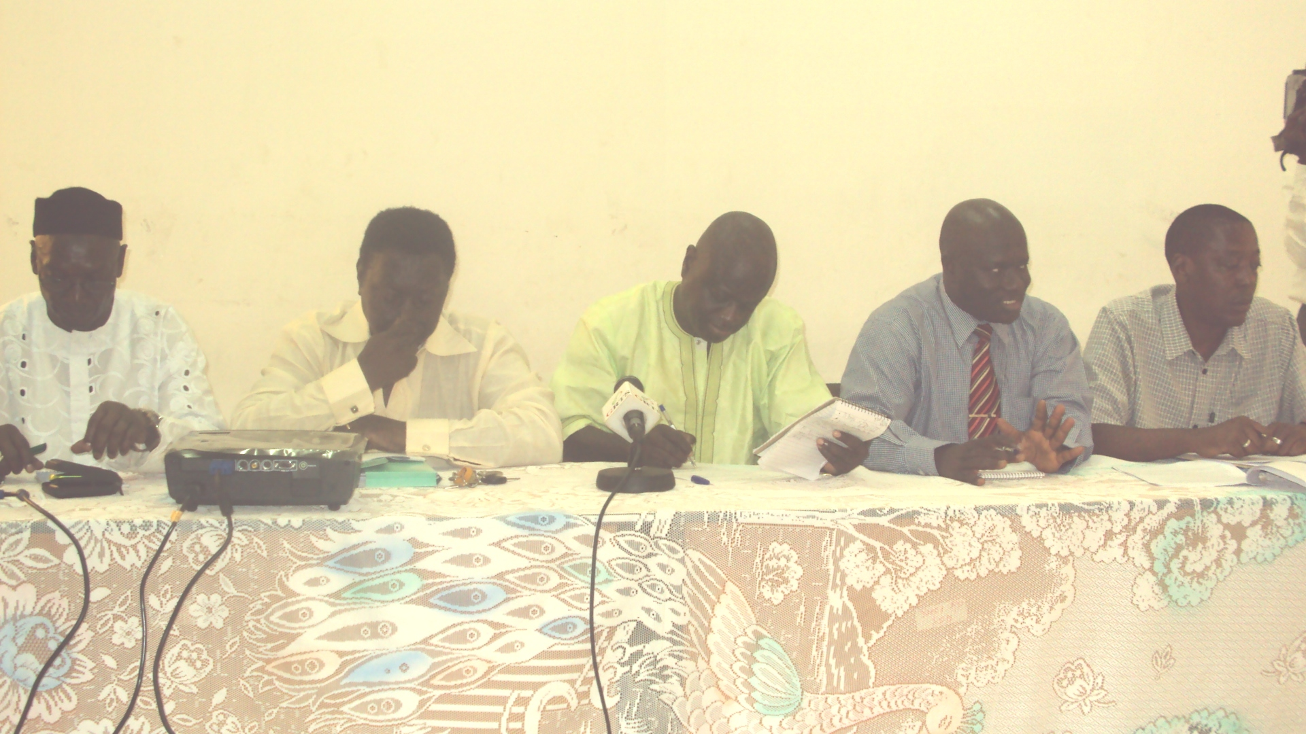

Funded by the Taiwanese Embassy
- Background:
The National Disaster Management Agency (NDMA) organized an Advocacy Training Workshop on Disaster Risk Reduction (DRR) for the None State Actors from the 6th to the 7th of June 2011 at the TANGO conference hall. The fund for the training was provided by the Government of The Republic of China on Taiwan.
- Objectives:
The main objective of the training workshop was among others is to enhance the capacities of the None State Actors on Disaster Risk Reduction through training and advocacy planning, monitoring, evaluation and reporting system.
The workshop provided the opportunity for the resource persons and participants alike to share and discuss on the following topics:
- The Hyogo Framework for Action (HFA)and other regional Frameworks
- Mainstreaming DRR into Development
- Disaster Risk Reduction and Climate Change Adaptation- the link
- Linking DRR to PRSP, Gambia’s Vision 2020, MDGs and UNDAF
- DRR Best Practices from the Sub-Region
- Role of Government and None State Actors on DRR Best Practices
- Overview of the NDMA Policy.
- Need for Non-State Actors to harmonize and align their programmes and activities in line with Government’s strategy on DRR

- Day One:
Opening Ceremony:
The workshop commenced with an opening ceremony with remarks by the Executive Director NDMA, Executive Director of TANGO, the Chairperson of the National Platform for Disaster Risk Reduction, and the permanent secretary office of the Vice President.
In his welcoming remarks, Mr. Essa Khan the Executive Director of the National Disaster Management Agency NDMA thanked everyone for their response to this important national call which he said will go a long way in facilitating a more robust collaboration and partnership in the NDMA’s DRR advocacy. According to Mr. Khan Disaster is a cross-cutting development issue that calls for concerted efforts for any meaningful impact especially the None State Actors who are out to compliment government’s efforts. He thanked the Embassy Republic of China on Taiwan for funding this programme among others.
Speaking earlier on Mr. Ousman Yabo, the TANGO Director call on the None State Actors to join efforts in a more coordinated manner. According to him, during the last floods the NGOs contributed immensely toward supporting victims but however, more could be done to harness more resources for a more effective response if things are better coordinated which the workshop intends to provide.
For his part the chairperson of the National Platform for Disaster Risk Reduction in The Gambia Mr. Albert Cox emphasized on the importance of the workshop and added that the advocacy could not have come at a better time than this and advised that participants to take the workshop seriously as no one is too old to learn.
In his opening speech the Permanent Secretary Office of the Vice President Mr. Lamin Nybally highlighted that in the past years and 2010 as a reference, all regions in the country were affected by various kinds of disasters and floods in particular causing uncountable agony to human life, field crops, livestock, and the environment alike. It’s in this regard that the NDMA and NDMC solicited funds from the Republic of China on Taiwan for institutional strengthening as a strategy for Disaster Risk Reduction.
He also stressed that as disasters cut across all areas of activity of Government, NGOs, private sectors and Civil Society Organizations, the NDMA is to engage all stakeholders in its advocacy drive on Disaster Risk Reduction as a means to reaching them and ultimately to the communities to ensure that they are fully equipped and involved in DRR enabling them to anticipate and respond to disasters.
This approach of NDMA according to him will bring a multi-stakeholder participatory approach at all levels and will integrate DRR in sustainable development policies and planning in order to promote a transparent, systematic and consistent approach to disaster risk assessment and management system. “Therefore None State Actors are indeed very relevant either as advocates and or as partners in prevention and effective response. The PS told the gathering that emphasis now is shifted away from managing crisis to managing risk, as disaster response” and crisis management are in the long run unsustainable due to dwindling global resources precipitated by the credit crunch, global instability etc. He finally expressed the urgent need to incorporate DRR and Climate Change Adaptation in our development agenda (Sectoral Policies, PRSP, MDGs) if we are to achieve sustainable development. He thanked the Taiwanese Embassy and NDMA for their foresight and declared the workshop opened by wishing participants fruitful deliberations.
The opening ceremony was chaired by Mr. Madi Suso programme manager TANGO.

The first presenter was Mr. Ibrahim Ceesay of Children for Childred Organisation/Global Network on DRR who presented on the topic The Hyogo Framework for Action (HFA) and other regional Frameworks. Mr. Ceesay talked on the background and history of the HFA, the birth of the HFA; that The World Conference on Disaster Reduction was held from 18 to 22 January 2005 in Kobe, Hyogo, Japan which gave birth to the Hyogo Framework for Action (HFA). According to him 168 Member States of the United Nations adopted the HFA which is a key framework for implementing disaster risk reduction within the overall goal of building the resilience of nations and communities to disasters.
He went on to discuss the expected outcome of the HFA which he said aims to achieve a substantial reduction of disaster losses by 2015 – both in lives, and in the social, economic, and environmental assets of communities and countries. He also elaborated on the strategic goals of the HFA which included;
- The integration of disaster risk reduction into sustainable development policies and planning
- Development and strengthening of institutions, mechanisms and capacities to build resilience to hazards
- The systematic incorporation of risk reduction approaches into the implementation of emergency preparedness, response and recovery programmes.
He went on to look at the five main priority strategic areas of the HFA which are:
- Governance
- Risk Assessment, Monitoring and Warning
- Knowledge and Education
- Underlying Risk Factors
- Disaster preparedness and response
Each of these areas were discussed at length with the participants. This was followed by a discussion on the HFA Cross Cutting Issues which according to Ceesay includes: Multi-hazard approach, Gender perspective and cultural diversity, Community and volunteers’ participation and Capacity building & technology Transfer.
Collaboration and cooperation are crucial to disaster risk reduction: states, regional organizations and institutions, and international organizations all have a role to play. Civil society, including volunteers and community-based organizations, the scientific community, the media, and the private sector, are all vital stakeholders in the implementation of the HFA. Each of the mentioned stakeholders’ responsibilities were clearly discussed.
Ceesay went on to look at The International Strategy for Disaster Reduction (ISDR) which he said was adopted, as a follow-up to the International Decade on Natural Disaster Reduction (IDNDR) 1990-1999 by the Member States of the United Nations in 2000. This strategy aims to achieve substantive reduction of disaster losses and build resilient communities and nations, as an essential condition for sustainable development.
This was followed by the discussion on the Africa Regional Strategy for Disaster Risk Reduction. The Strategy was adopted by African Ministers at the 10th Meeting of the African Ministerial Conference on the Environment (AMCEN) from 26-30 June 2004 and submitted to the AU Assembly Summit, where the Strategy was positively adopted by Heads of State at the 3rd Ordinary Session of the Assembly in Addis Ababa, Ethiopia, from 6-8 July 2004, which is a call to develop a Programme of Action for its implementation due to the fact that development was at risk from disasters mainly because of gaps in the following areas: institutional frameworks; risk identification; knowledge management; governance; and emergency response.
The aim of the Strategy is to contribute to the attainment of sustainable development and poverty eradication by facilitating the integration of disaster risk reduction into development and its strategy objectives are:
(1) Increase political commitment to disaster risk reduction;
(2) Improve identification and assessment of disaster risks;
(3) Enhance knowledge management for disaster risk reduction;
(4) Increase public awareness of disaster risk reduction;
(5) Improve governance of disaster risk reduction institutions; and
(6) Integrate disaster risk reduction in emergency response management.
Ceesay went on to look at the ECOWAS POLICY FOR DISASTER RISK REDUCTION, ITS VISION, POLICY STATEMENT AND OBJECTIVES. In conclusion, Mr. Ceesay had these two statements’ (wise words) for the participants:
- Disasters are no longer seen as extreme events, created entirely by natural forces, but as manifestations of unresolved problems of development.
- Governments and communities will benefit by understanding that disaster risk reduction policy is a wise investment and not an option, but a must.
This presentation was followed by that of Mr. Abdou B. Touray a National consultant who deliberated on the topics: Mainstreaming DRR into Development and Linking DRR to PRSP, Gambia’s Vision 2020, MDGs and UNDAF.
He discussed at length with the participants looking at the following terms PRSP, MDGs and UNDAF. Thus PRSPs Poverty Reduction Strategy Papers are at the heart of a new anti-poverty framework announced late in 1999 by the World Bank and international Monetary Fund (IMF). The PRSPs according to Touray are developed through a participatory manner and they should be: Country – driven, result –oriented, comprehensive, and Long-term in approach, based on partnership. UNDAF the United Nations Development Assistance Framework is a synthesis document that culminates all the interventions of the United Nations Agencies in the country. It outlines what each agency planned to do during the period 2007-2011. UNDAF is not a standalone framework but based on what the UN family can contribute to the national development plan which is the Poverty Reduction Strategy Paper with each agency focusing on areas based on their respectively comparative advantages.
Touray went on to discuss why the Mainstreaming of DRR into PRSP and UNDAF. According to him Mainstreaming is the process of taking on-board an issue as an integral part of something. In recent times development management calls for the integration of all crosscutting issues (things that go beyond a sectoral matter) in all sectoral and regional policies and strategies. Such crosscutting issues include; gender, environment, HIV-AIDS, disaster etc.
DRR is multi-sectoral and must be central for any sustainable development and poverty reduction. The link between poverty, environment and DRR has become prominent in recent years and that adopting single theme is no longer a viable option of promoting economic development and reducing poverty. Hence DRR issues should be incorporated in all national socio-economic endeavors or otherwise it can wipe out all economic gains and ultimately lead to heavy costs on recovery.
Essential of Sectoral Mainstreaming of DRR: Mainstreaming enables multi-sectoral and multi-stakeholder responses for ensuring integration of plans, resources and programme issues. Mainstreaming DRR stimulates the much needed action and promotes a programmatic approach to integration, so that sector programmes incorporate DRR relevant actions in their regular and institutional budget cycles and capacity building.
Mainstreaming DRR for whom and by whom: Policy-Makers, Planners and programming personnels, Development partners, DRR focal points at sectoral levels, Media, Private sector, Trade unions, NGOs, CSOs, and community –based Organizations, Decentralized structures/ authorities.
Mr. Touray went to look at How to mainstream DRR into PRSP and UNDAF
- A shared vision and institutional commitment to DRR action serves as a critical starting point for mainstreaming
- For change to happen, we need change agents, or people willing to champion a cause and who can inspire others to be become involved. (Look for committed and passionate individuals and groups and or organizations.)
- Create National awareness on disaster issues
- Choose an entry point for mainstreaming and identify a champion (planning units, religious forum, media, use of theme such as poverty reduction, gender, food security, climate change etc.
- Build capacity of critical masses particularly of planning units at central and local levels
- Establish DRR focal points in all sectors(focal points often have little influence, it is therefore important to involve people in higher levels, policy-makers, sector development partners, budget officers and human resource officers.)
- Create solid data and knowledge base for evidence based disaster planning
Disasters are unavoidable completely but can be greatly reduced and if they happen with adequate preparedness, the repercussion can be minimized and therefore the need for multi-sectoral approach to disaster risk reduction. No one group of stakeholders can do everything, but everyone can, and must, do something therefore everybody must take on board disaster risk reduction issues in whatever we do.
Picture of participants
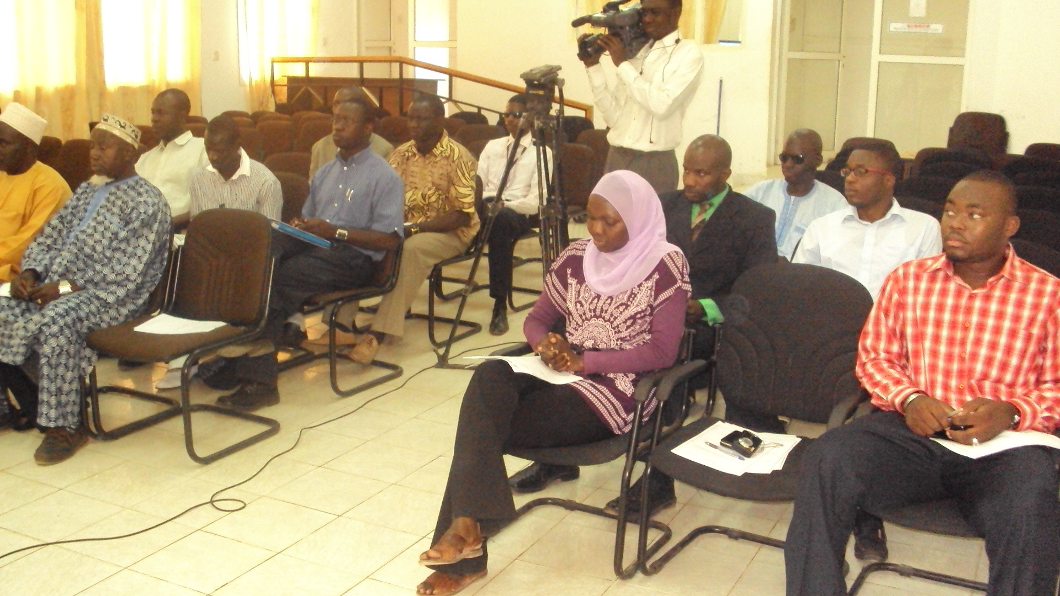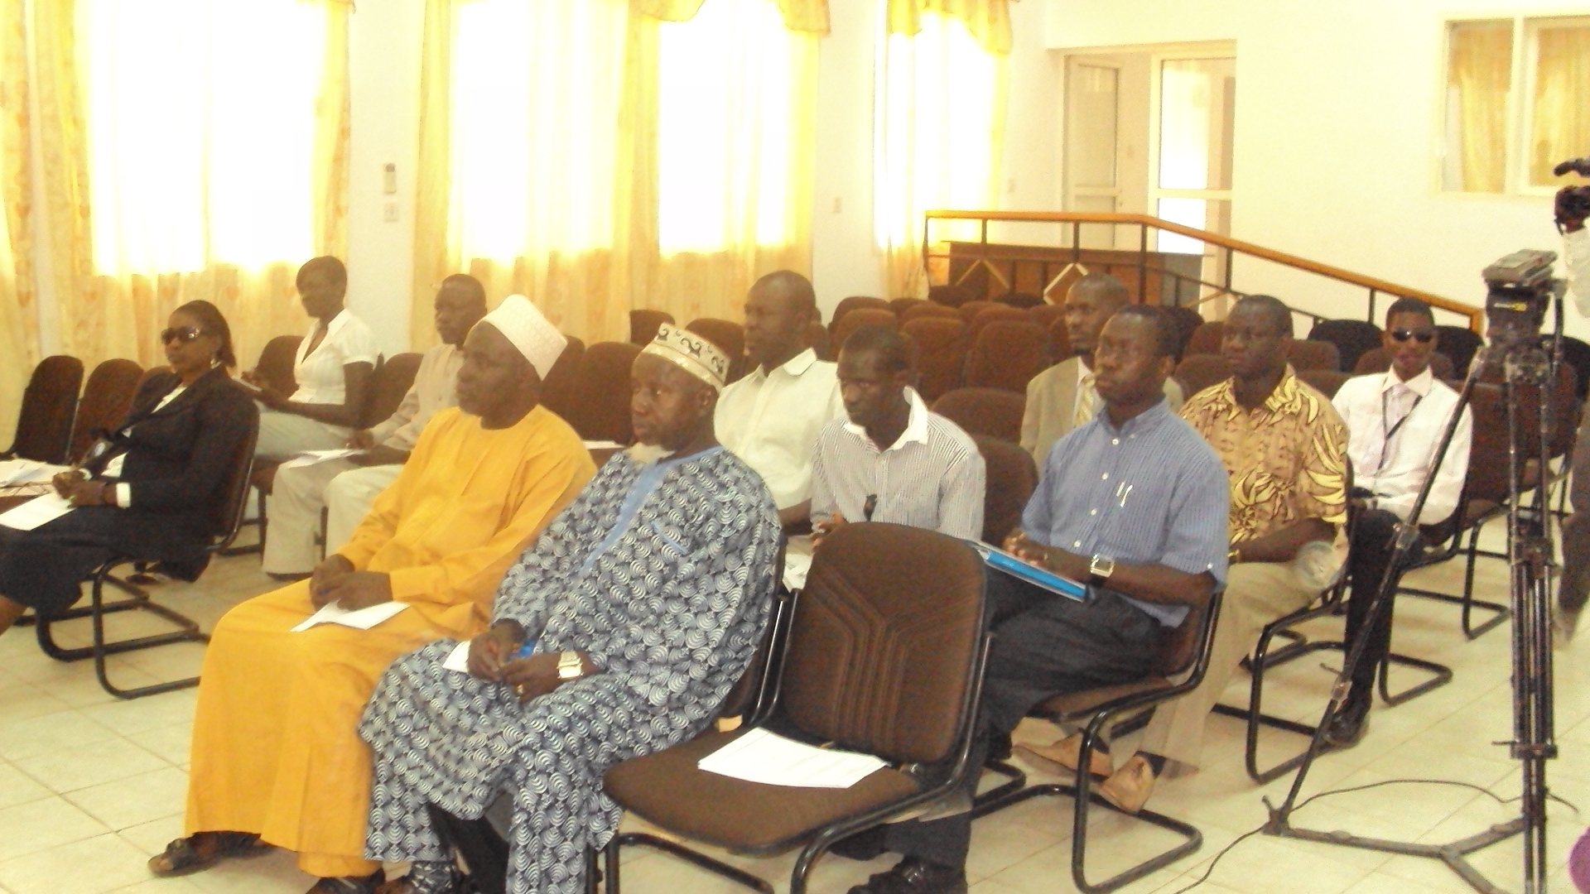
- Day Two:
Day-two presentations continued as on the agenda as thus:
DRR Best Practices from the Sub-Region presented by Mr. Ibrahim Ceesay of CFCO/Global Network on DRR. The first thing he looked at was General Best Practices on DRR:
- Linking policy with practice at community level
- DRR into development - tackling causes of vulnerability
- DRR into relief - using the opportunity created by disaster
- Integration with climate change adaptation
- Strong Institutional Framework for Implementation of DRR Policy
- Community Based DRR
- Need for Multi-stakeholder engagement (government, private sector, civil society) with vulnerable and affected populations and communities on DRR
- Ensure local ownership of the HFA to amplify local voices at grassroots and national level.
- Mobilise communities and civil society through capacity building training programmes and massive awareness campaign activities on DRR. Develop early warning systems and contingency plans by ensuring the pre-positioning or storage of a minimum amount of food and medical supplies/equipment that might be needed by affected communities in case of a disaster.
- Harnessing resources and coherency in disaster management and response by Improved partnerships between the civil society and the government through regular coordination meetings and networking coalitions
- Sharing experience, knowledge, good practice, building alliances and coalitions and networking on disaster reduction
- Empowerment of the poor and marginalised people as part of human and food security
- Mainstreaming gender in disaster and disaster reduction activities
- Promotion of accountability and transparency (primary accountability is to at-risk people and communities)
- Ensure proper use of natural resources to decrease environmental degradation and ensure that construction standards are disaster-resilient
HFA 2: Assess & monitor risks
- Hazard, Vulnerability and Capacity Assessment Tool to assess disaster risk at community level e.g. Gambia and Senegal
- Emphasis on effective warning systems for at risk communities (eg Ghana, Nigeria
- Combination of technology & local warning signs/signals, Ghana and Nigeria.
HFA 3: Knowledge & Awareness
- Participation in ISDR Calendar - “DRR begins in School” (eg Ghana and Ethiopia)
- Use of community radio to enhance local preparedness (eg Burkina Faso)
- Public education campaigns, Street Drama’s (eg Sierra Leone, Senegal)
HFA 4: Underlying risk factors
- Earthquake resistant building design (eg. Kashmir, Indonesia)
- Improving food security (eg Ethiopia, Malawi, Bangladesh)
- Alternative livelihoods plus savings/credit schemes (eg Bangladesh, India)
- Water conservation schemes (eg India, Malawi, Zimbabwe)
HFA 5: Increased Preparedness
- Community-level DM Committees and contingency plans (eg Gambia, Ghana, Togo)
- Linkages of community plans with Govt. measures (eg India)
- Selection & training of local volunteers ( Senegal and Gambia)
- Mobilising resources of local church networks - volunteers, buildings, education (Nigeria)
Networking in DRR
- Views from the Frontline Project in 90 Countries
- Global Network of Civil Society on Disaster Risk Reduction
- Global Network of Media on DRR
- National Platforms on DRR
- Participation in international fora for DRR (GP) and Climate Change (UNFCC)
He ended his presentation by a citation from Michael Secka: (Community Member from Basse – URR)
‘’Hence it is the community that is affected, it’s very important to involve them fully in the activities of DRR and capacitize them on the preparedness and response skills’’
Next on the presenters was Mr. Ebou Faye Njie (DRR) Project Manager Concern Universal, who presented on the topic: Role of Non-State Actors (NSAs) in Disaster Risk Reduction (DRR) Best Practice. Mr. Njie broke his presentation in to sub-headings and deliberated on each comprehensively as thus:
Key Components:
- Governance
- Risk Assessment
- Risk Management
- Knowledge & Education
- Disaster Response and Preparedness
DRR Best Practice:
- Application of Common Standards for Disaster Response to ensure Uniformity, Accountability and Quality
- Mainstreaming DRR in all Organizational and National Development Programmes
- Building on local capacities
- Community participation
- Coordination to reduce duplication of efforts
- Adoption of participatory impact measurement tools and approaches
Role of Non-state Actors (NSAs):
- Sharing of best practice with partner networks (training, mentoring, etc)
- Incorporation of best practices in DRR programmes
- Advocacy (community, partner and govt. Levels)
Role of NSAs: Risk Assessment Participatory Approaches: (Participatory Vulnerability Assessment, Vulnerability and Capacity Assessment, Participatory Rural Assessment, etc)
Role of NSAs: Risk Management:
- Mainstreaming DRR is presented as a ‘win-win’ solution for securing sustainable development, reducing poverty and strengthening hazard resilience.
Role of NSAs: Knowledge and Education:
- Encourage research in different fields of DRR and development (new trends, lessons learnt)
- Engage tertiary educational institutions (e.g. Universities) in research
- Engage Local Communities in Participatory Learning Approaches (Participatory Rural Appraisal, Participatory Vulnerability Assessment, Vulnerability and Capacity Assessment, etc)
Role of NSAs: Disaster Response & Preparedness:
- Response mechanism should factor in local capacities (resources and indigenous knowledge)
- Community Contingency Planning
- Building on and Improving Local Early Warning Systems
The Good Enough Guide: Basic Elements of Accountability:
- Provide public information to beneficiaries and other stakeholders on their organisation, plans, and relief assistance entitlements.
- Conduct ongoing consultation with those assisted
- Establish systematic feedback mechanisms that enable:
- Agencies to report to beneficiaries on project progress and evolution and
- Beneficiaries to explain to agencies the difference the project has made to their lives
- The Sphere Project: Humanitarian Charter and Minimum Standards in Disaster Response
- Core Beliefs: All possible steps should be taken to alleviate human suffering arising out of calamity and conflict and that those affected have a right to life with dignity and therefore a right to assistance.
- High Quality Response
- Accountability
- Partner Capacity Building
- Community Participation
- Adherence to Uniform and International Standards
Advocacy:
- Calibration of Disaster before the next flood seasons
Recommendations:
- Share all relevant information from NDMA with NGOs through TANGO
- Circulation of Contingency Plan to NGOs
- Partnership and Networking between NGOs and Government in DRR
- Coordination of partners at the same area
- Strengthen partnership at Regional level
- NGOs to mainstream DRR in their activities
- National network of NGOs and CSO on DRR
- Strengthening community participation and awareness on DRR
- NGOs share annual work reports and information about their plans and activities
- MOU between NGOs and NDMA on DRR
- NGOs to support NDMA DRR activities in areas where they have comparative advantages (Resources mobilisation and Coordination)
- Non State Actors to compliment NDMA RDMC through joint planning, Annual Work Plan etc
- Annual planning meeting NGOs and NDMA
- Contractor and engineers to factor DRR in their activity implementations

