Please fill out this section only if you are nominating an individual:
Nominee’s name: Not applicabale
Nominee’s address:
Email Nationality:
Date of birth Place of birth:
Sex:
Education:
Present position of nominee:
Current job description of nominee:
Nominee’s previous posts and functions:
Please fill out this section only if:

Please fill out this section only if you are nominating an institution
Institution name: Shri Mata Vaishno Devi Shrine Board (SMVDSB)
Address of headquarters: Chief Executive Officer, Shri Mata Vaishno Devi Shrine Board, Katra, District Reasi, Jammu & Kashmir, India
Address of nominated institution if different from headquarters: same as above
Date of creation of Main fields of activity: 2009
Size Organization structure: 3550 staff
Annual budget and sources of income: 50 million USD/ offerings and donations made by visitors/ pilgrims.
Name and title of chief executive officer: Dr. Mandeep K. Bhandari,
Indian Administrative Service (IAS),
Chief Executive Officer.

For those submitting nominations, please provide your details
Nominator’s name: Venkataram Arabolu
Managing Director, BSI Group India, A 2 The Mira Corporate Suites, Plot 1&2 Ishwar Nagar,
New Delhi 110065, India
Email:venkataram.arabolu@bsigroup.com

Previous posts and functions: (25 years at Det Norske Veritas and 5 years in Simon Carves)
Director at Det Norske Veritas
Regional Manager Middle East, South and South East Asia
General Manager at Det Norske Veritas
Station Manager at Det Norske Veritas
Field Engineer at Det Norske Veritas
Engineer at Simon Carves India

In less than 800 words, please describe the remarkable and innovative effort carried out by the nominee to reduce the impact of disasters and build disaster resilience under the theme “Shaping the Future.”
Background: Located amidst the picturesque Himalayan range is India’s holiest shrine Shri Mata Vaishno Devi in the State of Jammu & Kashmir. Following are the basic statistics:
Height of the Shrine | 5,200feet above sea-level
Total Trekking Area | 22.0 km
Location & State | Trikuta Hills, District Reasi, Jammu & Kashmir State, India.
Management | The Board (SMVDSB) is chaired by the Governor of Jammu & Kashmir, comprising eminent persons who have distinguished themselves in the fields of administration, social work etc. SMVDSB was created in the year 1986. Day to day affairs are managed by Senior Bureaucrat: Chief Executive Officer & his team of officers and employees/ allied agencies (Total strength is around 4000).
Key Agencies | Shrine Board Staff, Central Reserve Police Force, Jammu & Kashmir Police
Total shrine board staff Strength | 2750
Total CRPF + JKP | CRPF-1 battalion (600) & JKP- 2 companies (200)
Staff Strength at the Shrine | 950
Staff Strength at Bhairon Ghatti | 80
Staff Strength at Saanji Chat | 181
Staff Strength at Adhkuwari | 380
Staff Strength Banganga | 350
Staff Strength at Katra Base Station &  Jammu | 809
Modes of Transportation from  Base station to Shrine | Helicopters, Horses, Palanquins, Battery Operated Vehicles between Adhkuwari-Shrine-Adhkuwari (for old & disabled, children)
Total Number of Helicopters & Operators | 04(Helicopters) operated by 2 Operators (Global Vectra Helicorps Ltd. & Himalayan Heli Services Pvt. Ltd.)
Total Number of Horses | Around 7000
Total Number of Battery Cars | 20
Total Number of Palanquins | 150
Types of Natural Disasters | Landslide, Earthquake, Cloud Burst, Forest fires.
Types of Manmade Disasters | Fire, Stampede, Terror Attacks
Number of Pilgrims per day | Average number is 25,000- 30,000
Number of Pilgrims per day on special days | 45,000-50,000

What are the Innovative Efforts to reduce impact of Disasters & build resilience?
Based on the Guiding principles of the DM Act, 2005 & HFA’s since 2009, two pronged approach adopted, and they are : structural & non-structural measures to implement DRR activity at the local level. To begin, a systematic “needs assessment” was conducted on three components:
- Communication
- GIS
- Capacity Building
Methodologies: participant observation and physical verification of sites to understand various requirements.
Challenges:
1. Despite vulnerability to natural hazards, staff lacked in professional training on Basic or Advance Life Skills to handle any emergency situation.
2. Non-conformity to safety codes. For example: No Fire sensors, properly marked evacuation routes.
3. Communication systems were rudimentary. Wireless used by paramilitary personnel. In the 22 km of total Track length(from base camp to Shrine), Point to Point/ Multiple dedicated communication systems were not in place. Real time connectivity was an issue.
4. Hardly any Inventory/ equipment dedicated to meet Disaster situations.
Shaping the Future:
Some of the outcomes spread over four years have been:
-Institutionalized Disaster Risk Management at all levels. The subject of Disaster Management was not taken seriously prior to 2009. Post “Capacity building training” staff realized Basic Life Skills would actually help them directly in their daily lives. For example: use of commonly available material like a wet jute bag to douse small fire, administering Cardio-pulmonary Resuscitation to a pilgrim with cardiac arrest, checking the pulse, carrying an injured to nearest location of medical assistance without any help.

- To ensure sustainability of the Program, dedicated Disaster Management Task Force, in-house
Master Trainers, inventory build-up based on hazards.
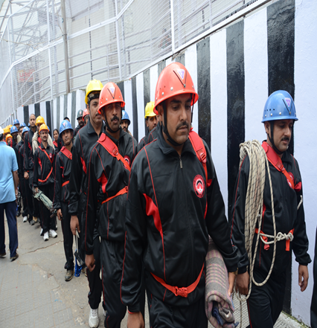
Fig. 1:Disaster Management Task Force
- Reduced Carbon Footprint by replacing florescent & incandescent lamps with Energy efficient lighting system along the entire track using battery operated vehicles instead of fossil-fuel driven cars to bring sustainable growth.
- Building of resilience : The structural measures ensured compliance of safety measures in the old buildings, razing un-safe structures, fire safety measures installed in older building; signage were put up (warning people about landslide prone areas, giving directions, evacuation routes); new buildings abided by the safety codes in terms of seismic strength, fire sensors, firefighting equipment, marking exit routes, slope binding comprising of netting, nailing, afforestation to cover land-slide and shooting stone in vulnerable stretches. Non-structural measures involved: capacity building of all staff on Basic Disaster Management Skills, and training in Advance Life Skills to the members of Disaster Management Task force.

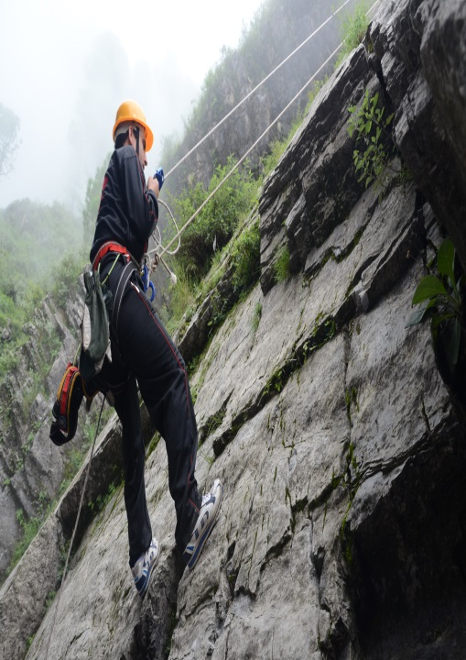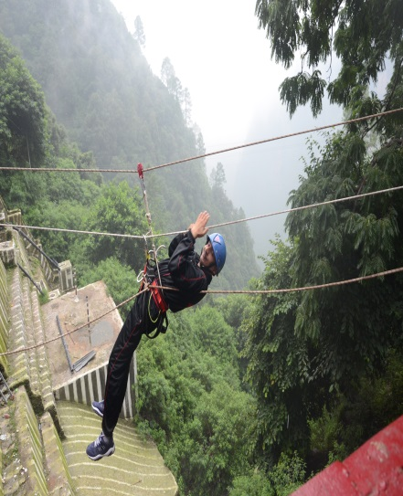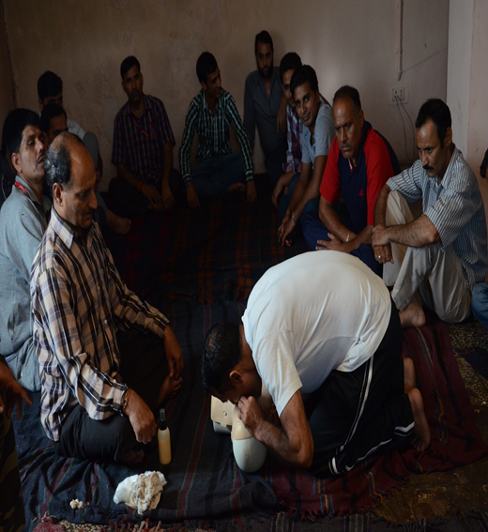
Fig.2 & 3: Advance Training for Task Force & Fig.4: Basic Training on CPR training for all staff

- Integrating DRR activities with Development activities: Focus given on solid waste management, sanitation campaigns, use of treated water from Sewerage Treatment Plants for landscaping etc.to ensure sustainable growth
- Communication system was enhanced for better coordination. Revamped Joint control rooms have robust communication networks, screens for monitoring footage of Closed Circuit Tele-vision cameras at various locations, monitoring of scanners (already existent) to handle the several challenges. Optical Fibre Cable has been spread over the entire track to ensure real time connectivity, faster communication, EPABX telephony etc.
Conclusion:
In September, 2014 the state suffered from incessant rains and consequent floods that left more than 200 people dead, thousands of families/ property affected. However there was NO loss of life & property along the entire track and more than 17,000 stranded people were safely evacuated!
The “capacity building training” brought an “attitudinal change” made the staff self- confident and generated interest on the subject and in the process they were involved in making “their” Disaster Management Plan, Standard Operating Procedures & a dynamic Response System and thereby fulfilling the “mission” of the administration to build resilience and ensure Disaster Risk Reduction activities are sustained lifelong!

In less than 400 words, please describe how the nominee’s work is funded
Shri Mata Vaishno Devi Shrine Board’s funding comes from offering and donations made by the visitors/ pilgrims. This generates an average annual revenue of US $ 50 million, and the organization has a corpus of around US $ 160 million. The entire project has been implemented in phases spread over 4 years within a budget of around 114304.40 USD. The training is completely funded by the Shrine Board and executed by the consulting agency viz. Centre for Disaster Risk Resilience (DRR) (www.cfdrr.com), that comprises of a group of professionals and DRR experts with a mission of bringing “definite change in the lives of the people” and making the entire gamut of DRR activities hands-on and implementable by giving training on: Basic & Advance Life Skills, making implementable plans, Standard Operating Procedures etc.

Over the last few years there has been a steady increase in the number of devotees visiting the Holy Shrine. The month & year wise devotee details is as follows till 2013:

Month | 2006 | 2007 | 2008 | 2009 | 2010 | 2011 | 2012 | 2013
January | 263887 | 292640 | 340303 | 414460 | 399665 | 4,21,231 | 4,59,172 | 4,36,021
February | 255251 | 254674 | 225438 | 297842 | 377217 | 3,69,755 3,92,868 3,49,433 | 3,92,868 | 3,49,433
March | 555042 | 489300 | 618236 | 673820 | 722209 | 7,55,799 | 8,74,468 | 7,87,659
April | 646441 | 584059 | 623841 | 699031 | 878378 | 10,32,316 | 9,61,025 | 10,32,301
May | 731741 | 799079 | 965950 | 815642 | 914522 | 9,37,275 | 12,30,440 | 9,88,051
June | 956368 | 956768 | 1118065 | 1013556 | 966295 | 12,07,688 | 12,62,305 | 12,68,313
July | 717573 | 715259 | 531129 | 909676 | 870615 | 11,75,759 | 12,01,900 | 8,46,693
August | 629734 | 703840 | 271544 | 825311 | 829912 | 10,50,725 | 9,84,441 | 7,66,625
September | 620112 | 756395 | 424838 | 783217 | 628698 | 8,58,876 | 8,77,703 | 8,32,183
October | 646372 | 771337 | 656554 | 764386 | 814617 | 9,17,881 | 9,92,188 | 9,85,432
November | 468201 | 562607 | 506566 | 475069 | 664425 | 6,95,806 | 6,58,581 | 5,62,160
December | 459851 | 531661 | 509759 | 562886 | 682773 | 6,92,536 | 6,00,178 | 468776
Total Number of devotees | 6950573 | 7417619 | 6792223 | 8234896 | 8749326 | 1,01,15,647 | 1,04,95,269 | 93,23,647

The visitor arrival has crossed the annula figure of more than 10 million. Considering the annual revenues being secure, the Shrine Board is ready to undertake projects for ensuring Risk resilience. Therefore, with internal funding coupled with a committed administration, constant up-gradation of skills, inventory built- up, use of new technology, building new safety compliance structures etc. makes it possible to have an overall approach which integrates the development activities with DRR activities and makes them sustainable.

In-case, Shri Mata Vaishno Devi Shrine Board would stand to be awarded, the prize money would be used as “dedicated DRR Fund” that would be used inter-alia for inventory build-up, advance skill trainings, and for better insurance coverage of the Task Force members, which would be highly motivating for them.

