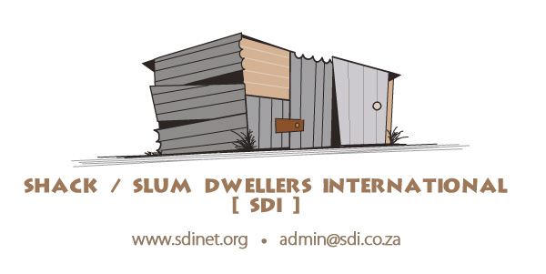

Shack / Slum Dwellers International (SDI)
1st Floor Campground Centre
Corner Raapenberg & Surrey roads,
Mowbray 7800
Cape Town, South Africa
Administrator of the Sasakawa Award
United Nations Office for Disaster Risk Reduction (UNISDR)
Palais des Nations
CH1211
Geneva, Switzerland

Dear Evaluation Committee,

It is with great pleasure that Slum/Shack Dwellers International (SDI) nominates the Philippines Alliance for consideration for the 2015 United Nations Sasakawa Award for Disaster Risk Reduction. The Philippines Alliance is made up of the Homeless People’s Federation Philippines, Inc. (HPFPI), a community-based federation of informal settlement residents, and the Philippine Action for Community-Led Shelter Initiatives, Inc. (PACSII), a non-profit that provides technical support to the federation.

As a global network of community-based organizations of the urban poor in 33 countries, SDI works to advocate and implement programs and policies that put the urban poor at the center of strategies for urban development. Countless examples—from the 2010 Haiti earthquake, to last year’s Typhoon Haiyan in the Philippines—show that informal communities of the urban poor are some of the most badly hit by climate-related disasters. Makeshift housing and insufficient infrastructure leave the poor extremely vulnerable to natural disasters, and lack of data on informal settlements makes post-disaster response in these areas chaotic and ineffective.

Two of the greatest tools for building resilient cities are strong housing infrastructure and accurate data. The Philippines Alliance has shown great leadership and success on both of these accounts. In order to develop sustainable and resilient cities, a critical first step is to have accurate data on what are often the most vulnerable parts of cities. City governments often do not have the data on informal settlements that is necessary for planning strategies for development and improvement. Over its 13 years of operation, the Philippines Alliance has profiled and enumerated over 30 settlements in ten cities in the Philippines. Through the process of profiling and enumerating settlements, the Philippines Alliance helps informal settlement communities collect their own data, which includes counting households, mapping settlements, and developing detailed socio-economic profiles of each settlement. The information gleaned from these settlement profiles is crucial for efforts to upgrade and improve housing and infrastructure, and thus build resilience, for the urban poor.

In in the past year, the Alliance, in partnership with the Iloilo City government, has mapped out 90 structures along the portion of Batiano River in Barangay Boulevard, Molo, using GIS tools. This survey aims to validate the total number of households that will need relocation and rehousing as a result of the ongoing dredging and rehabilitation of the Batiano River. After the processing of data, the Federation will proceed to survey the remaining settlements along the riverbanks until a complete picture of the whole Batiano River is put together.
The Philippines Alliance has also shown great leadership in engaging in risk mitigation through working with communities to improve their housing structures. The Alliance’s recent efforts have focused on helping the urban poor gain access to short-term financing for incremental housing improvement. The urban poor residing in informal settlements are often forced to relocate because of both natural disasters and demolitions of settlements on privately occupied land. Many financing institutions involved in government-sanctioned relocation schemes focus on permanent home construction, a feat which requires a large amount of capital. While permanent home construction is a worthy goal, urban poor families simply do not have the finances necessary to benefit from these financing institutions.

For this reason, the Philippines Alliance has worked to provide short-term, smaller loans for incremental structure improvement. Since 2012, the Philippines Alliance has helped 50 families who are members of the “Baldoza Homeowner’s Association” in Barangay Lanit, Jaro in Iliolo City, secure decent housing in the Lanit Relocation Site through incremental upgrading. This has inspired another community in the 16.2-hectare government-resettlement site in Barangay San Isidro, Jaro to replicate the same approaches, this time adopting a community-led approach to waste management. In order to finance incremental housing improvement, the Philippines Alliance supports the process of community savings, urging the urban poor to pool together resources to fund their own improvement programs.

The Philippines Alliance’s work facilitates the type of cross-sectoral engagement between city authorities, informal settlement residents, academia, and other actors that is necessary in order to move forward with settlement upgrading and disaster risk reduction. One important way the Alliance does this is by facilitating learning exchanges between various stakeholders. Together with the World Bank, the Technical Assistance Movement for People and Environment, Inc. (TAMPEI) and the Social Housing Finance Corporation, the Philippines Alliance recently hosted and facilitated a national learning exchange visit in Iloilo City involving 7 cities from Metro Manila and Davao. The event served as a learning venue for these cities to draw-out replicable strategies for informal settlements upgrading.
The Alliance continuously maximizes the power of learning exchanges to plan, engage and disseminate information, and influence different stakeholders to sustainably address the post-disaster needs of communities. With the onslaught of Typhoon Haiyan, the Alliance saw the need to utilize horizontal learning exchanges to immerse local government units and communities in post-disaster realities, and thus organized field visits and interactions between local government units and communities that have survived past disasters. These were effective in convincing local government authorities to roll out more responsive plans that considered practical inputs from informal settlement communities.
The Philippines Alliance works in a unique space in the Philippines—bringing together urban poor communities and local government units to work jointly to improve the safety, health, and resilience of cities in the face of the increasing threat of climate-related disasters. Their work has helped thousands of vulnerable families improve their housing, livelihoods, and visibility and is breaking ground in the effort to shape inclusive and sustainable cities of the future.

Thank you for your consideration.

Joel Bolnick
Manager, SDI Secretariat

