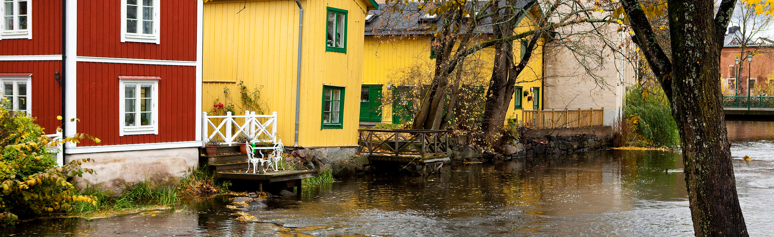

Welcome To a Conference on

Climate Change Adaptation and Disaster Risk Reduction, Making Cities Resilient
Purpose:
♣ strengthen climate change adaptation and disaster risk reduction at the local and county level
♣ raise local interest and participation in the UNISDR campaign "Making Cities Resilient: My City is Getting Ready"
Target Group: Municipal level: planning and building offices, technical offices, county climate adaptation coordinator, emergency rescue services, emergency preparedness coordinator

Organizers: Swedish Association of Local Authorities and Regions and Sweden's National Platform for Disaster Risk Reduction
Date: May 17, 2011, 0900 – 1600 hours
Place: City Hilton Slussen Hotel, Stockholm
and web-broadcasting that enables participation from across the country

Information: janet.edwards@msb.se +46 10 240 5108, + 46 70 686 1022

ProgramME
09.00 - 09.30 | Coffee and Registration
09.30 – 09.50 | Welcome  Ann-Sofie Eriksson, Section Supervisor, Swedish Association of Local Authorities and Regions, SKL  Political Support for Climate Change Adaptation and Disaster Risk Reduction  Peter Nyberg, Chairman of City Planning Committee, Botkyrka Municipality
09.50 – 10.00 | An Overview of Climate Change Adaptation in Sweden at the Municipal Level  Emilie Malmström, SKL
10.00 – 10.15 | The Swedish National Platform for Disaster Risk Reduction  Mette Lindahl Olsson, MSB and Sweden’s ”focal point” for HFA
10.15 – 10.30 | The New Swedish Planning and Building Act of 2011 Regarding Prevention and Mitigation of Natural Disasters  Patrik Faming, The Swedish National Board of Housing, Building and Planning’s representative in the Swedish National Platform
10.30 – 10:50 | Break and fruit
10.50 – 12.00 | Climate Adaptation at the Municipal Level, Case Studies  Anders Pålsson, Fire and Rescue Department, Kristianstad Municipality  Klas Jansson, Planning Director, Karlstad Municipality (UNISDR Resilient City)
12.00 – 13.00 | Lunch
13.00 – 13.40 | International Cooperation  Janet Edwards, MSB  Global Assessment Report: Implementing the HFA and Making Cities Resilient –a worldwide campaign  Maria Hauer, UNISDR-Nairobi
13.40 – 14.10 | Making Cities Resilient – Toward a Local Adaptation Plan for the City of Ancona, Italy  Marco Cardinaletti, Sustainable Development Manager, Environmental and EU Program Sector, Municipality of Ancona, Italy  The Early Warning System of Ancona for managing and reducing landslide risks  Stefano Cardellini, Geologist, Municipality of Ancona, Italy
14.10 – 14.30 | Information Sources for Climate Change Adaptation and Disaster Risk Reduction  Live demonstrations of www sites  The Swedish portal for adaptation to Climate Change  Elin Löwendahl, Core Services, Climate and Air, Swedish Meteorological and Hydrological Institute  PreventionWeb  Maria Hauer, UNISDR
14.30 – 15.00 | Coffee Break
15.00 – 15.15 | Support from the Government for Prevention and Mitigation of Natural Disasters  Margareta Nisser-Larsson, MSB
15:15 – 15:30 | Guidelines for Risk and Vulnerability Analysis  Emma Sjödin, MSB
15.30 – 16.00 | Concluding Discussion
 | 

