REPUBLIC OF NAMIBIA
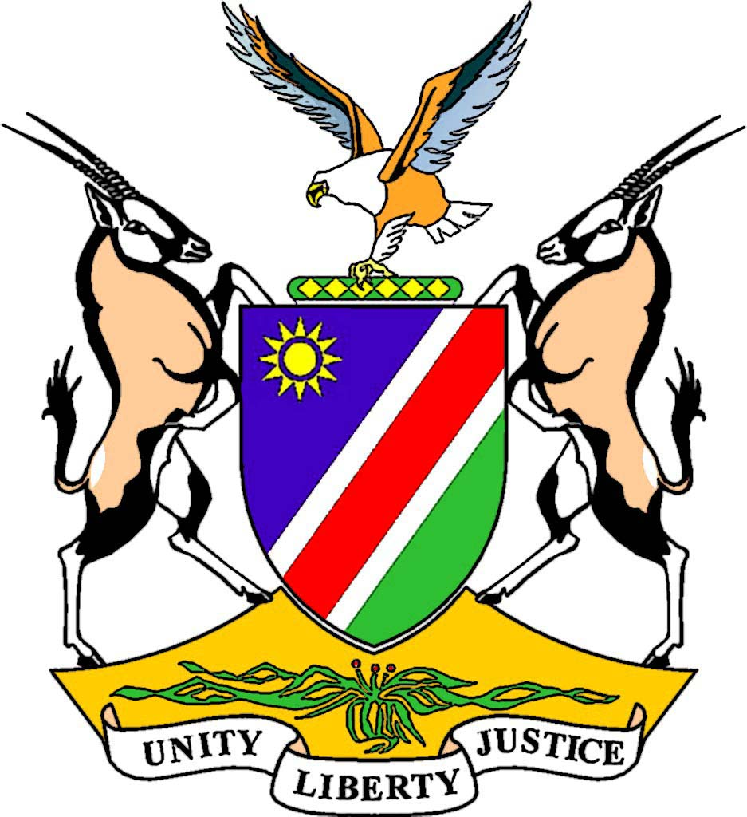

Remarks by Honourable Marco M. Hausiku, MP Deputy Prime Minister of the Republic of Namibia
On
The Occasion of the Fourth Session of the Global Platform for Disaster Risk Reduction, 19-23 May 2013

22 May 2013

Geneva - Switzer land
Mr. President,
Your Excellency’s,
Distinguished Delegates,
Ladies and Gentlemen,
It is my singular honour and privilege to address the Fourth Session of the Global Platform for Disaster Risk Reduction.
Firstly I would like to express on behalf of the Namibian delegation, our gratitude and appreciations to the Government of Switzerland and its people for having agreed to host this conference and making it possible for us to be here.
Secondly, I would like to thank the conference organizers for organizing such a wonderful conference and selecting a proper theme for this conference “Invest Today for a Safer Tomorrow”. It is not only the theme, which is relevant, but the topics too. Hence, organizers should be commended.
Excellency’s, Distinguished Delegates, Ladies and Gentlemen,
Different types of disasters, are on the increase in the world, and none of us can say, this will not happen to me or my country. Yes, no one is immune to these disasters.
Lives are being lost, properties and environment are damaged or destroyed, and developmental gains are reversed or delayed.
Causes for the known disasters are linked to human activities such as industrialization that has a strong link to climate change. Ways of living such as, un-planed urbanization and rural settlements, poverty, declining ecosystems and HIV/AIDS, influences the impacts of disasters in our countries and communities. Hence, the need to address the causes, with more comprehensive and appropriate tools.
In 2005, 168 countries of the world adopted an international guideline called Hyogo Framework for Action, to guide state actions in addressing the impacts of disasters. Namibia participated at the occasion that adopted the Hyogo Framework for Action, and resolved to implement the provision thereof, to the best of our ability.
Namibia established a national structure, dealing with disaster issues under the Office of the Prime Minister, supervised by the Deputy Prime Minster of the Republic of Namibia.
This structure is replicated at all levels of our administration (national, regional and local, including traditional authorities). Key role players are government, None-Governmental organizations, Community and Faith- Based Organizations, private sectors as well as the international community.
The structure is fully funded by the government. However, some projects such as training and research are supported by our development partners through bi-lateral or multilateral arrangements. The contributions made through the United Nation country office, and diplomatic missions in Namibia are huge and highly appreciated.
Likewise, we managed to develop a National Policy on Disaster Risk Management, passed the Disaster Risk Management Act, (Act No. 2 of 2012) and a number of operational plans and procedure manuals. In short, Namibia did well in terms of “Key Performance Area1” and “Key Performance Area2” of Hyogo Framework of Action 2005-2015.
Namibia achieved little regards “Key Performance Area3” that calls for the reduction on the underlying risk and vulnerability factors by improving risk management applications, due to socio-economic reasons such as, under development, un-employment, poverty, diseases and economic disparity, among members of our societies. However, efforts are being made for some of those factors to be addressed through the implementation of the Millennium Development Goals (MDGs).
We have done our best to address Key Performance Area 4 that deals with the strengthening of disaster preparedness, for effective emergency response and recovery practice at all levels. A number of hazard based contingency plans or multi-hazard contingency plans have been developed as well as providing training for government and non-governmental personnel. Nevertheless, effective implementation of such plans is a bit challenging in a society like ours.
Namibia is faced with a challenge in implementing activities regards key performance Area5, especially the integration of disasters risk reduction into schools, and learning institutions curricula, researches and community-based disaster Training programmes.
We urge that issues of capacity enhancement should form the basis of the new guidelines. Emphasis should be put on institutional capacity building, such as Regional Economic Blocks, National Learning or Training Institutions as well as research institutions.
Furthermore, a link between climate change, disaster risk reduction and development was clearly established during the implementation of Hyogo Framework of Action 2005-2015. Thus, the effective way of dealing with these two issues is to integrate climate change and disaster risk reduction into National and sector development plans.
Namibia would like to urge, for a new framework which will enjoy full political, public and community support.
I THANK YOU
I THANK YOU.

