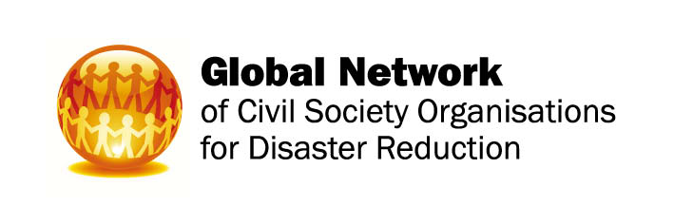 | GNDR  100 Church Road  Teddington  Middlesex TW11 8QE  UK

Fourth Global Platform for Disaster Risk Reduction: draft official statement

Mr Chairman, distinguished delegates

95% of people killed by disasters are in developing countries so it is in these countries that the HFA most needs to have an impact.
Since 2009 The Global Network for Disaster Reduction has researched perspectives on disaster risk governance from affected communities, local authorities and civil society organisations in low and middle-income countries. GNDR provides an independent overview of progress towards the implementation of the HFA at a local level. Over 20,000 people in 57 countries responded to GNDR’s 2013 Views from the Frontline survey – the latest in a programme that started in 2008. From extensive consultation with civil society, and VFL report research, we have developed recommendations for the HFA2.

We are calling on delegates here to support development of a holistic framework that reflects and impacts on local realities, prioritises the poorest and most marginalised, and recognises the role that inequality and power imbalances play in increasing vulnerability.
The VFL Report has shown that the majority of disaster losses result from small-scale recurrent ‘everyday’ disasters that hit homes and communities all over the world repeatedly. Because these don’t attract emergency relief, it is down to communities to deal with them themselves. Disasters disproportionately affect poorer countries with weaker governance and it is the poorest communities who most feel that disaster losses are increasing.

Besides the threat of natural disasters, the World Bank has reported that conflict, insecurity and fragility affect one in four people on the planet. It is no coincidence that over half of people affected by disasters live in fragile and conflict-affected countries.
Because state institutions are weak in low-income countries, the majority of poor people in these countries have little choice but to assume primary responsibility for the protection of their lives, livelihoods and assets from everyday natural and human induced disasters. The risks that the poorest face are not experienced separately so an effective DRM framework must reflect the local reality of multiple simultaneous risks. We need to break out of taking a siloed approach to development, climate change, conflict and natural disasters.
It is widely recognized that states struggle in promoting integrated, multi-sectoral strategies as agencies and ministries sometimes compete rather than cooperate.
Only when the diverse interventions in development aid are connected in a strategic manner can they be effective in making a difference to the implementation of the HFA.
The introduction of a common resilience framework, as a successor to the HFA, that promotes harmonization of laws and frameworks would be an important step towards achieving greater coherence between policy approaches. We also need inclusive, accountable and responsive states working in partnership with communities as this is essential to reducing the vulnerability of the poorest.

A clear indicator of a lack of political commitment currently is that less than 1% of development aid has been spent on DRR over the last decade. A ‘rights-based’ approach that puts responsibilities and accountabilities at the core of the framework is needed to incentivise efforts both to develop coherent policies that reflect local realities, and increase investment. Accountability mechanisms are essential to hold duty bearers to account. The HFA2 should put the relationship between people as rights holders and governments as primary duty bearers at the centre of the framework.

To support this, performance standards, targets, baselines and indicators to measure progress at all levels are needed to drive improved policy coordination and investment in DRR. Further, progress against goals and targets can only be measured effectively by establishing transparent independent and impartial monitoring systems.

Though these requests imply a rethink of global DRR governance, we are calling on delegates here to support them because unless we take a transformational approach to the HFA there is little chance of achieving its expected outcome of a ‘substantial reduction of disaster losses’. Global governance frameworks have a great capacity to catalyze change at a national and local level but the existing DRR framework has achieved little in relation to those who are suffering the greatest losses. As climate change, dynamic changes like urbanization and growing inequality in wealth continue to exacerbate the vulnerability of the poorest, the post 2015 DRR framework has the potential to provide a powerful counterweight to their impact.

