REPORT OF THE TWO DAY WORKSHOP ORGANISED BY THE NATIONAL DISASTER MANAGEMENT AGENCY (NDMA) FOR THE MEDIA AND SECURITY SERVICES INCLUDING THE PRIVATE SECURITY ON DISASTER RISK REDUCTION (DRR) ADVOCACY
BAOBAB HOLIDAY RESORT
10TH – 11TH FEBRURAY 2011
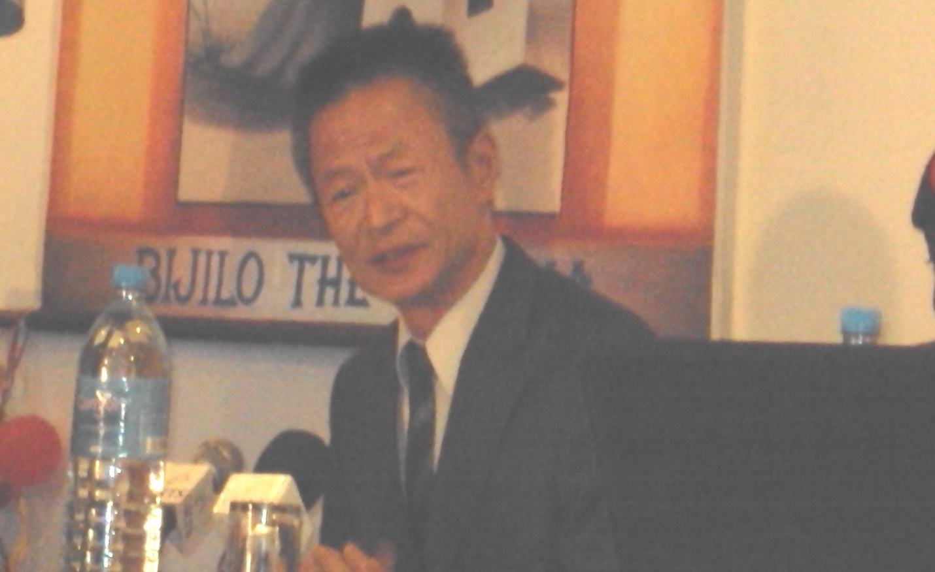
Funded by the Taiwanese Embassy
- Background:
The National Disaster Management Agency (NDMA) organized an Advocacy Training Workshop on Disaster Risk Reduction (DRR) for the Media and Security Services including the Private Security from February 10th to 11th at the Baobab Holiday Restored. The fund for the training was provided by the Government of The Republic of China on Taiwan.
- Objectives:
The main objective of the training workshop was to enhance the capacities of the media and security services on Disaster Risk Reduction through training on advocacy planning, monitoring, evaluation and reporting system.
The workshop provided the opportunity for the resource persons and participants alike to share and discuss on the following topics:
- The Hyogo Framework for Action (HFA)and other regional Frameworks
- Mainstreaming DRR into Development
- Disaster Risk Reduction and Climate Change Adaptation- the link
- Linking DRR to PRSP, Gambia’s Vision 2020, MDGs and UNDAF
- DRR Best Practices from the Sub-Region
- Role of Government and None State Actors on DRR Best Practices
- Overview of the NDMA Policy.

- Attached list of participant as Annex:

- Day One:
Opening Ceremony:
The workshop commenced with an opening ceremony with remarks by the Executive Director NDMA, the Chairperson of the National Platform for Disaster Risk Reduction, the CDS Gambia Arm Forces, and the representative of the Ambassador of the Republic of China on Taiwan.
In his welcoming remarks, Mr. Essa Khan the Executive Director National Disaster Management Agency NDMA thanked everyone for their response to this important national call which he said will go a long way in facilitating a more robust collaboration and partnership in the NDMA’s DRR advocacy. According to Mr. Khan Disaster is a cross-cutting development issue that calls for concerted efforts for any meaningful impact. He thanked the Embassy of China on Taiwan for funding this programme among others.
For his part the chairperson of the National Platform for Disaster Risk Reduction in The Gambia Mr. Albert Cox emphasized on the importance of the workshop and added that the advocacy could not have come at a better time than this and advised that participants to take the workshop seriously as no one is too old to learn.
The Chief of Defense of The Gambia Arm Forces Lieutenant General Masanneh Kinteh expressed his happiness to attend such an important forum. Kinteh told the gathering that the Arm Forces have a constitutional mandate to protect lives and the integrity of the state and hence they are ready at all times to render services to the people in times of need. He further went on to say that due to climate change and other environmental effects the Armed Forces is aware of their responsibilities to protect lives and save guide the environment at all times.
The representative of His Excellency the Ambassador of the Republic of China on Taiwan in The Gambia Mr. Herman T.C. Chiu Deputy Ambassador expressed his embassy’s pleasure to fund such an important activity. According to him looking at the nature, complexity and frequencies of both natural and manmade disasters, it is prudent for the risk associated with hazards around us to be neutralized were possible or reduced minimal level to reduce their impacts when they strike. According to him the Taiwanese Embassy will at all times give a helping hand to the NDMA to enable the government realize a steady sustainable development that would not be hampered by disasters. The diplomat thanked the participants and organizers for their commitment to the welfare of the Gambian people.
The opening speech was delivered by the Permanent Secretary Office of the Vice President Mr. Lamin Nybally. In his speech, Permanent Secretary, Nybally highlighted that in the past years and 2010 as a reference, all regions in the country were affected by various kinds of disasters and floods in particular causing uncountable agony to human life, field crops, livestock, and the environment alike. It’s in this regard that the NDMA and NDMC solicited funds from the Republic of China on Taiwan for institutional strengthening as a strategy for Disaster Risk Reduction.
He also stressed that as disasters cut across all areas of activity of Government, NGOs, private sectors and Civil Society Organizations, the NDMA is to engage all stakeholders in its advocacy drive on Disaster Risk Reduction as a means to reaching them and ultimately to the communities to ensure that they are fully equipped and involved in DRR enabling them to anticipate and respond to disasters.
This approach of NDMA according to him will bring a multi-stakeholder participatory approach at all levels and will integrate DRR in sustainable development policies and planning in order to promote a transparent, systematic and consistent approach to disaster risk assessment and management system. “Therefore all of the institutions present are indeed very relevant either as advocates and /or as partners in prevention and effective response. The PS told the gathering that emphasis now is shifted away from managing crisis to managing risk, as disaster response” and crisis management are in the long run unsustainable due to dwindling global resources precipitated by the credit crunch, global instability etc. He finally expressed the urgent need to incorporate DRR and CCA in our development agenda (sectoral Policies, PRSP, MDGs) if we are to achieve sustainable development. He thanked the Taiwanese Embassy and NDMA for their foresight and declared the workshop opened by wishing participants fruitful deliberations. Picture below was the opening ceremony
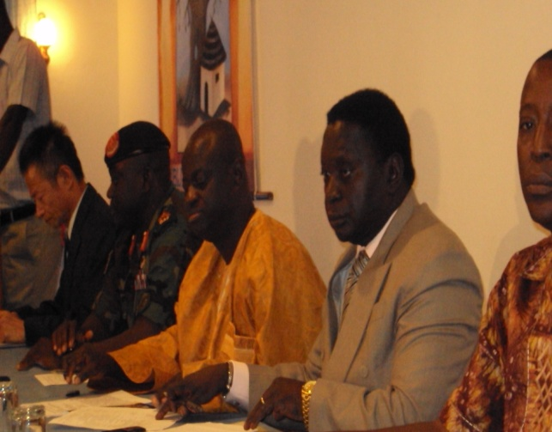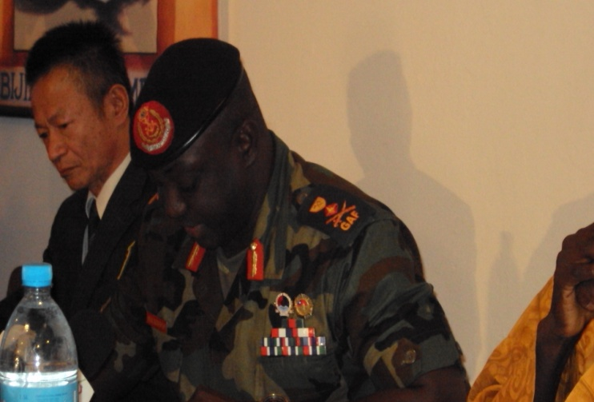
Following the opening ceremony, presentations were made in line with the agenda as thus:
The first presenter was Mr. Ibrahim Ceesay of CFCO/Global Network on DRR who presented on the topic The Hyogo Framework for Action (HFA) and other regional Frameworks. Mr. Ceesay talked on the background and history of the HFA, the birth of the HFA; that The World Conference on Disaster Reduction was held from 18 to 22 January 2005 in Kobe, Hyogo, Japan which gave birth to the Hyogo Framework for Action (HFA). According to him 168 Member States of the United Nations adopted the HFA which is a key framework for implementing disaster risk reduction within the overall goal of building the resilience of nations and communities to disasters.
He went on to discuss the expected outcome of the HFA which he said aims to achieve a substantial reduction of disaster losses by 2015 – both in lives, and in the social, economic, and environmental assets of communities and countries. He also elaborated on the strategic goals of the HFA which included;
- The integration of disaster risk reduction into sustainable development policies and planning
- Development and strengthening of institutions, mechanisms and capacities to build resilience to hazards
- The systematic incorporation of risk reduction approaches into the implementation of emergency preparedness, response and recovery programmes.

He went on to look at the five main priority strategic areas of the HFA which are:
- Governance
- Risk Assessment, Monitoring and Warning
- Knowledge and Education
- Underlying Risk Factors
- Disaster preparedness and response
Each of these areas were discussed at length with the participants. This was followed by a discussion on the HFA Cross Cutting Issues which according to Ceesay includes: Multi-hazard approach, Gender perspective and cultural diversity, Community and volunteers’ participation and Capacity building & technology Transfer.
Collaboration and cooperation are crucial to disaster risk reduction: states, regional organizations and institutions, and international organizations all have a role to play. Civil society, including volunteers and community-based organizations, the scientific community, the media, and the private sector, are all vital stakeholders in the implementation of the HFA. Each of the mentioned stakeholders’ responsibilities was clearly discussed.
Ceesay went on to look at The International Strategy for Disaster Reduction (ISDR) which he said was adopted, as a follow-up to the International Decade on Natural Disaster Reduction (IDNDR) 1990-1999 by the Member States of the United Nations in 2000. This strategy aims to achieve substantive reduction of disaster losses and build resilient communities and nations, as an essential condition for sustainable development.
This was followed by the discussion on the Africa Regional Strategy for Disaster Risk Reduction. The Strategy was adopted by African Ministers at the 10th Meeting of the African Ministerial Conference on the Environment (AMCEN) from 26-30 June 2004 and submitted to the AU Assembly Summit, where the Strategy was positively adopted by Heads of State at the 3rd Ordinary Session of the Assembly in Addis Ababa, Ethiopia, from 6-8 July 2004, with a call to develop a Programme of Action for its implementation due to the fact that development was at risk from disasters mainly because of gaps in the following areas: institutional frameworks; risk identification; knowledge management; governance; and emergency response.
The aim of the Strategy is to contribute to the attainment of sustainable development and poverty eradication by facilitating the integration of disaster risk reduction into development and its strategy objectives are:
(1) Increase political commitment to disaster risk reduction;
(2) Improve identification and assessment of disaster risks;
(3) Enhance knowledge management for disaster risk reduction;
(4) Increase public awareness of disaster risk reduction;
(5) Improve governance of disaster risk reduction institutions; and
(6) Integrate disaster risk reduction in emergency response management.
Ceesay went on to look at the ECOWAS POLICY FOR DISASTER RISK REDUCTION ITS VISION POLICY STATEMENT AND OBJECTIVES. In conclusion, Mr. Ceesay had these two statements’ (wise words) for the participants:
- Disasters are no longer seen as extreme events, created entirely by natural forces, but as manifestations of unresolved problems of development.
- Governments and communities will benefit by understanding that disaster risk reduction policy is a wise investment and not an option, but a must.
This presentation was followed by that of Mr. Abdou B. Touray a National consultant who deliberated on the topics: Mainstreaming DRR into Development and Linking DRR to PRSP, Gambia’s Vision 2020, MDGs and UNDAF.
He discussed at length with the participants looking at the following terms PRSP, MDGs and UNDAF. Thus PRSPs Poverty Reduction Strategy Papers are at the heart of a new anti-poverty framework announced late in 1999 by the World Bank and International Monetary Fund (IMF). The PRSPs according to Touray are developed through a participatory manner and they should be: Country – driven, result –oriented, comprehensive, and Long-term in approach, based on partnership. UNDAF the United Nations Development Assistance Framework is a synthesis document that culminates all the interventions of the United Nations Agencies in the country. It outlined what each agency planned to do during the period 2007-2011. UNDAF is not a standalone framework but based on what the UN family can contribute to the national development plan which is the Poverty Reduction Strategy Paper with each agency focusing on areas of comparative advantage.
Why the Mainstreaming DRR into PRSP and UNDAF. According to him Mainstreaming is the process of taking on-board an issue as an integral part of something. In recent times development management calls for the integration of all crosscutting issues (things that go beyond a sectoral matter) in all sectoral and regional policies and strategies. Such crosscutting issues include; gender, environment, HIV-AIDS, disaster etc.
DRR is multi-sectoral and must be central for any sustainable development and poverty reduction. The link between poverty, environment and DRR has become prominent in recent years and that adopting single theme is no longer a viable option of promoting economic development and reducing poverty. Hence DRR issues should be incorporated in all national socio-economic endeavors or otherwise it can wipe out all economic gains and ultimately lead to heavy costs on recovery places heavy cost on recovery.
Essential of Sectoral Mainstreaming of DRR: Mainstreaming enables multi-sectoral and multi-stakeholder responses for ensuring integration of plans, resources and programme issues. Mainstreaming DRR stimulates the much needed action and promotes a programmatic approach to integration, so that sector programmes incorporate DRR relevant actions in their regular and institutional budget cycles and capacity building.
Mainstreaming DRR for whom and by whom: Policy-Makers, Planners and programming personnels, Development partners, DRR focal points at sectoral levels, Media, Private sector, Trade unions, NGOs, CSOs, and community –based Organizations, Decentralized structures/ authorities.
Mr. Touray went to look at How to mainstream DRR into PRSP and UNDAF
- A shared vision and institutional commitment to DRR action serves as a critical starting point for mainstreaming
- For change to happen, we need change agents, or people willing to champion a cause and who can inspire others to be become involved. (Look for committed and passionate individuals and groups and or organizations.)
- Create National awareness on disaster issues
- Choose an entry point for mainstreaming and identify a champion (planning units, religious forum, media, use of theme such as poverty reduction, gender, food security, climate change etc.
- Build capacity of critical masses particularly of planning units at central and local levels
- Establish DRR focal points in all sectors(focal points often have little influence, it is therefore important to involve people in higher levels, policy-makers, sector development partners, budget officers and human resource officers.)
- Create solid data and knowledge base for evidence based disaster planning
Next on his discussion was the Role of the Media and Security Services. According to him the media can play a crucial role in promoting and advocating for mainstreaming disaster risk reduction in all national actions at the individual, community, regional and central levels. The key role of the media is to educate and inform the population and therefore a key catalyst in promoting transparent and sustainable development.
For the security service who are responsible for the maintenance of peace, public order and security of the country, ensuring disaster risk reduction forms an integral part of overall peace building in the country. This means the entire security forces need to be sensitized and abreast with disaster risk matters at all times so that an effective role in mitigating, and preparedness can be ensured. The security forces are one of the most importance institutions whose actions are needed immediately when disasters occur.
Mr. Touray’s Key Message:
Disasters are unavoidable completely but can be greatly reduced and if they happen with adequate preparedness, the repercussion can be minimized and therefore the needs for multi-sectoral approach to disaster risk reduction. No one group of stakeholders can do everything, but everyone can, and must, do something therefore everybody must take on board disaster risk reduction issues in whatever we do.
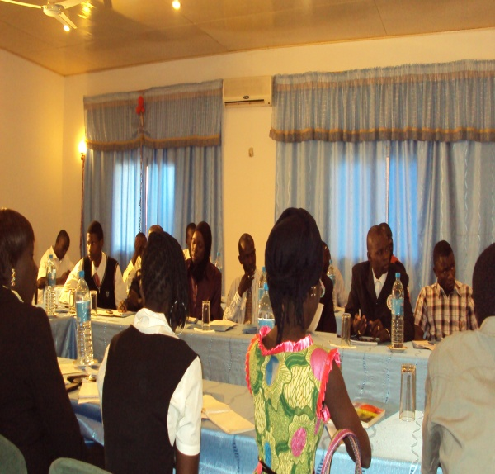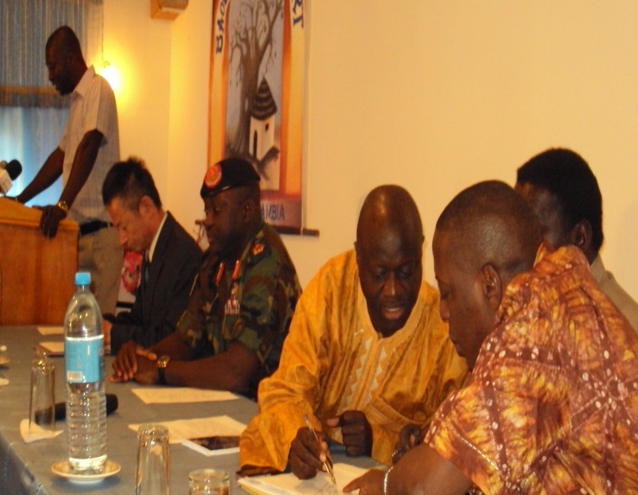
Day one participants from the media and security personnel and the high table
- Day Two:
Day-two presentations continued as on the agenda as thus:
DRR Best Practices from the Sub-Region presented by Mr. Ibrahim Ceesay of CFCO/Global Network on DRR. The first thing he looked at was General Best Practices no DRR:
- Linking policy with practice at community level
- DRR into development - tackling causes of vulnerability
- DRR into relief - using the opportunity created by disaster
- Integration with climate change adaptation
- Strong Institutional Framework for Implementation of DRR Policy
- Community Based DRR
- Need for Multi-stakeholder engagement (government, private sector, civil society) with vulnerable and affected populations and communities on DRR
- Ensure local ownership of the HFA to amplify local voices at grassroots and national level.
- Mobilise communities and civil society through capacity building training programmes and massive awareness campaign activities on DRR. Develop early warning systems and contingency plans by ensuring the pre-positioning or storage of a minimum amount of food and medical supplies/equipment that might be needed by affected communities in case of a disaster.
- Harnessing resources and coherency in disaster management and response by Improved partnerships between the civil society and the government through regular coordination meetings and networking coalitions
- Sharing experience, knowledge, good practice, building alliances and coalitions and networking on disaster reduction
- Empowerment of the poor and marginalised people as part of human and food security
- Mainstreaming gender in disaster and disaster reduction activities
- Promotion of accountability and transparency (primary accountability is to at-risk people and communities)
- Ensure proper use of natural resources to decrease environmental degradation and ensure that construction standards are disaster-resilient
HFA 2: Assess & monitor risks
- Hazard Vulnerability and Capacity Assessment Tool to assess disaster risk at community level e.g. Gambia and Senegal
- Emphasis on effective warning systems for at risk communities (eg Ghana, Nigeria
- Combination of technology & local warning signs/signals, Ghana and Nigeria.
HFA 3: Knowledge & Awareness
- Participation in ISDR Calendar - “DRR begins in School” (eg Ghana and Ethiopia)
- Use of community radio to enhance local preparedness (eg Burkina Faso)
- Public education campaigns Street Drama’s (eg Sierra Leone, Senegal)
HFA 4: Underlying risk factors
- Earthquake resistant building design (eg. Kashmir, Indonesia)
- Improving food security (eg Ethiopia, Malawi, Bangladesh)
- Alternative livelihoods plus savings/credit schemes (eg Bangladesh, India)
- Water conservation schemes (eg India, Malawi, Zimbabwe)
HFA 5: Increased Preparedness
- Community-level DM Committees and contingency plans (eg Gambia, Ghana, Togo)
- Linkages of community plans with Govt. measures (eg India)
- Selection & training of local volunteers ( Senegal and Gambia)
- Mobilising resources of local church networks - volunteers, buildings, education (Nigeria)
Networking in DRR
- Views from the Frontline Project in 90 Countries
- Global Network of Civil Society on Disaster Risk Reduction
- Global Network of Media on DRR
- National Platforms on DRR
- Participation in international fora for DRR (GP) and Climate Change (UNFCC)
He ended his presentation by a citation from Michael Secka:
‘’Hence it is the community that is affected, it’s very important to involve them fully in the activities of DRR and capacitize them on the preparedness and response skills’’
Next on the presenters was Mr. Ebou Faye Njie (DRR) Project Manager Concern Universal, who presented on the topic: Role of Non-State Actors (NSAs) in Disaster Risk Reduction (DRR) Best Practice. Mr. Njie broke his presentation in to sub-headings and deliberated on each comprehensively as thus:
Key Components:
- Governance
- Risk Assessment
- Risk Management
- Knowledge & Education
- Disaster Response and Preparedness
DRR Best Practice:
- Application of Common Standards for Disaster Response to ensure Uniformity, Accountability and Quality
- Mainstreaming DRR in all Organizational and National Development Programmes
- Building on local capacities
- Community participation
- Coordination to reduce duplication of efforts
- Adoption of participatory impact measurement tools and approaches
Role of Non-state Actors (NSAs):
- Sharing of best practice with partner networks (training, mentoring, etc)
- Incorporation of best practices in DRR programmes
- Advocacy (community, partner and govt. Levels)
Role of NSAs: Risk Assessment Participatory Approaches: (Participatory Vulnerability Assessment, Vulnerability and Capacity Assessment, Participatory Rural Assessment, etc)
Role of NSAs: Risk Management:
- Mainstreaming DRR is presented as a ‘win-win’ solution for securing sustainable development, reducing poverty and strengthening hazard resilience.
Role of NSAs: Knowledge and Education:
- Encourage research in different fields of DRR and development (new trends, lessons learnt)
- Engage tertiary educational institutions (e.g. Universities) in research
- Engage Local Communities in Participatory Learning Approaches (Participatory Rural Appraisal, Participatory Vulnerability Assessment, Vulnerability and Capacity Assessment, etc)
Role of NSAs: Disaster Response & Preparedness:
- Response mechanism should factor in local capacities (resources and indigenous knowledge)
- Community Contingency Planning
- Building on and Improving Local Early Warning Systems
The Good Enough Guide: Basic Elements of Accountability:
- Provide public information to beneficiaries and other stakeholders on their organisation, its plans, and relief assistance entitlements.
- Conduct ongoing consultation with those assisted
- Establish systematic feedback mechanisms that enable:
- Agencies to report to beneficiaries on project progress and evolution and
- Beneficiaries to explain to agencies the difference the project has made to their lives
- The Sphere Project: Humanitarian Charter and Minimum Standards in Disaster Response
- Core Beliefs: All possible steps should be taken to alleviate human suffering arising out of calamity and conflict and that those affected have a right to life with dignity and therefore a right to assistance.
Conclusion:
- High Quality Response
- Accountability
- Partner Capacity Building
- Community Participation
- Adherence to Uniform and International Standards
Advocacy:
- Calibration of Disaster before the next flood seasons
Recommendations:
- The security heads should create a special unit for DRR
- The police to be more involved
- A desk – officer in NDMA on health & safety on DRR
- Involve private media in international fora
- NDMA to involve Ministry of Finance to revisit the insurance Act (legal Framework)
- NDMA to organise more capacity building for the media and the security services
- Strengthening community sensitisation
- Incorporating DRR in school curriculum
- Accreditation for the media during disaster
- Establish a National Advocacy Network
- Fully involve the private securities
- Conduct research on DRR by involving the University
- Train journalists on responsible disaster reporting
- Development of advocacy strategy on DRR
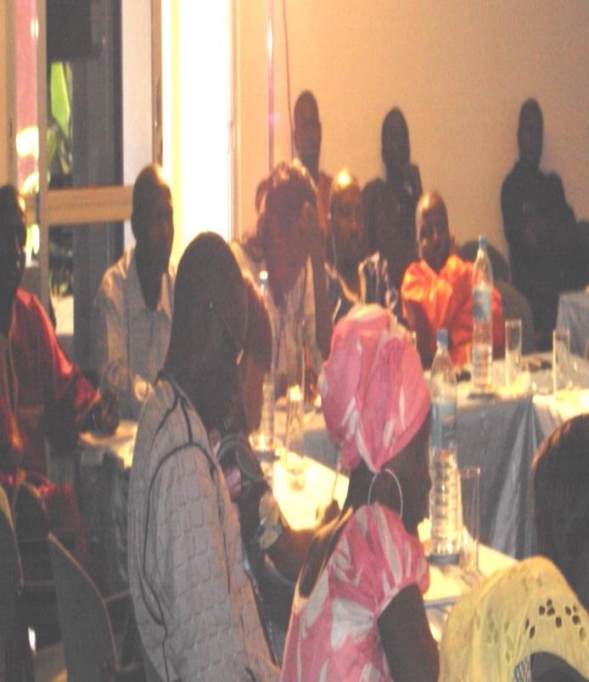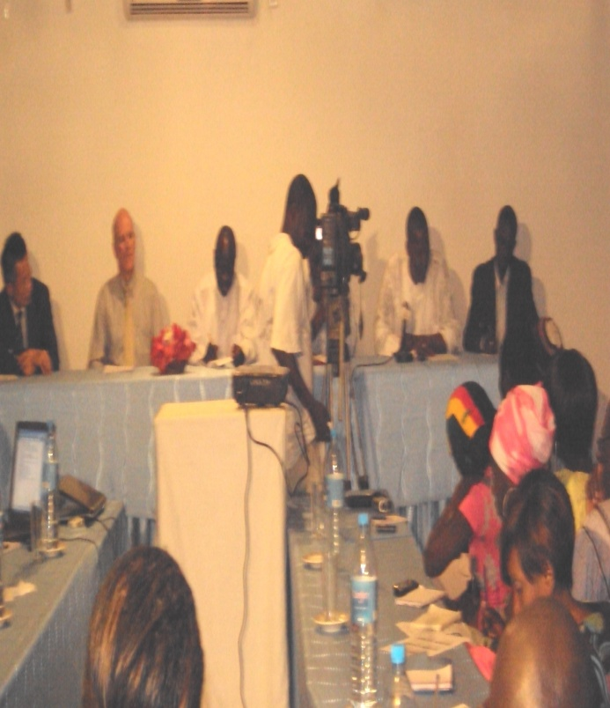
Day two closing ceremony (participants and the high table)
Conclusion
Permanent Secretary Nyabally stressed that as disasters cut across all areas of activity of Government, NGOs, private sectors and Civil Society Organizations, the NDMA is to engage all stakeholders in its advocacy drive on Disaster Risk Reduction as a means to reaching them and ultimately to the communities to ensure that they are fully equipped and involved in DRR enabling them to anticipate and respond to disasters.

All institutions are indeed very relevant either as advocates and/or as partners in prevention and effective response. Journalist should be on the crusade in the creation of awareness at all levels and as critical champions and entry points for mainstreaming DRR in development.

For his part, Deputy Ambassador of the Republic of China on Taiwan in The Gambia Mr. Herman T.C. Chiu indicate that the Taiwanese Embassy is willing to give a helping hand to the NDMA to enable the government realize a steady sustainable development that would not be hampered by disasters. The diplomat thanked the participants and organizers for their commitment to the welfare of the Gambian people.

The Executive Director, National Disaster Management Agency thanked the Taiwanese Embassy for their timely gesture for the implementation of DRR advocacy campaign to relevant stakeholders to make their cities, towns, and communities, resilient by putting in place the needed organization, and coordination, to understand and reduce, disaster risk, based on the participation of citizen groups, and civil society and to build local strategic alliances; ensure that all Departments understand their role in disaster reduction, and preparedness, including during Emergency situations.

