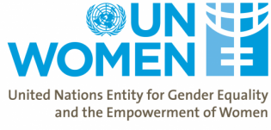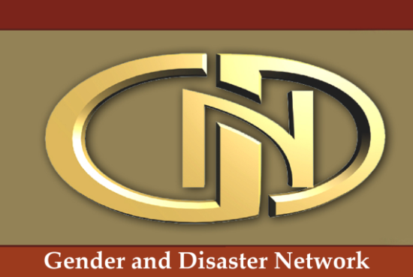Call for ContributionsThe Gender and Disaster Network with support from UN Women Pakistan is updating and developing the Gender and Disaster Sourcebook, a freely accessible online resource for disaster and development professionals, academics and all others interested in integrating gender in their work, advocacy or research.

This collaborative effort aims to upgrade the existing database and update the contents to reflect current discourses on gender and disaster risk reduction.
The GDN and UN Women Pakistan invite contributions (the original materials or links to them) on a range of topics and formats:
- Fundamental Concepts and Perspectives on Gender and Disaster Risk Reduction
- Planning and Practice tools, guidelines, analyses, policy frameworks
- Crosscutting issues (climate change, sexual and gender-based violence, men and masculinity, peace building, displacement , intersectionality (e.g., combining gender, age, race/ethnicity, sexual orientation, and/or any other defining category)
- Communications and training materials
- Case studies, gender and risk reduction projects and activities, gender aspects related to specific hazards (climate change, earthquakes, drought, landslides, etc)
- Links to NGOs, academia, local and national governments working on gendering disaster risk reduction and risk management
We welcome examples of and references to unpublished and published resources including:
-Books (including edited books and chapters)
-Conference papers and proceedings
-Reports (from INGOs, governments and UN agencies)
-Journal articles (including online and offline journals)
-Electronic resources (websites, video, webcasts, online news articles)
-Academic theses (academic publications)
-First hand accounts of disasters
-Disaster-related materials in other formats (e.g. artwork etc.)

We welcome suggestions for other types of resource.
Contributions from the South Asian region are highly encouraged.
Please send your resources and/or queries to sourcebook@gdnonline.org

