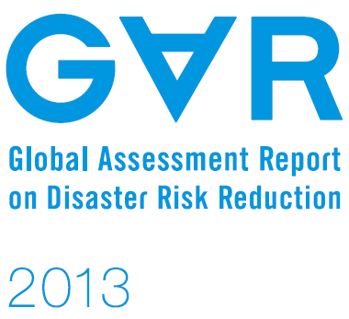
28 February 2014
Loss and damage, vulnerability and constraints to adaptation: case study findings

Input Paper

Prepared for the Global Assessment Report on Disaster Risk Reduction 2015

Kees van der Geest*
Koko Warner*
Sönke Kreft**
*United Nations University Institute for Environment and Human Security
**GermanWatch

Table of Contents

1. Introduction 4
Loss and damage 4
Conceptual framework 6
2. Methods 8
2.1 Fieldwork 9
2.2 Analsysis 11
3. Results 12
3.1 Descriptive case study findings 12
3.2 Vulnerablity 14
3.3 Coping with sudden-onset events 18
3.4 Adaptation to slow-onset changes 20
3.5 Loss and damage 21
4. Conclusions 24
References 26
References that still need to be integrated 28

List of images [we could add some more]
Image 1: Researcher conducting questionnaire interview in Bangladesh 10

List of figures
Figure 1: Conceptual framework: Linking loss and damage to vulnerability, risk management and adaptation 6
Figure 2: Relation between slow-onset processes and sudden onset events: Coastal erosion, sea level rise and storm surges in Micronesia 11
Figure 3: Proportion of sample population vulnerable by indicator and country 17
Figure 4: Example from the pacific: Mangroves, climate impacts and the importance of location 18

List of tables
Table 1: Different climatic stressors require different household responses 8
Table 2: Climatic stressors investigated in the case studies 8
Table 3: Vulnerability indicators and the proportion of vulnerable households 15
Table 4: Proportion of sample population vulnerable by indicator and country 16
Table 5: Uptake of coping strategies by country, type and vulnerability 19
Table 6: Uptake of adaptation measures by type, country and vulnerability 20
Table 7: Loss and damage from climatic events and processes by country 22
Table 8: Vulnerability indicators and L&D by country 22
Table 9: Coping measures and L&D from climate events by type and country 23
Table 10: Adaptation measures and L&D from slow-onset processes by country 24

1. Introduction
This input for research area 17 of UNISDR’s 15th Global Assessment Report uses survey data from a multi-country research on loss and damage in vulnerable communities to study how households with different vulnerability profiles try to deal with climatic stressors and their (in)ability to avoid loss and damage. The paper addresses ‘issue 2’ of the call, but also contributes to ‘issue 3’:
- ‘Issue 2’: Shared factors promoting or hindering adaptation, mitigation and disaster risk reduction;
  - Topic: Opportunities, constraints and limits to adaptation, mitigation and disaster risk reduction;
- ‘Issue 3’: Avoiding and addressing loss and damage associated with climate change impacts;
  - Topic: Roles of mitigation, adaptation and disaster risk reduction in avoiding and addressing loss and damage.
The structure of the paper is as follows: After a short introduction of the term loss and damage and its genesis in the UNFCCC arena, the concept will be placed in a larger framework connecting climatic stressors, vulnerability, risk management, impacts, coping strategies, adaptation and limits and contraints of adaptation. After that, the fieldwork and analysis methods are described. The results section starts by introducing 11 multi-dimensional vulnerable indicators which are apllied to households in six study sites. After that, the measures households adopt to cope with impacts of sudden-onset climatic events and to adapt to longer-term climatic changes are described. In the last part of the results section, the relations between household vulnerability indicators, coping strategies, adaptation and loss and damage are tested using binary logistic models. The last section of this input paper draws conclusions from the data presented.

Loss and damage
‘Loss and damage’ is a new concept that emerged in climate policy after the establishment of a work programme on the topic at the 16th UNFCCC Conference of the Parties in Cancun, Mexico in December 2010. The concept has gained further interest from 2012 onwards, as a mandate was given to establish institutional arrangements to address loss and damage. At COP19 (November 2013) the Warsaw International Mechanism was established to promote “implementation of approaches to address loss and damage associated with the adverse effects of climate change…in a comprehensive, integrated and coherent manner” (UNFCCC, 2013). The mechanism creates a policy space to discuss and address the negative consequences of climate change if society´s efforts to mitigate and adapt are not sufficient. An important question that needs to be answered over the next few years is what can be done to support vulnerable people, communities and societies who are already feeling the negative consequences of climate change (Kates, 2012; Warner, 2013).
Loss and damage is already a significant – and in some places growing – consequence of inadequate ability to adapt to changes in climate patterns across the world (Warner et al., 2012, 2013; Huq et al., 2013). Loss and damage undermines sustainable development, and can impede progress in improving human well-being. Yet there is currently a lack of empirical evidence of the circumstances under which households manage climatic stressors, the resulting societal impacts, and the loss and damage that results from not being able to adjust sufficiently. Policymakers need better information, empirical data and analysis of both the challenges and the potential solutions.
While there is a tendency in the media and among some parties in the climate negotiations to reduce the topic of ‘loss and damage’ to compensation and liability, the authors of this input paper try to link loss and damage more explicitly to adaptation limits and constraints. The authors acknowledge that there is a need for policy addressing situations in which losses and damages are not avoidable, but emphasize that much loss and damage could be avoided if efforts to reduce greenhouse gas (GHG) emissions are boosted; if more adaptation funding becomes available; if more effective adaptation policy is designed; and if sustained progress in disaster risk reduction is achieved.
Definitions of the term ‘loss and damage’ vary. For this research project, a working definition of loss and damage was used that includes households’ inability to respond adequately to climate stressors and the costs and adverse effects associated with the adaptation and coping measures themselves:
Adverse effects of climate-related stressors that households have not been able to avoid through adaptation
In our working definition we used the term households because these were our units of anlysis. However, the term ‘households’ can be replaced by ‘actors’ (e.g. companies, governments, communities, etc.) to widen the appliccability of the definition. The working definition for our local case studies does not explicitly mention reduction of GHG emissions because this was less relevant for the empirical work in vulnerable communities. However, we do recognize that emission reductions play a crucial role in avoiding dangerous climate change and its impacts.
The working definition we used links the concept of loss and damage firmly to the emerging research field of adaptation limits and constraints (Burton, 2009; Adger et al., 2009; Dow et al., 2013; Preston et al., 2013), which for the first time will have a chapter in the Fifth Assessment Report of the Intergovernmental Panel on Climate Change (IPCC AR5). Loss and damage from sudden-onet events as well as slow-onset processes is examined. Household measures to avoid loss and damage include risk reduction, coping strategies and adaptation. The climate-related stressors studied in the different case study areas include floods, droughts, sea level rise, coastal erosion, salinity intrusion and changing rainfall patterns.
In this paper, original survey data are used to link household vulnerability and coping and adaptive behaviour to loss and damage. In other words, it investigates what kinds of households pursue particular risk management and adaptation strategies, and how successful these are in preventing impacts/loss and damage. The following section introduces a framework connecting the key concepts used in the sutdy.

Conceptual framework
The framework discussed in this section connects loss and damage from climate-related stressors to vulnerability, risk management, impacts, coping strategies, adaptation and limits and contraints of adaptation (Figure 1). The framework results from progressive insights of working on loss and damage in vulnerable communities in the past two years (Warner et al., 2012, 2013; Warner & van der Geest, 2013), and previous work on impacts of and adaptation to climate change in dryland West Africa (van der Geest 2004, 2011, van der Geest & Dietz, 2004).

Figure 1: Conceptual framework: Linking loss and damage to vulnerability, risk management and adaptation
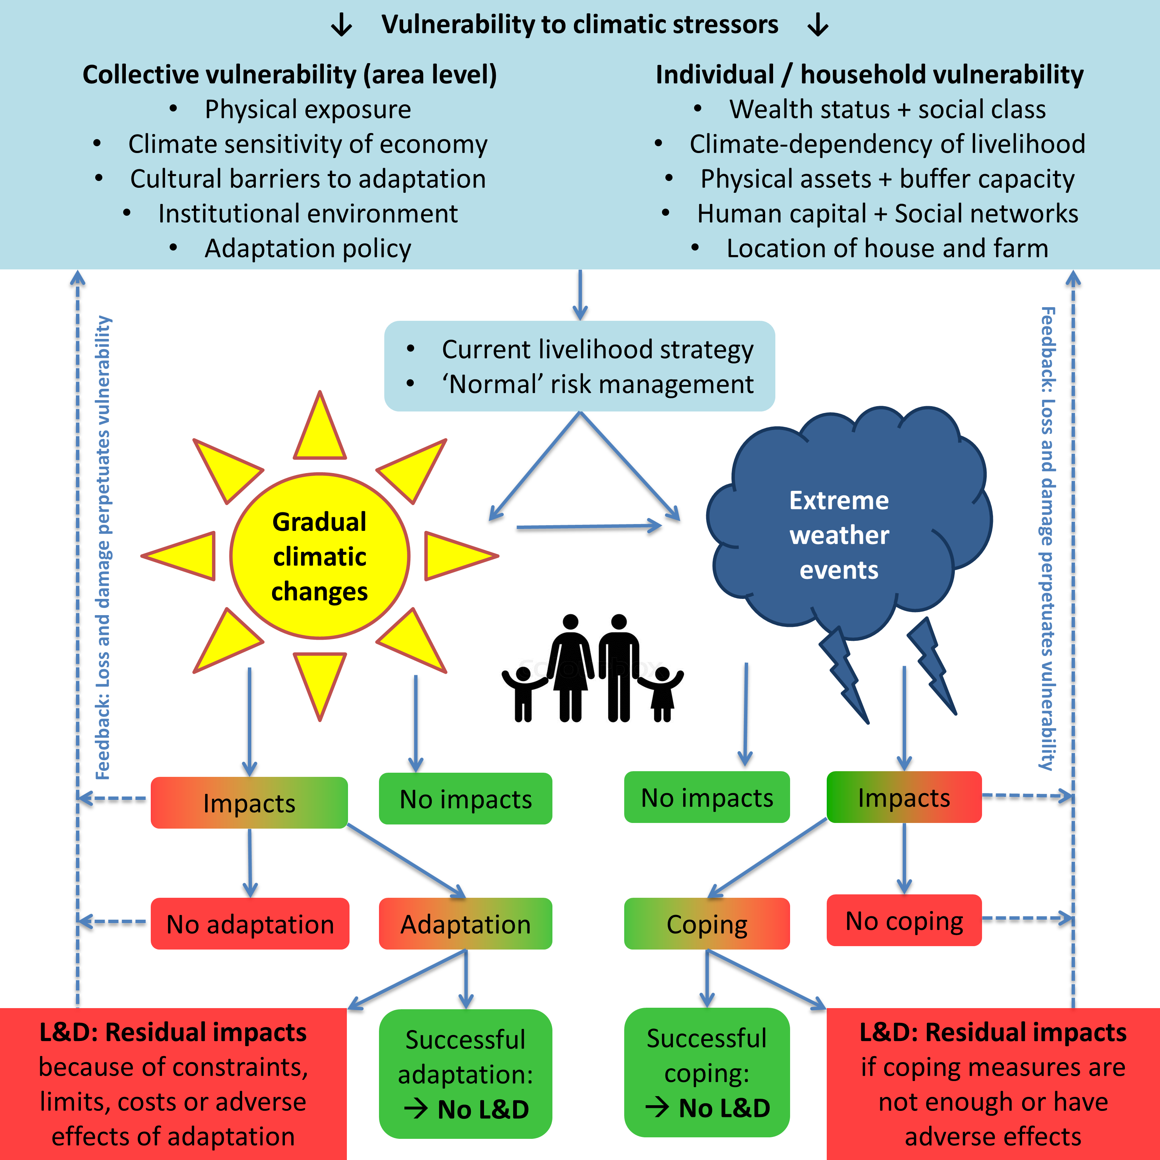

The blue box in the upper part of Figure 1 shows the vulnerability context of households and communities that shapes the livelihood strategies that househods adopt and the measures they put in place to reduce the risk of being adversely affected by climatic and other stressors. The framework distinguishes collective vulnerability – resulting from area-level variables that are the same for all households in a given community – and individual or household vulnerability. When a region experiences changes in the climate or when extreme weather events hit, some households will experience impacts (such as a crop failure or damage to properties) while others may not. This depends on their vulnerability profile – particulary their exposure – and household risk management. When the household experiences no impact, there is also no loss and damage (hence the green color of the ‘no-impact-box’). When the household is affected by the climatic stressor, it may incur or avoid residual loss and damage depending on whether measures are adopted to adjust (hence the red-green color of the impact and coping/adaptation boxes). If there is nothing the household can do to adjust, it will incur loss and damage (hence the red color of the no-adaptation and no-coping boxes). If coping or adaptation measures are adopted, these may or may not be effective in avoiding residual loss and damage, depending on the household’s adaptive capacity and the magnitude of the climatic stressor (or other words: adaptation constraints and limits). If measures are insufficient, costly or ‘erosive’ in the longer term, households incur loss and damage (Warner & van der Geest, 2013). Lastly, there is a feedback loop connecting loss and damage back to the household’s vulnerability profile. This is because the losses and damages incurred render the household more vulnerable in the face of ongoing climatic changes and future extreme events.
The framework distingishes two types of household responses to climate-related stressors: ‘coping’ and ‘adaptation’. Many studies use these terms synonymously (Birkmann 2011). This is problematic because they involve different types of responses to different types of stresses. Coping strategies are short-term responses to the impacts of sudden or usunsual events. By contrast, adaptation refers to longer-term adjustments to more permanent changes in the climate. Besides coping and adaptation, a third type of response involves the preventive measures (risk reduction) that households adopt in response to normal characteristics (including variability) of the climate and environment and in anticipation of unusual events.
The three groups of climatic stressors and household responses are shown in Table 1, with some non-exclusive examples. In reality, there are multiple linkages between different types of household responses to climatic stressors. For example, the success of ex-ante preventive measures determines the need for ex-post coping strategies; short-term coping measures can evolve into more permanent livelihood adaptations when they become recurrent; and when households change their peventive measures in response to changes in perceived risk, they are adapting.

Table 1: Different climatic stressors require different household responses
CLIMATIC STRESSOR |  | HOUSEHOLD RESPONSE
Climate variability  - ‘Normal’ uncertainties  - ‘Normal’ risk of extreme  weather events |  | Preventive measures  - Physical protection  - Risk spreading  - Creating buffers  - Build Safety nets
‘Unusual’ climate-related events  - Floods  - Droughts  - Cyclones/storms |  | Coping strategies  - Rely on social networks  - Food aid and other relief  - Alternative income  - Selling assets
Climatic changes  - Changes in ‘average’  - conditions  - Changes in risk of extreme  - weather events |  | Adaptation  - Agricultural change  - Livelihood diversification  - Migration  - Changes in ‘normal’  risk management

2. Methods
A research project, coordinated by the United Nations University’s Institute for Environment and Human Security (UNU-EHS), focused on the losses and damages that climate-related stressors are already causing in vulnerable communities. Researchers in Bangladesh, Bhutan, the Gambia, Kenya, Micronesia and Nepal conducted a total of 2,068 household interviews and over 100 focus groups and key informant interviews. They looked at a wide range of climate-related stressors, such as droughts, floods, changing rainfall patterns, sea level rise, cyclones, salinity intrusion and coastal erosion. Each case study looked at extreme weather events as well as slow-onset changes (See Table 2). The overall research question was: How does the impact of climate-related stressors lead to loss and damage among households in vulnerable countries?

Table 2: Climatic stressors investigated in the case studies
Country | Climate-related event | Slow-onset climatic change | Sample size
Bangladesh | Cyclone | Salinity intrusion | 360
Bhutan | GLOF | Changing rainfall patterns | 273
The Gambia | Drought | Changing rainfall patterns | 371
Kenya | Flooding | Changes in flood frequency and intensity | 400
Micronesia | Storm surge | SLR / Coastal erosion | 364
Nepal | Flooding | Changes in flood frequency and intensity | 300

2.1 Fieldwork
The research presented here generated original data from the perspective of vulnerable people who experience climate-related stressors, using a systematic assessment approach that employed a variety of methods including a household survey, focus group discussions, in-depth interviews with a select number of questionnaire respondents, and expert interviews. In addition, local meteorological and other relevant data was gathered and compared to local perceptions of changes in climatic stressors. Household data were gathered in the following domains: experience with climate-related stressors, impacts in households, the current adaptation and coping measures, and residual loss and damage.
The data source for the current paper is the questionnaire survey that was conducted in the case study sites. A template questionnaire, designed by the project’s science coordinator at UNU-EHS, was used, but national research teams adapted the template for each case study to suit its thematic focus and the characteristics of local livelihood systems and environments. The questionnaire had ten pages and interviews usually took 45 minutes to an hour. The questionnaires had four sections. The first section focused on socio-economic and demographic characteristics of the household and their sources of food and income. The information gathered in this section was used to create and apply the multidimensional vulnerability indicators presented in this paper. Sections 2 and 3 of the questionnaire focused on impacts of extreme weather events and slow-onset processes, household responses (coping and adaptation) and residual losses and damages. Open questions were combined with closed question to optimise the balance between listening to the voices of vulnerable people and being able to quantify how widespread different impacts and responses are. Section 4 contained open questions about differences in vulnerability between households in the communties, between men and women, and children and adults. In this section, respondents were also asked to share their ideas about ways to address loss and damage.

Image 1: Researcher conducting questionnaire interview in Bangladesh
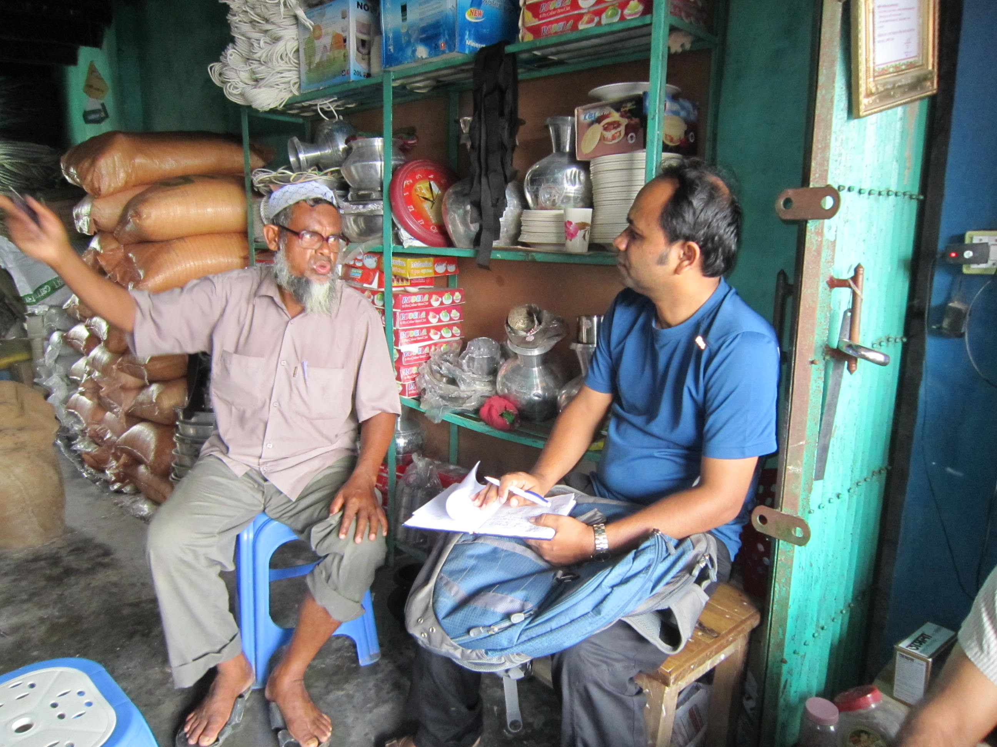
Photo credit: Golam Rabbani
Table 2 showed the slow-onset and sudden-onset stressors that the cases focussed on. In reality these stressors are often interrelated, and have non-climatic components. In Figure 2, this is illustrated for the Micronesian case study. The focus in this case study was on loss and damage from coastal erosion and storm surges. Whilie strom surges may have direct impacts for households to cope with, these sudden-onset events also exallerate longer-term process of coastal erosion. Vice-versa, coastal erosion makes the area more susceptible to impacts of storm surges as the natural protection capacity of the coast is reduced. Similarly to coastal erosion, a slow-onset process such as sea level rise affects the potential damage of sudden-onset stressors: when the ‘normal’ water level is higher, a storm surge will cause more damage than when the water is lower.
Coastal erosion can result from climate factors, such as sea level rise, but there are often also local, man-made causes (e.g. removal of mangroves and coral dredging). In the other study sites similar situations were found (e.g. floods in Kenya and Nepal resulting from extreme rainfall events, but also from unsustainable land use upstream; salinity intrusion in Bangladesh because of cyclones and sea level rise, but also because of shrimp farming).

Figure 2: Relation between slow-onset processes and sudden onset events: Coastal erosion, sea level rise and storm surges in Micronesia
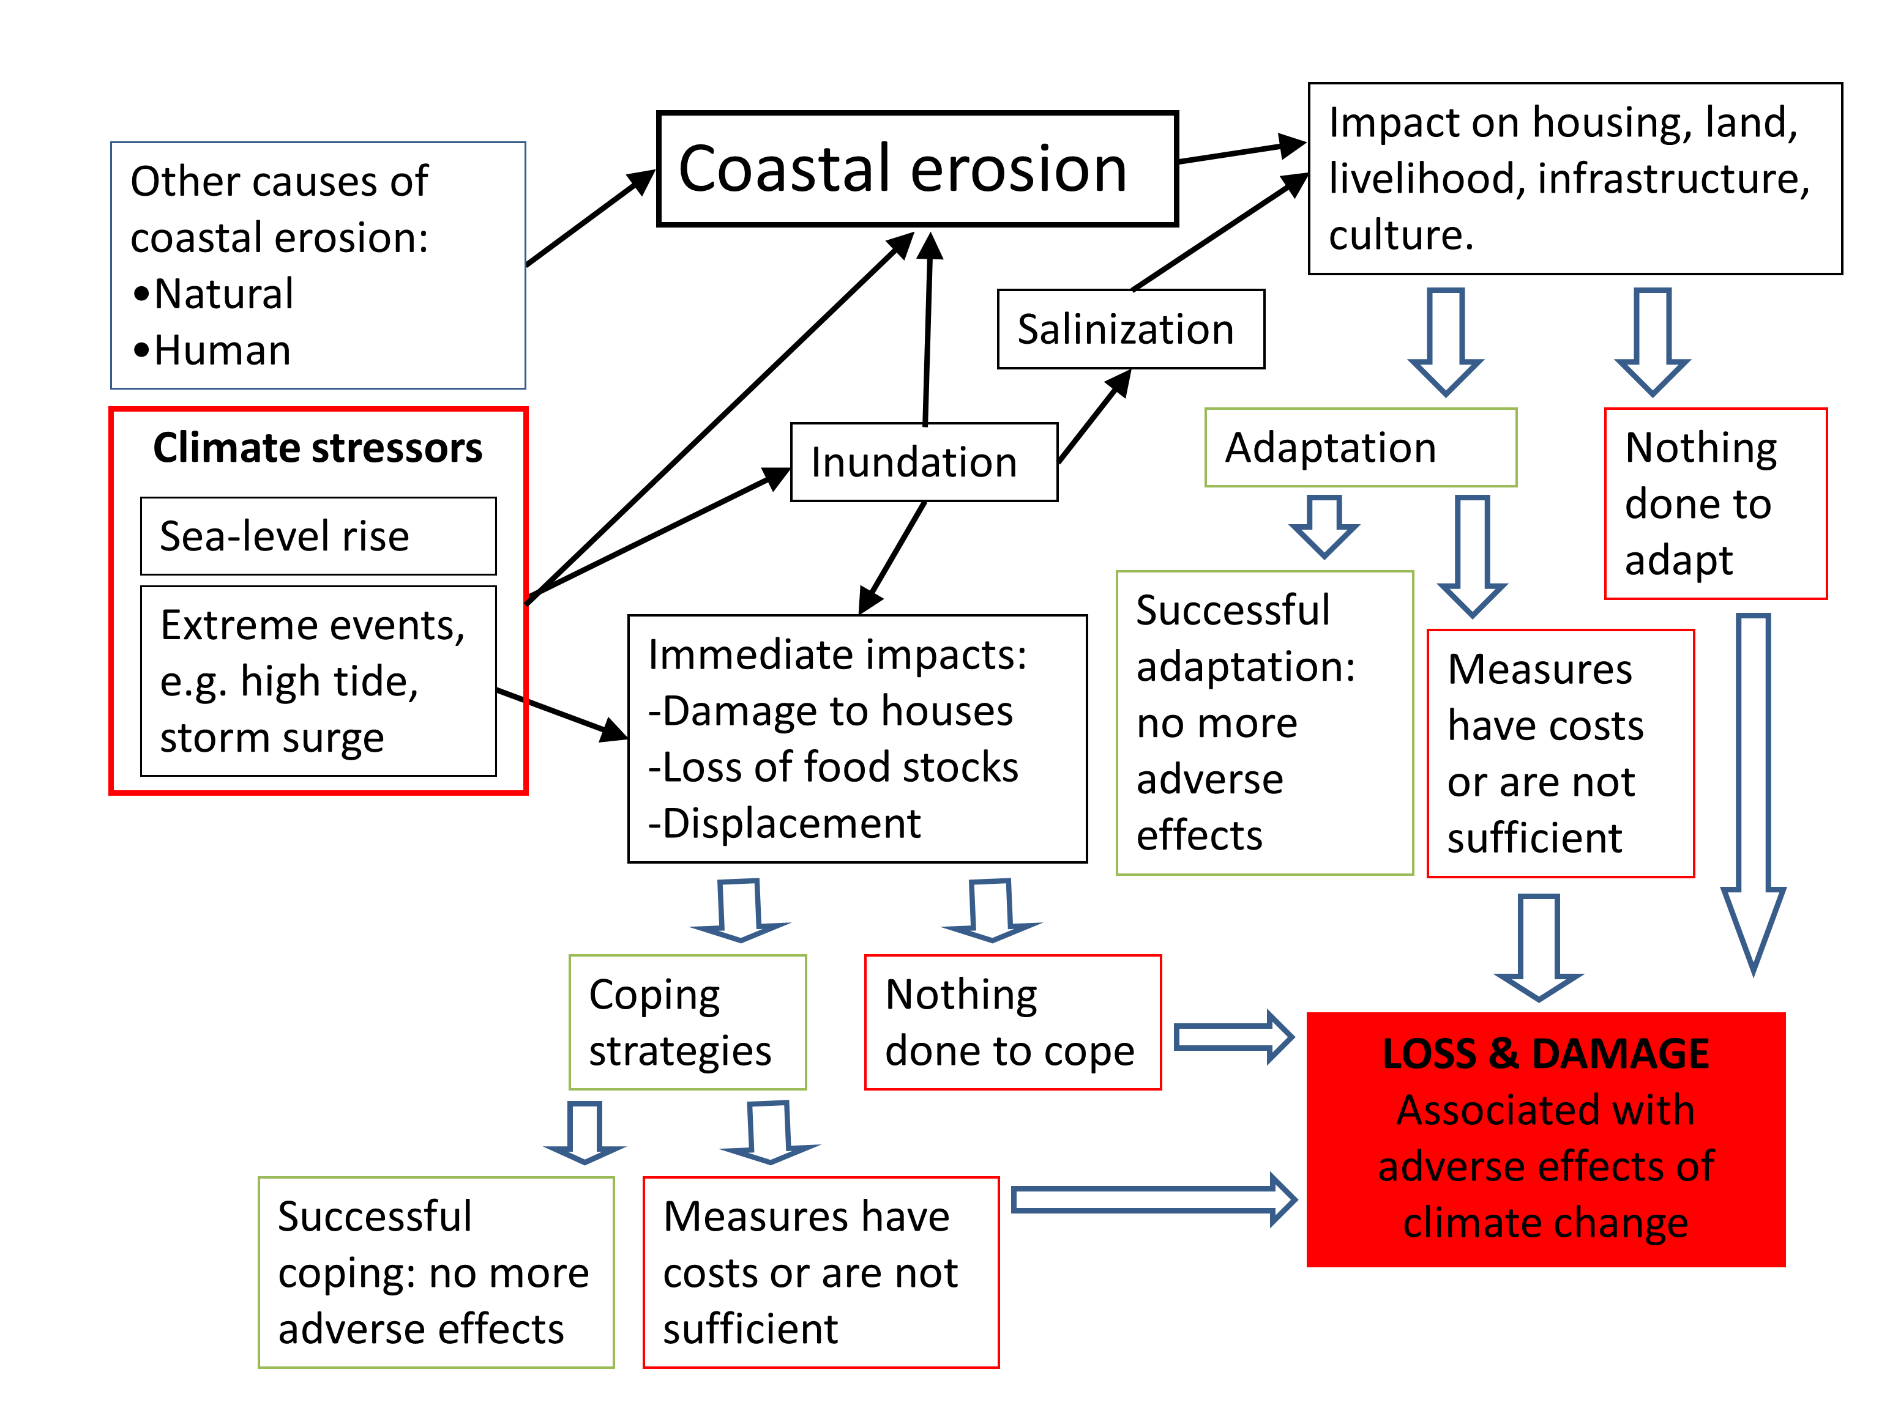
Source: Monnereau and Abraham (2013: 6)

The example from Micronesia illustrates that it is usually not possible to attribute losses and damages entirely to climate change (Huggel et al., 2013; Wrathall et al., in press). That was also not the objective of the research project this input paper reports on. Rather, the objective was to explore situations in which households face adaptation contraints and lack coping capacity, and to assess the consequences for people’s livelihoods and sutainable delopment pathways. The study and its methods should be treated as points of departure for further research on loss and damage in vulnerable communities.

2.2 Analsysis
The results of this research project presented so far have been mostly descriptive. By contrast, the analysis presented in this UNISDR input paper goes beyond the descriptive to find out which household-level factors affect people’s ability to cope, adapt and avoid loss and damage from climate-related stressors.
The aim of the analysis in this paper is to examine the effect of different vulnerability indicators and the coping and adaptation measures that households adopt on whether or not household incurred loss and damage from climate-related stressors (the dependent variable). To examine these effects, we used binary logistic regressions. The regressions were conducted for the whole sample (N=2068); for individual case study sites; and for vulnerable and non-vulnerable households in the study sites separately. A first step was to determine for each household in the sample whether it incurred loss and damage or not. No attempt was made to quantify loss and damage in monetary terms. In line with the conceptual framework in Figure 1, households incurred loss and damage when:
- Climate-related stressors affected them and they did not / could not adopt any measures to ameliorate the effects;
- The measures that they adopted to ameliorate the effects of climate-related stressors were not enough to avoid loss and damage or had adverse effects.
The next step was to assess the effect of three groups of independent variables on household loss and damage: 1) a group of multi-dimensional vulnerability indicators; 2) the coping strategies that people adopted in the aftermath of climatic events; and 3) the adaptation measures in response to longer-term climatic changes.

3. Results
The results section is structured as follows: First, some findings from the more descriptive, qualitative and anecdotal case study papers are highlighted to provide a context for the statistical analysis presented in the rest of the result section. Second, multidimensional vulnerability indicators are introduced and applied to the households data. Third, the measures households adopted to cope with extreme events and to adapt to changes in the local climate are presented. Differences between vulnerable and non-vulnerable households in the uptake of coping and adaptation measures are highlighted. In the last part of the result section, the effects of household vulnerability indicators and coping and adaptation measures on loss and damage is examined with binary logistic regressions.

3.1 Descriptive case study findings
Across the research sites, it was found that households struggled to manage impacts of climatic stressors on their their livelihoods, assets and culture. Despite their efforts to cope with the impacts of extreme weather events and to adapt to slow-onset climatic changes, many could not avoid incurring residual impacts. Some of the most notable impacts were on household food production and livelihoods, raising questions about the ability of adaptation measures, both formal and informal, to stem the interacting negative impacts of climate change and vulnerable societies.
Results from the case studies revealed four different ‘loss and damage pathways’ (Warner and van der Geest, 2013): loss and damage from climate-related stressors occur when:
- measures to cope or adapt are not enough to avoid loss and damage;
- measures have costs (including non-economic) that are not regained;
- despite short term merits, measures are erosive and undermine longer term livelihood sustainability;
- no measures are adopted or possible at all
Each of the case studies has a different story to tell, but all point to the same key finding: that loss and damage is happening now, despite adaptation efforts. Box 1 highlights some of the key findings of individual case studies.
Box 1: Some key findings of individiual case studies
Bangladesh: Satkhira, a coastal district in Bangladesh, faces the threat of sea-level rise and cyclones. Both result in saltwater intrusion, which severely impacts rice cultivation, the mainstay of the local economy. To adapt, farmers have planted new saline tolerant-rice varieties. This worked well until 2009, when cyclone Aila hit and caused a sudden and drastic increase of salt content in the soil. Almost all farmers lost their complete harvest that year.
Bhutan: Changing monsoon patterns are affecting the livelihoods of small-scale farmers in Bhutan who depend on these rains to irrigate their rice fields. Rainfall amounts have decreased substantially over the last two decades. Adaptation measures included a shift from rice to maize cultivation and from two harvests to one harvest per year, developing water-sharing mechanisms, and intensifying the maintenance of irrigation channels. However, these measures are insufficient and come with monetary and non-monetary costs.
Gambia: The North Bank Region of The Gambia experienced a severe drought in 2011, affecting almost all farmers in the area, many of whom lost their entire harvests. They tried to cope by looking for additional income (e.g. sale of property) to buy food. However, the majority had to reduce their food intake, for example by changing from three to two meals a day because their coping measures were insufficient.
Kenya: In December 2011, River Nzoia in Western Kenya broke its dykes and wreaked havoc in Budalangi Division. Crops were washed away, livestock drowned, houses were severely damaged and there was an outbreak of waterborne diseases. For survival, many households were forced to adopt erosive coping strategies, such as the sale of productive assets and taking children out of school to earn a meagre income in the informal sector. Erosive coping measures have severe implications for future livelihood security.
Micronesia: The Pacific island of Kosrae in Micronesia is particularly vulnerable to climate change. Sea-level rise around the island has been 10mm a year over the past decades, compared to a global average of 3.2mm. Coastal erosion, storm surges, and other coastal hazards are a severe threat to the island’s population. They try to adapt by building sea walls and planting trees along the shore. However, these measures are not sufficient. The study also found that a cultural heritage site has been damaged as the ancient ruins were dismantled to build seawalls.
Nepal is particularly susceptible to climate-related disasters, such as floods, landslides, and debris flows. In the Udayapur district floods have become more severe over the past two decades, destroying crops and damaging houses. In addition, the study found that food prices increased sharply in the aftermath of floods. While households expend much effort on preventive and coping measures, these have not been enough to counteract adverse effects.
Source: These excerpts have earlier been published in a blog of the Thomson Reuters Foundation. See http://www.trust.org/item/20131120115704-706cv/

3.2 Vulnerablity
The conceptual framework for this study distinguished collective vulnerability (area-level) and individual vunlerability (household-level). This section shows some of the differences between the study sites in terms of the proportion of households being vulnerable on different indicators. We used a vulnerability index that builds on the Alkire Foster method for measuring the multiple dimensions of poverty (Alkire & Foster, 2011). The method was developed by researchers at the Oxford Poverty and Human Development Initiative (OPHI) to measure deprivations in health, education and living standard, based on household surveys. To adjust the multi-dimensional poverty index to a multi-dimensional vulnerability index, household variables were selected that represent household vulnerability to climate-related stressors. Based on the household survey data, 11 multi-dimensional vulnerability indicators were defined, including for example education level, land and livestock ownership, income, involvement in non-farm activities, house quality, and food security.
For each variable a threshold is chosen (e.g. for education: household head has not gone beyond primary school; for housing: floor is made of mud, earth of cow dung; for land ownership: farm household owns less than the median). Then, for each vulnerability indicator, it is determined which households are above and below the threshold. Lastly, to determine whether a household is considered vulnerable or non-vulnerable overall, a second threshold or cut-off is set, for example: the household is considered vunerable when it scores ‘vulnerable’ on at least half the indicators. The vulnerability indicators selected for the analyses in this paper are listed and described in Table 3.

Table 3: Vulnerability indicators and the proportion of vulnerable households
Indicator | Household is vulnerable if: | Threshold  if median | %Vulnerable | Missing values (N=2068)
1.EDUCATION | Education of household head < secondary |  | 69% | 18
2.DEPENDENCY | Dependency ratio* is > median of sample population | 100 | 35% | 25
3.LAND | Land owned is < median of sample population | 0.4128 ha | 51% | 38
4.LIVESTOCK | Amount of livestock is < median of sample population | 1.17 TLU* | 50% | 0
5.NFI | Household has no non-farm income activities |  | 37% | 8
6.REMIT | Household receives no remittances |  | 61% | 8
7.INCOME | Annual household cash income < median of sample population | US$ 771 | 58% | 32
8.HOUSE | Floor of the house is made of mud, earth or cow dung |  | 52% | 6
9.HYGENE | Household does not have its own toilet or latrine |  | 20% | 22
10.FOOD | In the past year, household experienced food shortage in more months than the median of the sample population | 1 months | 44% | 17
11.PERCEPTION | Respondent perceives his/her own household to be more vulnerable than other households in the community |  | 38% | 38
- TLU refers Tropical Livestock Units. Conversion factors: horse 0.8; cow 0.7; donkeys 0.5; pig 0.2; sheep/goat 0.1; poultry 0.01.
- Dependency ratio calculated as number of dependents (aged <18 and >65) / adult population (18-65) * 100
- For indicators that use the median of the sample population as a threshold, one would expect exactly 50% to be classified as ‘vulnerable’. This is not always the case, however. For example, for dependency ratio, the value for over 300 out of 2068 households was exactly the median (100), reducing the proportion of households having a higher dependency than the media. In the case of total income, there were 51 households whose exact cash income could not be calculated, but for whom it was known that they earned more than the median of US$ 771 because they were white-collar salary workers.

Table 4 and Figure 3 show the proportion of households in each case study site considered vulnerable on each of the 11 indicators. According to the index, households were found to be particulary vulnerable in the study sites in Bangladesh, Kenya, Nepal and Gambia (54-67%), and much less in Bhutan (13%) and Micronesia (20%). The multi-dimensional vulnerability indicators further illustrate that different study areas are vulnerable for very different reasons. For example, households surveyed in Bangladesh were very vulnerable overall, but depedency ratios (number of children and elderly per adult aged 18-65) were very low. Similarly, in Gambia vulnerability was high, but very few households lacked land. Households surveyed in Bhutan had the lowest levels of vulnerability, but they were vulnerable in terms of education levels.
[note: as shown in section 3.5, some of the vulnerability indicators perform poorly in predicting L&D. Although in some cases there could be valid reasons for that, it is worthwhile to try to improve indicators. For example, we created a new indicator, which looks at livelihood diversity to replace the poorly performing non-farm income indicator. However, at this stage there was not enough time to work with adjusted indicators].

Table 4: Proportion of sample population vulnerable by indicator and country
 | ALL | BGD | BHU | GAM | KEN | MIC | NEP
Vulnerability Indicator | (%) | (%) | (%) | (%) | (%) | (%) | (%)
1.Education | 69 | 63 | 94 | 92 | 73 | 18 | 78
2.Dependency ratio | 35 | 11 | 28 | 54 | 51 | 33 | 30
3.Land | 51 | 67 | 42 | 3 | 43 | 88 | 68
4.Livestock | 50 | 66 | 31 | 28 | 53 | 85 | 30
5.Non farm income | 37 | 38 | 39 | 32 | 30 | 44 | 40
6.Remittances | 61 | 92 | 59 | 64 | 53 | 36 | 65
7.Income | 58 | 72 | 51 | 78 | 70 | 18 | 59
8.House | 52 | 94 | 8 | 48 | 68 | 1 | 85
9.Hygene | 20 | 2 | 5 | 33 | 20 | 3 | 57
10.Food security | 44 | 46 | 1 | 55 | 89 | 14 | 45
11.Perception | 38 | 39 | 16 | 46 | 46 | 50 | 26
Vulnerable households | 49 | 67 | 13 | 54 | 65 | 20 | 64
Non-vulnerable households | 51 | 33 | 87 | 46 | 35 | 80 | 36
- Cut-off for ‘Vulnerable households’: when they are considered vulnerable on at least half the indicators

Figure 3: Proportion of sample population vulnerable by indicator and country
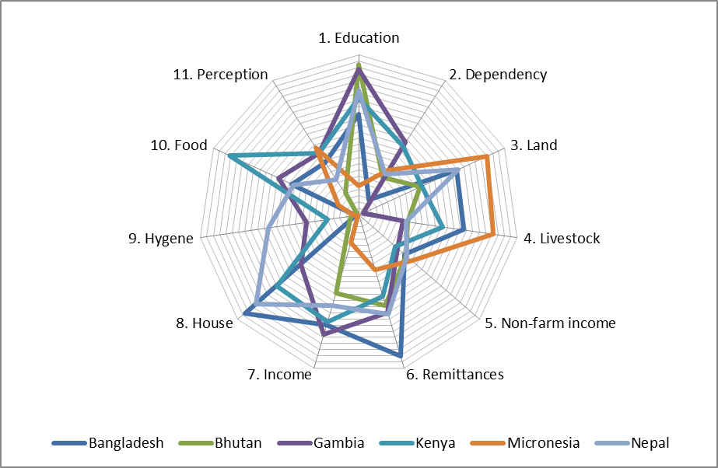

A data limitation for the multidimensional vulnerable index is that we did not systemiatically gather information about the location of house and farmland in most study sites. Qualitative research findings on vulnerability (and with hindsight: common sense) show that location is a crucial variable, especially in the case studies where the focus was on flooding (Bhutan, Kenya, Nepal), salinity intrusion (Bangladesh) and Coastal erosion (Micronesia). The maps that were made for the case study on the island of Kosrae in the Federated States of Micronesia illustrate the importance of location. Impacts of storm surges were much more severe among coastal households living in areas whithout mangroves.

Figure 4: Example from the pacific: Mangroves, climate impacts and the importance of location
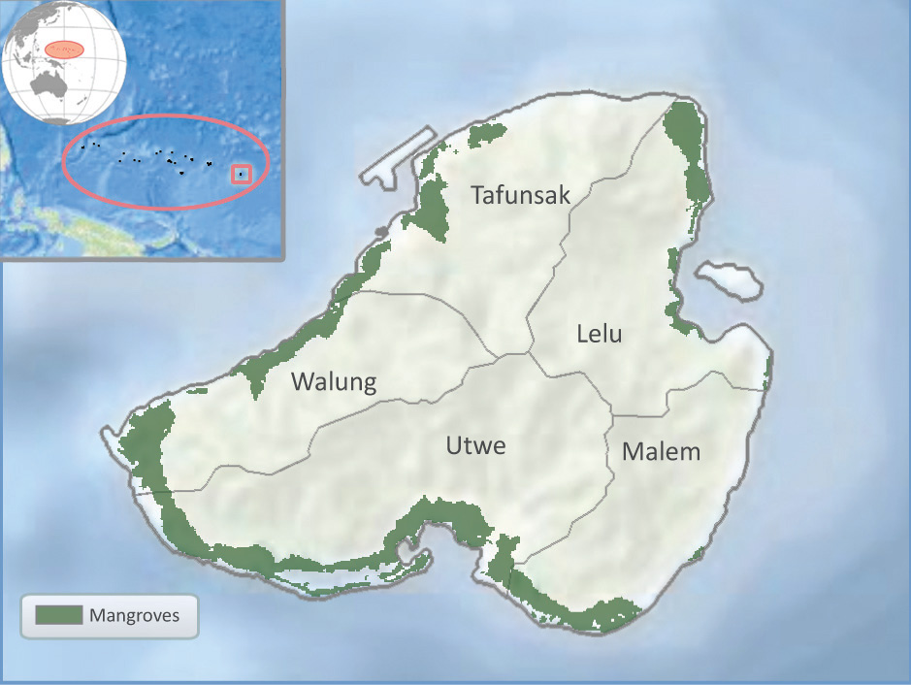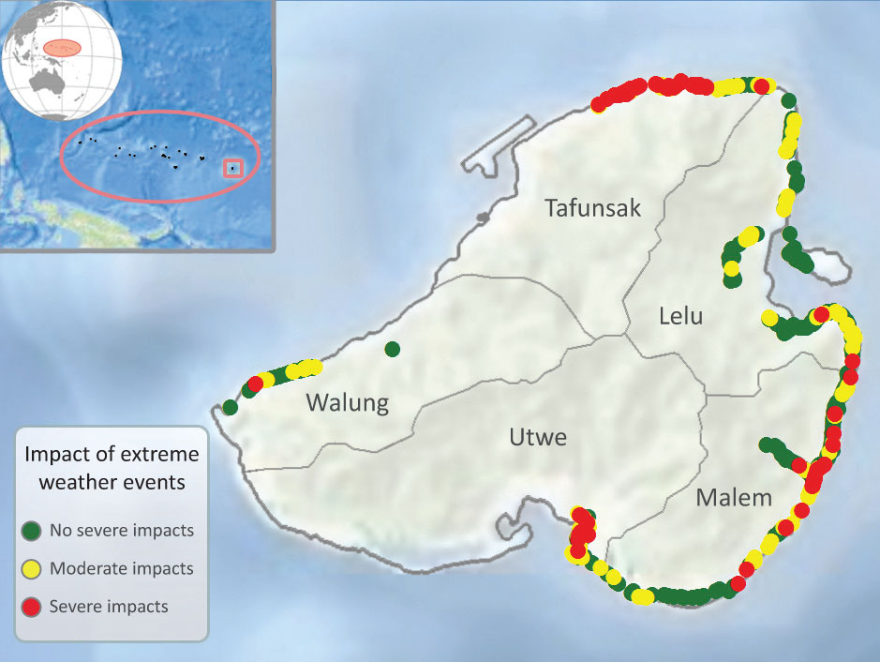
Note: Households living in coastal areas without mangroves were much more likely to experience severe impacts of storm surges (the red dots on the right map) than households living in areas with mangrove vegetation (the green areas on the left map). Maps created by CIESIN for UNU-EHS

3.3 Coping with sudden-onset events
[Note: the paper jumps from vulnerability to coping here. In the concepual framework and questionnaire design, there is an intermediary step: the first-line impacts of climatic events and changes. We have data on impacts per sector – crops, livestock, fishing, trees, trade, food prices, houses, properties, other – that could/should be presented first. Assessing the impact types in different households and for vulnerable vs non-vulnerable households could actually benefit the paper by providing some more detail on the side of the dependent variable in the paper: loss and damage.]
Table 5 shows the proportion of households that adopted different types of coping measures to deal with impacts of climatic events (see Table 2 for an overview of the climatic events by study site). Data for the Bhutan case study are omitted from the table because the study yielded data of limited use with regard to impacts of sudden-onset climate events. The study looked at glacier lake outburst floods, which as it appeared had affected only very few households in the area. Besides looking at GLOFs, the study also investigated impacts of longer-term changes in monsoon patterns on rice production (Kusters and Wangdi, 2013).

Table 5: Uptake of coping strategies by country, type and vulnerability
 | ALL | BGD | GAM | KEN | MIC | NEP
Coping measure | % | % | % | % | % | %
Any coping? | 89 (V) | 94 (V) | 97 (V) | 98 | 53 | 87
Rely on social network | 45 (V) | 72 (V) | 48 (V) | 34 | 17 | 43 (V)
Rely on support/relief | 50 | 27 | 49 | 80 | 7 | 59
Rely on non-farm income | 45 | 59 (V) | 56 (NV) | 37 | 1 (V) | 44
Migration | 37 | 32 | 23 | 61 | 35 | 24
Sell assets (mostly livestock) | 31 (V) | 27 | 55 | 20 | 1 | 31
Reduce expenses | 68 (V) | 78 (V) | 66 | 73 | 52 | 54 (V)
Modify food intake | 73 (V) | 76 (V) | 66 (V) | 87 | 66 | 56 (V)
Other coping | 26 | 36 | 20 | 21 (NV) | 14 | 31
- Calculated over the households that adopted coping measures (see third row)
- Figures in bold indicate significant differences in the uptake of coping measures between vulnerable and non-vulnerable household (p<0.05, one-way Anova); V=More common among vulnerable households; NV=More common among non-vulnerable households
A first important finding from Table 5 is that approximately nine out of ten households across the study sites adopted coping measures to deal with impacts of climatic events. This is not surprising because most households, when confronted with a drought-induced crop failure for example, have no choice but to adopt measures to cope and get food on the table. The exception was the Island of Kosrae in the Federated States of Micronesia. Here, the study focussed on impacts of strom surges on coastal households. About half the households said they did not adopt any coping measures – except for “cleaning up the mess” – after their houses or yards were flooded. The difference between Micronesia and the other sites was that most households’ main source of food and income was not affected.
The most common coping strategies adopted in the case study sites were ‘modifying food intake’ (73%) and ‘reducing expenses’ (68%). This is worrying because modifying food intake (eating less meals a day, smaller portion, and/or cheaper food), apart from being a is a way to deal with shortage, can be considered an indication that other coping measures are failing. Not surprisingy, vulnerable households were significantly more likely to modify their food intake than non-vulnerable households.
Reliance on support/relief, social networks and non-farm income were also common (45-50%) and over a third responded by migrating. This involved temporary relocation of entire households over small distances to avoid dangerous situations (e.g. in the case of flooding), or migration to urban centres or other rural areas to look for money to buy food when harvests were affected by climatic events.
Table 5 also indicates differences in the uptake of coping measures by vulnerable and non-vulnerable households. Clearly, vulnerable households were more likely to adopt different coping measures. This pattern was discernible across the research sites. An explanation could be that less vulnerable households needed less measures to ameliorate impacts of climate stressors because the measures they adopted were more effective.

3.4 Adaptation to slow-onset changes
Table 6 shows the proportion of households that adopted different types of adaptation measures in response to longer-term climatic changes (see Table 2 for an overview of the climatic events by study site). An important difference between coping and adaptation measures needs to be highlighted here: Whereas households in the different study sites adopted very similar coping measures in the aftermath of climate-related events, adaptation to longer-term climatic changes was much more varied. This is not surprising. Whether a household looses its harvest in a flood, a drought or a cyclone, it will have to find ways to gain access to food. By contrast, to adapt to increasing flood risks, entirely different measures are needed than to adapt to sea level rise, drought or changing monsoon patterns.
The broad types of adaptation measures (agricultural change, livelihood diversification and migration) that we identified in the questionnaire design phase were useful, but not exclusive and somewhat unspecific. Individual case studies adjusted the questionnaire for location-specific measures, such as the the construction of flood barriers in Nepal, and additional information can be retrieved from follow-up questions (open and closed). [Some of these measures are summarized in the temporary table below, but require some more work]
Temporary table – to be integrated in table 6
% of households | Flood barriers | New crop cultivars | Planting trees | Shift to horticulture
Country | % | % | % | %
Bangladesh | 0 | 0 | 0 | 0
Bhutan | 0 | 0 | 2 | 2
Gambia | 0 | 12 | 15 | 18
Kenya | 1 | 23 | 1 | 5
Micronesia | 37 | 0 | 14 | 1
Nepal | 77 | 0 | 18 | 0
Total | 18 | 7 | 8 | 5

Table 6: Uptake of adaptation measures by type, country and vulnerability
Country | ALL | BGD | GAM | KEN | MIC | NEP
Any adaptation | 72 | 99 | 77 | 77 | 31 | 72 (NV)
Agricultural change | 32 | 42 | 55 | 42 (NV) | 7 (NV) | 7 (NV)
Non-farm activities | 34 | 57 (V) | 47 | 38 (NV) | 3 (NV) | 20
Migration | 26 | 24 (V) | 23 (NV) | 47 | 17 (V) | 15
Other | 31 | 72 | 5 | 8 | 12 | 65 (NV)
- Percentage in bold format indicate significant differences in the uptake of adaptation measures between vulnerable and non-vulnerable household (p<0.05, one-way Anova); V=More common among vulnerable households; NV=More common among non-vulnerable households
- Bangladesh and Nepal have high percentages for uptake of ‘other adaptation’ measures. To specify, four separate adaptation variables have been created (physical flood barriers, tree planting, adopting drought- or water-resistant crop varieties and shift to vegetable gardening, see tempoary table), but we still need to run the more advanced analyses
- Work in progress: Bangladesh: Many ‘other adaptation’, but mostly unexplained. However, in open question about adaptation, most of these mention agricultural adaptations (e.g. salt-tolerant crop cultivars, on-farm measures to reduce salinity in fields,etc).
The uptake of adaptation measures in response to longer-term climatic changes was slightly less (72% on average) than in the case of coping with impacts of climatic events. Roughly a quarter of households adapted agricultural practices (e.g. changes in crop mix, tillage methods or irrigation, adopting drought-tolerant crop cultivars or going into horticulture or tree cropping). Another difference with coping is that the uptake of adaptation measures was not higher among vulnerable households.
[Section unfinished: some more descriptive findings and interpretation on adaptation measures; and run analyses for four new adaptation measures]

3.5 Loss and damage
In this section, the relations between household vulnerability indicators, coping strategies, adaptation and loss and damage are tested using a binary logistic model. The aim is to examine the effect of different vulnerability indicators and the coping and adaptation measures that households adopt on whether or not household incurred loss and damage from climate-related stressors (the dependent variable). As mentioned in the methods section, and in line with the conceptual framework in Figure 1, we consider that households incur loss and damage when:
- Climate-related stressors affected them and they did not / could not adopt any measures to ameliorate the effects;
- The measures that they adopted to ameliorate the effects of climate-related stressors were not enough to avoid loss and damage or had adverse effects.
Table 7 shows the proprortion of households incurring loss and damage from climatic events (column 2) and from slow-onset climatic changes (column 3) in the study sites. The last column of table 7 shows the proportion of households incurring loss and damage from either climatic events or slow-onset changes. Typically, around two thirds (60-76%) of the households incurred loss and damage from climatic events, except in the Bhutan case study (13%). Slightly higher figures were found for loss and damage from slow-onset changes (though less so in Nepal), which is an interesting finding because sudden-onset events tend to receive much more attention. The proportion of households incurring loss and damage from sudden-onset or slow-onset events ranged between 66% in Nepal to 91% in Kenya, with an average of 79%.

Table 7: Loss and damage from climatic events and processes by country
Country | Loss and Damage from sudden-onset events | Loss and Damage from slow-onset changes | Loss and Damage from events and/or processes
Bangladesh | 69% | 69% | 78%
Bhutan | 13% | 72% | 76%
Gambia | 68% | 75% | 82%
Kenya | 76% | 73% | 91%
Micronesia | 60% | 67% | 79%
Nepal | 62% | 40% | 66%
Total | 60% | 67% | 79%

Table 8 looks at the effects of different vulnerability indicators on whether or not households incurred loss and damage. Some indicators were much better predictors of loss and damage than others. Education level, dependency ratio, land and livestock ownership and non-farm income had no siginificant (p<0.5) relation to loss and damage in any of the study sites. The strongers predictors of loss and damage were cash income, food security and, most of all, respondents’ own perception of poverty. This is interesting because conventional vulnerability indices do not usually include a perception indicator.
[option for further – qualitative – analysis: discuss the answers of the open question on why people thought they were more or less vulnerable than others in their communities]

Table 8: Vulnerability indicators and L&D by country
Vulnerability Indicator | ALL | BGD | GAM | KEN | MIC | NEP
1.EDUCATION
2.DEPENDENCY
3.LAND
4.LIVESTOCK
5.NON FARM INCOME
6.REMITTANCES |  |  |  | EFB
7.INCOME | EFB | EFB |  | FB
8.HOUSE |  |  | EFB
9.HYGENE
10.FOOD SECURITY | EFB | EFB |  |  | EFB
11.PERCEPTION | EFB | EFB | FB | EFB | EFB | EFB
- Based on binary logistic regression. Models were run thrice with all vulnerability indicators as potential explaining variables: Forward (F), Backward (B) and Enter (E). The table shows the variables that contributed significantly (p<0.05) to explaining the binary response variable.
- When an explaining variable enters the model in each of the three procedures, it can be considered a robust factor.

[note: as shown in Table 8, some of the vulnerability indicators perform poorly in predicting L&D. Although in some cases there could be valid reasons for that, it is worthwhile to try to improve indicators. For example, we created a new indicator, which looks at livelihood diversity to replace the poorly performing non-farm income indicator. However, at this stage there was not enough time to work with adjusted indicators].
[some more interpretation of table 8 needed; with link to adapation constraints]
Table 9 looks at the effect of adopting different coping measures on whether or not households incurred loss and damage from climate-events. The findings for all case studies together show that households that coped by relying on non-farm income were significantly more likely to avoid loss and damage (+) and that households who ‘coped’ by modifying food intake were significantly less likely to avoid loss and damage (-). Findings for migration and reduction of expenses point in the same direction, but less robustly.

Table 9: Coping measures and L&D from climate events by type and country
Coping measures | ALL | BGD | GAM | KEN | MIC | NEP
Rely on social network |  | B- |  | B-
Rely on support/relief |  |  |  | FB-
Rely on NFI | EFB+ |  | EFB+
Migration | BF- |  |  |  |  | B-
Sell assets |  | EFB- | EFB+ |  |  | B-
Reduce expenses | F- | FB- |  | EFB+
Modify food intake | EFB- | EFB- |  |  | EF-
Other coping |  |  | B-
- Based on binary logistic regression. Models were run thrice with all vulnerability indicators as potential explaining variables: Forward (F), Backward (B) and Enter (E). Table shows the explaining variables that contributed significantly (p<0.05) to explaining the binary response variable.
- When an explaining variable enters the model in each of the three procedures, it can be considered a robust factor.
- (+) inidicates that the measures contributed positively to avoiding loss and damage. For example, households that relied on non-farm income were more likely not to incur loss and damage from climate events; (-) inidicates that households adopting the measure were less likely to avoid loss and damage.

Table 10 looks at the effect of adopting different adaptation measures on whether or not households incurred loss and damage from slow-onset climatic changes. The findings for all case studies together show that households that relied on migration/mobility to adapt to slow-onset climatic changes were significantly more likely to report loss and damage. Migration could involve relocation of entire households, usually over small distances, to avoid dangerous situations (e.g. in the case of flooding), or migration to urban centres or other rural areas, usually by individual household members, to earn money or to reduce pressure on the available food at home. Reliance on non-farm income is positively associated with avoiding loss and damage in the Gambian and Kenyan study sites, but negatively in Nepal. In Bangladesh, ‘other adaptations’, which appeared to be instrumental in avoiding loss and damage primarily involved on-farm measures to reduce salinity in rice fields and adoption of salt-tolerant crop cultivars (see also Rabbani et al., 2013).

Table 10: Adaptation measures and L&D from slow-onset processes by country
Adaptation measures | ALL | BGD | GAM | KEN | MIC | NEP
Agricultural change
Non-farm activities |  |  | EFB+ | EFB+ |  | EFB-
Migration | EFB- |  |  |  |  | EFB-
Other |  | FB+
[add findings for specific adaptations TREES, BARRIERS, SEEDS, GARDEN]
- Based on binary logistic regression. Models were run thrice with all vulnerability indicators as potential explaining variables: Forward (F), Backward (B) and Enter (E). Table shows the explaining variables that contributed significantly (p<0.05) to explaining the binary response variable.
- When an explaining variable enters the model in each of the three procedures, it can be considered a robust factor.
- (+) inidicates that the measures contributed positively to avoiding loss and damage. For example, households in The Gambia that adapted to changing rainfall patterns (drier conditions) by diversifying their livelihoods into non-farm activities were more likely not to incur loss and damage; (-) inidicates that households adopting the measure were less likely to avoid loss and damage.

4. Conclusions
This paper uses original data from the first ever multi-country study of loss and damage in vulnerable communities to explore which household factors influence households’ capacity to avoid loss and damage. Researchers in Bangladesh, Bhutan, The Gambia, Kenya, Micronesia, and Nepal conducted household surveys (n=2,068) about climatic stressors, impacts, household risk management strategies, adaptation measures and residual loss and damage.
[add a few lines about what the paper did and did not do before drawing conclusions]
Some conclusions [in bullets for the moment, work in progress]
- High proportion of households (79%) incurring loss and damage despit adopting coping and/ adaptation measures
- Counter-intuitive finding that factors such as education level, land ownership and non-farm income do not seem to play a significant role in explaining which household occurred loss and damage or not. Cash income, food security and especially ‘own perception of vulnerability’ were the best predictors of loss and damage
- The vast majority of households (89%) adopted coping measures in response to impacts of climatic events, usually several per households. Those that coped by relying on non-farm income were significantly more likely to avoid loss and damage; those who ‘coped’ by modifying food consumption less likely.
- About three quarters of households tried to adapt to slow-onset climatic changes. Migration negatively associated with loss and damage.
- [some more interpretation of “what does it mean”, “how can this kind of information help practioners and policy makers to design better adaptation policy?”]
- While still working on better analysis of the survey findings, need to be modest in conclusions.
- Suggestions for improving this kind of analysis.

References
Adger, W.N., Dessai, S., Goulden, M., Hulme, M., Lorenzoni, I., Nelson, D.R., Naess, L.O., Wolf, J. and Wreford, A. (2009) Are there social limits to adaptation to climate change? Climatic Change 93: 335-354.
Alkire, S., & Foster, J. (2011). Counting and multidimensional poverty measurement. Journal of public economics, 95 (7), 476-487.
Alkire, S. and Santos, M. E. (2010). Acute Multidimensional Poverty: A New Index for Developing Countries, OPHI Working Paper 38. Oxford Poverty and Human Development Initiative, University of Oxford.
Allen, M. (2003). Liability for climate change. Nature 421: 891-892.
Bauer K. (2013). Are preventive and coping measures enough to avoid loss and damage from flooding in Udayapur District, Nepal? International Journal of Global Warming Vol. 5, No. 4, pp. 433-451.
Birkmann, J. (2011) First- and second-order adaptation to natural hazards and extreme events in the context of climate change. Natural Hazards 58: 811–840.
Burton, I. (2009) Climate Change and the Adaptation Deficit. In Schipper, E.L.F. and Fung, R., Lopez, A. and New, M. (2010) Water availability in +2°C and +4°C worlds. Philosophical Transactions of the Royal Society A 369: 99-116.
Davies, S. (1996) Adaptable livelihoods: Coping with food insecurity in the Malian Sahel. MacMillan Press, London.
Dow, K., Berkhout, F., Preston, B. L., Klein, R. J., Midgley, G., & Shaw, M. R. (2013). Limits to adaptation. Nature Climate Change, 3(4), 305-307.
Hahn, M., Riederer, A., & Foster, S. (2009). The Livelihood Vulnerability Index: A pragmatic approach to assessing risks from climate variability and change—A case study in Mozambique. Global Environmental Change, 19(1), 74-88.
Huggel, C., Stone, D. i., Auffhammer, M., & Hansen, G. (2013). Loss and damage attribution. Nature Climate Change, 3(8), 694-696.
Huq, S., Roberts, E. & Fenton, A. (2013). Loss and damage. Nature Climate Change, 3(11): 947-949.
Kates, R.W., Travis, W.R. and Wilbanks, T.J. (2012) Transformational adaptation when incremental adaptations to climate change are insufficient. PNAS 109(19): 7156-7161.
Kusters K. and Wangdi N. (2013). The costs of adaptation: changes in water availability and farmers’ responses in Punakha district, Bhutan. International Journal of Global Warming Vol. 5, No. 4, pp. 387-399.
Lott, F. C., Christidis, N., & Stott, P. (2013). Can the 2011 East African drought be attributed to human-induced climate change? Geophisical Research Letters, 40(6), 1177–1181.
Monnereau I. and Abraham, S. (2013a). Limits to autonomous adaptation in response to coastal erosion in Kosrae, Micronesia. International Journal of Global Warming Vol. 5, No. 4, pp. 416-432.
Monnereau, I. and Abraham, S. (2013b). Loss and damage from coastal erosion in Kosrae, The Federated States of Micronesia. Loss and Damage in Vulnerable Countries Initiative, case study report. Bonn: United Nations University Institute for Environment and Human Security.
Moser, S.C. and Ekstrom, J.A. (2010) A framework to diagnose barriers to climate change adaptation. PNAS 107(51): 22026-22031.
Opondo D. (2013). Erosive coping after the 2011 floods in Kenya. International Journal of Global Warming Vol. 5, No. 4, pp. 452-466.
Otto, F. E. L., Jones, R. G., Halladay, K., & Allen, M. R. (2013). Attribution of changes in precipitation patterns in African rainforests. Phil Trans. B, 368: 20120299.
Pinninti, K. R. (2014). Climate Change Loss and Damage: Economic and Legal Foundations. Heidelberg, New York, Dordrecht and London: Springer.
Preston, B.L., Dow, K. and Berkhout, F. (2013) The climate adaptation frontier. Sustainability 5: 1011-1035.
Rabbani G., Rahman A. and Mainuddin K. (2013). Salinity induced loss and damage to farming households in coastal Bangladesh. International Journal of Global Warming Vol. 5, No. 4, pp. 400-415.
UNFCCC (2013) Decision 1/CP.19: Warsaw international mechanism for loss and damage associated with climate change impacts. Online, accessed 19 February 2014, http://unfccc.int/resource/docs/2013/cop19/eng/l15.pdf.
van der Geest, K. (2004). “We’re Managing!” Climate Change and Livelihood Vulnerability in Northwest Ghana. Leiden: African Studies Centre.
van der Geest, K. (2010). Local perceptions of migration from Northwest Ghana. Africa, 80(4), 595-619.
van der Geest, K. (2011). The Dagara farmer at home and away: migration, environment and development in Ghana. Leiden: African Studies Centre.
Van der Geest, K. & T. Dietz (2004). A literature survey about risk and vulnerability in drylands, with a focus on the Sahel. In: Dietz, T., R. Rueben & J. Verhagen (eds). The Impact of Climate Change on Drylands. Kluwer, Dordrecht. pp.117-146.
Warner, K. (2013). The Warsaw International Mechanism: A legitimate policy space for loss and damage widens and deepens. Online blog, http://www.ehs.unu.edu/file/get/11501.pdf
Warner K. and van der Geest K. (2013). Loss and damage from climate change: Local-level evidence from nine vulnerable countries. International Journal of Global Warming Vol. 5, No. 4, pp. 367-386.
Warner, K., van der Geest, K. & Kreft, S. (2013). Pushed to the limits: Evidence of climate change-related loss and damage when people face constraints and limits to adaptation. Report No.11. Bonn: United Nations University Institute for Environment and Human Security (UNU-EHS).
Warner, K. & van der Geest, K. (2013). Loss and damage from climate change: Local-level evidence from nine vulnerable countries. International Journal of Global Warming, Vol 5 (4): 367-386.
Wrathall, D., Oliver-Smith, A., Fekete, A., Gencer, E., Lepana, M. and Sakdapolrak, P. (in press). Problematizing loss and damage. International Journal of Global Warming.
Yaffa S. (2013). Coping measures not enough to avoid loss and damage from drought in the North Bank Region of The Gambia. International Journal of Global Warming Vol. 5, No. 4, pp. 467-482.

References that still need to be integrated
Berrang-Ford, L., Ford, J.D. and Paterson, J. (2011) Are we adapting to climate change? Global Environmental Change 21: 25-33.
Hertel, T.W., Burke, M.B. and Lobell, D,B. (2010) The poverty implications of climate-induced crop yield changes by 2030. Global Environmental Change 20(4): 577-585.
IPCC (2007) Climate Change 2007: Climate Change Impacts, Adaptation and Vulnerability, Summary for Policy Makers, Contribution of Working Group II to the Fourth Assessment Report of the Intergovernmental Panel on Climate Change. Cambridge University Press, Cambridge and New York.
IPCC (2012) Managing the Risks of Extreme Events and Disasters to Advance Climate Change Adaptation. A Special Report of Working Groups I and II of the Intergovernmental Panel on Climate Change. Cambridge University Press, Cambridge and New York.
Klein, R. J. (2011). Adaptation to Climate Change: More than technology. In: Linkov, I. & Bridges, T.S. (eds). Climate: Global Change and Local Adaptation, pp. 157-168. Springer Netherlands.
McGray, H., Hammill, H., Bradley, R., Schipper, E.L.F. and Parry, J.E. (2007) Weathering the Storm: Options for framing adaptation and development. World Resources Institute, Washington, DC.
O´Brien, K. and Wolf, J.A. (2010) A values-based approach to vulnerability and adaptation to climate change. WIREs Climate Change 1: 232-242.
Röckstrom, J., et al. (2009) A safe operating space for humanity. Nature 461: 472-475.
Schipper, E.L.F. (2007) Climate Change Adaptation and Development: Exploring the Linkages. Working Paper 107. Tyndall Centre for Climate Change Research, Norwich.
Thornton, P.K., Jones, P.G., Ericksen, P.J. and Challinor, A.J. (2011) Agriculture and Food Systems in Sub-Saharan Africa in a 4°C World. Philosophical Transactions of the Royal Society A 369: 117-136.
van Vliet, J., van der Berg, M., Schaeffer, M., van Vuuren, D.P., den Elzen, M., Hof, A.F., Beltran, A.M. and Meinshausen, M. (2012) Copenhagen accord pledges imply higher costs for staying below 2°C warming. Climatic Change 113: 551-561.

With funding from the Climate and Development Knowledge Network (CDKN), case studies were conducted in Bangladesh, Bhutan, The Gambia, Kenya, Micronesia and Nepal. Three additional case studies, funded by the Africa Climale Policy Centre (ACPC), were conducted in Ethiopia, Burkina Faso and Mozambique. The ACPC-funded case studies are not included in this paper due to issues related to data use.
For discussions of avoidable and unavoidable loss and damage, see Huq et al. (2013) and Pinninti (2014).
IPCC’s Fifth Assessment Report defines adaptation constraints as “factors that make it harder to plan and implement adaptation actions” and adaptation limits as “the point at which an actor’s objectives … cannot be secure from intolerable risks through adaptive actions” (See also Dow et al., 2013).
For the more elaborate definition of adaptation we used in the case studies, see Moser and Ekstrom (2010). Their definition recognizes that adaptation measures are often adopted in response to a mix of climatic and non-climatic changes and aim to meet more than climate goals alone.
The relationship between preventive strategies, coping and adaptation is described in detail in van der Geest (2004: 20-29).
For an overview of linkages between prevention, coping and adapting, see van der Geest & Dietz (2004). The framework is inspired by the early work of Susana Davies (1996) on ‘adaptable livelihoods’ in Mali.
See Allen (2003), Lott et al., (2013) and Otto et al. (2013) for discussion of and attempts to estimate the ‘fraction of attributable risk’ of climatic events to external drivers of climatic change, such GHG emmsions (Poster presentation by Rachel James at CCDA-3, Addis Ababa).
Van der Geest & Warner (2013); Warner et al. (2012, 2013); Bauer (2013); Kuster & Wangdi (2013); Monnereau and Abraham (2013); Opondo (2013); Rabbani et al. (2013); Yaffa (2013).
See e.g. Hahn et al’s (2009) work on the livelihood vulnerability index.
The methodology is explained in more detail in Alkire and Santos (2010).
The different roles of migration in short-term coping with food shortage is described in Van der Geest (2010), with examples from Northern Ghana.

