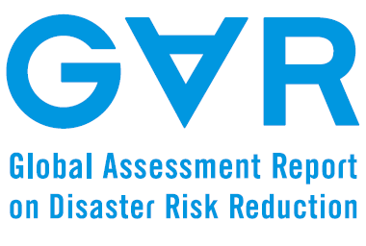
Date 30 December 2013

Input Paper

Prepared for the Global Assessment Report on Disaster Risk Reduction 2015

TITLE
Land Use Planning For Disaster Risk Reduction And Climate Change Adaptation: Operationalizing Policy And Legislation At Local Levels
Subtitle (Tahoma 11+Center)

Authors David King, Sharon Harwood, Alison Cottrell and Yetta Gurtner, Agung Firdaus
Institution/contributors
Centre for Disaster Studies, James Cook University, Australia

Table of Contents
Introduction………………………………………………………………………………………………………………3
HFA Context of Planning for DRR ……………………………………………………………………………….4
Practical Planning Approaches to DRR ………………………………………………………………………..5
Zoning……………………………………………………………………………………………………………5
Settlement Design…………………………………………………………………………………………..6
Information and mapping…………………………………………………………………………….....6
Local Government……………………………………………………………………………………………6
Tropical Queensland (northern Australia) Case Studies………………………………………………….6
Land Use Planning in Australia………………………………………………………………………….7
Land Use Planning in Queensland……………………………………………………………………..8
Machans Beach Case Study: a Delta Beach Community………………………………………9
Beach Front Communities: Recovery at Tully Heads and Hull Heads……………………11
Recovery and Planning following the Tsunami:
case study of Recovery at Phuket, Thailand ………………………………………………………………..13
Community Based Redevelopment……………………………………………………………………13
Government Tourism Related Policy and Redevelopment……………………………………14
Community Resilience and adaptation……………………………………………………………….15
Indonesian Case Study:
Integrating Coastal and Disaster Management Legislation and Practice………………………….15
Recommendations for Integration of Coastal and Disaster Legislation………………….17
Progress and Shortcomings………………………………………………………………………………………..18
Recommendations to 2025…………………………………………………………………………………………19
References……………………………………………………………………………………………………………….20

Map 1: Hazard zones at Machans Beach, Cairns………………………………………………………….11
Image 1: Machans Beach Esplanade after a minor storm surge …………………………………..10
Image 2: Storm Surge Destruction from Cyclone Yasi 2011…………………………………………12
Image 3:QRA/CTS design for rebuilding for storm surge (QRA 2011)…………………………….12
Image 4: Reconstructed dwelling at Tully Heads/Hull Heads…………………………………………12
Image 5: Integration framework
for disaster management and coastal management planning………………………………………..16

Introduction
DRR and climate change adaptation are enhanced by good practice land-use planning at local and regional levels. The responsibility of urban and regional planners to actively engage in DRR through land-use planning processes and mechanisms developed as a need during the IDNDR and was identified as a priority action in the HFA. In a rapidly urbanising world where population growth has remained high, greater numbers of people than ever before in human history are moving to towns and cities, many of which are sited in hazard prone areas where new residents lack local knowledge. Furthermore EM-DAT (2013) and IPCC (2013, 2012) predict increases of climate driven natural disasters as a consequence of climate change. Since 1900 there has been an increase in the numbers of natural disasters with an even greater increase in the economic costs of these events. The numbers of people affected by natural disasters have increased comparably, but numbers of deaths have diminished, most probably as a consequence of better warnings and communication combined with the emergency management focus on raising awareness, preparation and mitigation of risk.

Floods and tropical cyclones have caused enormous economic losses, while both floods and cyclone surge have contributed significantly to deaths in disasters (EM-DAT 2013). Heatwaves are another major cause of death, although not of property losses. In some countries, such as Australia, bushfire, or wildfire, add to death rates and economic losses. While river inundation is the most destructive type of flood, flash floods and severe storms, accompanied by landslides are further disaster impacts. All of these natural hazards -- floods and landslides, severe tropical cyclones and surge, bushfire, and heatwaves are predicted to increase in quantity and intensity as a consequence of climate change (IPCC 2013). All of these hazards are conducive to amelioration and mitigation by planning practice and control. Drought is also predicted to increase with global warming, but it is less directly amenable to risk reduction through land-use planning. However, the negative impacts of drought will have secondary impacts upon planning practice through relocation, the decommissioning of declining or abandoned settlements, and associated long-term land-use changes.

IPCC (2012) notes the increase in economic losses and increasing exposure of both people and their assets. IPCC also stresses the social and cultural nature of hazard vulnerability, and specifically that "settlement patterns, urbanisation and changes in socio-economic conditions have all influenced observed trends in exposure and vulnerability to climate extremes (high confidence)" (IPCC 2012 p7). “The most vulnerable industries, settlements and societies are generally those in coastal and river flood plains, those whose economies are closely linked with climate-sensitive resources and those in areas prone to extreme weather events, especially where rapid urbanisation is occurring.” (IPCC 2007 p48)
Two processes require an engagement of land-use planners in DRR.
1. An increase in population and migration to cities and coastal settlements that places greater numbers of people at risk.
2. Climate change that is predicted to increase the severity and frequency of climate generated natural hazards.

This paper reviews the role of land-use planning as an element of DRR in the context of the Hyogo Framework for Action 2005 to 2015. A summary of planning roles outlined by the HFA is followed by a discussion of strategies and practices that may be utilised by planners to reduce hazard risk. Case studies from Australia (especially the tropical north), Thailand and Indonesia illustrate some approaches to planning for DRR. A discussion of progress and shortcomings identified in the case studies is followed by recommendations for the next decade.

HFA Context of Planning for DRR
Following on from Yokohama and the IDNDR, the role of land-use planning was reinforced in the HFA (ISDR 2007). Specifically an integrated multi-hazard approach recommended policies for planners. Planning was identified in relation to protection of infrastructure and assets with a particular opportunity to build resilience and reduce risk during post-disaster reconstruction. Planners have the responsibility to move communities forward in allocating safe land and encouraging more hazard resistant structures, thereby reducing "underlying risk factors" (ISDR 2007 p6).

National legislation frameworks should integrate risk reduction into "development policies and planning at all levels of government" (ISDR 2007 p6). Emphasis on all levels of government and on development planning as well as urban growth requires legislation and good practice. A number of planning specific requirements were outlined:
1. hazard mapping and risk assessment, which are precursors for strategic planning and development decisions;
2. ecosystem sustainability which may be achieved through land-use planning and development to reduce risk;
3. integrated environmental and natural resource management structural and non-structural flood controls alongside ecosystem protection;
4. climate change adaptation and risk reduction are incorporated into planning practice;
5. protection of critical infrastructure and cultural heritage is achieved through design and retrofitting;
6. the relocation of displaced populations should not increase hazard risk and vulnerability in destination settlements;
7. incorporation of disaster risk assessment into urban planning of vulnerable settlements includes a range of housing types including informal settlements and slums;
8. incorporation of disaster risk reduction into the planning of all infrastructure projects should use social impact assessment, environmental impact assessment and economic assessments;
9. there should be incorporation of DRR guidelines and monitoring tools into land-use planning and policy;
10. rural development planning and floodplain management must ensure safe locations for settlement;
11. building codes and standards should be upgraded or developed, especially in relation to climate change adaptation, and also need to include informal housing.

The Australian government, for example, had acted upon the need to mainstream DRR across all sectors, thereby identifying land-use planning as a key tool for reducing future risks. The 2009 Council of Australian Governments Natural Disaster Resilience Statement (COAG 2009) closely replicates the HFA strategy for action. Priority outcomes for reducing risk in built environments required decision-making in planning and building controls to identify risks, and to develop hazard information tools that make risk knowledge broadly available, while concurrently regularly reviewing building codes. Secondary support for these measures was to be developed through tertiary and vocational education, through hazard protective structures especially for critical infrastructure as well as enhancement of insurance cover. During post-disaster reconstruction consideration is to be given to relocation of vulnerable populations, land-use change and enhanced building codes. Many of these sorts of measures were taken up globally by other governments.

The HFA Mid Term Review was less than optimistic about progress that had been made. A precursor to planning development controls, comprehensive risk assessments had been completed in few countries by 2007. The priority to reduce underlying risk factors was reported as having made the least progress, partially because of rapid urbanisation, climate change and the vulnerability that is exacerbated by poverty. Difficulties highlighted "poor urban and local governance" (ISDR 2011 p28). Disaster impact, response and resilience are focused at local government levels where planning decisions have the greatest impact upon risk reduction, but it is at this level the governance is at its most constrained.

Practical Planning Approaches to DRR
Land use planners are urged to engage centrally in DRR. However it is not the primary activity of planners to practice hazard mitigation. It is at best a minor or subsidiary role in a profession which is primarily concerned with the development of land for new uses, especially urban growth. Responsible land use planning can prevent or reduce the severity of impact that a natural hazard can have upon a community. Building standards can mitigate the damage and destruction to property and infrastructure and therefore increase the resilience of a community during and after a disaster. These two approaches in combination contribute to the creation of safer and more sustainable communities.

Conversely irresponsible planning would be described as permitting the development of settlements and infrastructure in locations that have a high likelihood of experiencing a natural disaster. Differentiating between responsible and irresponsible planning is the challenge. Having complex disaster prediction models is useless if they are unable to be applied in land use planning or are not capable of withstanding peer (or judicial) review. Whether land use planning is responsible or irresponsible depends upon who is making this judgement and is determined primarily by whether the profession they come from assesses the risk of a disaster or if they personally respond to disasters.

Climate change adaptation has been interpreted within land-use planning as hazard mitigation through the identification of constrained land. Future development of the land is then restricted but not prohibited, to ensure appropriate hazard mitigations are in place. Emergency management agencies, however, view that same area of constrained land as priority evacuation zones when specific disasters are declared.

Planning for DRR typically takes place prior to a disaster, at the mitigation or preparation and prevention phase, but planners also have a role in post-disaster recovery and reconstruction (Donovan 2013). Planners have three main areas through which they may reduce hazard risk or reduce vulnerability to risk. These are the zoning of current and future land uses whereby development controls and building codes are applied as appropriate to the type of land and its structures, urban infrastructure and settlement design, and information and mapping. These activities primarily take place within the jurisdiction of local governments which experience constraints of resources and capacity. Local governments also inherit the legacy of past planning decisions which usually were not concerned with DRR.

Zoning
Land is zoned through strategic plans that specify preferred development and modify existing zones. Land-use zones are driven by economic considerations, with pressures from developers and entrepreneurs on the one hand, and infrastructural, environment and heritage issues on the other. Burby (2000), Godschalk (2003), Cardona and Maarten (in IPCC 2012), Handmer et al and Cutter and Ossman-Elasha (in IPCC 2012) identify reduction of vulnerability through control or curtailment of new developments in hazard prone areas. Climate change adaptation and associated hazards have placed greater emphasis on the legacy issues of settlements in risk prone areas. Floodplains, bushfire and coastal zones are subject to increasing risk.

Titus (1991) drew attention to the need to abandon some hazardous locations. The Australian Department of Climate Change (2010) formalised adaptation options under the headings of Protect, Retreat, and Accommodate. Protect options are engineered structures such as seawalls and levees. Planners have some authority over the structures, but are divided concerning their usefulness and maintenance costs, especially in the longer term (King at al 2013). Accommodate strategies fall largely into community resilience building, awareness and communication, requiring residents to adapt to an increased risk. Planners may play a supportive role through implementation of building codes, settlement layouts and building heights for example. Retreat is a more controversial policy as it may require buybacks and occasionally compulsory relocation, especially after a major disaster (King at al 2013). Retreat may also involve voluntary relocation of people and the decommissioning and rezoning of highly vulnerable places. Planned retreat confronts the legacy of poor planning decisions made in the past, but it is constrained by politics and community acceptance.

Settlement Design
Urban and settlement design enhance DRR at the levels of disaster recovery (Donovan 2013, Olshansky 2008), resilience and social capital enhancement (Godschalk 2003, Lavell and Oppenheimer in IPCC 2012) and through the design of resilient infrastructure (Donovan 2013, Measham at al 2011) including protective structures and measures (DCC 2010). Settlement layouts, heights of houses, the design and landscaping of drainage and flood retention areas are integral to flood, flash flood and surge control. Road design is an additional element of transport planning that adds to both drainage and planned safe evacuation routes. While urban design has much to contribute to DRR, there are trends in design, such as New Urbanism, that call for greater density. While New Urbanism as such does not increase vulnerability, greater density of population increases risk unless accompanied by targeted mitigation measures, (Stevens et al 2010) and good practice new urbanist design, even with DRR measures, contributes to the safe development paradox (Stevens et al 2010, Berke et al 2009, Burby 2006) where people think that hazard mitigation has made them safer than they really are.

Information and mapping
Local government strategic planning requires comprehensive hazard mapping that informs land-use decisions (Godschalk 2010, Burby 2000, Measham et al 2011) and provides supportive information to communities, thereby empowering both the community and its residents (King 2008) and the institutions responsible for their care (Burby 2005, Godschalk 2003) Communication is an essential aspect of hazard education (ISDR 2012) that emerges as a critical need after a natural disaster (Donovan 2013).

Local Government
All of these planning approaches, zoning, design and information, are concentrated at the local level where the disaster has the greatest impact. Local government has the least resources, weakest governance and lowest capacity of all of the levels of government, but has to deal with the practical application of planning for DRR, building community resilience, response and recovery (Ahrens and Rudolph 2006, Gabriel 2003, King 2008). Slow progress of the HFA may be attributed to problems and capacity at the local government level.

Tropical Queensland (northern Australia) Case Studies
The purpose of this section is to provide an overview of how climate change and disaster risk reduction have been conceptualised in Australia and in turn operationalised in statutory Land Use Planning in tropical Queensland. The case studies suggest that the range of responses is dependent upon the agency’s appetite for risk. Land use planning plays a significant role in the way in which communities adapt to climate change and mitigate the effects of the extreme events upon the ongoing sustainability of communities. The difference between the perspectives of the emergency professionals is that they have no tolerance for risk whereas planning has an entirely different approach as they are tied to political terms which overshadow the long term. As settlements continue to expand and grow, some have moved on to more environmentally constrained land which further exacerbates the risk from hazard events. This approach to planning has been criticised by academics and politicians subsequent to the Queensland flood disasters in 2011 and Victorian bushfires in 2009. Haynes et al reported that ‘more thoughtful land use and planning could curb the destruction they [bushfire] cause in and around cities’, where residents had complained that government restrictions had prevented them from clearing trees on their land as a fire break and that suburbia continues to expand into untamed bush land without due preparedness and protection’ (2013 p469). In addition planning tends to focus on the future impacts of climate change as opposed to the impacts that current weather and hazard events are having upon communities. Impact and mitigation strategies must be considered in current planning activities not in 2050 for the worst case scenario. Creating complex prediction models and having knowledge and understanding of hazards and risks is useless if they are not designed for incorporation into statutory land use plans and building codes.

Land Use Planning in Australia
To understand how land use planning operates in Australia first requires an overview of the relationship between the Australian constitution and the three levels of government. The constitution does not recognise the role of the local government and as such the constitution is limited to separation of powers at the federal and state/territory government levels. The local governments are created and administered via legislation within each of the six states and two mainland territories. This means that there is no direct link between federal policy initiatives and the operationalisation of these at the local government level in Australia except through the endorsement of the administering state or territory. This became painfully evident to the presiding government in 1992 when they realised that while the federal government could agree to international conventions such as Agenda 21, there were no provisions within the Australian constitution to support the international obligations and therefore no legal platform to implement the structural adjustments throughout the various levels of government. To overcome this structural impediment, the federal government created the Council of Australian Governments (COAG) in 1992 (its members include the prime minister, state and territory premiers or chief ministers and the president of the Australian Local Government Association - who represents the views of approximately 560 local governments in Australia). The primary role of COAG is to facilitate policy reforms that are of national significance and require the co-ordination of all levels of government. Under COAG the Police and Emergency Services Standing Council have the lead responsibility for providing national leadership on emergency management (all-hazards) and disaster resilience, including national policies and priorities.

This does not preclude disaster management being addressed by other Standing Councils. For instance, the Standing Council for Transport and Infrastructure (SCOTI) is tasked specifically with issues relevant to transport, infrastructure and related land use planning, but does not address hazard resilience or disaster management.

In 2011 the federal government released the National Disaster Resilience Strategy (NDRS), an initiative of the Standing Council for Police and Emergency Management to create and adopt a nationwide resilience-based approach to disaster management. This strategy (amongst many others) is a policy outcome designed to support the National Disaster Resilience Framework. Contained within the NDRS are a series of priority policy outcomes that specifically target the role of land use planning to create disaster resilient communities.

The NDRS acknowledges the need to undertake comprehensive assessments of hazards and risks and requires agreement on risk management principles in the approach taken in strategic planning and development controls to adequately mitigate identified risks (Commonwealth of Australia 2011). There were seven priority outcomes reflected in the NDRS (Commonwealth of Australia 2011:12):
1. All levels of decision making in land use planning and building control systems take into account information on risks to the social, built, economic and natural environments.
2. Information on the likelihood of damage from hazards is actively shared, and tools are available to support understanding of potential consequences and costs.
3. Building standards and their implementation are regularly reviewed to ensure they are appropriate for the risk environment.
4. Development decisions take account of both private and public risks.
5. Natural hazard management principles are included in tertiary and vocational training and education curricula for relevant professional and building industry sectors.
6. Settlements, businesses and infrastructure are, as far as is practicable, not exposed to unreasonable risks from hazards or have implemented suitable arrangements, which may include hardening infrastructure or taking up adequate insurance, to protect life and property from known hazards.
7. Following a disaster, the appropriateness of rebuilding in the same location, or rebuilding to a more resilient standard to reduce future risks, is adequately considered by authorities and individuals.

The SCOTI recently completed a review of the strategic planning framework of Australian capital cities. There were no linkages or references made in this assessment to ensure that the seven abovementioned issues are reflected within the strategic urban planning frameworks. The capital city framework assessment was reviewed by the COAG Reform Council to determine the extent to which these improve integration to achieve consistent planning and delivery across relevant parts of the government especially transport, economic development and land use. The review concluded that none of the capital city strategic planning systems were found to be wholly consistent with the national criteria. Moreover, there was no consideration of hazard mitigation within the review nor were there any recommendations to address natural hazards within the planning frameworks.

Land-use planning has not evolved through or with consideration of natural hazards. Rather, its recent focus, particularly in Australia subsequent to the Agenda 21 in 1992, has been upon the creation of frameworks to mitigate the impacts of development upon ecological processes and environmental values. There is a distinct lack of integration throughout the COAG Standing Councils on the matters of natural hazards and disaster resilience. The case studies further highlight the importance of integrating data sets that emergency management apply in their role in disaster management, with the land use planning frameworks to enable the creation of hazard resilient communities.

Land Use Planning in Queensland
The case studies examine the extent to which policy creates hazard vulnerable communities by reviewing the planning legislation, state planning policies, and local planning scheme provisions, associated with natural hazards compared to the data used by emergency management services. This review applies comparative policy analysis methods (Geva-May 2002) to examine the relationship between the problem (hazard vulnerability and disaster resilience) and the solutions (hazard mitigation) via land-use planning frameworks and procedures.
The criteria that are used to guide the comparative analysis include legislation, state planning policies, local planning schemes, property disclosures and emergency management systems relevant to each state or territory. The first of four components broadly comprise the planning frameworks within each state or territory in Australia. While each jurisdiction creates its own separate procedures specific to its own circumstances and history, they broadly share four components:
1. Planning legislation – Does the object of the act require plans or the planning process to address climate change and disaster risk reduction? Does strategic planning (location of future communities or expansions of current) or development assessment assess the risks at individual site level in the absence of a strategic framework) or consider the vulnerability of communities to natural hazards?
2. State Planning Policies – These are planning instruments that protect matters of state or territory that are of interest to the state. A state planning policy specific to hazard mitigation is in place but local government planning schemes are in the process of reflecting the elements outlined in state planning policies.
3. Planning Scheme – the extent to which the planning scheme considers natural hazards and either prohibits or limits development in identified hazard locations varies significantly between councils.
The fourth component has been included to determine the extent of integration between data sets applied by emergency management within the applicable planning schemes.
4. Emergency Management Systems – describe the data made available by state and local governments to identify and mitigate the risk of natural disasters.

All development in Queensland is controlled through the Sustainable Planning Act 2009 (hereafter referred to as SPA, but due to be superseded by a Planning and Development Act in 2014). The purpose of the SPA is to achieve ecological sustainability through management of the planning process, the effects of development and government co-ordination. The objects of this act are advanced through decision-making processes, sustainable use of natural resources, reduction of environmental effects of development (climate change, urban congestion and human health), diversification of housing and the economy, infrastructural efficiency, enhancement of the amenities of the built environment, and opportunities for community involvement.

SPA requires planning schemes to address the impacts of climate change, but not natural hazards (unless these hazards can be proven to be the result of climate change). There is no mandate to create hazard-resilient communities within SPA, rather the focus is on procedural and environmental matters. The structure of the act requires all planning schemes within the state to comply with State Planning Policies.

Machans Beach Case Study: a Delta Beach Community
Machans Beach is a beachside suburb of Cairns in tropical north Queensland Australia, sharing hazard threats common to many hundreds of such beachside communities. The suburb is located within the Barron River Delta, surrounded by three river networks, (Barr Creek, Redden Creek and the Barron River) and has a 2.5km shoreline along the Coral Sea. During moderate to high rainfall events the rivers often breach the mainland causing flooding to properties located along the delta.

Cyclones, storm-surge events and flooding pose the greatest threats to Machans Beach and these are directly related to the topography and geophysical aspects of the Barron delta-based community. The lone access road is impassable when high rainfall coincides with high tide. In these instances, Machans Beach is inaccessible and, in turn, the residents are trapped. Machans Beach has experienced small-scale cyclone-generated storm-surge events from Tropical Cyclone Justin in 1997, Rona in 1999, Steve in 2000 and Yasi in 2011. Regular flooding occurs within the area due to its physical profile.

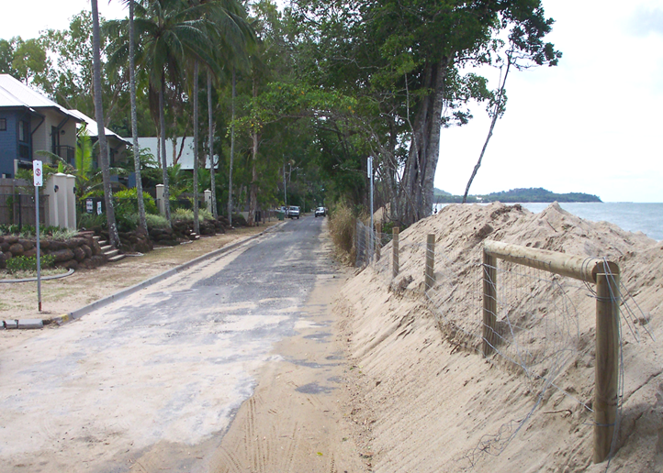
Image 1: Machans Beach Esplanade after a minor storm surge

Storm-surge mapping indicates that the entire delta within Machans Beach would experience inundation at two metres or greater, notwithstanding sea level rise. Due to its topography and three surrounding river networks, it would be subject to minor and major storm-surge events. According to the storm-surge models (Granger et al 1999) the suburb would be one of the most seriously affected residential suburbs within Cairns with approximately 90% of dwellings flooded or isolated by water.

The community has had a storm surge evacuation map created to guide residents and emergency management agencies to prioritise the evacuation of locations within the Council area. However when the same area is examined within the draft planning scheme it is entirely covered in the flood inundation overlay and contains some bushfire hazard. The point that is made is that no one area is determined to be any worse than another in the land use planning maps, but the evacuation maps clearly identify the areas that are on a continuum of high risk of experiencing an inundation.

The Queensland Department of Environment and Heritage have created a mapping database to identify locations that experience ‘coastal hazards’. Coastal Hazards are defined as areas that experience the natural processes of coastal erosion and storm tide inundation. These processes are considered to be hazards because they have the potential to impact development upon the coast and pose a significant threat to community safety. The area that is identified as containing a coastal hazard also includes consideration of climate change effects such as increasing sea levels and cyclone intensity. However the fall back position of the Queensland government has been to project a sea level rise of 0.8m by the year 2100 as per the predictions from the IPCC.
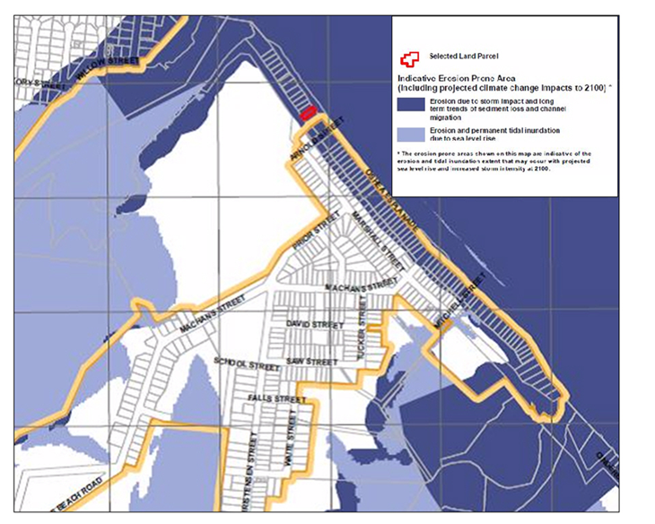
Map 1: Hazard zones at Machans Beach, Cairns

It is important to note that despite data indicating that a range of hazards exist in developing areas along the coast line, development is not prohibited from occurring. Rather the local government would seek to see a range of mitigations that have addressed the impacts of a hazard upon the proposed development. Where the developer can demonstrate that they have adequate mitigation in place to meet the outcomes sought by the local government then the development will be approved. It should be noted that land use-planning operates in a highly litigious environment. If developers do not get their development approved by the local government they are able to take the matter to court for the Judge to decide.

Two category 5 cyclones and several catastrophic flood episodes since 2006 have cost the Queensland economy many billions in lost production and revenue in addition to the cost of clean-up and recovery. Some local governments have taken a more proactive stance in the way in which they undertake planning by restricting the settling of constrained lands through identifying more appropriate future locations. The planning approach has been to offer a range of incentives to developers, such as infrastructure provision, to develop the unconstrained land and alternatively applied planning controls on hazard prone land that impose extensive upfront costs to mitigate hazard risks. At no point in time is the developer responsible for the loss of life or clean up and recovery after they have developed and sold the property. The responsibility of post disaster clean up becomes that of the local government and emergency management to deal with.

The case of Machans Beach in Cairns provides an example of how development works in a free market economy where the land is owned privately and regulated by the state to achieve social objectives. The following case study provides examples within the same state government policy environment, where natural disaster destroyed similar beachfront communities.

Beach Front Communities: Recovery at Tully Heads and Hull Heads
Two category 4/5 tropical cyclone devastated coastal communities 150 kms south of Cairns in 2006 and 2011. Storm surge was especially destructive during Cyclone Yasi in 2011. These communities are very similar to Machans Beach and other Northern Beaches suburbs of Cairns, having been established when beachfront land was cheap and DRR was not part of land-use planning practice. Beachside communities are the clearest example of the risk legacy and all are ultimately threatened with sea level rise and a long-term likelihood of "retreat" as beachfront land is eroded and inundated. However, many residents of these communities are retirees who do not expect the climate change threat to eventuate in their lifetimes, despite having recently experienced a 5 metre storm surge. Residents who have rebuilt, expressed a stoic attitude of endurance and resilience. On the other hand many housing blocks remain empty, following complete destruction of dwellings while many more that have been rebuilt are for sale. An out-migration of disaster impacted residents has already taken place.

The communities of Tully Heads and Hull Heads were severely damaged by storm surge, especially dwellings that had been built along the beach ridge. People evacuated well in advance of the cyclone warning so there was no loss of life. Storm surge obliterated some dwellings constructed of light materials such as timber, but even where substantial block built houses withstood the impact of the sea, saltwater ingress ruined their interiors. Almost all had to be rebuilt.

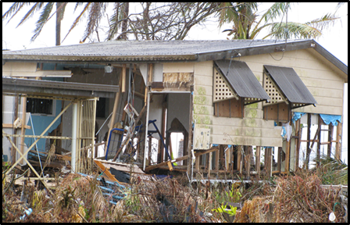
Image 2: Storm Surge Destruction from Cyclone Yasi 2011

After the 2011 floods had occurred throughout Queensland and Cyclone Yasi in the North, the Queensland government established a disaster response planning agency -- the Queensland Reconstruction Authority, QRA. Planners with the QRA consulted impacted communities and provided advice and guidance for rebuilding. In Tully Heads and Hull Heads the QRA worked with the Cyclone Testing Station of James Cook University to design stronger dwellings built to cyclone standards and able to withstand a severe storm surge. The sketch design is illustrated and below in image 4 is a very sturdy example of a re-built dwelling that reflects the QRA/CTS design.

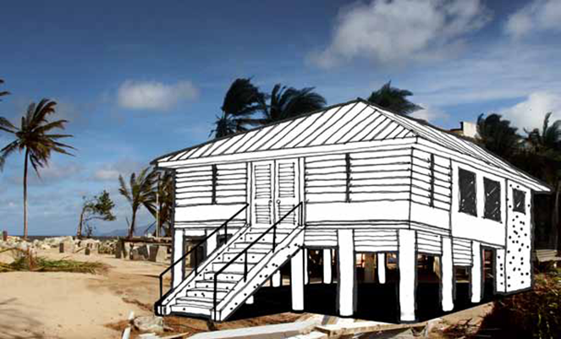
Image 3:QRA/CTS design for rebuilding for storm surge (QRA 2011)

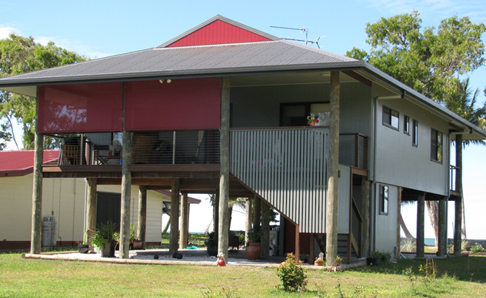
Image 4: Reconstructed dwelling at Tully Heads/Hull Heads

The rebuilding of Tully Heads and Hull Heads is a best practice example of a land-use planning response agency engaging in extensive community consultation to meet the desires of residents to rebuild to a higher safety standard. However, residents are still living on the same fragile beach ridge (in most cases the only land that they own -- insurance coverage paid for rebuilding the house, usually for replacement rather than building back better) that remains as susceptible to sea level rise and storm surge as before. The hazard risk has not been mitigated. The solution is a short-term adaptation, but as noted by residents probably long enough to cover their lifetimes, and meanwhile the location is paradise. Relocation was not an option for people who had invested all they owned into living on the beach. The planners were impeccable in their community consultation, but there has been minimal hazard reduction.

Recovery and Planning following the Tsunami: case study of Recovery at Phuket, Thailand
Community Based Redevelopment
Despite the fact that the Thai government made a formal commitment to provide ongoing community support and assistance to the Phuket tourist area following the 2004 Indian Ocean tsunami, the unstable political context and established policy of decentralisation meant that this responsibility was relegated down to the provincial and sub-district levels (Calgaro and Lloyd 2008). With an apparent emphasis on the tourist centre of Patong, many long term recovery initiatives were compromised due to funding shortages and weakness in governance structures. Government efforts were subsequently short lived as the private sector, community, and social networks mobilised to facilitate their own recovery initiatives.

In many coastal communities such as Khao Lak and Phi Phi, elite and dominant landholder groups used existing network alliances and resources to influence the government to grant access and entitlement to development opportunities that often contravened official planning and zoning regulations (Calgaro and Llyod 2008). Such policy and initiatives resulted in pervasive tension, conflicts, controversy, and increasing disparity between social groups. The political influence of this private sector further swayed the direction of official tourism marketing strategies to maximise self-interest, with limited input or consultation from other stakeholder groups.

Lacking such political associations or linkages, expatriates and smaller scale operators utilised established international and external contacts to support independent reconstruction and recovery efforts, but enthusiasm and the financial backing for many of these endeavours waned over subsequent months. More entrepreneurial residents established partnerships, leases or co-ownership arrangements. Having lost all official documentation (ie business registration, proof of assets etc) many small businesses were unable to secure funding to rebuild (Calgaro and Llyod 2008). Some owners were forced to sell their struggling businesses and seek alternative income, while other establishments and infrastructure were left in abandoned disrepair. Numerous shop and store fronts became transitory, reflecting the seasonal and annual fluctuations in visitor demand.

At the host community level, the familial group functioned as the primary welfare and support structure throughout most of the local rebuilding and restoration process. Consistent with the strong role of the family unit and high value of self-sufficiency in Thai culture, extended kin members provided child minding, psychological care, spiritual support, informal education and monetary aid where possible. Residents who had previously remitted income to remote and rural family members were often forced to reduce or cease such payments as limited prospects resulted in higher employment attrition rates and migration (Nidhiprabha 2007).

Frenetic activity towards rebuilding and even increasing tourism capacity in popular tourist destinations was starkly contrasted in the more remote and marginal communities. Smaller subsistence style coastal communities were left to fend almost completely for themselves. In more accessible locations, minority groups including Thai Muslims and indigenous Moken/Chao Le (sea gypsies) were directly discriminated against receiving no formal government aid or support. Without acknowledged land ownership, many villagers were refused access to proper dwellings, running water and electricity. Increasing tourism development, overfishing, and the designation of extensive national parks and marine protected zones have further impacted on existing traditional fishing and seafaring livelihoods.

As the demand for permanent shelter was resolved, the more experienced and resolute non-government agencies still operating within the region again prioritised the traditionally marginalised subsections of the population including ethnic minorities, elderly, women, children, and micro-enterprise. Despite a number of positive resettlement, micro finance, and economic diversification initiatives, most short to medium term recovery projects were unsuccessful. Given the scale and sheer number of the affected population, the relief environment in Southern Thailand revealed a chaotic multitude of agencies and organisations often having different mandates and agendas, working at various levels. Similarly, a lack of coordinated planning and policies resulted in a range of new and emerging vulnerabilities, including natural resource depletion, overt profiteering, and aid dependency

Rather than providing an equal opportunity for community participation, growth and redevelopment, Southern Thailand’s aid experience highlighted the significance of social and community dynamics in influencing the direction of resilience and recovery. Impacts were highly differential at the micro level, contrasting stakeholder innovation and informal initiatives against the weakness of the formal governance system. Similarly, a pervasive lack of trust of authorities and public officials seemed to increase existing social unrest undermining formal planning development proposals.

Government Tourism Related Policy and Redevelopment
The Thai government used the opportunity of the disaster to rethink its’ development priorities for the region. With a formal policy preference oriented toward “quality tourism” the plan was to substitute larger scale high-end tourist enterprise for the traditional small, lower-end enterprises and operators within the informal sector. Strict zoning regulations, building codes, and an integrated set back system were also mandated to mitigate future adversity and exposure to coastal hazards. Formulated without any community consultation or consideration for local businesses and vendors, all buildings and structures were strictly prohibited along the beach and coastline. However, just as sun lounges, Jet Skis and vendors returned to the beaches of Phuket in defiance of such government prohibitions, coastal development resumed in other restricted set-back zones. On the popular island of Phi Phi Don (Koh Phi Phi Don) hundreds of residents ignored construction bans to rebuild on the extensively damaged and exposed central isthmus of the Ton Sai Resort area, in an attempt to re-establish custom and livelihoods. Similarly, both large and small scale development was undertaken in the Khao Lak coastal region with limited regulatory control or regard for government rehabilitation plans. Without the financial and/or human resources to enforce legislative changes, built structures and inhabitants were again directly exposed to a potential tsunami hazard.

Disaster Management was developed through an extensive risk management assessment and planning process for the tsunami impacted region. The Phuket Province Risk Management Plan and Municipality Disaster Management Plan were further progressed in 2008 utilising an “all hazards” approach rating the overall level of risk for each identified hazard, based on likelihood of occurrence and severity of consequences.

Community Resilience and adaptation
At the individual, micro-industry, and small to medium business level, effects were highly variable. Residents with influential family/contacts, access to extensive assets and resources, or well developed entrepreneurial skills managed to adapt and in some cases expand and prosper. Others have received direct assistance from overseas contacts and networks of loyal return customers. Empirical evidence however, suggests that most members of the host community that were dependant on tourism for their livelihoods were forced to adopt difficult coping strategies.

Financially, few local residents in any of the affected regions possessed significant savings, investments or assets. This was particularly evident for those working in the informal sector. In response to concerns about repeat disaster events and adversity, government proactively engaged in a review of existing disaster management knowledge, capacity and procedures. Extensive hazard and vulnerability mapping was performed, resulting in regional risk management planning and community education strategies.

While effective, the majority of these practices were voluntary. Without any legal obligation, mandate, or enforcement, such efforts have not been widely sustained. In Southern Thailand a lack of effective development control has seen the construction and rebuilding of extensive infrastructure in coastal areas that were specifically designated as set-back areas post tsunami – leaving tourist and staff directly exposed to future threats. Unplanned and uncontrolled development continues, while environmental problems such as degradation, coastal erosion, pollution and resource depletion are becoming more apparent.

Indonesian Case Study: Integrating Coastal and Disaster Management Legislation and Practice
A major question in disaster management and coastal management planning is how to integrate disaster management and coastal management to meet environmental, resource and community needs. This has implications for both conceptual and practical applications in the form of legislation and planning requirements. Integration of coastal and disaster management is constrained by the different legislation dealing only with its own jurisdiction, such that coastal management addresses resource issues without paying attention to natural hazards, while disaster management addresses the hazards without acknowledging resources and livelihoods. Integration is also required to avoid contradictions in legislative processes and to optimise available resources. The Indonesian context illustrates the complexity and challenges of d integration because:
i) its vulnerability to coastal disaster is very high,
ii) Indonesia has enacted disaster management and coastal management legislation, and
iii) there are three different levels of planning systems from national through provincial to local (district/city) which add to the complexity of the planning process.
Assessment of Indonesian legislation and planning arrangements resulted in the development of a framework that integrates disaster management and coastal management for coastal communities. The framework uses existing conceptual and theoretical approaches in both fields and provides a new relationship between disaster management communities and coastal management communities at conceptual, legal, planning, and implementation levels.
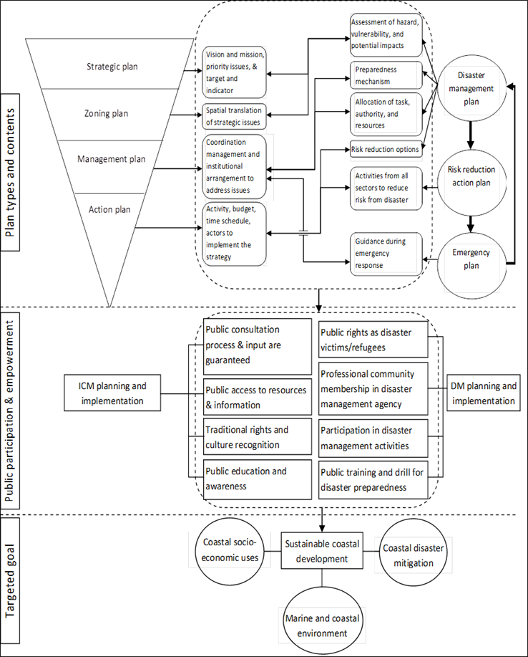
Image 5: Integration framework for disaster management and coastal management planning, (Firdaus 2012)

This integrated framework for coastal and disaster management addresses coastal hazards, legal constraints, spatial boundary and program limitations, planning time horizons that vary between legislation, vulnerability assessment, environmental, and governance contexts. The application of this framework at local government level shows that multidimensional vulnerability factors cannot be addressed by only disaster management or coastal management policies and programs. Weaknesses of existing plans and fragmentation of programs and policies are the basic problem. GIS analysis of coastal hazard and community vulnerability in northern Java (Semarang and Pekalongan) corroborated the potential problems in disaster management and coastal management legal and planning assessments. The issues identified suggest a process of integration that eliminates cultural barriers between sectoral agencies that perceive integration as a threat to their authority. The framework allows both disaster and coastal management communities to optimise their strengths and reduce their limitations without compromising their existing development, ultimately achieving coastal sustainability.

Recommendations for Integration of Coastal and Disaster Legislation
It is recommended that coastal disaster management planning and its regulations should be undertaken more inclusively to integrate both disaster management and coastal management stakeholders. In the Indonesian context, communication between the Ministry of Marine Affairs and Fisheries and the National Disaster Management Agency in developing detailed regulations to implement the acts need to be strengthened. Moreover, the national government needs to increase its facilitation for local government to accelerate the fulfilment of the acts’ mandates in disaster and coastal management planning. As the mandates are very complex and are potentially a disincentive to implementation, optimising local universities’ roles to provide technical and expertise assistance is important. One crucial action is developing a national gazette for village names to reduce the problem of compatibility between census data and base maps to support national vulnerability assessments.

At the governance level, examination of post disaster rehabilitation planning in coastal areas needs to be undertaken. At the implementation level, the interaction between coastal habitat rehabilitation and conservation and community capacity to cope with and recover from coastal hazards still needs assessment. In particular it needs to identify how the activities in coastal management can be matched with the activities in disaster management both spatially and over time.

Aside from legislative and planning processes, basic data is required to inform decision making. For example, detailed ground elevation data to provide more accurate inundation distribution. Vulnerability distributions do not match with existing spatial arrangements in the Coastal Management Act and allocation of coastal management and disaster management programs to address it are limited. Specific attention needs to be given to assess how the program and funding location, not only total allocation, matches with the spatial distribution of coastal hazards and community vulnerability. This then can be used for monitoring and evaluation of the effectiveness of coastal disaster management by applying census data from different years to examine vulnerability changes and associated socio-economic development.

In addition, from a spatial planning point of view, it is essential to evaluate potential future losses caused by existing development especially city spatial plans which still allocate significant activities in hazardous zones. The results can then be examined with proposed mitigation actions to see the benefit and cost of the programs against potential loss. These are important for safer and more resilient coastal development in the future.

Progress and Shortcomings
The intent of the HFA strategy for land-use planning has been followed in a piecemeal manner, demonstrating some successes, but also a significant proportion of failures and constraints. Initiatives developed and agreed at the international level were endorsed by national governments. The agreement had then to be actioned through legislation to multiple levels of government over a period of time.

The most fundamental constraint is that land-use planning is oriented towards the promotion and facilitation of new developments, where consideration of DRR and climate change adaptation are still relatively minor issues. Bottlenecks to attitudinal change amongst planners are political and economic realities that continue to be influenced by climate change scepticism. Additionally there are tight development costs that begrudge expenditure by developers on DRR or restrictions on land-use. Attitudinal change is slow and requires education and change, not only among planners (who are generally open to DRR and climate change) but the private enterprise entrepreneurs and politicians who drive the process.

Land-use planning is structured through legislation, requiring new laws and their implementation in order to practise DRR and climate change adaptation in new developments. Again it is the politicians and private sector that drive legislative change with planners acting primarily as respondents and facilitators.

Once the legislation is activated, further bottlenecks occur. Firstly land-use planners can only specify DRR actions on land that is proven to be a hazard prone. Extensive comprehensive hazard mapping has to take place to a high level of detail (1 metre differences in height are critical for surge and flood). Detailed mapping is slow, expensive and further constrained by boundary and jurisdictional issues.

Responsibility for mapping, information, communication and community education, awareness and resilience building falls primarily on local governments, whose resources and capacity are the lowest in the political system. Furthermore there are enormous inequalities between the capacity of city councils in contrast to rural local governments, especially remote and indigenous communities.

Local government areas inherit the legacy of past planning decisions, where most hazard risk resides. Planners are extremely limited in their capacity to reduce risk in communities that are already well established in hazard zones. A priority is DRR retrofitting of infrastructure and lifelines in hazard prone areas although this is also constrained by limited resources balanced against more immediate community and economic needs. Hazard proofing infrastructure requires long time periods to implement (a decade to realign and flood proof a highway is not unusual).

Alongside these bottlenecks to land-use change, rapid urban growth and urbanisation continue alongside strong population growth, adding to the constant need for new infrastructure and housing. Climate change then exacerbates the need for stronger DRR through adaptation and community resilience.

There have been successes in the area of land-use planning for DRR. The enormous task of detailed hazard mapping has advanced, although it is only after mapping has been completed that strategic plans may be modified effectively (hazard zones are more easily applicable at the strategic plan level as they require less detail than a residential development plan). As mapping has moved ahead, alongside advances in IT, information has been made available to communities. However, information is not in its self education and many local governments are still wary of releasing too much information and mapping.

Building codes, although not the direct responsibility of planners, have been extremely successful in reducing the risk of cyclonic destruction of residential dwellings. The use of building codes, within urban design, extends to such features as raised slabs and high set living areas, enabling planners to specify a range of conditions for building in areas of minor to moderate flood risk.

Integration of DRR into a broad range of legislation and government departmental jurisdictions has enhanced the role of land-use planners in furthering DRR. Where DRR has become a priority for institutions and is incorporated into specific legislation, such as the construction of critical infrastructure, planners are able to incorporate additional risk reduction strategies into planning decisions.

Recommendations to 2025
ISDR (2013) proposes a framework for recommendations that drive extension of land-use planning as an agency of DRR. Guiding principles identify areas that have been addressed in this paper; public planning, prevention of the accumulation of new risk, open information and knowledge generation. Reference is made to the need to incorporate risk reduction into governance frameworks for local government, civil society and the private sector.

Within the framework of the ISDR guiding principles, and drawing on the content of this paper, we recommend that land-use planning for disaster risk reduction requires development and resourcing in the following areas.
1. Governments must target local needs and the constraints of local government.
2. Community resilience through land-use planning needs information, consultation, and education and awareness in order to empower communities and households so that they are able to use the information that becomes available, in order to enhance their own risk reduction and climate change adaptation.
3. Comprehensive plans for disaster reduction need detailed mapping that requires significant government resources and policy initiatives. Mapping processes are under way in many countries but still have some way to go, especially in non-metropolitan regions.
4. There must be integration of legislation across government sectors with DRR and climate change adaptation fully incorporated into planning legislation as well as in related legislation and jurisdictions that impinge upon land-use planning.
5. A priority for reduction of existing risk (the legacy of past planning decisions) is critical infrastructure -- hazard proofing lifelines that will be critical to evacuation and recovery in the event of disaster, and relocating infrastructure that is threatened by climate change (residential properties are much more difficult to relocate in the short to medium term).
6. Future DRR and climate change adaptation must be built into strategic plans that indicate future settlement growth. Hazard zones must be clearly mapped, identified and strict conditions applied to the sort of land-use that will be permitted in these areas. Hazard mitigation, climate change adaptation and disaster risk reduction must be conditions of development at the local government level.
7. Urban design needs to evolve to incorporate disaster risk reduction and climate change adaptation. Design principles play an important role in recovery and reconstruction where there is enormous potential to build back better and to hazard proof future communities. Urban design (for example the New Urbanism movement) has been very effective in establishing principles of sustainability, but so far that sustainability has neglected hazard reduction and climate change.

References
Ahrens, J. and P. Rudolph 2006. The Importance of Governance in Risk Reduction and Disaster Management. Journal of Contingencies and Crisis Management Vol 14 N0 4
Berke, P., Y. Song and M. Stevens. 2009. Smart developments in dangerous locations: a reality check of existing New Urbanist developments. Int Journ Mass Emergencies and Disasters 27: 1-24
Burby, R. (2005). Have State Comprehensive Planning Mandates Reduced Insured Losses from Natural Disasters?. Nat. Hazards Rev., 6(2), 67–81
Burby, R. 2006. Hurricane Katrina and the paradoxes of government disaster policy: bringing about wise governmental decisions for hazardous areas. Ann Am Acad Pol Sci 604: 171-191
Burby, R., R. Deyle, D.Godschalk, and R. Olshansky. 2000. Creating Hazard Resilient Communities through Land-Use Planning. Nat. Hazards Rev., 1(2), 99–106
Calgaro E. and K. Lloyd. 2008. Sun, sea, sand and tsunami: examining disaster vulnerability in the tourism community of Khao Lak, Thailand. Singapore Journal of Tropical Geography, Volume 29, Issue 3, pages 288–306, November 2008
COAG. 2009. National Strategy for Disaster Resilience: Building our nation’s resilience to disasters. Australian Government, Canberra
Commonwealth of Australia. 2011. National Strategy for Disaster Resilience: Building our nation’s resilience to disasters.
Department of Climate Change. 2010. Climate Change Risks to Australia’s Coast: a First Pass National Assessment. Published by the Department of Climate Change, Commonwealth of Australia.
Donovan J. 2013. Designing to Heal. CSIRO, Melbourne.
EM-DAT. 2013. Natural Disaster Trends. The International Disaster Database, Centre for research on the Epidemiology of Disasters, Université Catholique de Louvain (UCL), Brussels.
Firdaus A. 2012. Towards An Integrated Coastal Disaster Management Framework: Bridging Conceptual and Practical Applications Using the Indonesian Legal and Planning Context as a Case Study. PhD Thesis, James Cook University, Australia.
Gabriel P. 2003. The development of municipal emergency management planning in Victoria, Australia. Australian Journal of Emergency Management, Vol 18, No 2 74-80
Geva-May I. 2002. Comparative Studies in Public Administration and Public Policy. Public Management Review, 4(3), 275-290.
Godschalk, D. 2003. Urban Hazard Mitigation: Creating Resilient Cities. Nat. Hazards Rev., 4(3), 136–143.
Granger, K., Jones, T., Leiba, M. and Scott, G. 1999. Community risk in Cairns: A multi hazard risk assessment. GeoScience Australia, Commonwealth of Australia.
Haynes K., Bird D. and McAneney J. 2013. Nature Climate: Mitigate damage risk from bush fires. Nature Vol: 503, Page:469 (28 November 2013)
IPCC. 2007: Climate Change 2007: Synthesis Report. Contribution of Working Groups I, II and III to the Fourth Assessment Report of the Intergovernmental Panel on Climate Change [Core Writing Team, Pachauri, R.K and Reisinger, A. (eds.)]. IPCC, Geneva, Switzerland, 104 pp.
IPCC. 2012. Summary for Policymakers. In: Managing the Risks of Extreme Events and Disasters to Advance Climate Change Adaptation [Field, C.B., V. Barros, T.F. Stocker, D. Qin, D.J. Dokken, K.L. Ebi, M.D. Mastrandrea, K.J. Mach, G.-K. Plattner, S.K. Allen, M. Tignor, and P.M. Midgley (eds.)]. A Special Report of Working Groups I and II of the Intergovernmental Panel on Climate Change. Cambridge University Press, Cambridge, UK, and New York, NY, USA, pp. 3-21.
IPCC. 2013. Summary for Policymakers. In: Climate Change 2013: The Physical Science Basis. Contribution of Working Group I to the Fifth Assessment Report of the Intergovernmental Panel on Climate Change [Stocker, T.F., D. Qin, G.-K. Plattner, M. Tignor, S. K. Allen, J. Boschung, A. Nauels, Y. Xia, V. Bex and P.M. Midgley (eds.)]. Cambridge University Press, Cambridge, United Kingdom and New York, NY, USA.
ISDR. 2007. Hyogo Framework for Action 2005-2015: Building the Resilience of Nations and Communities to Disasters: Extract from the final report of the World Conference on Disaster Reduction (A/CONF.206/6) International Strategy for Disaster Reduction, Geneva
ISDR. 2011. Hyogo Framework For Action 2005-2015: Building the Resilience of Nations and Communities to Disasters: Mid-Term Review 2010-2011. International Strategy for Disaster Reduction, Geneva
ISDR. 2013. Proposed Elements for Consideration in the Post 2015 Framework for Disaster Risk Reduction by The UN Special Representative of the Secretary-General for Disaster Risk Reduction. International Strategy for Disaster Reduction, Geneva
King D. 2008. Reducing hazard vulnerability through local government engagement and action. Natural Hazards. 47: 497-508
King, D., Ginger J., Williams S., Cottrell A., Gurtner Y., Leitch C., Henderson D., Jayasinghe N., Kim P., Booth K.,Ewin C., Innes K., Jacobs K., Jago-Bassingthwaighte M., Jackson L. 2013. Planning, Building and Insuring: Adaptation of Built Environment to Climate Change Induced Increased Intensity of Natural Hazards. National Climate Change Adaptation Research Facility, Griffith University
Leaning, J., and. Guha-Sapir D. 2013. Natural Disasters, Armed Conflict, and Public Health. The New England Journal of Medicine, 369:1836-42, Massachusetts Medical Society
Nidhiprabha, B. 2007. Adjustment and recovery in Thailand two years after the tsunami, ADB Institute Discussion Papers, No. 72, Tokyo: Asian Development Bank Institute
Olshansky R.B, L.A. Johnson, J. Horne & B. Nee. 2008. Longer View: Planning for the Rebuilding of New Orleans. Journal of the American Planning Association, 74:3, 273-287, DOI: 10.1080/01944360802140835
QRA. 2011. Planning for a stronger, more resilient North Queensland. Part 1: Rebuilding in storm tide prone areas: Tully Heads and Hull Heads. Queensland Reconstruction Authority, Brisbane, p. 15.
Stevens, M, Y. Song, and P. Berke. 2010. New Urbanist developments in flood-prone areas: safe development or safe development paradox? Natural Hazards, 53(3), pp605-629.
Titus, J.G. 1991 Greenhouse Effect and Coastal Wetland Policy: How Americans Could Abandon An Area The Size of Massachusetts at Minimum Cost. Environmental Management Vol 15 (1) pp39 – 58

http://www.coag.gov.au/sites/default/files/national_strategy_disaster_resilience.pdf accessed 30/13
http://www.emdat.be/natural-disasters-trends accessed 18/12/13

