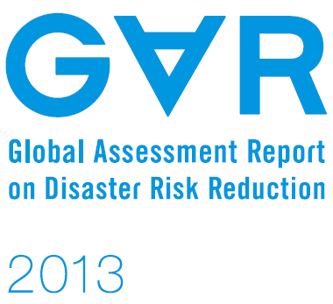“ha



Input Paper

Prepared for the Global Assessment Report on Disaster Risk Reduction 2015

**THE IMPORTANCE OF SCHOOLS IN DISASTER RISK REDUCTION**

Encouraging results in the Municipality of Amadora | Portugal

**Luís Carvalho**

Civil Protection Municipal Service

Municipality of Amadora, Portugal

[luis.carvalho@cm-amadora.pt](mailto:luis.carvalho@cm-amadora.pt)

**Nuno Leitão**

e-GEO Research Centre for Geography and Regional Planning

Universidade Nova de Lisboa, Lisbon, Portugal

[nuno.leitao@fcsh.unl.pt](mailto:nuno.leitao@fcsh.unl.pt)

**Table of Contents**

[Introduction 3](#_Toc380269989)

[The importance of awareness and prevention in schools, Portugal 5](#_Toc380269990)

[DRR in school curricula 9](#_Toc380269991)

[Encouraging results in the Municipality of Amadora 11](#_Toc380269992)

[Making Cities Resilient – Amadora is Getting Ready 11](#_Toc380269993)

[Schools participation in DRR 13](#_Toc380269994)

[Conclusion 21](#_Toc380269995)

[References 22](#_Toc380269996)

[Image1– Great natural catastrophes worldwide 1950-2011 4](#_Toc380267533)

[Image3 – Program for Young Volunteers (forest monitoring; Loulé, Algarve) 6](#_Toc380267534)

[Image4 – Summary of the Hyogo Framework for Action 2005-2015 7](#_Toc380267535)

[Image5 – Program “We and Risks” 8](#_Toc380267536)

[Image6 – Program “Civil Protection Club” 9](#_Toc380267537)

[Image7 – Awareness to the community (self-protection measures for intense cold) by students of schools in Amadora 10](#_Toc380267538)

[Image8 – Floods in municipality of Amadora (May, 2011) 12](#_Toc380267539)

[Image9 – Leadership and stakeholder’s involvement 14](#_Toc380267540)

[Image10 – ANPC’s program “Civil Protection Club” 15](#_Toc380267541)

[Image11 – School session “Climate Change” 16](#_Toc380267542)

[Image12 – School session “SOS – Earthquake Exercise” 17](#_Toc380267543)

[Image13 – School Nucleus of Civil Protection (Primary 2+3 School Miguel Torga – Amadora) 18](#_Toc380267544)

[Image14 – Program “Prevent to Protect” 19](#_Toc380267545)

[Image15 – Seismic risk prevention in schools 19](#_Toc380267546)

[Image16 – Awareness for school community 21](#_Toc380267547)

[Chart 1 – Total number of treated and analysed occurrences (Amadora, 2000-2010) 13](#_Toc380269927)

[Chart 2 – Number of sessions and students involved 20](#_Toc380269928)

# Introduction

The extreme natural phenomena do not necessarily become risks to individuals and social systems. This only happens when their manifestation threatens stability of a society or of its development resources. In fact, societies may, in their activities in the territory, interfere with the magnitude of risks and their impacts. Through the interaction between the biophysical environment and social structures, processes and sociocultural frameworks of human action, the risks may emerge and manifest themselves as disasters (Carvalho & Leitão, 2013).

Global trends show that urban growth, environmental degradation and climate change potentiate the impact of disasters and increase the vulnerability of communities. Prospective scenarios are no more encouraging. The United Nations estimates that by 2050 the annual losses from natural disasters could reach 250 billion EUR and nearly 100,000 fatalities.

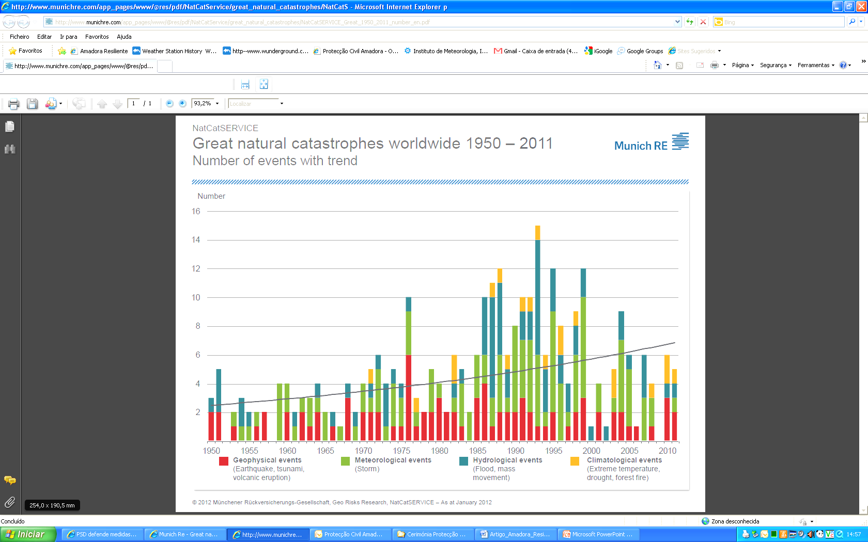

Image1– Great natural catastrophes worldwide 1950-2011

It has been estimated that over the last two decades, on average, natural disasters affected 250 million people. The human losses in the same period amounted to about 58 thousand people and economic damage to around € 55 billion, as a result of natural disasters (Image1).

The numbers show a bleak picture, but do not reflect the true impact that disasters cause and consequences that they generate to the physical and mental health of the affected people, to the economies and respective livelihoods, and to the production by the local population. They also do not reveal the impact caused by the so-called small disasters that can dramatically augment the presented numbers.

The responsibility to reduce risks is a mission that involves everyone and the ethics and principles of humanism and solidarity should be part of daily life, from the ways of educating our young to how we organize the cities. Every decision can make a society either more vulnerable, or more resilient.

The experiences indicate that the key to prevent, mitigate and, at best, to avoid the impact of disasters is to reduce the risk before disaster occurs. In a potentially destructive event, good preparation can ensure a quick, effective and appropriate reconstruction. However, strategies for reducing disaster risks will only be successful when governments and civil society understand that disasters are more than casual events and that actually represent their failure to anticipate.

In recent years the municipality of Amadora has responsibly and determinately invested in areas that mark various stages of the disaster cycle:

* Preparation,
* Rescue, and
* Recovery.

It is the responsibility of the State to promote self-protection measures, but it is the duty of the citizen to have an intervening role in society by promoting a safety culture and becoming the first civil protection agent. His/her action can take place in various scenarios, such as at home, school, workplace, or community/neighbourhood.

In order to ensure that citizens join the collective responsibility it is essential to make them aware about the need to take an active role in reducing the number of occurrences in the municipality and, consequently, in reducing the exposure to risks (Carvalho & Leitão, 2013).

In the school context, the decisive factor for an adequate response to the emergency lies in the preparation and early prevention (Machado, 2012). This article brings forward an overview of the importance of raising awareness about reducing disaster risk in Portuguese schools, as well as the results obtained in this area in the municipality of Amadora.

Reducing disaster risk will be effective only when a community feels a genuine concern for its own safety. In this sense, the purpose of this article is to share the implemented strategy, practice activities and exercises, as well as the process of collaboration and cooperation between the educational community in the municipality of Amadora, the Civil Protection Local Authority and the local campaign “Resilient Amadora[[1]](#footnote-1)”.

# The importance of awareness and prevention in schools, Portugal

Although the political power transmits carelessness and irresponsibility in promoting safety culture in Portuguese society, citizens, who are also responsible, show lack of interest in reducing disaster risk and lack of concern with the quality of the housing buildings structures (Machado, 2012). This severity of this situation grows where there is no public awareness campaigns devoted to risks to which all citizens are normally exposed.

Besides the importance of having an efficient legislation, information and prevention have a key strategic value for the success of disaster reduction, as well as for the motivation of people to become more active in risk prevention and for encouraging communities to take greater responsibility for their own protection.

According to several studies (Machado, 2012), the public awareness campaigns for the adoption of preventive measures transmitted by the media, as well as campaigns through leaflets inserted in newspapers and magazines have a positive effect on raising awareness and motivating people (Image 2).

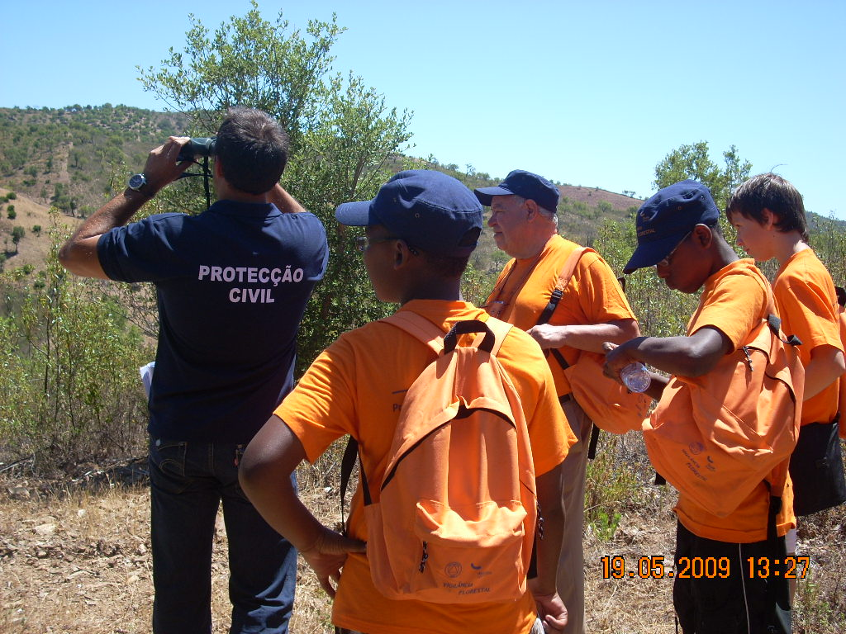

Image3 – Program for Young Volunteers (forest monitoring; Loulé, Algarve)

Schools, along with public security and civil protection authorities, can and should play a key role in disseminating prevention and emergency rules among the population. However, risk-related education requires implementation of a clear, coherent and consistent strategy that should be valid for several generations through multidisciplinary educational programs designed for the entire educational community (Machado, 2012).

As regards the international guidelines, the Hyogo Framework for Action 2005-2015 (UNISDR, 2013) in the Priority Action 3 (*Use knowledge, innovation and education to build a culture of safety and resilience at all levels*) clearly defines critical role that schools should play in raising public awareness to building safer and resilient communities through (Image 3):

* Information concerning risks and self-protection measures easily noticeable in order to motivate and empower people to act;
* Inclusion of knowledge on disaster risk reduction in school curricula;
* Assessment of local risks and implementing prevention and emergency plans;
* Programs and activities related to the minimization of the effects caused by hazards;
* Regular exercises of prevention.

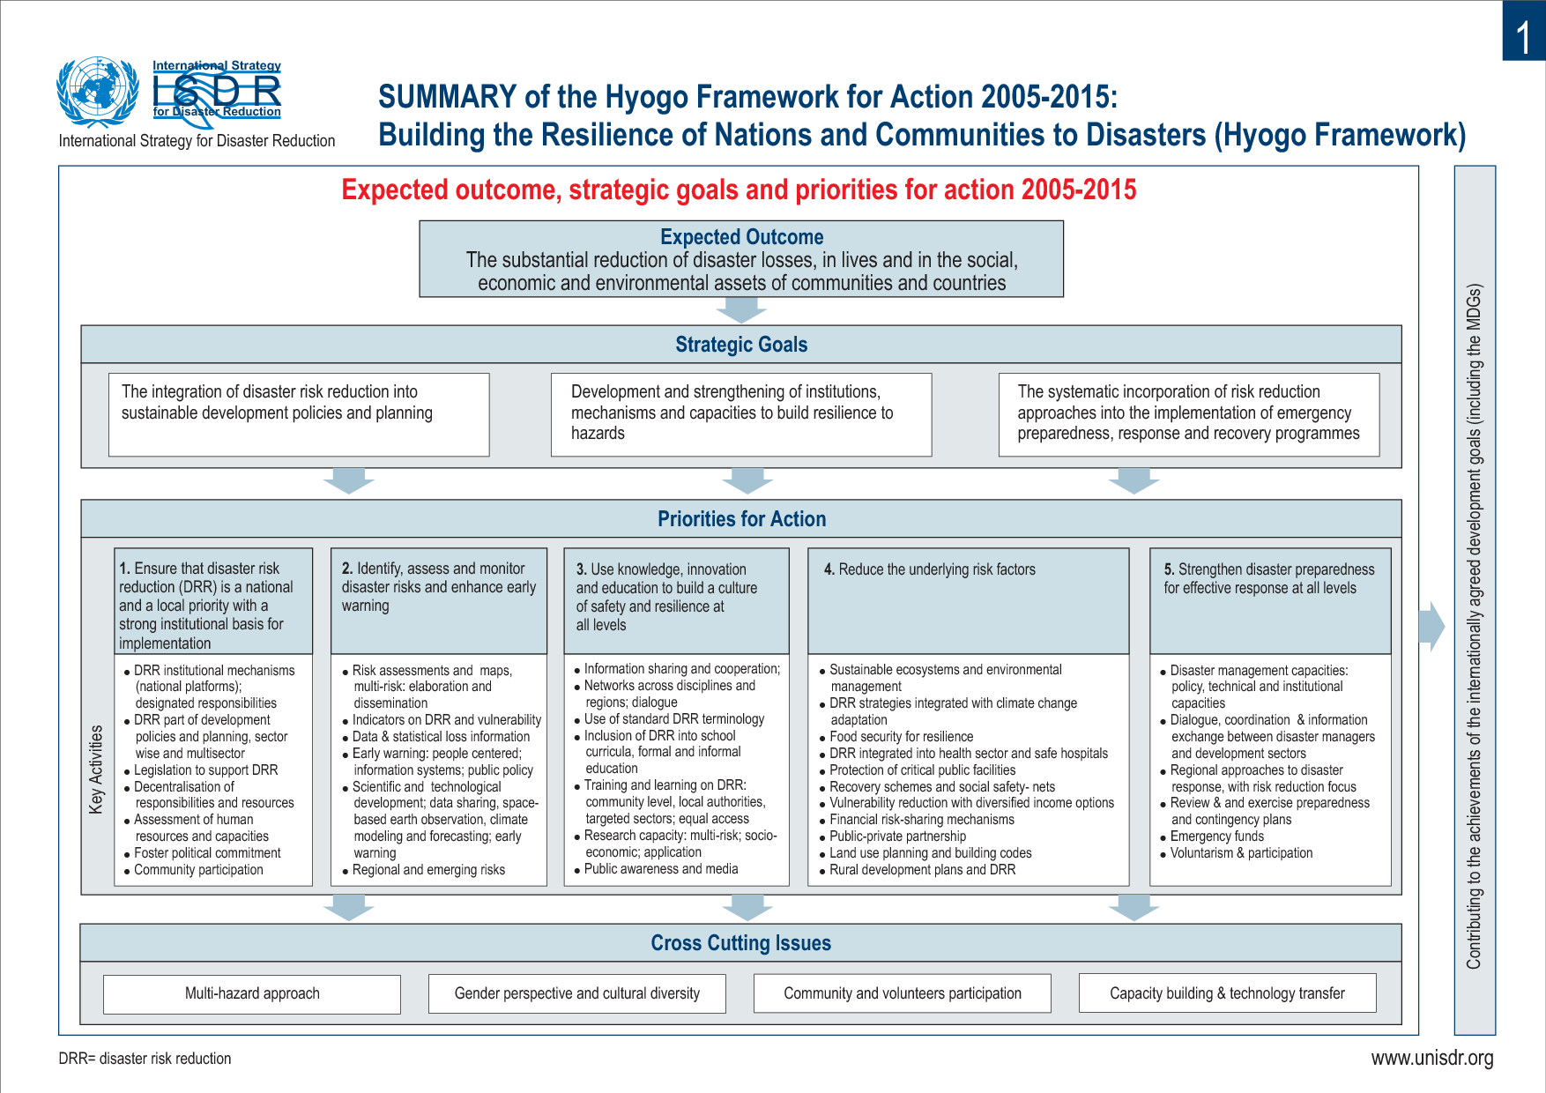

Image4 – Summary of the Hyogo Framework for Action 2005-2015

In order to operationalize the Hyogo Framework for Action 2005-2015, the United Nations launched one of the most iconic initiatives/campaigns ever with regard to the theme of risk and disaster resilience – “World Disaster Reduction Campaign 2010-2015 - Making Cities Resilient”. This campaign, which the municipality of Amadora joined in November 2010, addresses the need of local communities to face the problem of fatalism associated with the disaster and to develop a set of good practices that enable them to resist, adapt and recover (resilience).

In the national context, the involvement in this initiative means to assume that the models of prevention and response are important vehicles to boost the communities’ resilience. To this end, however, it is essential that entities responsible for these issues are able to create the necessary conditions in order to develop actions for the mitigation of risks and limitation of their effects when they occur.

The Portuguese legislation addresses the prevention of natural and technological risks in a limited way. The sector of Civil Protection (Ministry of Interior), with responsibilities in this area has focused much of its attention on the development of emergency plans, to ensure the relief and assistance to people and other living beings in danger, as well as to protect goods and cultural, environmental and other values of public interest.

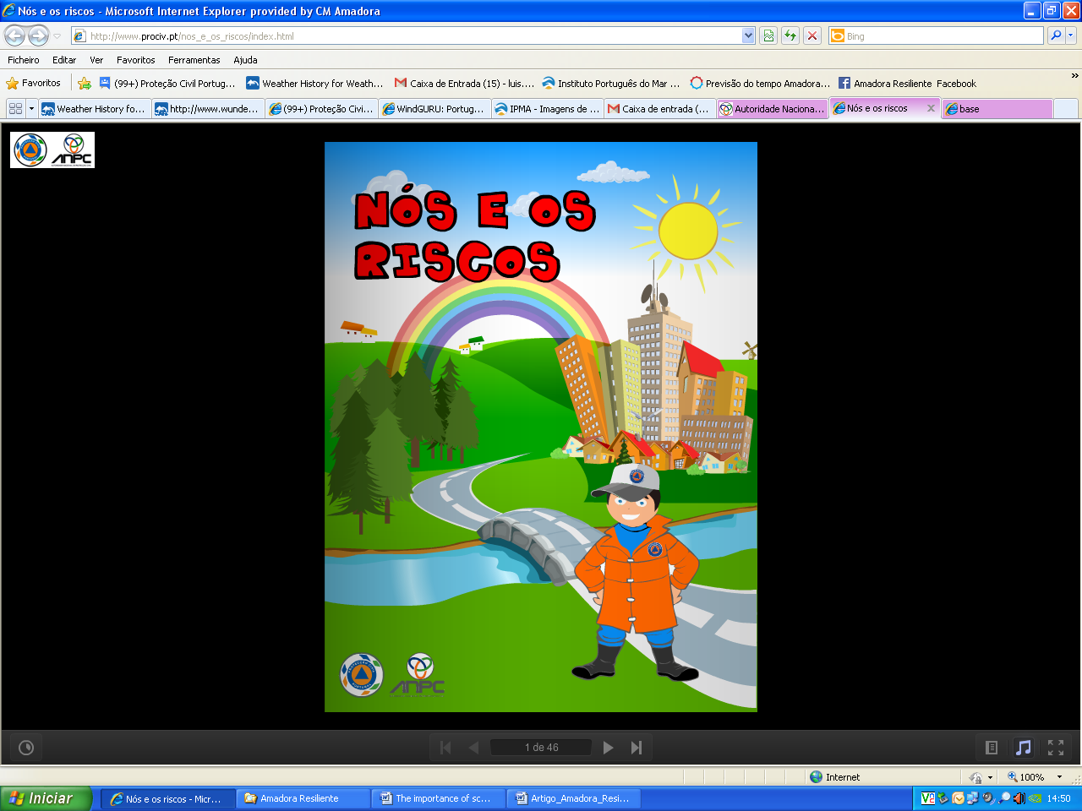 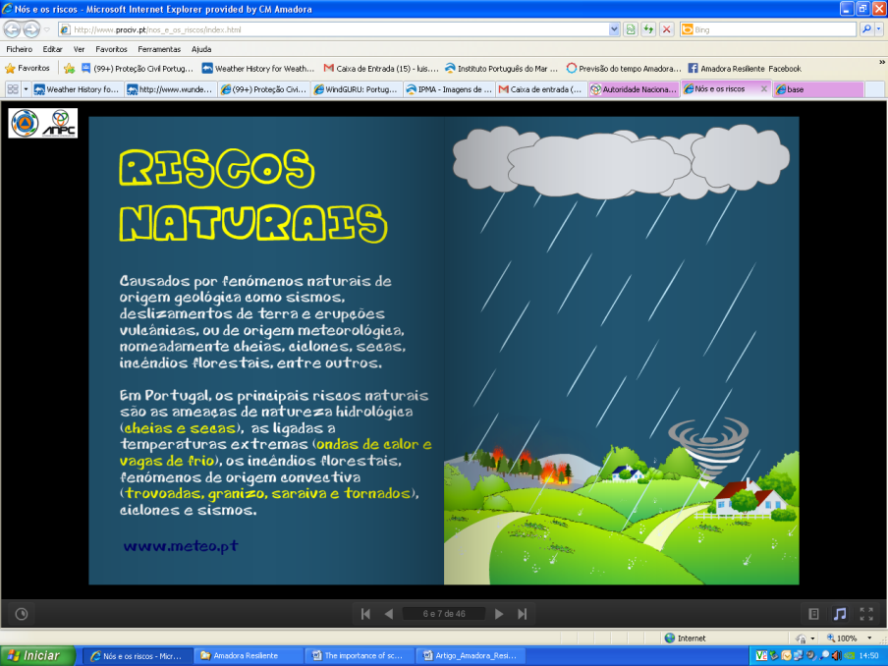

Image5 – Program “We and Risks”

However, there have been several educational activities and actions aimed at awareness-raising of the population, especially the young, in order to inform about risks that affect their territory and about measures for their preparedness, prevention and self-protection in emergency situations. National programs “We and Risks” (Image4) and “Civil Protection Club” (Image5) developed by the National Civil Protection Authority (ANPC), despite presenting the basic principles for community outreach in reducing disaster risk, have not had adequate visibility and promotion.

The objectives of these programs are:

* To inform the school population on collective risks;
* To involve the school community in building a culture of safety;
* To educate to prevent and minimize risks;
* To promote an active and participatory citizenship;
* To sensitize students about the civil protection competences;
* To identify natural and technological risks at local, regional and national scales;
* To promote appropriate attitudes and behaviours in emergency situations.

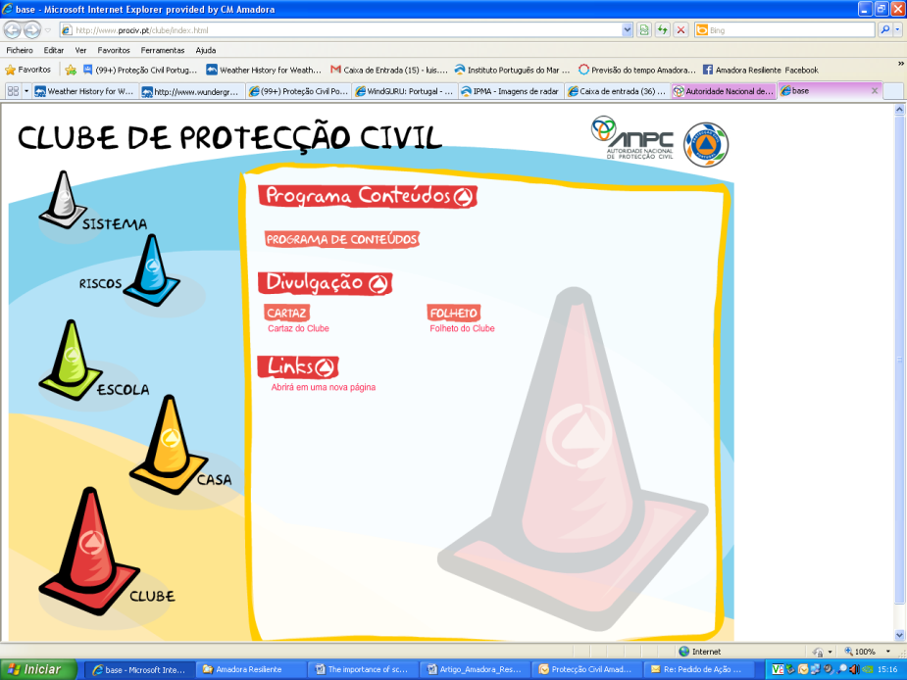

Image6 – Program “Civil Protection Club”

However, only few municipalities and entities have implemented these programs. The reasons are several:

* Lack of coordination between the ANPC, the Ministry of Education and municipalities for the implementation of the program content locally;
* Lack of incentives to the school community;
* Lack of a collaborative platform between the school community and civil protection authorities;
* Political apathy and non-existence of safety culture in Portuguese society.

A joint effort should be made by various national authorities, Ministry of Interior and Ministry of Education so that the developed programs become incorporated in school textbooks. It should be the responsibility of these entities to establish necessary mechanisms for an effective implementation at local level.

## DRR in school curricula

Reducing disaster risk should be systematically addressed in school curricula. The approach should be extended beyond the basic scientific knowledge about the risks and security measures. The development of prevention, mitigation, vulnerability and resilience should be considered (UNESCO & UNICEF, 2012).

Educating for reducing the disaster risk is to promote understanding among students about the causes, nature and effects of risks, while promoting a range of knowledge and skills that allow them to contribute proactively to the prevention and mitigation of disasters.

Several studies have provided examples and methodologies (UNESCO & UNICEF, 2012) that ensure the integration of the theme of risk and disaster resilience in school curricula through

* Interactive learning: brainstorming sessions; discussions in small workgroups; interactive presentations;
* Affective learning: sharing feelings about serious accident or disaster episodes; exercises of empathy for those who experienced disasters;
* Learning to do research: analysis of case studies;
* Audio-visual learning: film production; drama performance; simulation games; school assemblies on reducing disaster risk;
* Experiential learning: study visits to places of greater risk and dangerousness; participation in the preparation of risk maps; street and awareness raising campaigns.

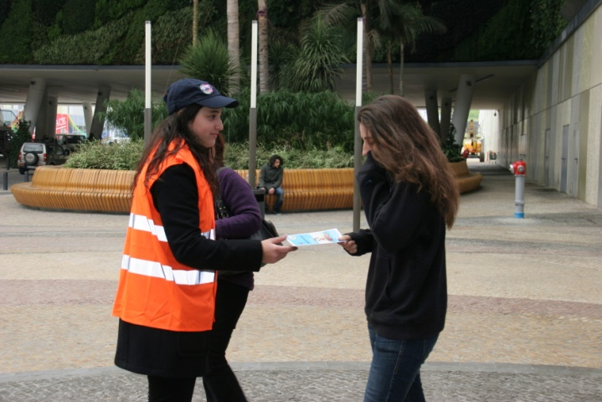

Image7 – Awareness to the community (self-protection measures for intense cold) by students of schools in Amadora

In Portugal, the National Council of Education (Ministry of Education) in its Recommendation No. 05/2011 states that schools should promote risk education by including in the curricula the theme of disaster risk reduction. That recommendation points to the need for recognizing the school as an agent of intervention and an engine to mobilize society in the field of risk education through the students, their families and the rest of the educational community (Nunes, Almeida, & Nolasco, 2013).

Although the curricula of some school subjects do contemplate the theme of reducing the risk of disaster, this is done very sporadically. In this area, Geography has been a discipline that has most contributed to a better perception of danger/risk and of its consequences.

The Geography curriculum of the 7th school grade contains the theme “Natural Risks and Catastrophes”, which includes conducting group work (interactive learning) with the intention that students identify risks and evaluate the consequences of disasters. However, this approach does not offer reference to the explicit basic concepts of risk and disaster. In fact, the process of teaching/learning should focus on prevention and mitigation of disasters as crucial in creating a culture of prevention that can lead to reducing negative effects of the consequences (Nunes, Almeida, & Nolasco, 2013).

Since it is the last sub-theme of the 7th grade, the time teachers dedicate to risks is very variable (2 - 9 hours) which is clearly inappropriate for an adequate treatment of this theme. In addition, an analysis of more than a dozen textbooks revealed that the approach to the risks and disasters theme lacks clarity and scientific rigor, which has implications in the teaching/learning process. It is also worth stressing that all the necessary importance has not been given to some risks and disasters that cause most economic damage and human losses, such as forest fires and urban fires.

The theme of risk is present again in the 9th grade of schooling by exploring human intervention in the creation or enhancement of risks, particularly related to climate change. However, issues related to prediction and prevention remain omitted

In order to overcome such gaps in school curricula it is essential to promote and develop approaches in greater depth. It would be relevant, for example, that all schools be associated with programs promoted by the ANPC.

# Encouraging results in the Municipality of Amadora

## Making Cities Resilient – Amadora is Getting Ready

Over the past 20 years, the municipality of Amadora suffered many damages and human losses from natural and technological disasters, with particular emphasis on urban flooding (Image 7), urban, industrial and forest fires, land movements and road accidents. According to the civil protection statistics, more than 12,000 occurrences were registered between 2000 and 2010 (Chart 1).

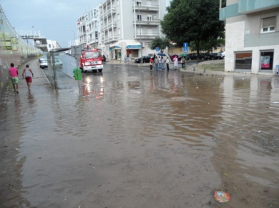 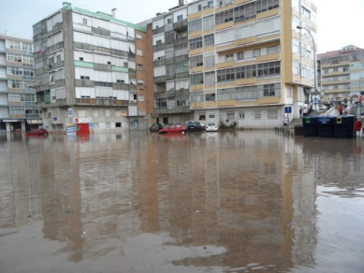

Image8 – Floods in municipality of Amadora (May, 2011)

With a resident population of 175,135 (2011 Census), an area of ​​23.7 km2 and a population density of 7300 inhabitants per km2 (2011 Census), the municipality of Amadora faced the following challenges till 2010:

* A weak participation of various stakeholders in urban planning and risk analysis process;
* A severe impact on the community of many extreme meteorological phenomena;
* Inability to develop a survey and analysis of all the risks in the territory and to build a culture of safety;
* Introducing the reduction of disaster risk on the municipal agenda.

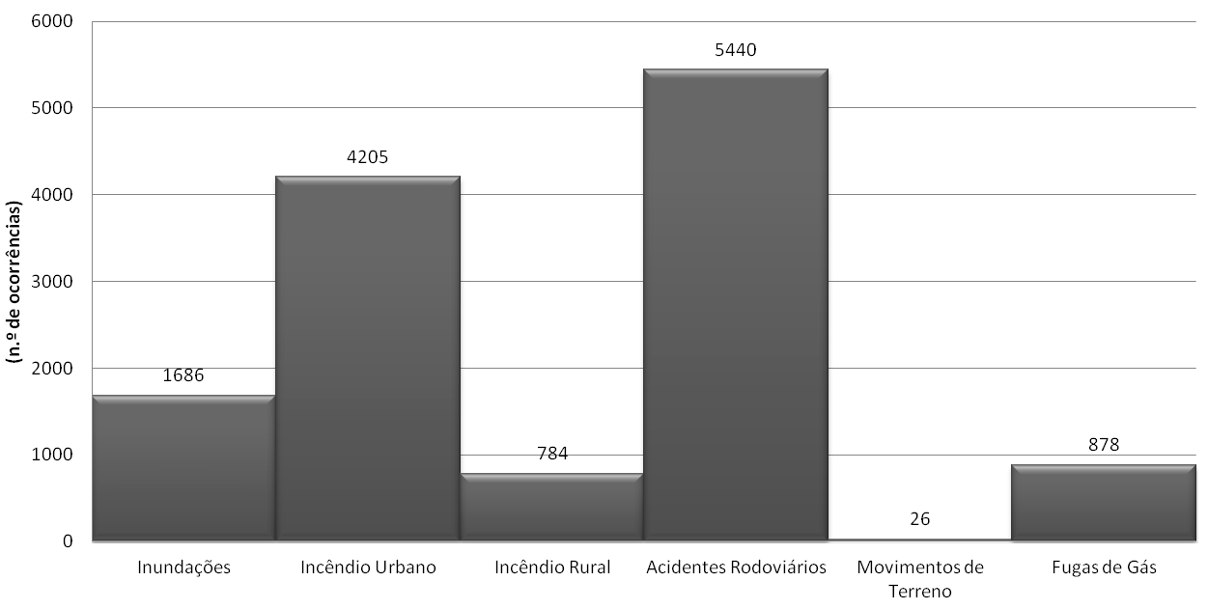

Chart 1 – Total number of treated and analysed occurrences (Amadora, 2000-2010)

After the municipality joined the International Campaign for Disaster Risk Reduction - Building Resilient Cities 2010-2015, there was a need to create a working group/multidisciplinary team to address the challenges set out and implement the resilient city principles at the local scale, entitled Local Campaign 2010-2015 “Always in Motion, Amadora is Resilient” (Image 8).

The first step made by the Local Campaign Team was to mobilize various stakeholders (municipal services, local agents, civil society groups, universities and specialized organizations), offering them local partnerships and alliances. For this, numerous workshops and public meetings were organized in order to explain the benefits and the necessary compromises to guarantee a more resilient community. Currently, the Local Campaign 2010-2015 “Always in Motion, Amadora is Resilient” has more than 40 stakeholders.

The second step was to develop mechanisms of sensitization and training for the general public and stakeholders in order to be able to transmit to them the correct procedures to take in emergency situations. With the support of partners, the Local Campaign Team brought forward several publications[[2]](#footnote-2) and emergency plans (according to the Technical Guidelines of the National Civil Protection Authority) and organized technical-scientific studies devoted to risk analysis in the municipality and to structural and non-structural measures to be applied. The Campaign Team also developed a methodology[[3]](#footnote-3) for reducing disaster risk in the stakeholders’ infrastructures, by providing technical advice for the identification of noncompliance and for the proposed improvements within the Legal Framework for Fire Safety in Buildings (SCIE) and by offering training and awareness among the users of facilities.

Y:\Campanha Amadora Resiliente\UNISDR Europa\Local Government Self Assessment Tool\Parcerias.tif

Image9 – Leadership and stakeholder’s involvement

The existence of education, training and awareness raising programs on disaster risk reduction has been a major focus of the Local Campaign. In the last academic year (2012/13) about 80 actions involving over 2000 students were organized. On the other hand, participation in various events and local festivities, a commemorative conference of the International Day for Disaster Reduction and organization of various training sessions (prevention and self-protection measures) and information (about hazards and disasters) to the partners of the Local Campaign and community allowed the Campaign Team to insert the issue of disaster risk reduction in everyday life of the municipality.

## Schools participation in DRR

Schools should play a key role in education for resilience, contributing to the formation of citizens with high levels of sociability, cooperation in networks, with communication skills and abilities to act efficiently. In this perspective, the system composed of teachers, professionals and students should recognize, value and promote resilience-promoting strategies by providing opportunities for educational communities to deal with adverse and stressful situations, such as those related to the preparation for disasters and to the management of emergencies caused by both anthropogenic accidents and natural disasters.

Although schools constitute a link between different generations and have a distinct role in raising awareness among the population about the risks and dangers, by 2005 very little had been done to increase the participation of the educational community in the municipality of Amadora in the process of disaster risk reduction at the local scale.

Despite its implementation has fallen well short of expectations at the national level, in 2005 the Municipal Civil Protection Service[[4]](#footnote-4) of the municipality of Amadora launched the ANPC’s program “Civil Protection Club” (Image 5) for the school community by means of:

* Submission of the program and membership dossier to all schools in the municipality;
* Meetings to present the program at the headquarters of school clusters;
* Raising awareness of the Department of Education and Socio-Cultural Development of the municipality;
* Definition of partnerships with the Volunteer Firefighters of Amadora, Portuguese Red Cross and Municipal Police.

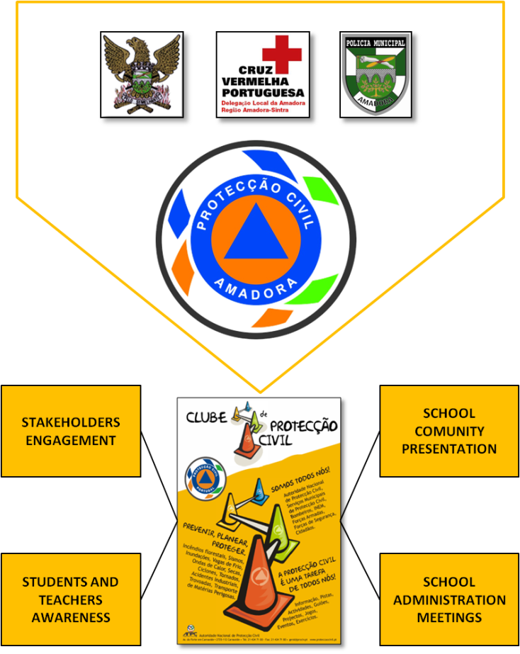

Image10 – ANPC’s program “Civil Protection Club”

Despite having poor adhesion in its first year (Chart2), this initiative gradually came gaining expression in the schools of Amadora (2nd and 3rd cycles and secondary schools)[[5]](#footnote-5) over the last years. Through theoretical and practical presentations of the appropriate procedures to take in emergencies and natural and technological risks at local level, it has been possible to sensitize the young and children to acquire safety habits and complement school curricula in various disciplines (geography, geology, natural sciences and biology) that address the issues of risk and disaster resilience.

The theoretical and practical presentations to students always have had a ludic and participatory component:

* Climate Change (Image 10) – students are invited to submit the most advantageous arguments in terms of mitigation or adaptation and applicable local scale;
* Risk and Disaster – main risks (natural and technological) that exist in the municipality and self-protection measures to be adopted in disaster situation;
* SOS Earthquake Exercise (Image 11) – practical exercise with students about the correct procedures before, during and after an earthquake;

**D:\Formação 2012_2013\Alterações Climáticas\Climate change.tif 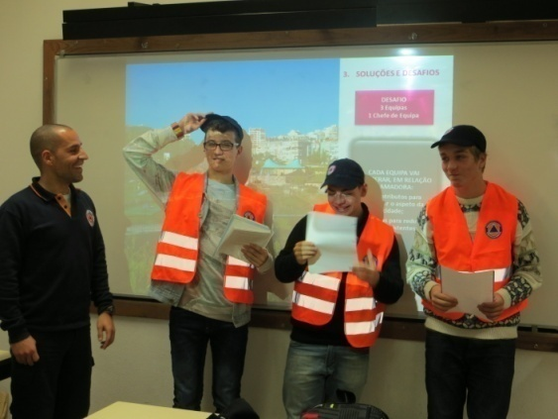**

Image11 – School session “Climate Change”

* SOS Storm Exercise – practical exercise with the students on correct procedures before, during and after a thunderstorm;
* Risk Zones (Amadora) – the highest risk areas in the municipality and presentation of mitigation measures;
* Urban and Forest Fires – causes, consequences, self-protection measures and thematic visits to the most affected areas;
* First Aid – practical demonstration of procedures for basic life support;
* Emergency Kit – presentation of the main tools that are essential in a disaster situation;
* Anthropic Presence – the interconnection between the risks and planning; Theoretical and practical exercises on preventive measures to reduce the risks in the territory.

D:\Formação 2012_2013\Exercício SOS SISMO\SOS Earthquake.tif 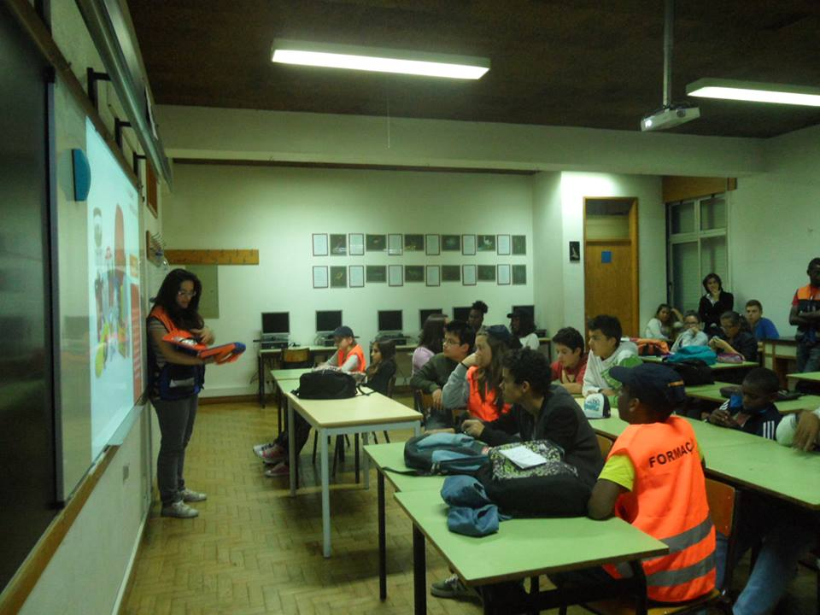

Image12 – School session “SOS – Earthquake Exercise”

In some schools where the acceptance of this project has been favourable it was possible to create “School Nuclei of Civil Protection” defined as spaces where students develop work related to the Civil Protection themes (hazards, disasters, prevention, rescue, recovery, etc.) and promote awareness and training in the classes to which they belong.

There are currently three “School Nuclei of Civil Protection” in three schools (Secondary School Fernando Namora, Primary 2+3 School Miguel Torga, and Primary 2+3 School Sophia de Mello Breyner). Each nucleus consists of 5 to 10 students[[6]](#footnote-6) selected by the School Board and is equipped with a flag, caps and jackets of civil protection. The main mission of each nucleus is to encourage the participation of their school community in reducing disaster risk. They do it in different ways throughout the school year:

* Surveys;
* Games and thematic exhibitions;
* Evacuation exercises;
* Celebrations (International Day of Civil Protection, Environment Day, Forest Day, International Day of Natural Disaster Reduction);
* Invitations to public figures to give thematic lectures on risk and disaster.

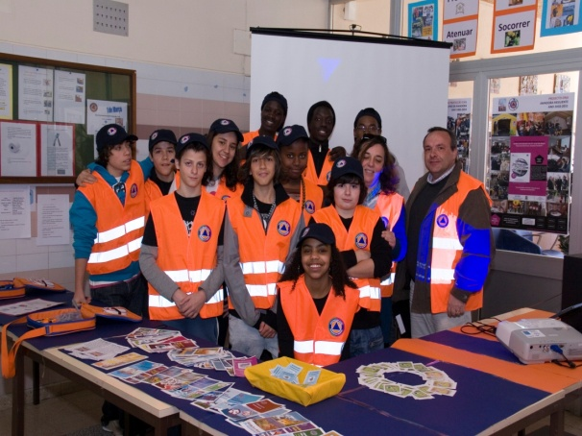

Image13 – School Nucleus of Civil Protection (Primary 2+3 School Miguel Torga – Amadora)

At the end of each academic year all students of the civil protection nuclei are rewarded for their efforts and dedication with a certificate, a cap and an emergency kit. Additionally, an annual evaluation is made to identify various difficulties and what more should be done to improve the functionality of every nucleus (Image 12).

After the municipality joined the International Campaign 2010-2015 “Making Cities Resilient – My City is Getting Ready” of the International Strategy for Disaster Reduction of the OUN, the Team of the Local Campaign 2010-2015 “Always in Motion, Amadora is Resilient” developed a school program entitled “Prevent to Protect” for students of the 1st cycle schools and pre-schools[[7]](#footnote-7) aimed at raising the awareness about the prevention and self-protection measures.

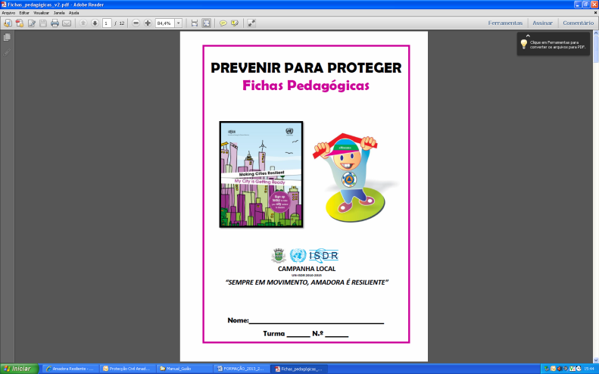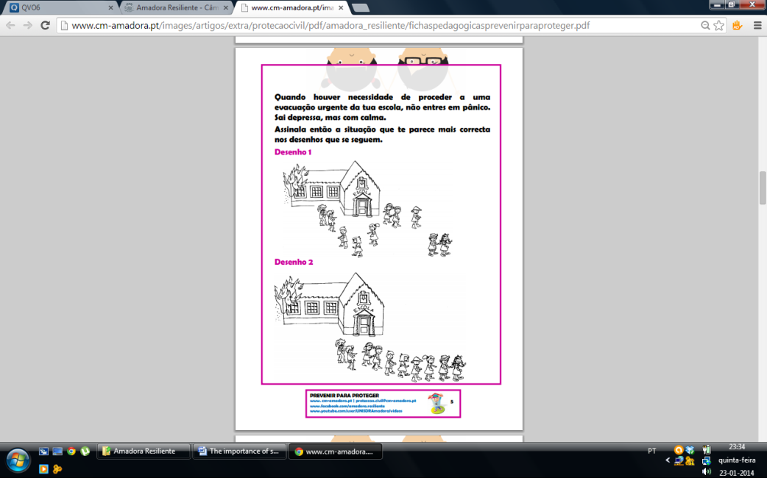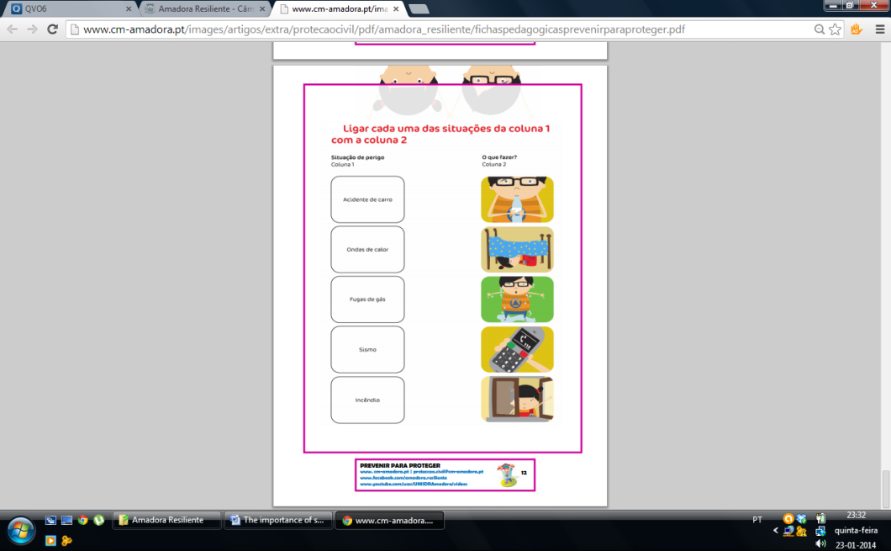

Image14 – Program “Prevent to Protect”

The school program “Prevent to Protect” aimed at a younger audience is based on:

* Dissemination of an educational file sheet on self-protection measures for different risks;
* Exhibition of a video about safety procedures and evacuation scenarios in a classroom;
* Promotion of ludic activities and evacuation drills in the classroom.

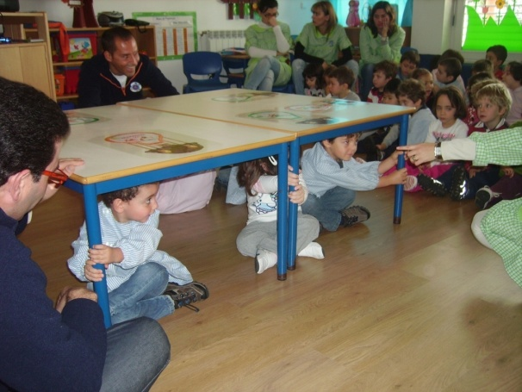

Image15 – Seismic risk prevention in schools

In collaboration with the Department of Education and Social Development of the Municipality of Amadora it has been largely possible to boost this program in primary schools and pre-schools in the municipality. To ensure the success of the program a mascot “Riskas” was created, as well as several awards for the best children’s drawings of reducing disaster risk.

Thanks to “Civil Protection Club” and “Prevent to Protect” programs there was a steady increase of awareness and of the number of involved students. In the last academic year (2012/2113) the subject of disaster risk reduction was introduced to more than 10 schools in the municipality and about 2,000 students were involved in 77 organized actions.

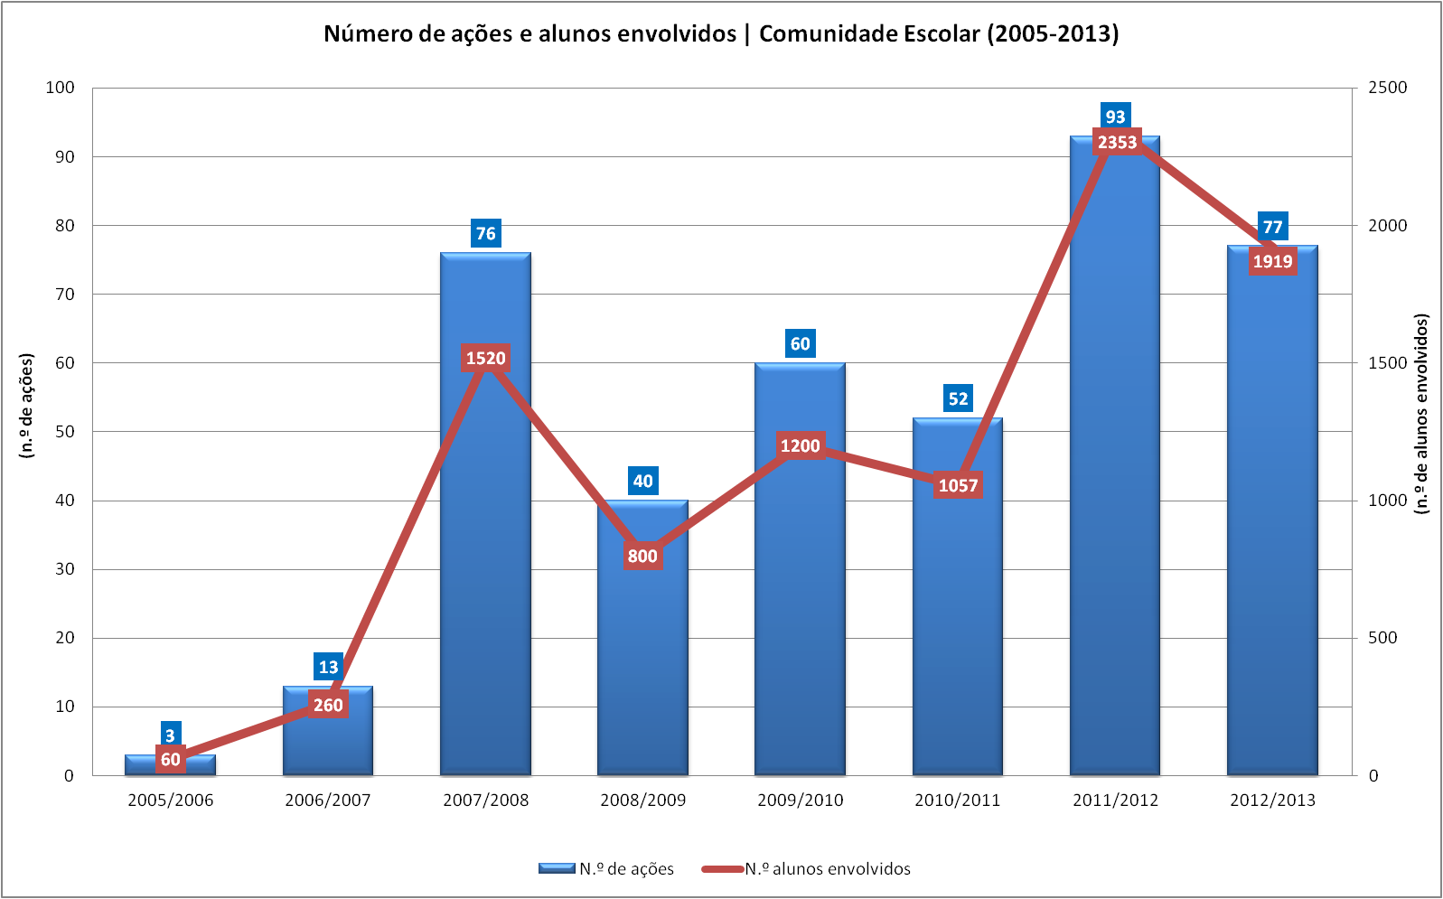

Chart 2 – Number of sessions and students involved

Given the high demands from schools and wider community to raise awareness and information about disaster risk reduction in the municipality, “Information and Awareness Program for Disaster Risk Reduction in Amadora, 2013 – 2014” was created in order to establish a schedule for continuous and sustainable awareness creation in partnership with various local entities responsible for this matter.

This program involves:

* Mobilization of agents and entities in an appropriate and effective manner, so that a true culture of safety in the city can be built, particularly in the school community, the Local Campaign partners and the community in general;
* Continuation of the school community projects “Civil Protection Club” (2nd and 3rd cycle and secondary schools), “School Nuclei of Civil Protection” (2nd and 3rd cycle and secondary) and “Prevent to Protect” (4th year of the 1st cycle ) by ensuring their greater dynamism and comprehensiveness;
* Continuation of the process of training of the Local Campaign partners in self-protection and prevention measures for their infrastructure and users;
* Organization and streamlining of workshops, seminars and conferences on the subject of disaster risk reduction, involving the whole community;
* Participation in events and festivities organized by the municipality and the Local Campaign partners.

With the “Information and Awareness Program for Disaster Risk Reduction in Amadora, 2013 – 2014” it has been possible to increase citizens' consciousness about reducing risks in urban settings, to strengthen and support local government, community groups and various institutions involved in risk management process, as well as to urge the local government to take measures to reduce population's vulnerability to disasters.

In addition, this document is part of the Declaration of Commitment that the municipality of Amadora established with the International Strategy for Disaster Reduction of the United Nations, when joining the Making Cities Resilient Campaign. In this document, the municipality of Amadora pledges to undertake all necessary efforts for the campaign to involve a maximum possible number of actors in local, scientific and academic community to demonstrate the relevance of risk reduction in view of a high incidence of natural and technological disasters plaguing this territory.

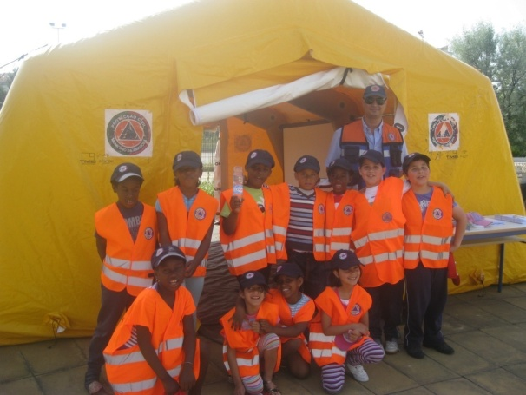

Image16 – Awareness for school community

# Conclusion

Disregarding disaster risk reduction can lead to serious economic problems and deterioration of ecosystems, as well as to the loss of public confidence. As proven by the experiences at the local scale, disasters can seriously compromise the essential services of a community, such as water systems, health, transport, waste, communications and food distribution.

It is known that the preparation and response to disasters calls for active participation of the community. Relying solely on institutional structures for rescue and response can be dangerous and is not effective when responses to multiple disasters are required. The first to respond to disasters and early warning measures are the local people and authorities. They must be given all possible support, as well as the encouragement to resilience through planning processes.

Nevertheless, and despite the recognized fundamental role of the school, there is still a long way to go until the risk education aspects are included in school curricula, and thereby improvements are achieved in a behaviour based on security, prevention and adequate risk management (Nunes, Almeida, & Nolasco, 2013).

The education/awareness about the risk in school environment requires implementation of a well-defined, consistent and systematic strategy (Machado, 2012). The efforts made by the municipality of Amadora with regard to the involvement of the educational community in reducing disaster risk will remain throughout the generations due to the institutionalization of a diversified set of programs, activities and educational resources, which have resulted in the development of skills related to the prevention, adaptation and recovery from disasters.

However, in the strategy that has been implemented there are aspects to improve, thus ensuring a continuous raising awareness and communication about risks in schools, such as:

* Promoting information sessions on rules of conduct in emergency situations for teaching staff and technical and operational assistants in the schools;
* Giving preference to curricular contents related to the hazards, risks and vulnerabilities that affect populations;
* Encouraging greater transmission of prevention measures and appropriate behaviours in emergencies upsetting family members and friends;
* Encouraging instructional sessions on basic techniques for handling first response resources (e.g., fire extinguishers).

In the territory of Amadora, vulnerability of the population to natural, technological and environmental risks justifies schools’ strategic importance in promoting a culture of prevention and safety that is essential in building a more resilient community.

# References

Amaratunga, D & Haigh, R. 2011. Introduction. *Post-Disaster Reconstruction of the Built Environment: Rebuilding for Resilience.* Wiley-Blackwell. Pages 1-12. New Jersey, USA.

Carvalho, L., & Leitao, N., 2013, *Disaster Loss (2000-2010) and Climatological Data for Municipality of Amadora (1915-2012)*. Civil Protection Service of Amadora & TERCUD - Center for the Study of the Territory, Culture and Development, Lisbon

Machado, A. B., 2012. *Perception of Risk and Implementing a Safety Culture: Building Resilient Communities Education*. University of Lisbon - Institute of Geography and Spatial Planning. Lisbon

Nunes, A., Almeida, A. C., & Nolasco, C. 2013. *Risk Education: the contribution of geography in the 3rd cycle*. In L. F. Lawrence & M. A. Matthew, Natural, Anthropogenic and Mixed Risk. Tribute to Professor Fernando Rebelo (pp. 143-152). Coimbra: Department of Geography - Faculty of Arts, University of Coimbra . Coimbra

Tedim, F., Ferreira, M., Cunha, M., & Sousa, C. 2010. *Forest Fire Risk in Teaching Geography in the 3rd cycle of basic education. Teaching Geography and the Bologna Process*. Proceedings of the XII Colloquium Iberian Geography. Port: Department of Geography, Faculty of Arts, University of Porto.

UNESCO & UNICEF. 2012. *Disaster Risk Reduction in the School Curriculum: Case Studies of Thirty Countries*. Geneva and Paris.

UNISDR. 2012a. *Making Cities Resilient Report 2012: My city is getting ready! A global snapshot of how local governments reduce disaster risk.* Genève, Switzerland: UNISDR.

UNISDR. 2012b. *Towards a Post-2015 Framework for Disaster Risk Reduction*. Genève, Switzerland: UNISDR.

UNISDR. 2013. *Implementing the Hyogo Framework for Action in Europe: Regional Synthesis Report 2011-2013*. Genève, Switzerland: UNISDR.

**Laws**

Ministry of Education. (20 October 2011). Recommendation No 5/2011 -. Risk Education. Lisbon 09/11/2013

<http://dre.pt/pdf2sdip/2011/10/202000000/4165941662.pdf> (

1. Making Cities Resilient – My City is Getting Ready. [↑](#footnote-ref-1)
2. Family Emergency Plan, Technical Guidelines for Preparation of Security Plans, Educational Files “Prevent to Protect”, History of Events in the Municipality of Amadora 2000-2010, and Climatic Normals 1915-2012, informative leaflets about extreme weather events and technical-operational statements on weather conditions, weather warnings and alerts for civil protection [↑](#footnote-ref-2)
3. AXIS 1: Identification of non-conformities and proposed improvements as recommended in the Legal System for Fire Safety in Buildings (SCIE); AXIS 2: Streamlining/technical support in the Self-protection Measures; AXIS 3: Training/sensitization for staff and users of facilities; AXIS 4: Conducting thematic workshops on specific dates and locations; AXIS 5: Participation in the ongoing events of the Campaign. [↑](#footnote-ref-3)
4. The authority responsible for preparedness, relief and recovery of Amadora community in serious accident or disaster. [↑](#footnote-ref-4)
5. Ages between 10 and 17 years old. [↑](#footnote-ref-5)
6. Only those with best schooling results. [↑](#footnote-ref-6)
7. Ages between 4 and 9 years old. [↑](#footnote-ref-7)